1. create table employee (

empno number(5) primary key,

empname varchar(20) not null,

gender char(1) check (gender in ('M', 'F')),

salary number(10) not null,

address varchar(50) not null,

dno number(5),

foreign key(dno) references department(deptno) );

1. 3. create table department (

deptno number(5) primary key,

deptname varchar(20),

location varchar(50) );

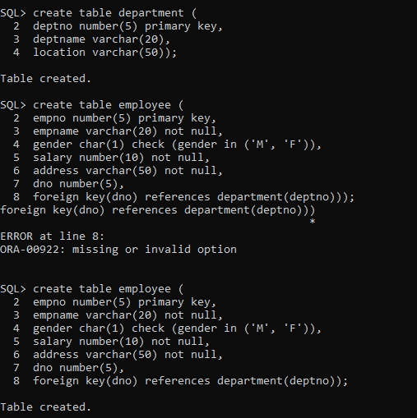



1. insert into employee values (&empno, &empname, &gender, &salary, &address, &dno);

Enter value for empno: 00001

Enter value for empname: 'Sam'

Enter value for gender: 'M'

Enter value for salary: 75000

Enter value for address: 'Manipal'

Enter value for dno: 10002

insert into employee values (&empno, &empname, &gender, &salary, &address, &dno);

Enter value for empno: 00002

Enter value for empname: 'Bright'

Enter value for gender: 'M'

Enter value for salary: 70000

Enter value for address: 'Mangalore'

Enter value for dno: 10001

insert into employee values (&empno, &empname, &gender, &salary, &address, &dno);

Enter value for empno: 00003

Enter value for empname: 'Mia'

Enter value for gender: 'F'

Enter value for salary: 100000

Enter value for address: 'Delhi'

Enter value for dno: 10003

insert into employee values (&empno, &empname, &gender, &salary, &address, &dno);

Enter value for empno: 00004

Enter value for empname: 'Megan'

Enter value for gender: 'F'

Enter value for salary: 150000

Enter value for address: 'Mumbai'

Enter value for dno: 10001

insert into employee values (&empno, &empname, &gender, &salary, &address, &dno);

Enter value for empno: 00005

Enter value for empname: 'Kate'

Enter value for gender: 'F'

Enter value for salary: 125000

Enter value for address: 'Kerala'

Enter value for dno: 10005

insert into employee values (&empno, &empname, &gender, &salary, &address, &dno);

Enter value for empno: 6

Enter value for empname: 'Dom'

Enter value for gender: 'M'

Enter value for salary: 85000

Enter value for address: 'Chennai'

Enter value for dno: 10004

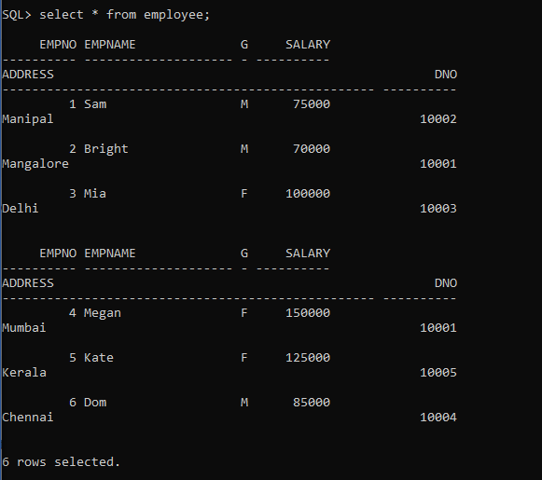

1. insert into employee values (&empno, &empname, &gender, &salary, &address, &dno);

Enter value for empno: 5

Enter value for empname: 'Maya'

Enter value for gender: 'F'

Enter value for salary: 50000

Enter value for address: 'Assam'

Enter value for dno: 10001

insert into department values(&deptno, &deptname, &loaction);

Enter value for deptno: 10003

Enter value for deptname: 'CSE'

Enter value for loaction: 'Udupi'

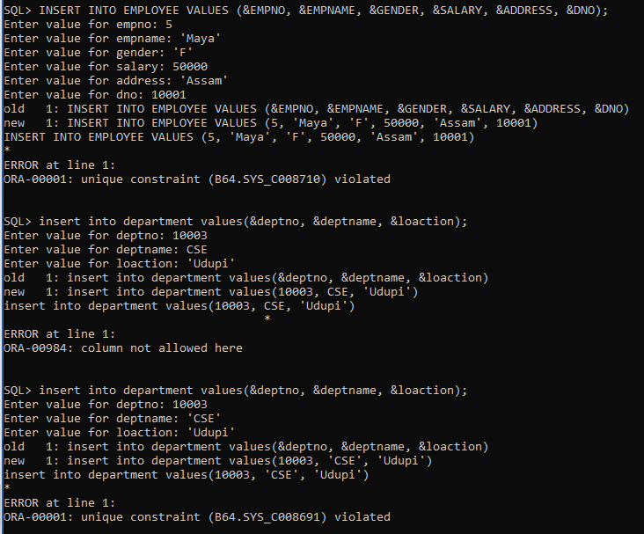



1. update employee set empno = 3 where empname = 'Kate';

delete from department where deptno = 10004;

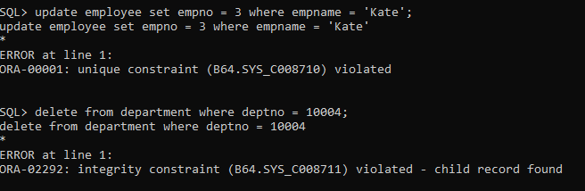

1. alter table employee add constraint c1 foreign key(dno) references department(deptno) on delete cascade;

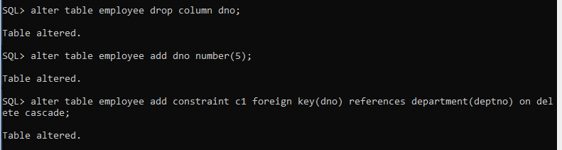

1. alter table employee modify salary default(10000);

alter table employee modify salary check(salary>=10000);

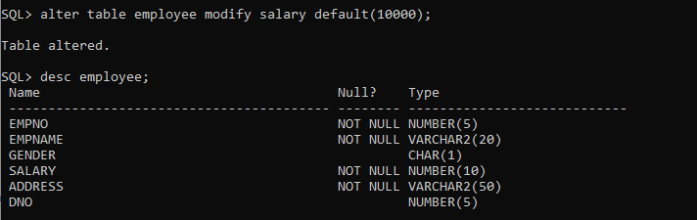

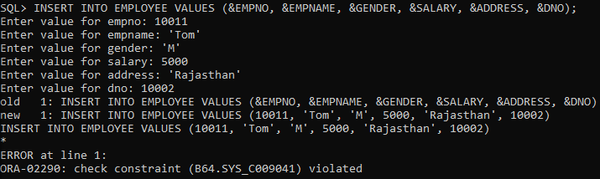

1. select name, dept_name from student;

1. select * from instructor where dept_name = 'Comp. Sci.';

1. select title from course where dept_name = 'Comp. Sci.' and credits =3;

1. select student.id,takes.course_id, course.title from student, takes, course where student.id = takes.id and takes.course_id = course.course_id;

1. select * from instructor where salary between 40000 and 90000;

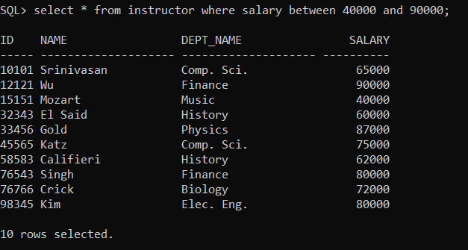

1. select * from instructor where instructor.id not in (select distinct teaches.id from teaches);

1. select student.name, course.title, section.year from student, takes, course, section where student.id = takes.id and takes.course_id = section.course_id and takes.course_id = course.course_id and section.room_number = 303;

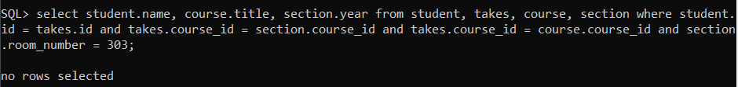

1. select student.name, takes.course_id, course.title as c_name from student, takes, section, course where student.id = takes.id and takes.course_id = section.course_id and takes.year = 2015;



1. select name, salary as inst_salary from instructor where salary > (select min(salary) from instructor where dept_name='Comp. Sci.');

1. select name from instructor where dept_name like '%ch%';

1. select name, length(name) from student;

1. select dept_name, substr(dept_name, 3, 3) from instructor;

1. select upper(name) from instructor;

1. update student set tot_cred = 100 where tot_cred=null;

1. select salary, round(salary/3, -2) from instructor;

