1. select course_id from section where semester = 'Fall' and year = 2009 union select course_id from section where semester = 'Spring' and year = 2010;

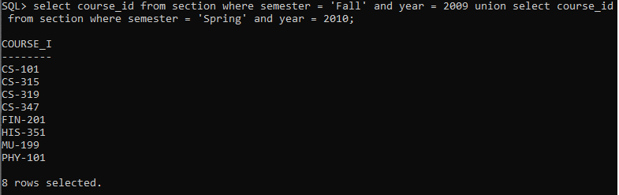

select course_id from section where semester = 'Fall' and year = 2009 union all select course_id from section where semester = 'Spring' and year = 2010;

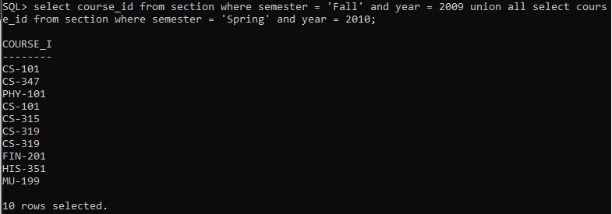

1. select course_id from section where semester = 'Fall' and year = 2009 intersect select course_id from section where semester = 'Spring' and year = 2010;

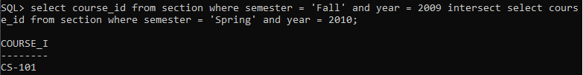

1. select course_id from section where semester = 'Fall' and year = 2009 minus select course_id from section where semester = 'Spring' and year = 2010;

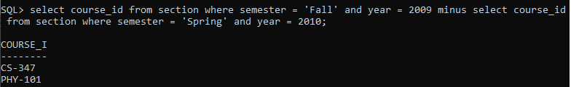

1. select course_id from course minus select course_id from takes;

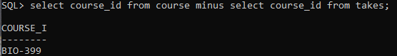

1. select course_id from section where semester = 'Fall' and year = 2009 and course_id in ( select course_id from section where semester = 'Spring' and year = 2010);

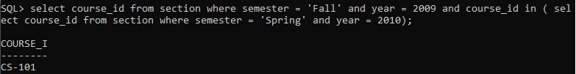

1. select count(distinct takes.id) from takes where course_id in (select course_id from teaches where id = 10101);

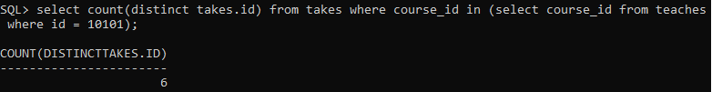

1. select course_id from section where semester = 'Fall' and year = 2009 and course_id not in ( select course_id from section where semester = 'Spring' and year = 2010);

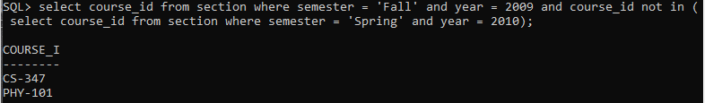

1. select distinct student.name from student where student.name in (select distinct instructor.name from instructor);

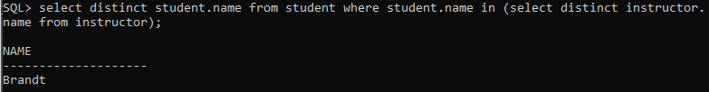

1. select instructor.name from instructor where salary > (select min(salary) from instructor where dept_name = 'Biology');

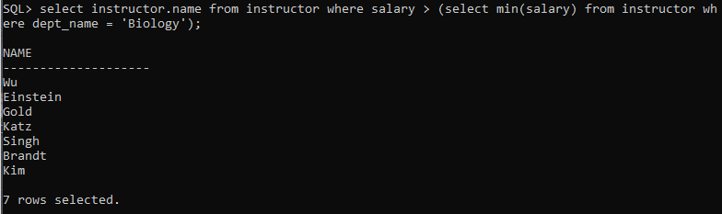

1. select instructor.name from instructor where salary > (select max(salary) from instructor where dept_name = 'Biology');

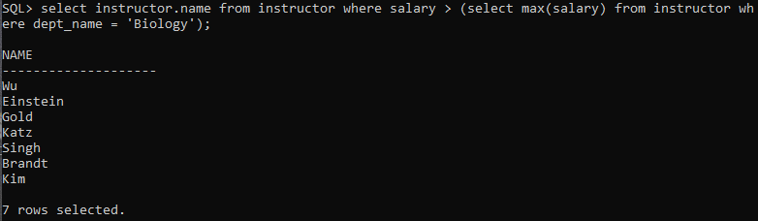

1. select dept_name from instructor group by dept_name having avg(salary) >= all(select max(avgsal) from (select avg(salary) as avgsal from instructor group by dept_name));

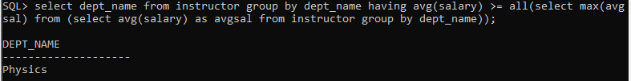

1. select dept_name from instructor natural join department group by dept_name having avg(budget)<avg(salary);

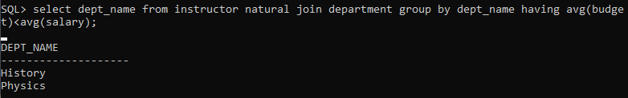

1. select course_id from section S where semester = ’Fall’ and year= 2009 and exists (select *from section T where semester = ’Spring’ and year= 2010 and S.course_id= T.course_id);

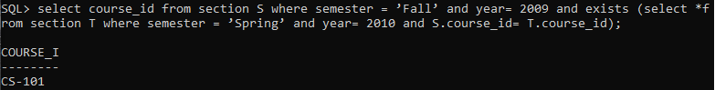

1. select S.name from student S natural join takes T where dept_name = 'Biology' and not exists (select course_id from course where dept_name = 'Biology' and T.course_id = course.course_id);



1. select course_id from section where year = 2009 group by course_id having count(course_id)<=1;

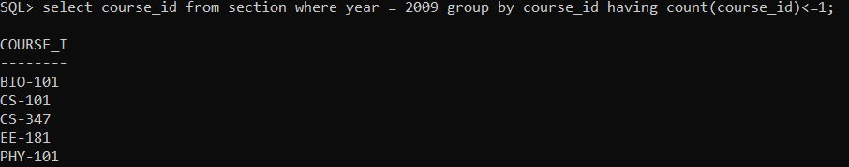

1. select name from student, takes where student.id = takes.id and dept_name = 'Comp. Sci.' group by name having count(course_id)>=2;

1. select dept_name, avgsal from (select dept_name, avg(salary) as avgsal from instructor group by dept_name) where avgsal > 42000;

1. create view all_courses as select sec_id, section.building, room_number from section, department where section.building = department.building and dept_name = 'Physics' and semester = 'Fall' and year = 2009;

1. select * from all_courses;

1. create view department_total_salary as select dept_name, sum(salary) as sumSalary from instructor group by dept_name;

