1. select course_id, count(*) from takes group by course_id;

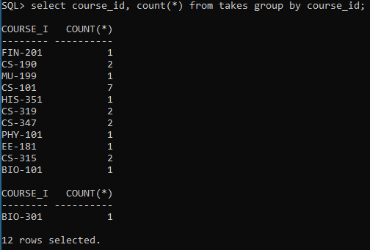

1. select dept_name from student group by dept_name having count(*) > 3;

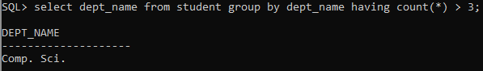

1. select dept_name, count(*) from course group by dept_name;

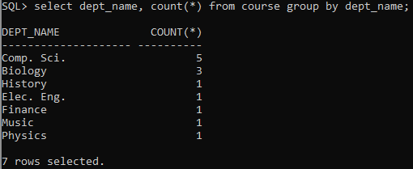

1. select dept_name, avg(salary) from instructor group by dept_name having avg(salary) > 42000;

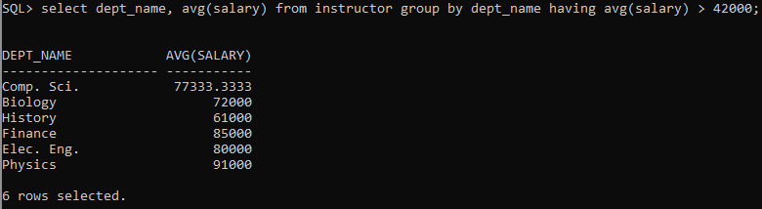

1. select sec_id, count(*) from takes natural join section where semester = 'Spring' and year = 2009 group by sec_id;

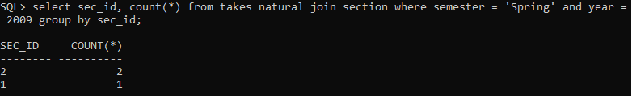

1. select * from prereq order by course_id;

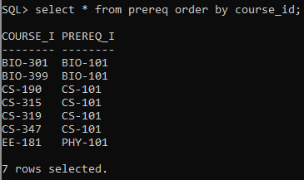

1. select * from instructor order by salary desc;

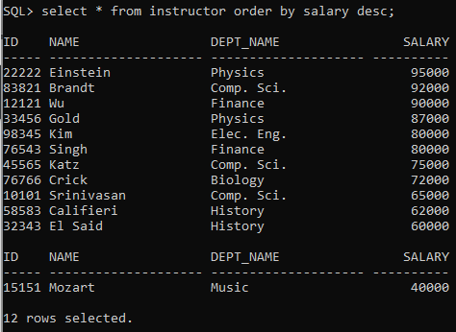

1. select max(tot_sal) from (select dept_name, sum(salary) tot_sal from instructor group by dept_name);

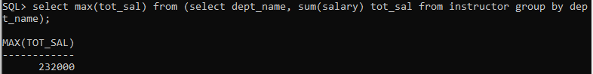

1. select dept_name, avg(salary) from instructor group by dept_name having avg(salary) > 42000;

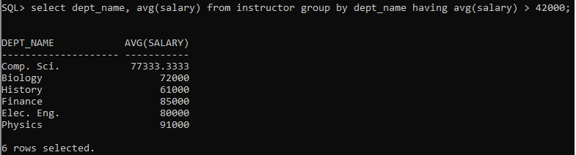

1. select max(tot) from (select sec_id, count(*) tot from takes natural join section where semester = 'Spring' and year = 2010 group by sec_id);



1. select i.name from instructor i, teaches te, takes ta, student s where i.id=te.id and te.course_id=ta.course_id and ta.id = s.id and s.dept_name = 'Comp. Sci';



1. select dept_name, avg(salary) from instructor group by dept_name having avg(salary) > 50000 and count(*) > 2;

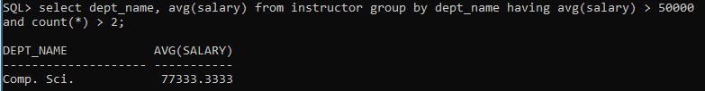

1. with temptbl(dname, avgbgt) as (select dept_name, avg(budget) from department group by dept_name) select dept_name from department, temptbl group by dept_name having avg(budget) = max(avgbgt);

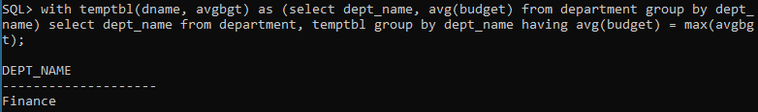

1. with temptbl(dname, totsal) as (select dept_name, sum(salary) from instructor group by dept_name) select dept_name, sum(salary) from instructor group by dept_name having sum(salary) > (select avg(totsal) from temptbl);

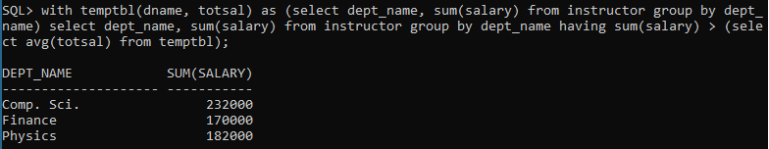

1. with temptbl(section, total) as (select sec_id, count(*) from takes natural join section where semester = 'Spring' and year = 2009 group by sec_id) select section from temptbl where total = (select max(total) from temptbl);



1. with temptbl(totcredfin) as (select sum(credits) from takes natural join course group by dept_name having dept_name = 'Finance') select dept_name, sum(credits) from takes natural join course group by dept_name having sum(credits) > (select * from temptbl);



1. savepoint s;

commit;

select * from instructor where dept_name = 'Finance';

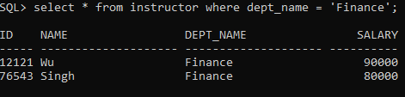

delete from instructor where dept_name = 'Finance';





rollback;

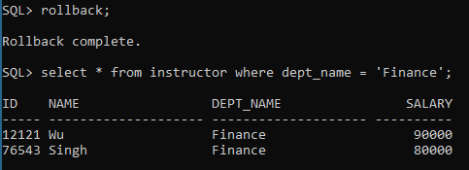

1. commit;

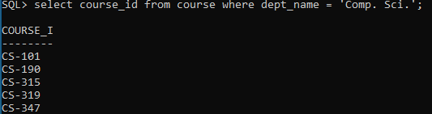

delete from course where dept_name = 'Comp. Sci.';





rollback;

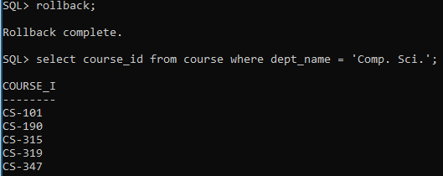

1. commit;

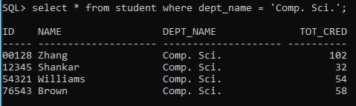

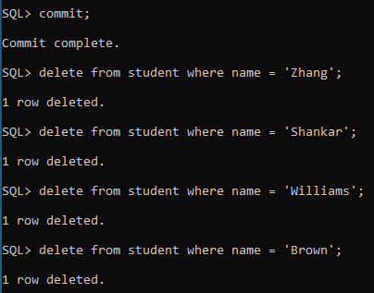

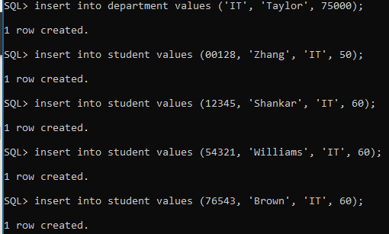

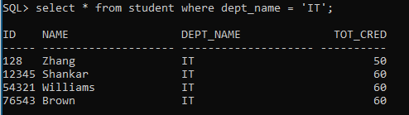

rollback;



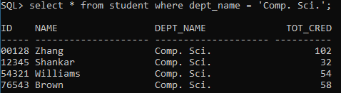

1. commit;

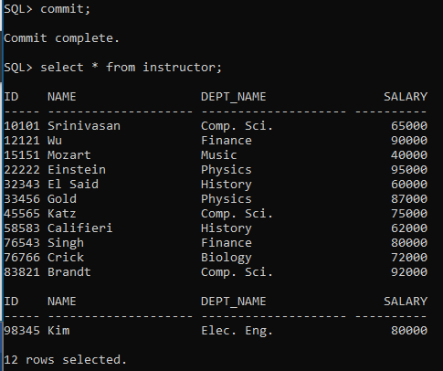

rollback;

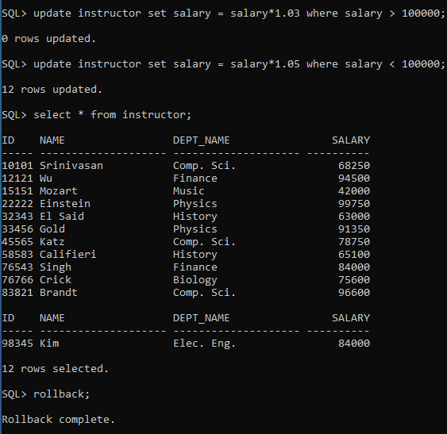

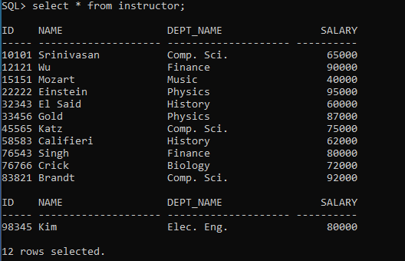

1. commit;

insert into student values (13468, 'Wu', 'History', 0);

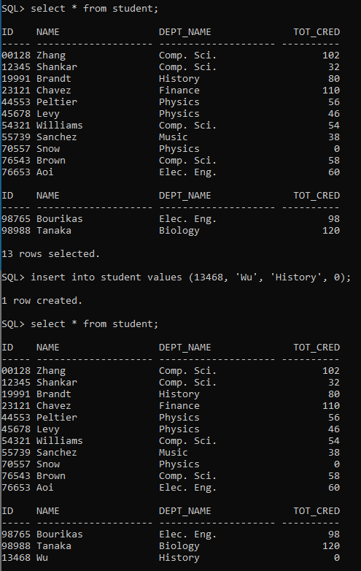

rollback;

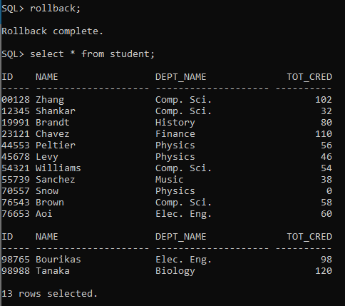

1. commit;

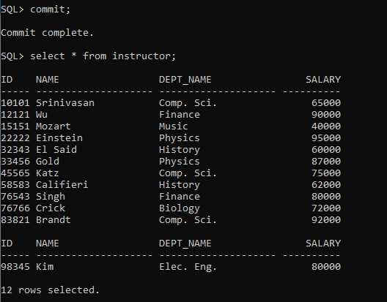

rollback;

