DECLARE

rno studenttable.rollno%TYPE;

score studenttable.gpa%TYPE;

BEGIN

rno := &rno;

select gpa into score from studenttable where rollno = rno;

dbms_output.put_line(score);

END;

/

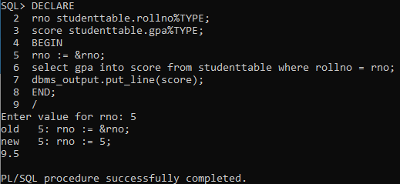

DECLARE

marks number(2);

BEGIN

marks := &marks;

IF marks between 0 and 4 THEN

dbms_output.put_line('F');

ELSIF marks between 4 and 5 THEN

dbms_output.put_line('E');

ELSIF marks between 5 and 6 THEN

dbms_output.put_line('D');

ELSIF marks between 6 and 7 THEN

dbms_output.put_line('C');

ELSIF marks between 7 and 8 THEN

dbms_output.put_line('B');

ELSIF marks between 8 and 9 THEN

dbms_output.put_line('A');

ELSE

dbms_output.put_line('A+');

END IF;

END;

/

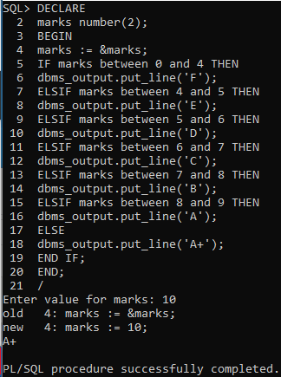

DECLARE

issue date;

return date;

diff number(3);

fine number(5);

BEGIN

issue := TO_DATE('&issue', 'DD-MM-YYYY');

return := TO_DATE('&return', 'DD-MM-YYYY');

diff := TO_DATE(return, 'DD-MM-YYYY') - TO_DATE(issue, 'DD-MM-YYYY');

IF diff between 0 and 7 THEN

fine := 0;

ELSIF diff between 8 and 15 THEN

fine := diff-7;

ELSIF diff between 16 and 30 THEN

fine := 8+2*(diff-15);

ELSE

fine := 8+30+5*(diff-30);

END IF;

dbms_output.put_line('FINE: ' || fine);

END;

/