create table salary_raise (instructor_id varchar(5), raise_date date, raise_amt number(10));



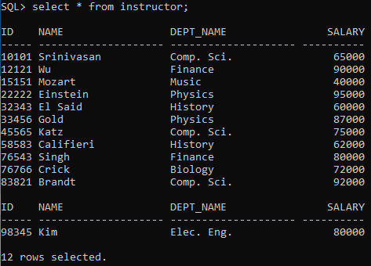

DECLARE

CURSOR C1 is select * from instructor for update;

BEGIN

for inst in C1

LOOP

update instructor set salary = salary + 0.05*salary where current of C1;

insert into salary_raise values(inst.id, '05-may-22', 0.05*inst.salary);

IF SQL%FOUND THEN

dbms_output.put_line('Rows have been updated and values have been inserted into the new table.');

ELSE

dbms_output.put_line('No updations done.');

END IF;

END LOOP;

END;

/

