FINAL PROJECT SUBMISSION REPORT

Online Desktop Exam Simulator
with Anti-Cheat System

Team Name | Team Double Quotation
Course | Software Engineering / Final Year Project
Language | Python 3.11+
Framework | Tkinter (GUI) | SQLite3 (Database)
GitHub | https://github.com/RZBv2/Team-Double-Quotation
Submitted | May 2026

─────────────────────────────────────────────
A desktop-based Python application that enforces a secure, OS-level controlled
exam environment for academic institutions.

1. Introduction

With the rapid growth of online education, ensuring exam integrity has become a critical challenge for academic institutions. Most existing solutions rely on browser-based systems, which are vulnerable to cheating techniques such as tab switching, screen recording, and use of external applications — none of which can be effectively prevented from within a web browser.
This report documents the design, development, and evaluation of the Online Desktop Exam Simulator with Anti-Cheat System — a fully functional, offline-capable Python desktop application that uses OS-level mechanisms to enforce exam integrity. The application provides two distinct role-based portals: one for Teachers (create exams, view results, manage students, monitor violations) and one for Students (take exams in a locked full-screen environment, view results).
Unlike browser-based alternatives, this system operates at the operating system level, allowing it to:
- Block system hotkeys (Alt+Tab, Win, Esc, Cmd) via the keyboard module
- Detect and log window switch attempts using win32gui API
- Force the exam window back to the foreground after any focus violation
- Prevent the exam window from being closed or minimized during an active exam

The system is built entirely using Python's standard library plus a small set of Windows OS integration packages, requiring no external server or cloud infrastructure.

2. Motivation and Requirements

2.1 Problem Statement
Current online exam systems suffer from the following well-documented issues:
- Browser-based tools have no access to OS-level APIs, making it impossible to reliably block tab switching, hotkeys, or screen sharing.
- Students can easily open other applications, use a search engine, or share their screen with another person during an exam.
- Existing anti-cheat solutions are expensive, cloud-dependent, or require invasive browser extensions that students can bypass.
- Most tools provide no detailed violation log that teachers can review after the exam.

2.2 Why a Desktop Application?
A desktop application built in Python offers direct access to OS-level APIs that are impossible to access from a browser. Specifically:
- The keyboard library can intercept and block system hotkeys at the OS level.
- The win32gui library can detect which window is in the foreground in real time.
- Tkinter can enforce full-screen mode and override the window close button (WM_DELETE_WINDOW).
- The application works entirely offline — no internet dependency during exam.

2.3 Stakeholder Requirements
Stakeholder | Requirements
Teacher / Admin | Create and manage MCQ exams; schedule exams with date/time; view student scores with grades; access anti-cheat violation logs; manage student accounts from within the app; clear violation logs when required.
Student | Secure login with password hashing; take exams in a locked, full-screen environment; real-time countdown timer; navigate between questions; receive instant grade feedback after submission; view result history.
Institution | Reliable academic integrity enforcement; detailed violation logs per exam; grade records stored persistently in local database; offline operation — no cloud dependency.

3. Key Features

3.1 Authentication and Security
- Role-based login: Teacher Portal (green) and Student Portal (blue) on the Role Selection screen.
- Passwords hashed with PBKDF2-HMAC-SHA256 (260,000 iterations) with a cryptographically random 32-byte salt per account using os.urandom(32).
- Login rate limiting: 5 failed attempts lock the account for 60 seconds (in-memory defaultdict).
- Input validation: username limited to 64 characters; password must be 6–128 characters.
- Legacy SHA-256 accounts are automatically upgraded to PBKDF2 on the next successful login.
- Show/hide password toggle (eye icon) on all login screens.

3.2 Teacher Dashboard Features
- Create MCQ Exams: enter exam name, subject, duration (minutes), total marks, exam date/time; add unlimited questions each with 4 answer options, a correct answer selector, and individual marks.
- View My Exams: sortable table of all created exams with subject, duration, marks, and date.
- View Results: student results with Score, Total Marks, Percentage, Grade (A–F), and submission timestamp.
- Anti-Cheat Logs: full violation table with violation type, student name, exam name, details, and timestamp; one-click "Clear All Logs" button with confirmation dialog.
- Manage Students: add new student accounts or update existing accounts (name, username, password) directly from within the app — no database access required.
- Clickable stats cards: Total Exams, Total Submissions, Total Violations — each navigates to the relevant section.
- Logout with confirmation dialog.

3.3 Student Dashboard Features
- Clickable stats: Exams Taken, Average Score, Available Exams — each navigates to the relevant view.
- Available Exams: lists all exams not yet taken, showing subject, duration, total marks, and scheduled date.
- My Results: personal result history with score, percentage, and grade.
- Logout with confirmation dialog.

3.4 Exam Window
- Full-screen enforced mode using Tkinter attributes('-fullscreen', True) with TclError fallback to state('zoomed').
- WM_DELETE_WINDOW overridden — the window close button is disabled during the exam.
- Real-time countdown timer displayed in the header; turns red when fewer than 5 minutes remain.
- Question navigation: Previous / Next buttons; question navigator panel shows answered vs unanswered.
- Manual Submit button with a confirmation dialog; timer auto-submits with a warning message when it reaches zero.

3.5 Anti-Cheat System (AntiCheatSystem class)
- Runs in a background daemon thread — does not block the UI.
- Polls win32gui.GetForegroundWindow() every 500ms to detect window switch attempts.
- Blocks system hotkeys using the keyboard module: Alt, Tab, Esc, Win, Cmd.
- Forces the exam window back to the foreground using win32gui.SetForegroundWindow() on any focus loss.
- Logs every violation to the SQLite anti_cheat_logs table with timestamp, type, and details.
- Gracefully degrades if keyboard/win32gui are not installed (platforms other than Windows).

4. Workflow and Data Flow Diagram

4.1 Development Model: Incremental Development
This project followed the Incremental Development Model. Rather than designing and building all features at once, the system was constructed in five discrete, testable iterations — each delivering a working layer before the next began.

Iteration | Focus | What Was Built
1 — Core | Foundation | Role selection screen, Teacher/Student login with basic SHA-256 hashing, SQLite schema (users, exams, exam_results, anti_cheat_logs), basic Teacher dashboard.
2 — Exam Flow | Exam Engine | ExamWindow class, full MCQ display with navigation (Prev/Next), countdown timer, answer saving, manual submit with confirmation, auto-submit at timeout, result calculation.
3 — Anti-Cheat | Integrity Layer | AntiCheatSystem class with daemon thread, keyboard key blocking, win32gui window monitor, forced foreground, violation logging to database.
4 — Security | Hardening | PBKDF2-HMAC-SHA256 hashing (upgrade from SHA-256), per-user salt via os.urandom(32), login rate limiting, input validation, SQL parameterization, bare except removal.
5 — UX Polish | Usability | Clickable stat cards, centered headers, Logout buttons, show/hide password, Manage Students, Clear Logs, fix of collapsed welcome frame, hover effects, pack-order fixes.

4.2 Why Incremental?
The Incremental Model was chosen because the anti-cheat subsystem and the security layer each depended on the core exam functionality being stable and testable first. Building and validating each layer in isolation prevented regressions and made debugging significantly easier. Each iteration produced a runnable application that could be demonstrated to stakeholders — exactly mirroring agile practice in industry.

4.3 Data Flow — Student Exam Path
The following sequence describes the complete data flow when a student takes an exam:
- Student enters credentials on the Student Login screen.
- Input validation (length, empty check) runs first; if it fails, an error is shown immediately.
- Rate limit check: if the account has 5+ failed attempts in the last 60 seconds, login is blocked.
- Database lookup: SELECT id, username, role, full_name, password, password_salt FROM users WHERE username=? AND role="student".
- If the salt is present: PBKDF2-HMAC-SHA256 verification. If the salt is empty (legacy): SHA-256 fallback; on success, the account is upgraded to PBKDF2 automatically.
- On successful authentication: Student Dashboard opens, user tuple (id, username, role, full_name) is passed.
- Student selects an exam from the Available Exams list and confirms the start dialog.
- ExamWindow opens in full-screen mode; AntiCheatSystem thread starts simultaneously.
- Student navigates and answers questions; answers are stored in memory (self.answers dict).
- Timer counts down; UI updates every second. At < 5 minutes, timer turns red.
- On submission (manual or auto): score is calculated, result is INSERTed into exam_results, anti-cheat monitoring stops, results dialog is shown.
- Student Dashboard refreshes to reflect the new exam result.

4.4 Data Flow — Teacher Exam Creation Path
- Teacher logs in via Teacher Portal (same authentication flow as student but role="teacher").
- Teacher navigates to Create New Exam and fills in: exam name, subject, duration, total marks, exam date.
- Server-side validation: duration must be integer 1–600; marks must be integer 1–10,000; all fields non-empty.
- Teacher adds questions: each question has text, 4 options, a correct answer selection, and individual marks.
- On Save: questions are JSON-serialized; exam record is INSERTed into the exams table.
- Students immediately see the new exam appear in their Available Exams list (database lookup).
- After students submit, Teacher opens View Results: Treeview shows Score, Percentage, Grade.

5. Technologies Used and GitHub Link

Category | Technology | Purpose
Language | Python 3.11+ | Core application language; all components written in Python.
GUI | Tkinter (built-in) | All windows, forms, tables, and navigation. Custom widget classes: StyledButton, StyledEntry, GradientFrame, ModernButton.
GUI — Tables | ttk.Treeview | Sortable, scrollable data tables for exam list, results, and logs.
Database | SQLite3 (built-in) | 4 tables: users, exams, exam_results, anti_cheat_logs. Centralized via DatabaseManager.get_connection().
Hashing | hashlib (built-in) | PBKDF2-HMAC-SHA256 with 260,000 iterations for password storage.
Salt Gen | os.urandom(32) | Cryptographically secure 32-byte random salt per user account.
Rate Limiting | collections.defaultdict | In-memory login attempt tracking. 5 failures = 60-second lockout.
Anti-Cheat | keyboard (3rd party) | OS-level hotkey blocking: Alt, Tab, Esc, Win, Cmd.
Anti-Cheat | win32gui / win32con | Detect foreground window; force exam window to front on violation.
Threading | threading (built-in) | Daemon thread for continuous focus monitoring without blocking UI.
Serialization | json (built-in) | Serialize/deserialize question arrays stored in the database.
Time | datetime / time | Exam scheduling, violation timestamps, timer management.

5.1 GitHub Repository
Repository: https://github.com/RZBv2/Team-Double-Quotation
The repository contains the complete source code (main.py), the project proposal document, and all supporting materials. All development iterations are reflected in the commit history.

6. Screenshots of Key Features

The following screenshots demonstrate the complete application flow, from the initial Role Selection screen through to final exam results. Screenshots are presented in the order a user would naturally experience them.

6.1 Role Selection Screen
The application opens with a Role Selection screen. The student portal and teacher portal are presented side-by-side on the same line, separated by an "or" label. This design was introduced in a UX iteration after the initial stacked layout was found to require excessive scrolling.
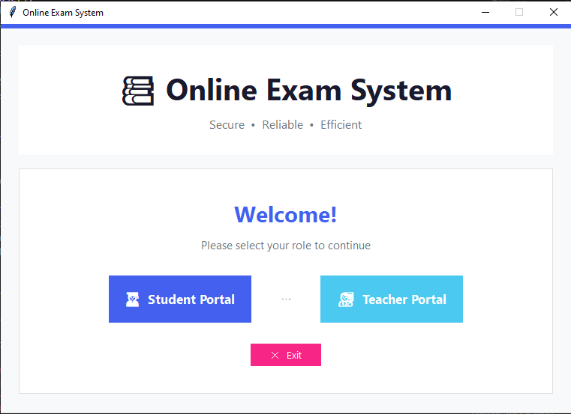
Figure 1 — Role Selection Screen: Student Portal (blue) and Teacher Portal (green) on one line

6.2 Teacher Login
The Teacher Login screen uses a card-based layout with an accent colour matching the teacher role (green). All input fields including the password field with the show/hide toggle are fully visible. The Back button returns the user to the Role Selection screen. Login is rate-limited after 5 failed attempts.
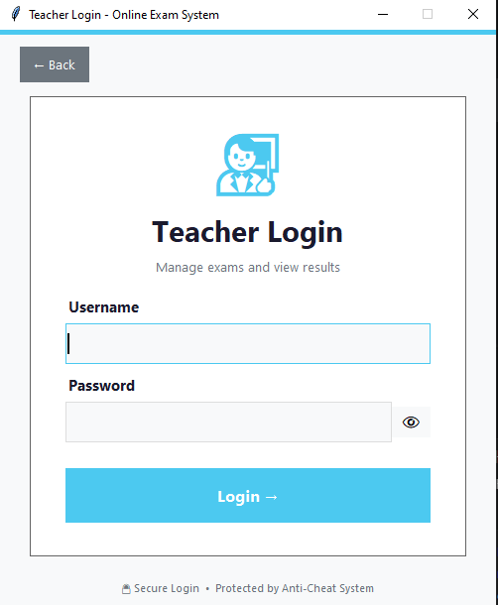
Figure 2 — Teacher Login: card layout with show/hide password toggle and rate-limited authentication

6.3 Teacher Dashboard
The Teacher Dashboard opens after a successful teacher login. The header displays the teacher's full name on the left, "Teacher Dashboard" centered, and a red Logout button on the right. Three clickable stat cards display Total Exams, Total Submissions, and Total Violations — each navigates to the relevant section when clicked.
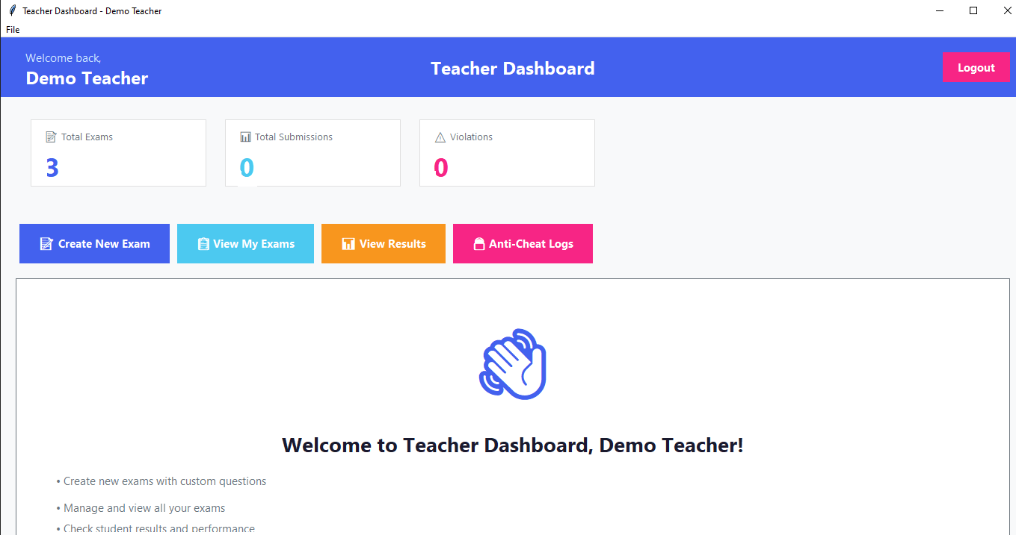
Figure 3 — Teacher Dashboard: centered title, name on left, logout on right, clickable stat cards

6.4 Teacher Navigation Menu
The navigation bar below the stats cards provides five actions: Create New Exam, View My Exams, View Results, Anti-Cheat Logs, and Manage Students. The Manage Students option was added in a later iteration to allow teachers to register new student accounts from inside the application without needing direct database access.
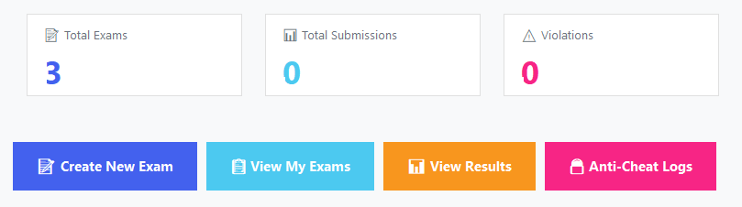
Figure 4 — Teacher Navigation Menu: five action buttons added across iterative development

6.5 Create New Exam
The Create Exam form allows teachers to enter all exam metadata (name, subject, duration, total marks, exam date) and add an unlimited number of MCQ questions. Each question has a text field, four answer option fields, a correct answer radio button, and an individual marks field. Input validation enforces correct data types and value ranges before saving.
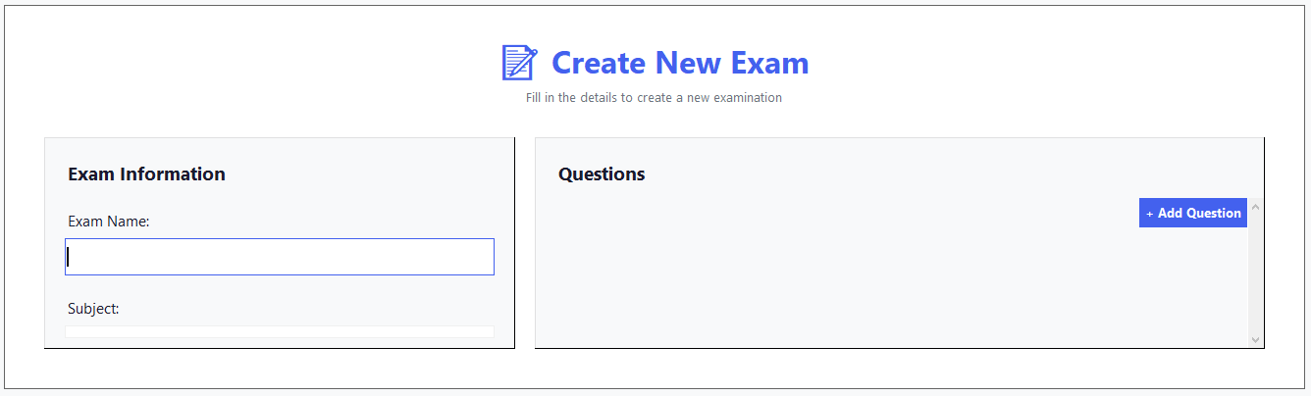
Figure 5 — Create New Exam form: metadata fields and per-question MCQ configuration

6.6 View My Exams
The View My Exams screen presents all exams created by the logged-in teacher in a sortable Treeview table. Columns include Exam Name, Subject, Duration, Total Marks, and Scheduled Date. Teachers can see at a glance how many exams are active and their configuration details.
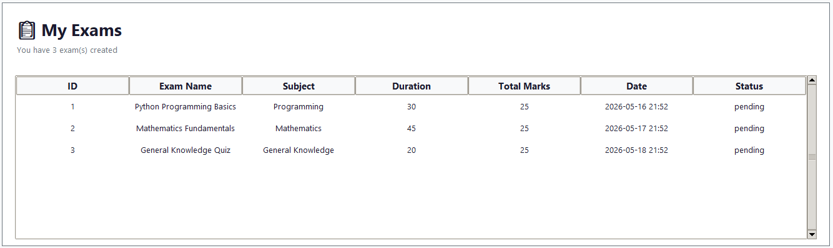
Figure 6 — View My Exams: sortable table of all created exams with metadata

6.7 Anti-Cheat Violation Logs
The Anti-Cheat Logs screen shows all recorded violations for exams created by this teacher. Each entry records the violation type, student name, exam name, details, and timestamp. The red "Clear All Logs" button (top right) permanently removes all entries after a confirmation dialog. This feature was added so teachers can reset the log between exam sessions.
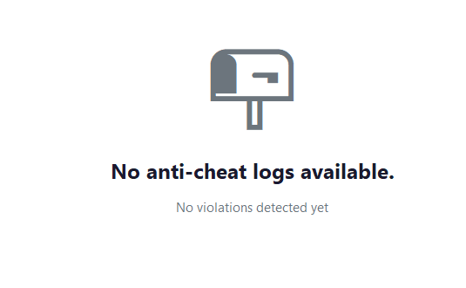
Figure 7 — Anti-Cheat Violation Logs with timestamp, violation type, and Clear All Logs button

6.8 Student Login
The Student Login screen mirrors the Teacher Login in structure but uses blue accent colours for the student role. The window height was increased from 550px to 580px in a UI fix iteration after the password field and Login button were found to be hidden below the visible area of the original design. The show/hide password toggle and Return-key-to-submit bindings are present.
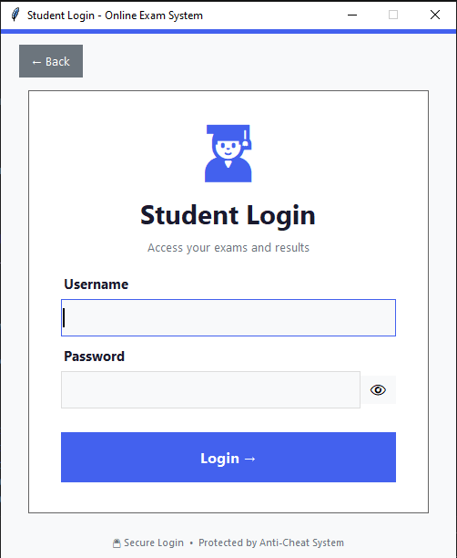
Figure 8 — Student Login: fixed height ensuring all fields are visible; show/hide password toggle

6.9 Student Dashboard
The Student Dashboard opens after a successful student login. The header shows the student's full name on the left, "Student Dashboard" centered, and a Logout button on the right. The three stat cards (Exams Taken, Average Score, Available Exams) are clickable and navigate to the relevant view. The welcome frame height collapse bug (caused by pack_propagate(False) with no explicit height) was fixed to ensure the name always displays correctly.
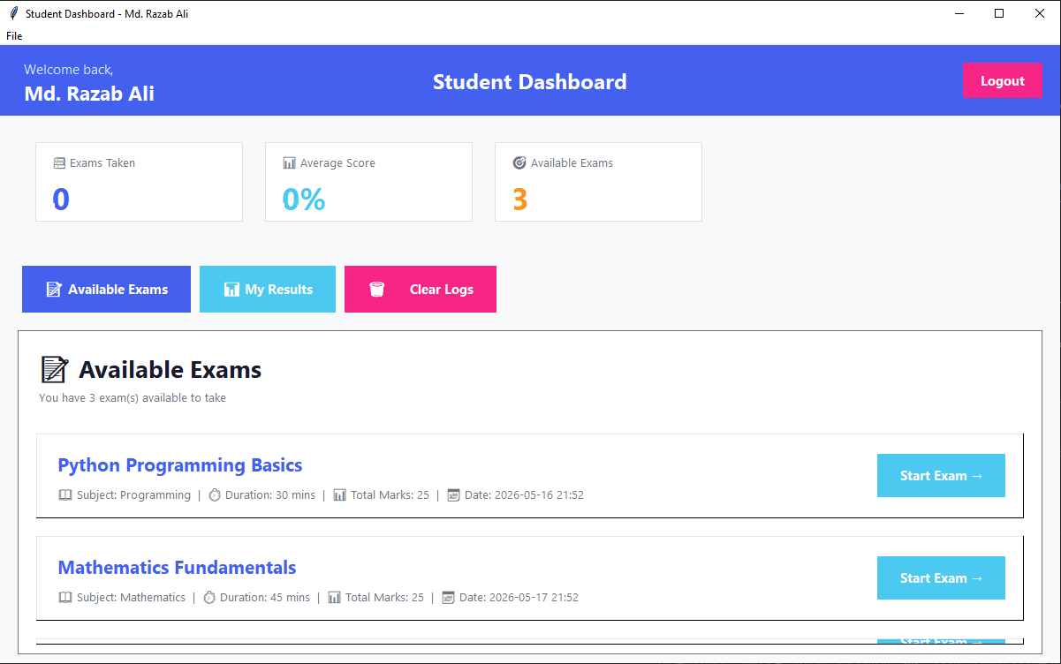
Figure 9 — Student Dashboard: fixed name display, centered title, logout button, clickable stat cards

6.10 Available Exams
The Available Exams view lists all exams that the student has not yet submitted. Each exam card shows the exam name, subject, duration, total marks, and scheduled date. A "Start Exam" button on the right of each card opens a confirmation dialog before launching the full-screen exam window.
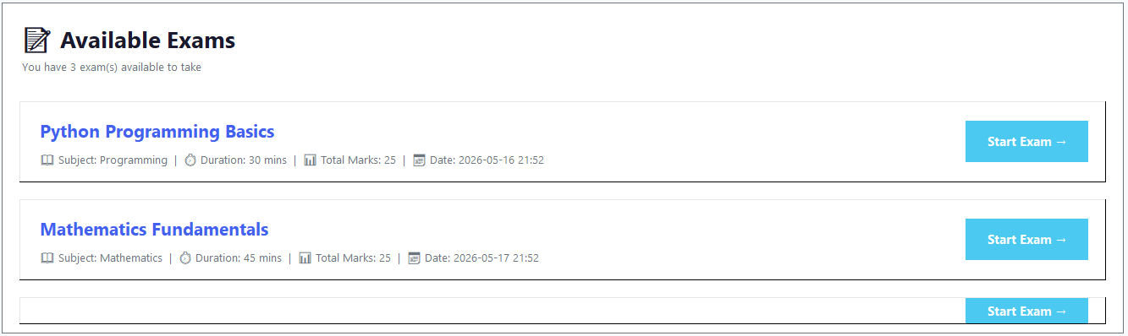
Figure 10 — Available Exams: exam cards with metadata and Start Exam button

6.11 Student Results
The My Results view displays the student's complete exam history. Each entry shows the exam name, score, total marks, percentage, and grade (A–F). The grading scale is: A >= 90%, B >= 80%, C >= 70%, D >= 60%, F < 60%.
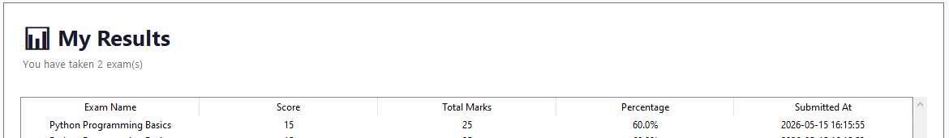
Figure 11 — My Results: exam history with score, percentage, and letter grade

7. SQA and Testing Strategies

7.1 Testing Approach
The project followed an Iterative Manual Testing strategy, with each increment tested in isolation before the next was started. This matched the Incremental Development Model: new bugs introduced in one iteration could not propagate undetected into subsequent iterations.

7.2 Functional Testing
- Login — correct credentials, wrong password, locked account after 5 attempts, reset after 60 seconds.
- Legacy SHA-256 account: login succeeds on first attempt and password is silently upgraded to PBKDF2.
- Exam creation: valid inputs accepted; non-integer marks rejected; empty fields blocked; out-of-range duration (0, 601) rejected.
- Exam submission: manual submit dialog accepts and rejects correctly; auto-submit triggers at timer = 0 without showing a confirmation dialog; partial answers saved correctly; grade calculated correctly for 0%, 40%, 80%, 100% score scenarios.

7.3 Security Testing
- PBKDF2 output verified: same password + two different salts always produce different hashes.
- Rate limiting confirmed: 5 wrong passwords trigger a 60-second lockout; counter resets after the window.
- SQL injection: all database queries use ? parameterized inputs — no string concatenation found in any query.
- Input validation: username > 64 characters rejected; password < 6 characters rejected; password > 128 characters rejected.

7.4 Anti-Cheat Testing
- Full-screen lock: confirmed the window cannot be minimized, resized, or closed during an active exam.
- WM_DELETE_WINDOW override: clicking the window close button during an exam shows a warning and does not close the window.
- Focus monitor: switching to another application (e.g., Task Manager) immediately generates a violation log entry.
- Key blocking: Alt, Tab, Esc, and Win keys confirmed non-functional during exam on Windows 10/11.
- Race condition fix: the anti-cheat thread was tested to confirm it only starts after the exam window is fully rendered.

7.5 UI/UX Testing
- Login window height: confirmed all fields (username, password, show/hide toggle, Login button) are fully visible at 500x580px.
- Student welcome frame: confirmed the full name is displayed correctly after removing pack_propagate(False).
- Stat card navigation: all three teacher and all three student stat cards confirmed to navigate to the correct section.
- Logout confirmation: both teacher and student logout buttons confirmed to show a dialog before ending the session.
- Timer color change: confirmed the timer label turns red when fewer than 5 minutes remain.

7.6 Code Quality Review
- All bare except: pass instances replaced with specific exception types (TclError, sqlite3.Error, ValueError, Exception).
- All direct sqlite3.connect() calls replaced with DatabaseManager.get_connection().
- Invalid rgba() color strings that crashed on certain Windows versions replaced with valid hex codes.
- Lambda loop-variable capture bug in exam card hover bindings fixed using default argument capture (b=start_btn).
- INSERT OR IGNORE replaced with INSERT ... ON CONFLICT(username) DO UPDATE to ensure name updates propagate correctly.

8. Contributions, Limitations, and Future Work

8.1 Contributions
The following contributions were made across the five development iterations:
- Designed and built the complete desktop exam platform from scratch using Python's standard library.
- Implemented OS-level anti-cheat that genuinely locks the exam environment — a stronger guarantee than any browser-based alternative.
- Upgraded password storage from plain SHA-256 to PBKDF2-HMAC-SHA256 with per-user cryptographic salt.
- Added Manage Students feature so teachers can add and update student accounts from inside the app.
- Fixed three critical bugs in the anti-cheat system: silent fullscreen failure, window handle race condition, and WM_DELETE_WINDOW override.
- Added login rate limiting, comprehensive input validation, and parameterized SQL throughout the codebase.
- Fixed the collapsed welcome frame bug (pack_propagate(False) without height) that caused the student name to be invisible.

8.2 Limitations
- Anti-cheat is Windows-only: the keyboard and win32gui libraries do not work on Linux or macOS.
- No network backend: all data is stored in a local SQLite database file. Multi-campus or remote deployment is not supported in the current version.
- MCQ-only question format: no support for short answer, essay, fill-in-the-blank, or file-upload questions.
- No webcam proctoring or facial recognition — a student using a second physical device cannot be detected.
- Single-file architecture: all code is in one main.py file, which becomes harder to maintain as the feature set grows.

8.3 Future Work
- Cross-platform anti-cheat using xdotool (Linux) and AppKit / Quartz (macOS).
- Flask or FastAPI backend with a MySQL database for centralized, multi-campus deployment.
- Webcam proctoring using OpenCV and face_recognition for facial detection and identity verification.
- AI-based behavioral anomaly detection: keystroke timing analysis, answer change frequency, idle time patterns.
- Support for additional question types: True/False, Short Answer, Fill-in-the-blank.
- Exportable reports: PDF result sheets per student; Excel grade summary per exam.
- Email or SMS notifications for upcoming exam reminders.
- Code refactoring into a package structure (separate modules for auth, exam, anti_cheat, db, ui).

9. Discussion

9.1 Problems Faced During Development

Problem 1 — Anti-Cheat System Not Working (Critical Bug)
This was the most significant challenge encountered during the project. The initial implementation had three separate bugs that together made the anti-cheat system completely non-functional:
  - The full-screen call (attributes('-fullscreen', True)) silently failed on some Windows configurations because a bare except: pass was swallowing the TclError exception. The window appeared to start normally but was not actually full-screen.
  - The window switch monitor thread was started before the exam window was fully rendered by Tkinter's mainloop. When the thread tried to call win32gui.GetWindowByTitle() immediately, it could not find the window handle — resulting in the monitor running against a None handle and never detecting any violations.
  - The WM_DELETE_WINDOW override was set but the associated function did not actually prevent the window from closing in all cases.
The fixes applied were: replace bare except with except tk.TclError with a state('zoomed') fallback; move the window handle lookup inside the thread loop so it is resolved after the window is rendered; and add an explicit early-return in the prevent_close method.

Problem 2 — UI Sizing: Invisible Input Fields
The login windows used a hard-coded geometry("500x550") string. The login card inside the window had excessive padding (padx=40, pady=40) on the outer card, plus large icon and title labels above the fields. Together, these consumed all available height before the password entry and Login button were reached — both were rendered but invisible (zero vertical space remaining). The fix was to remove the hard-coded geometry string, rely on center_window() with 500x580, and reduce internal padding to allow the layout to breathe.

Problem 3 — Wrong Student Name Displayed After Login
When new student account records were added to the database seed list in the initialize_database() function, existing rows in the database were not updated because INSERT OR IGNORE silently skips any row where the username already exists. Students who had a database row from an earlier run of the application kept their old full_name value — including an account that had been registered with the wrong name. The fix was to change all seed INSERTs to use the SQLite upsert syntax: INSERT ... ON CONFLICT(username) DO UPDATE SET full_name=excluded.full_name. This ensures the name is always current regardless of whether the row existed before.

Problem 4 — Welcome Frame Collapsed to Zero Height
The student dashboard welcome frame (showing "Welcome back / [Name]") was set with pack_propagate(False) and a fixed width=280, but no height was given. In Tkinter, pack_propagate(False) tells the geometry manager not to resize the frame to fit its children. Without an explicit height, the frame defaulted to 0px — the labels inside were rendered but had zero vertical space, making them invisible. The fix was to remove pack_propagate(False) and the fixed-width constraint entirely, allowing the frame to size naturally around its label children.

9.2 Key Lessons Learned
- Never use bare except: pass on OS and GUI API calls. Swallowed exceptions turn bugs invisible — the application appears to run but behaves incorrectly in ways that are extremely difficult to trace.
- UI layout bugs only appear at runtime with real content. The invisible password field bug existed in code that appeared correct at a glance — only running the application revealed the problem.
- Security should be designed from the first iteration, not added at the end. Retrofitting password hashing and SQL parameterization into existing code was significantly more error-prone than designing it in from the start.
- The Incremental Model provided a critical safety net: each working iteration could be demonstrated and validated before the next feature was added, which prevented cascading regressions.

9.3 Conclusion
The Online Desktop Exam Simulator with Anti-Cheat System successfully delivers a fully functional, multi-user exam platform with genuine OS-level integrity enforcement. It demonstrates that a production-quality security-aware desktop application can be built entirely with Python's standard library and a small set of OS integration packages.
The project encountered real security flaws, real UI bugs, and a genuinely broken anti-cheat system during development — all of which were identified through systematic iterative testing and fixed through careful debugging. This process reflects the real challenges of software engineering practice far more authentically than a project that works perfectly from the first iteration.
GitHub Repository: https://github.com/RZBv2/Team-Double-Quotation

End of Report

