WordChessBrainX V4.00

ChessBrainVB chess engine by Roger Zuehlsdorf 2023 (contact: rogzuehlsdorf@yahoo.de)
(based on engines LarsenVB by by Luca Dormia, on Faile by Adrien M. Regimbald and on ideas from Stockfish and other engines)
Written in VBA ( Visual Basic for Applications). Playing level is about 2600 ELO compared to CCRL 40/4.
Press ALT+F11 to show source code.
Press ALT+F8 to show the list of macros: execute the „auto_open“ macro

How to unblock a downloaded Word file.
In file explorer right click on Excel file and select <Properties>, check <Unblock>
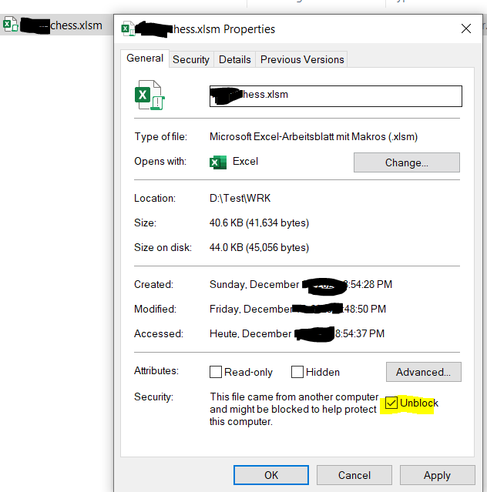


If Macros are disabled: click options and enable macros
How to activate macros to run „Auto_Open“ macro:
English:
Activate Macros in MS Office:
https://support.office.com/en-nz/article/Enable-or-disable-macros-in-Office-documents-7b4fdd2e-174f-47e2-9611-9efe4f860b12
Hint: the Auto Open macro is not used here because AVAST virus scanner creates a false positive alert.
German:
Aktivieren von Macros in MS Office:
https://support.office.com/de-at/article/Aktivieren-oder-Deaktivieren-von-Makros-in-Office-Dateien-12b036fd-d140-4e74-b45e-16fed1a7e5c6
Activate Developer Tab:
If the Developer tab is not available, click the Microsoft Office Button , and then click Excel(Word) Options.
In Excel 2007: Click Popular (German "Haeufig verwendet"), and then select the Show Developer tab in the Ribbon check box.
In Excel 2010, click the File>>Options>>Customize Ribbon. In the right side, check the Developer option.
