Starting from Saturday, 10 October, 2020

Day 1:
Read the project description carefully
Discover the Weaveworksdemos github account to find the useful files
Discover each microservice repo.
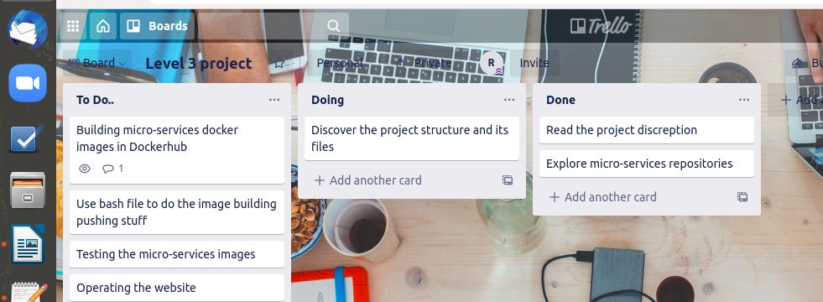
Problems: project seems very huge

Day 2:
Clone 10 micro-services locally
Try to use dockerfiles for some services
pull the microservices’ images and run them

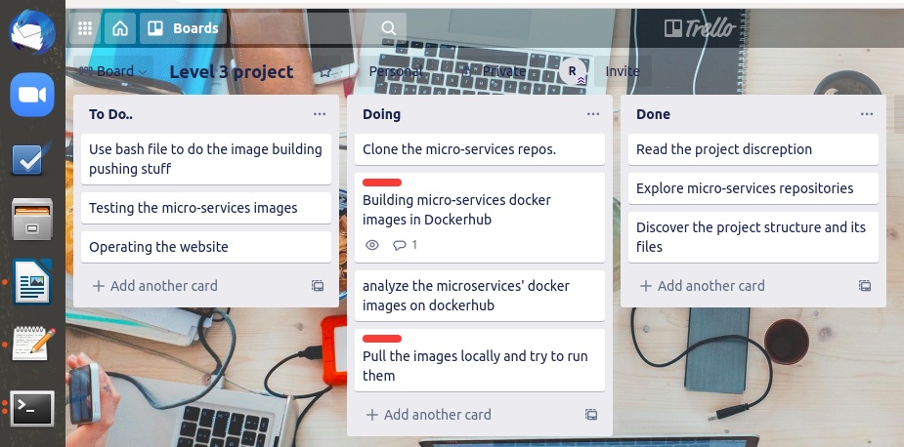
Problems:
Dockerfiles not working
My progress for today is zero

Day 3:
Dive deeply into orders and carts microservices
Use bash scripts inside repos. to run the docker files
play with the images and running them
Push the images into my docker hub account
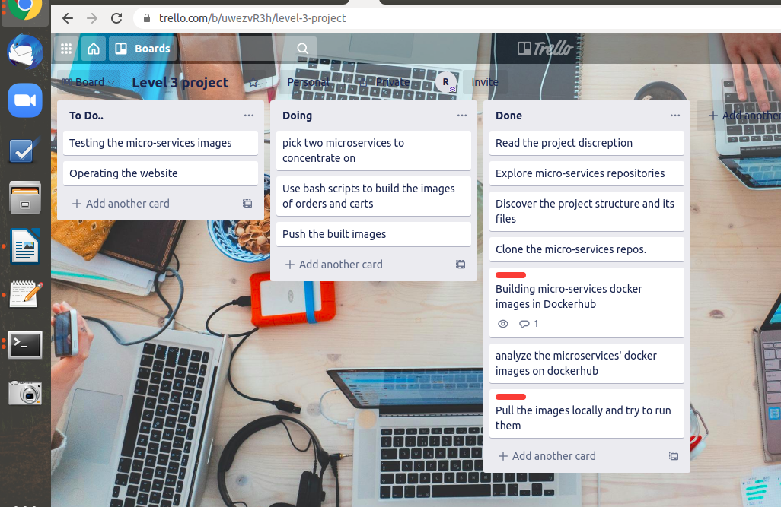
Problems: database is not working and IDK how to run it or where to find it

Day 4:
Building the user and user DB, but it’s not working
trying to understand the build bash file
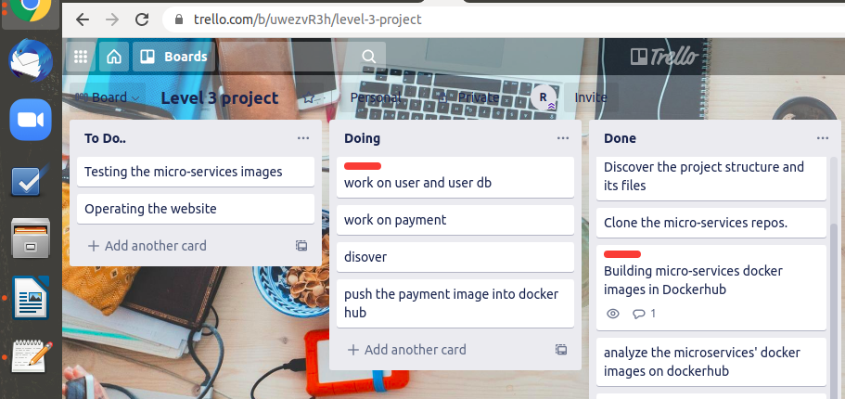
Day 5:
Making multi staged docker file for shipping
Push image to docker hub
Test if the image locally
Making multistage dockerfile for payment
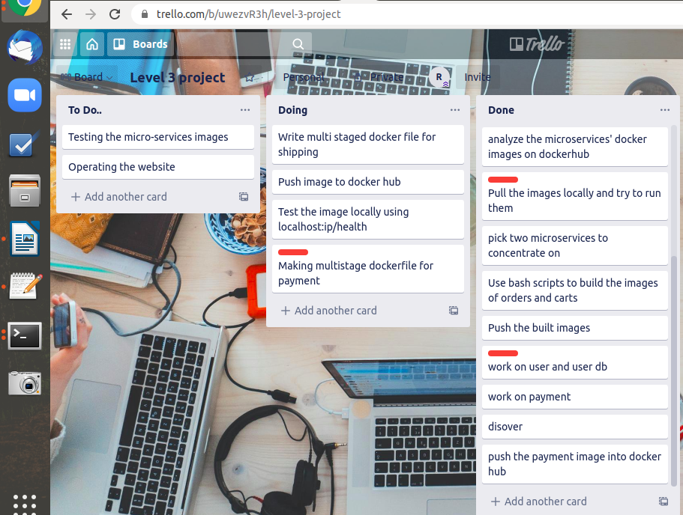

Problems: payment dockerfile is not working without the bash script

Day 6 & 7:
Working on user and user db
Working on orders db
Working on carts db
Made modifications to orders and carts source codes
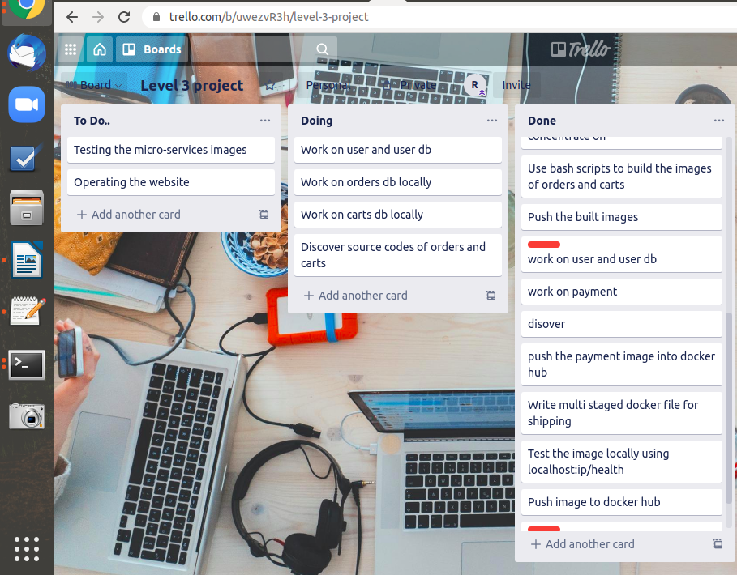

Starting from Sunday, 18 October, 2020

Day 8:
Built catalogue and catalogue db docker images and pushed it to docker hub
Built frontend image and pushed it to dockerhub
built queue master image and pushed it
Test the images locally (catalogue db not working)
Build the load test image (not working)
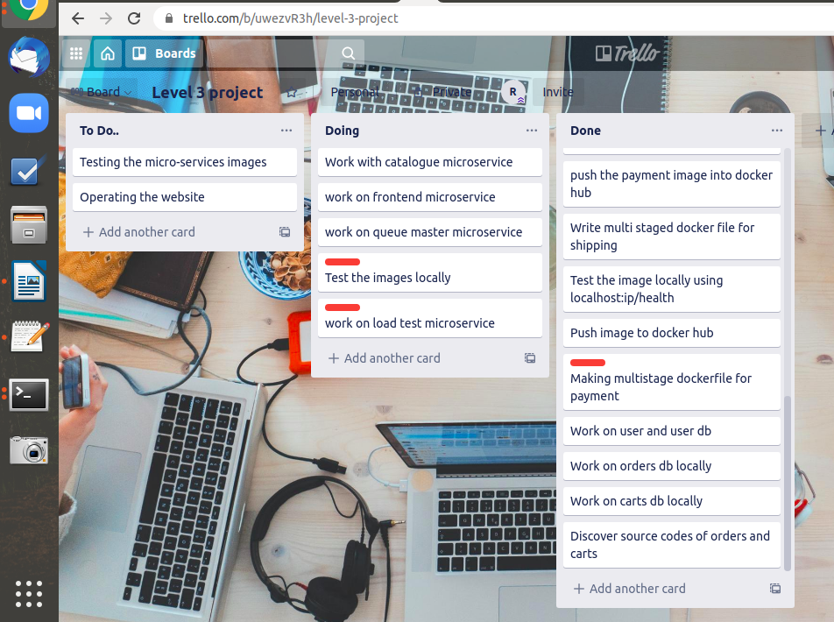

Day 9:
Try to run payment dockerfile locally
Try to run databases with there services using docker netowrk locally

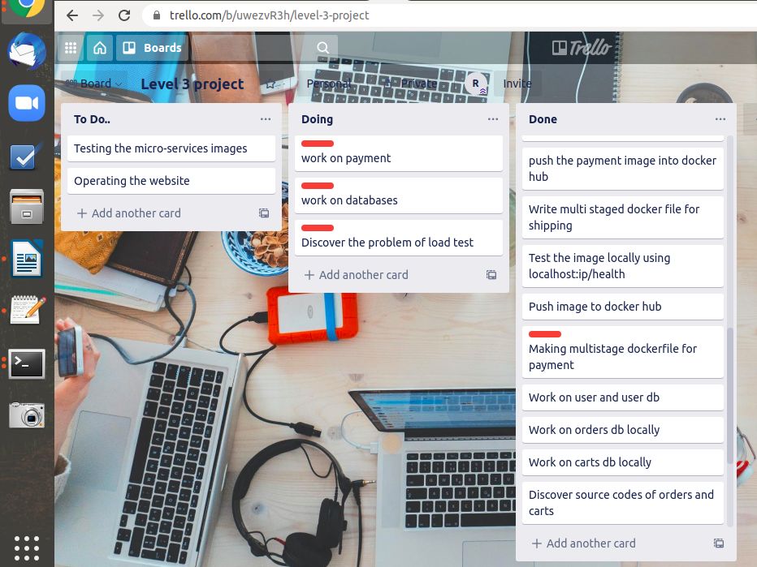

Day 10 - 14:
Look for how to create deployment and service files
try to play with microservices deploy and service files
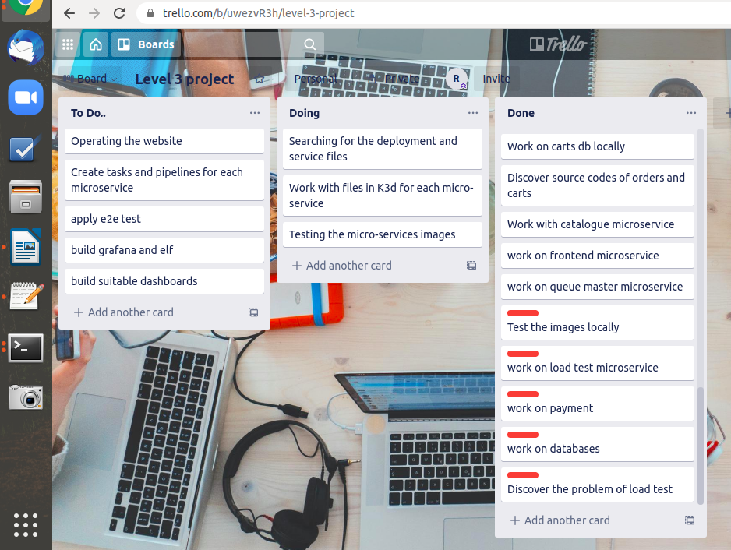

Day 15 till the final day:
Working on tekton tasks and pipelines
Modify some docker files to work with pipelines
testing the website on the browser
Debugging and fixing problems Looking how to apply triggers
Working on e2e-test
Try to automate dashboard provisioning in grafana and elf
Cleaning the project

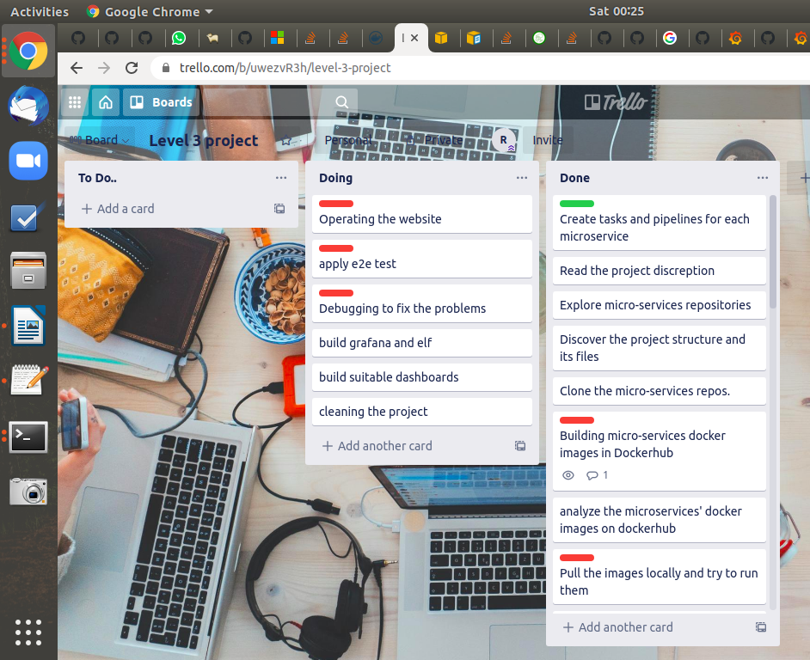

Done:
Got every microservice working (tasks and pipelines) correctly (based on the health check)
Operating Grafana and elf

Not Done:
Got Errors when operating the website
The test is not 100% passed
Couldn’t automatically provision the dashboards into grafana and elf

Trello:
https://trello.com/b/uwezvR3h/level-3-project

