Generated Forum Workbook
Question 1 of 1

Activity title: Securing communication using Site-to-Site IPsec VPN

Scenario: Securing Communication Between ADIB Bank's Sharjah and Abu Dhabi Branches

ADIB Bank operates two key branches in Sharjah and Abu Dhabi. To protect the transmission of sensitive financial data between these branches, it's crucial to implement a secure communication channel. As the appointed Network Security Engineer, your responsibility is to establish a secure Site-to-Site IPsec VPN over the public internet, ensuring encrypted and safe data exchange between both locations. This VPN will safeguard the bank’s data integrity and confidentiality, enabling the seamless and secure transfer of information between the two branches.

Network Overview:
- Sharjah Branch:
- LAN Network: 192.168.1.0/24
- Router LAN Interface: 192.168.1.1
- Router WAN Interface: 10.1.1.2
- WAN Network: 10.1.1.0/30
- Abu Dhabi Branch:
- LAN Network: 192.168.2.0/24
- Router LAN Interface: 192.168.2.1
- Router WAN Interface: 10.2.2.2
- WAN Network: 10.2.2.0/30

Task 1:

Create Network Topology using packet tracer

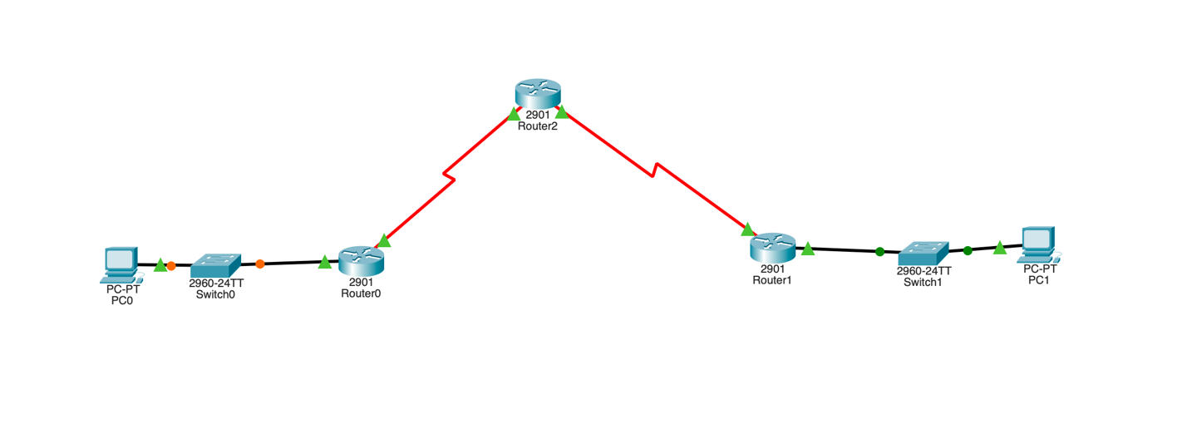

Task 2: Configure IP Addresses on both PC’s:

For PC0 do the below configuration:

static ip address as 192.168.1.3

subnet mask-255.255.255.0

default gateway-192.168.1.1

For PC1 do the below configuration:

static ip address as 192.168.2.3

subnet mask-255.255.255.0

default gateway-192.168.2.1

Task 3: Configuring IP Addresses on all the Routers

Sharjah Branch Router (Router 0)

Configure the LAN and WAN interfaces:

R0>enable

R0# configure terminal

R0(config)# interface GigabitEthernet 0/0

R0(config-if)# ip address 192.168.1.1 255.255.255.0

R0(config-if)# no shutdown

R0(config-if)# exit

R0(config)# interface s0/0/0

R0(config-if)# ip address 10.1.1.2 255.255.255.252

R0(config-if)# no shutdown

Abu Dhabi Branch Router (ADIB-AUH-R1)

Configure the LAN and WAN interfaces:

R1>enable

R1# configure terminal

R1(config)# interface GigabitEthernet 0/0

R1(config-if)# ip address 192.168.2.1 255.255.255.0

R1(config-if)# no shutdown

R1(config-if)# exit

R1(config)# interface s0/0/0

R1(config-if)# ip address 10.2.2.2 255.255.255.252

R1(config-if)# no shutdown

Intermediate Router (R2)

Configure WAN interfaces between Sharjah and Abu Dhabi:

R2>enable

R2# configure terminal

R2(config)# interface s0/0/0

R2(config-if)# ip address 10.1.1.1 255.255.255.252

R2(config-if)# no shutdown

R2(config-if)# exit

R2(config)# interface s0/0/1

R2(config-if)# ip address 10.2.2.1 255.255.255.252

R2(config-if)# no shutdown

Task 4: configure static routes on all Routers

Sharjah Router (R0)
- Add a static route to reach the Abu Dhabi LAN (192.168.2.0/24) via the intermediate router’s IP (10.1.1.1):

R0(config)# ip route 192.168.2.0 255.255.255.0 10.1.1.1

- Now Add a static route to reach (10.2.2.0/30) via the intermediate router’s IP (10.1.1.1)

R0(config)# ip route 10.2.2.0 255.255.255.252 10.1.1.1

Abu Dhabi Router (R1)

1. Add a static route to reach the Sharjah LAN (192.168.1.0/24) via the intermediate router’s IP (10.2.2.1):

R1(config)# ip route 192.168.1.0 255.255.255.0 10.2.2.1

2. Now Add a static route to reach (10.1.1.0/30) via the intermediate router’s IP (10.2.2.1)

R1(config)# ip route 10.1.1.0 255.255.255.252 10.2.2.1

Intermediate router(R2):

Add static routes to forward traffic between Sharjah and Abu Dhabi networks:

R2(config)# ip route 192.168.1.0 255.255.255.0 10.1.1.2

R2(config)# ip route 192.168.2.0 255.255.255.0 10.2.2.2

Task 5: Testing connectivity between two LAN’s

Ping PC1 from PC0 and vice versa to make sure the connectivity

Task 6: Configure IPsec Parameters on R0

Step 1: Enable the Security Technology package.

a. On R0, issue the show version command to view the Security Technology package license information.

b. If the Security Technology package has not been enabled, use the following command to enable the package.

R0(config)# license boot module c2900 technology-package securityk9

c. Accept the end-user license agreement.

d. Save the running-config and reload the router to enable the security license.

e. Verify that the Security Technology package has been enabled by using the show version command.

Step 3: Identify interesting traffic on R0.

Configure ACL 110 on R1 to the LAN on R2 as interesting.

R0(config)# access-list 110 permit ip 192.168.1.0 0.0.0.255 192.168.2.0 0.0.0.255

Step 4: Configure the IKE Phase 1 ISAKMP policy on R0.

R0(config)# crypto isakmp policy 10

R0(config-isakmp)# encryption aes 256

R0(config-isakmp)# authentication pre-share

R0(config-isakmp)# group 5

R0(config-isakmp)# exit

R0(config)# crypto isakmp key secret address 10.2.2.2

Step 5: Configure the IKE Phase 2 IPsec policy on R0.

create the transform-set VPN-SET to use esp-aes and esp-sha-hmac.

R0(config)# crypto ipsec transform-set VPN-SET esp-aes esp-sha-hmac

b. Create the crypto map VPN-MAP that binds all of the Phase 2 parameters together. Use sequence number 10 and identify it as an ipsec-isakmp map.

R0(config)# crypto map VPN-MAP 10 ipsec-isakmp

R0(config-crypto-map)# description VPN connection to R1

R0(config-crypto-map)# set peer 10.2.2.2

R0(config-crypto-map)# set transform-set VPN-SET

R0(config-crypto-map)# match address 110

R0(config-crypto-map)# exit

Step 6: Configure the crypto map on the outgoing interface.

Bind the VPN-MAP crypto map to the outgoing Serial 0/0/0 interface.

R0(config)# interface s0/0/0

R0(config-if)# crypto map VPN-MAP

Task 7: Configure IPsec Parameters on R1

Step 1: Enable the Security Technology package.

a. On R1, issue the show version command to verify that the Security Technology package license information has been enabled.

b. If the Security Technology package has not been enabled, enable the package and reload R1.

Step 2: Configure router R1 to support a site-to-site VPN with R1.

Configure reciprocating parameters on R1. Configure ACL 110 identifying the traffic from the LAN on R1 to the LAN on R0 as interesting.

R1(config)# access-list 110 permit ip 192.168.2.0 0.0.0.255 192.168.1.0 0.0.0.255

Step 3: Configure the IKE Phase 1 ISAKMP properties on R1.

Configure the crypto ISAKMP policy 10 properties on R1 along with the shared crypto key secret.

R1(config)# crypto isakmp policy 10

R1(config-isakmp)# encryption aes 256

R1(config-isakmp)# authentication pre-share

R1(config-isakmp)# group 5

R1(config-isakmp)# exit

R1(config)# crypto isakmp key secret address 10.1.1.2

Step 4: Configure the IKE Phase 2 IPsec policy on R1.

a. Create the transform-set VPN-SET to use esp-aes and esp-sha-hmac.

R1(config)# crypto ipsec transform-set VPN-SET esp-aes esp-sha-hmac

b. Create the crypto map VPN-MAP that binds all of the Phase 2 parameters together. Use sequence number 10 and identify it as an ipsec-isakmp map.

R1(config)# crypto map VPN-MAP 10 ipsec-isakmp

R1(config-crypto-map)# description VPN connection to R0

R1(config-crypto-map)# set peer 10.1.1.2

R1(config-crypto-map)# set transform-set VPN-SET

R1(config-crypto-map)# match address 110

R1(config-crypto-map)# exit

Step 5: Configure the crypto map on the outgoing interface.

Bind the VPN-MAP crypto map to the outgoing Serial 0/0/1 interface. Note: This is not graded.

R1(config)# interface s0/0/0

R1(config-if)# crypto map VPN-MAP

Task 8: Verify the IPsec VPN

Step 1: Verify the tunnel prior to interesting traffic.

Issue the show crypto ipsec sa command on R0. Notice that the number of packets encapsulated, encrypted, decapsulated, and decrypted are all set to 0.

Step 2: Create interesting traffic.

Ping PC-0 from PC-1.

Step 3: Verify the tunnel after interesting traffic.

