LIBRARY MANAGEMENT SYSTEM
Python / Problem Solving Academic Project
Student | Rachit Chirag Pandya
Registration Number | 26BCE11620
Faculty | Dr. Vikas Panthi
Academic Year | 2026-2027

Project Report

Cover Page
Project Title: Library Management System
Subject: Problem Solving / Python Programming
Project Type: Individual Academic Project
Language: Python
Student: Rachit Chirag Pandya
Registration Number: 26BCE11620
Faculty: Dr. Vikas Panthi

Introduction
Libraries keep records about books and students and require keeping track of the circulation of books. A simple menu-driven application can save a lot of time for doing repetitive tasks and illustrate basic programming principles.
This is an implementation of a Library Management System in basic Python. This system is based on functions and basic data structures and not any advanced framework/database techniques.

Problem Statement
Manual library management can make it difficult to search for books, maintain student information, and track which books are currently issued. The project provides a structured menu-driven system to perform these operations.

Objectives
- Apply Top Down Design.
- Convert a real-world problem into algorithms.
- Implement algorithms using Python.
- Use functions with parameters and arguments.
- Apply lists, tuples, sets, and dictionaries.
- Use conditional and iterative control flow.
- Implement searching, counting, and summation.
- Perform basic input validation.
- Analyze the time complexity of important operations.
- Demonstrate version-controlled project organization.

Functional Requirements
FR1 - Book Management
The system shall add, view, search, update, and delete books.
FR2 - Student Management
The system shall add and view students.
FR3 - Circulation Management
The system shall issue and return books.
FR4 - Fine Calculation
The system shall calculate a fine for books returned after 14 days.
FR5 - Transaction Management
The system shall display issue and return transactions.

FR6 - Reporting
The system shall display library statistics.

Non-Functional Requirements
Usability
The system shall use a simple numbered menu.
Reliability
The system shall validate positive IDs and reject invalid operations.
Maintainability
The program shall be divided into meaningful Python modules.
Resource Efficiency
The system shall use simple lists, dictionaries, sets, and sequential algorithms suitable for a small library.

Error Handling
The system shall display meaningful messages for invalid IDs, duplicate IDs, unavailable books, and invalid menu choices.

System Architecture
The system follows a simple modular architecture.
- `main.py` controls the menu.
- `books.py` manages books.
- `students.py` manages students.
- `transactions.py` manages circulation.
- `reports.py` generates statistics.
- `validation.py` performs common validation.
- `data.py` stores the in-memory collections.

Design Decisions and Rationale
Why functions?
Functions are directly covered by the syllabus and support Top Down Design.
Why lists?
Books, students, and transactions are collections, so lists are suitable.
Why dictionaries?
Each book, student, and transaction has multiple named fields, making dictionaries convenient.
Why sets?
Sets provide unique authors and categories for statistics.
Why tuples?
The reporting module converts unique sets to tuples when displaying fixed result collections.
Why no classes?
Object-oriented programming is not part of the stated syllabus, so classes were intentionally avoided.
Why no database?
Database programming is not part of the stated syllabus. In-memory structures keep the project within the taught concepts.

Implementation Details
This code begins from `main.py`. The menu is written using the `while` loop and conditionals. The book, student, and transaction functionalities are realized using functions.
Data will be passed to functions through parameters. The search operation will involve a linear traversal approach. Fine computation will involve arithmetic expressions and conditionals.

Data Structure Design

Books
A list containing dictionaries:
id`, `title`, `author`, `category`, `available

Students
A list containing dictionaries:
id`, `name`, `course

Transactions
A list containing dictionaries:
book_id`, `student_id`, `days_borrowed`, `fine`, `status

Algorithm Analysis
Worst-case scenario for sequential search is O(n). All book views are O(n). Statistical calculations are O(n + m), where n = number of books, m = transactions. Efficiency optimization is not considered due to implementation priorities.

Screenshots / Results
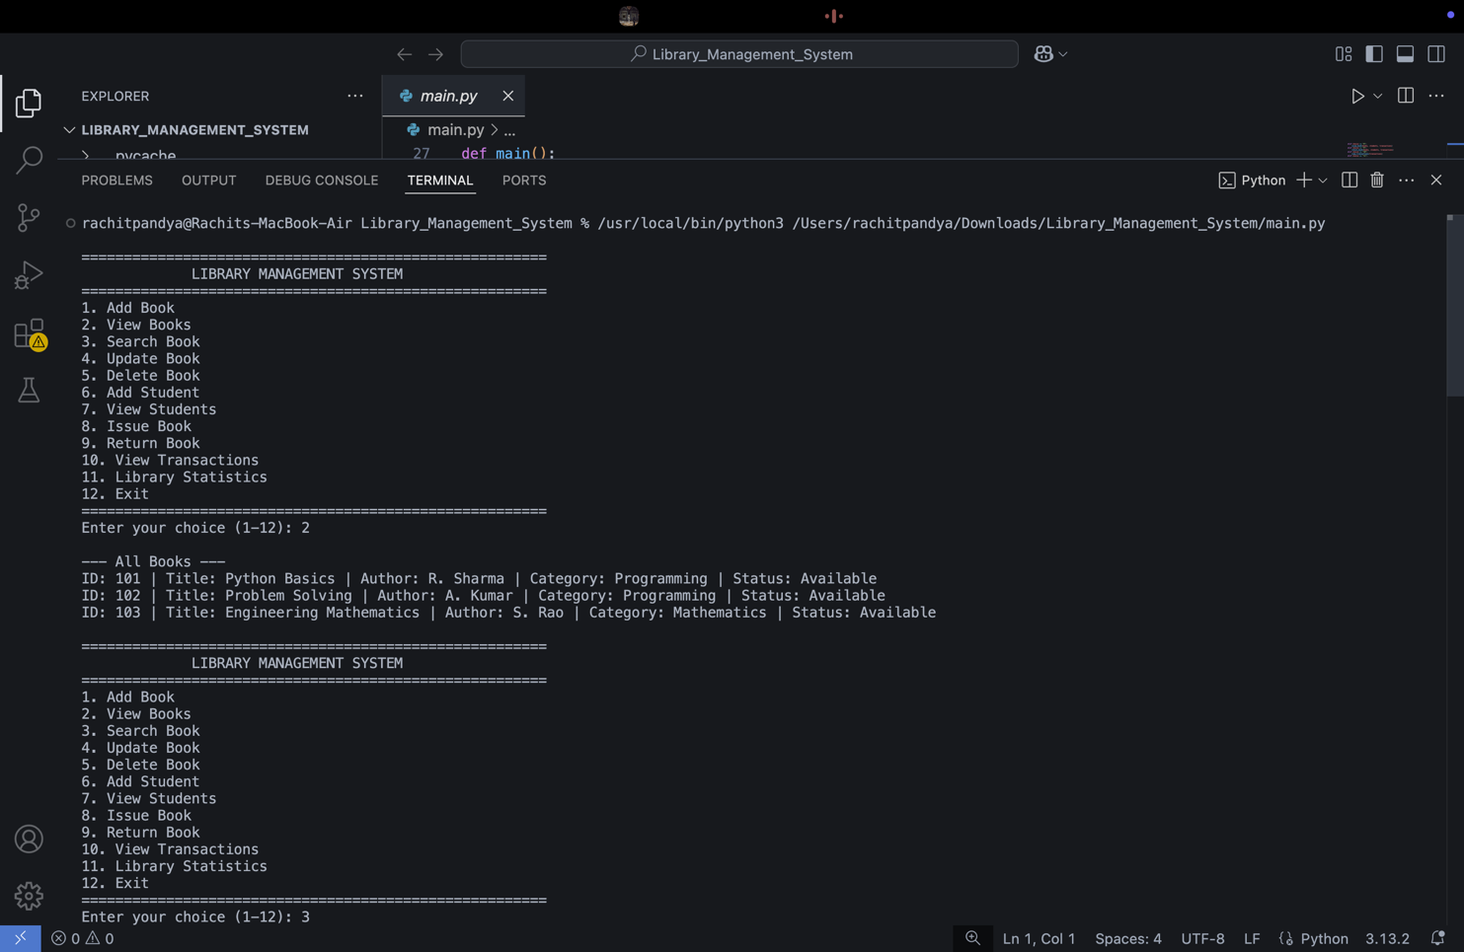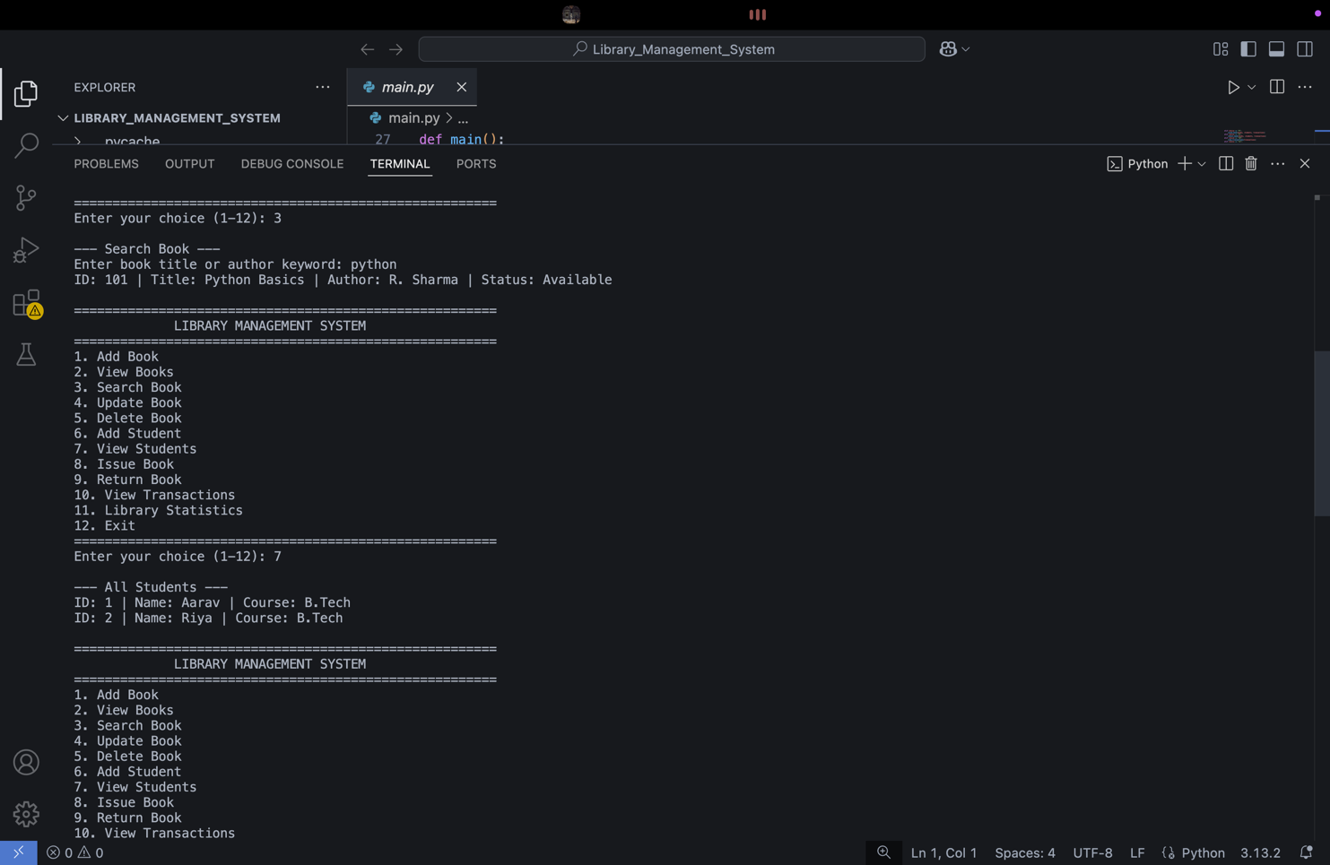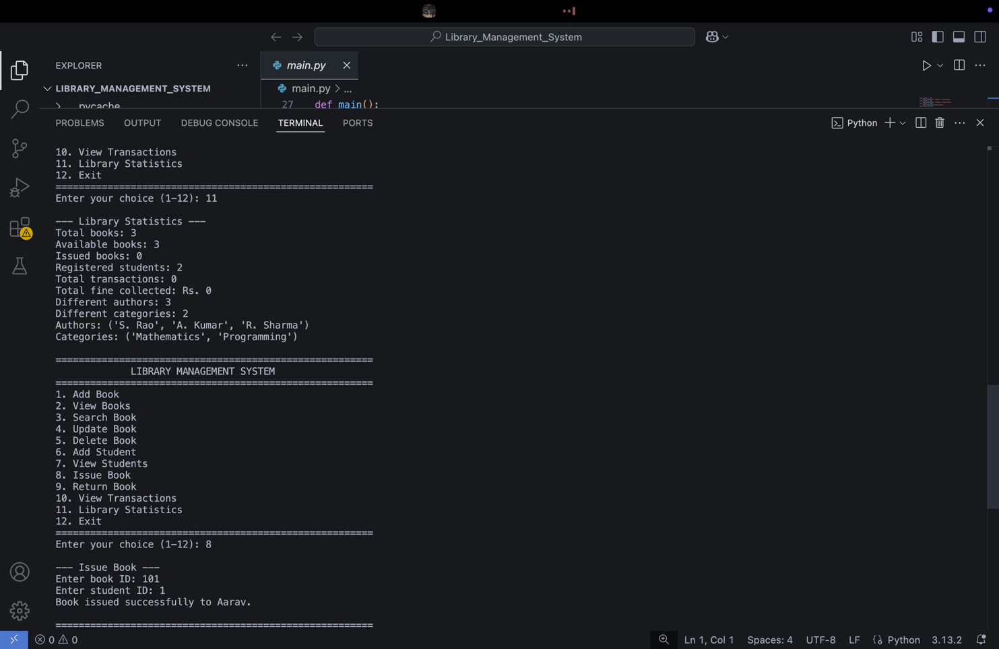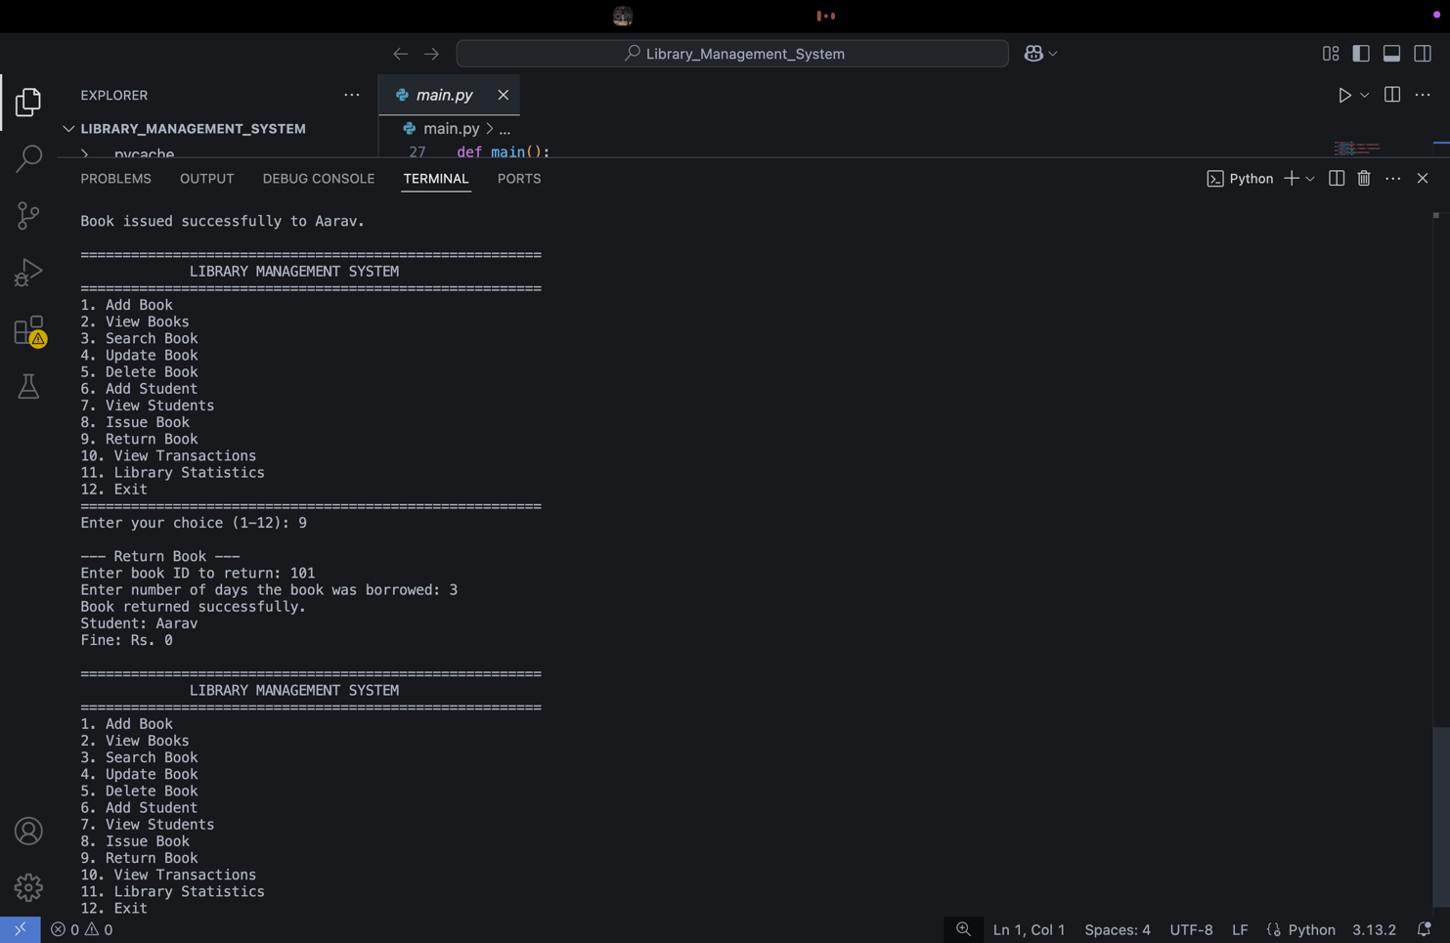

Challenges Faced
• Segmenting the problem into suitable modules.
• Selecting proper data structures according to the syllabus.
• Avoiding duplicate IDs.
• Taking care of invalid operations.
• Keepting simplicity in the program while giving proper functionality.
• Maintaining connections between books, students, and transactions.\

Learnings and Key Takeaways
- Big problems can be broken up into smaller ones.
- Lists and dictionaries can represent real-world data.
- Sets are good for unique items.
- Validation avoids bad program states.
- The algorithm should be thought of beforehand.
- Simple sequential algorithms work well for small data sets.
- Programs become easier to write and maintain through modularity.

Future Enhancements
If additional technologies are introduced later, the system could be extended with:
- Permanent storage
- User authentication
- Graphical user interface
- Database support
- Advanced reports
- Multiple library operators
These are future enhancements and are not part of the current implementation.

References
- VITyarthi - Build Your Own Project: General Project Instructions & Submission Guidelines.
- Python course/semester syllabus provided for the project.
- Python 3 documentation and classroom notes, where applicable.

