**Problem 2 : Image Mapping**

## AIM:

2. Create a web page with the following using HTML5

(i) To embed an image map in a web page

(ii) To fix the hot spots

(iii) Show all the related information when the hot spots are clicked.

## PROGRAM CODE:

|  |  |
| --- | --- |
| Imagemapping.html | <html><head><title>image mapping</title></head><body><center><h1><u>welcome to my image mapping</u></h1></center><style> body {background-color:#433D44 ; } </style><center><img src="C:\Users\New\Desktop\New folder\white_wolf.jpg" width="1000" height="auto" usemap="#white_wolf"><map name="white_wolf"><area shape="rect" coords="0,0,82,126" alt="Sun" href="C:/Users/New/Desktop/New%20folder/black_wolf.html"></map></center></body></html> |
| Black_wolf.html | <html><head><title>image mapping</title></head><body><center><h1><u>welcome to my image mapping</u></h1></center><style> body {background-color:#433D44 ; } </style><center><img src="C:\Users\New\Desktop\New folder\white_wolf.jpg" width="1000" height="auto" usemap="#white_wolf"><map name="white_wolf"><area shape="rect" coords="0,0,82,126" alt="Sun" href="C:/Users/New/Desktop/New%20folder/black_wolf.html"></map></center></body></html> |
| Black_wolf2.html | <html><head><title>image mapping</title></head><body><center><h1><u>welcome to my image mapping</u></h1></center><style> body {background-color:#433D44 ; } </style><center><img src="C:\Users\New\Desktop\New folder\white_wolf.jpg" width="1000" height="auto" usemap="#white_wolf"><map name="white_wolf"><area shape="rect" coords="0,0,82,126" alt="Sun" href="C:/Users/New/Desktop/New%20folder/black_wolf.html"></map></center></body></html> |
|  |  |

## RESULT:

We can embed an image map in a web page and can fix the hot spots & Show all the related information when the hot spots are clicked.

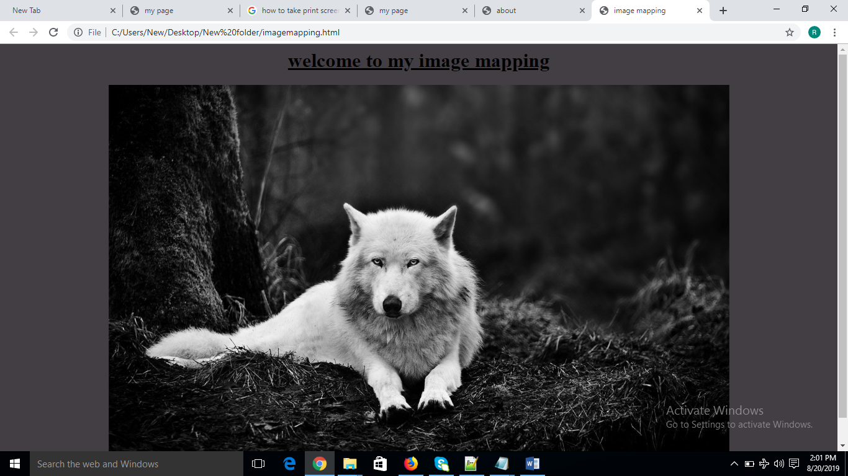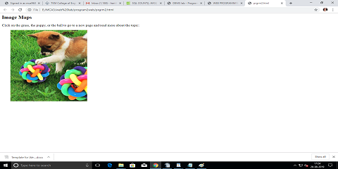

## 

## Figure 1: Home page for the image mapping.



 