**Problem 2 : Cascading Style Sheets**

## AIM:

## Create a web page that displays college information using various style sheets.

## (i)Inline

## (ii)Internal

## (iii)External

## PROGRAM CODE:

## 

|  |  |
| --- | --- |
| Prgrm03.html | <html><body><h1 style="color:blue;">TKM COLLEGE OF ENGINEERING</h1><img src="tkm.jpg" width="300" height="300"><h2 style="color:brown;">Departments</h2><ol><li>Architecture</li><li>Chemical Engineering</li><li>Chemistry</li><li>Civil Engineering</li><li>Computer Science & Engineering</li><li>Electrical & Electronics Engineering</li><li>Electronics & Communication Engineering</li><li>Master of Computer Application</li><li>Mathematics</li><li>Mechanical Engineering</li><li>Physical Education</li><li>Physics</li><li>Power System</li><li>Computer Integrated Manufacturing</li><li>Industrial Instrumentation and Control</li></ol></body></html> |
| internalcss.html | <html><head><style>body {background-color: rgb(218, 162, 213);}h1 {color: blue;font-family: verdana;font-size: 250%;}h2 {color: rgb(11, 45, 48);}h5 {color: brown;font-family: verdana;font-size: 200%;border: 1px solid black;}</style></head><body><h1><center><u>Contact Details</u></center></h1><br><img src="tkm.jpg" width="300" height="300"><h2><b><u>Address</b></u></h2><h5>TKM College of Engineering,<br>Karicode,<br>Kollam-691005,<br>Kerala,India<br>Contact Details<br>+91 474-2712024, 2712022, 2713126<br>+91 474-2712023<br>info@tkmce.ac.in</h5></body></html> |
| extrnal.html | <html><head><link rel="stylesheet" href="external.css"></head><body><h1><center><u>Academics</center></h1><center><img src="tkm.jpg" width="300" height="300"></center><p>Teaching at TKMCE is structured around 11 departments. The Institution is affiliated to the University of Kerala &APJ Abdul Kalam Technological University, and all the courses offered in the college are approved by All IndiaCouncil for Technical Education. It offers 8 Undergraduate, 8 Postgraduate and 2 Research programmes.Research centers are part of the departments,<br> encouraging inter-departmental collaboration and opportunity for studentsto participate in exciting research projects.</p></body></html> |
| external.css | body {background-color: powderblue;}h1 {color: blue;}p {color: red;} |

## RESULT:

## We can create a web page that displays college information using various style sheets like Inline, Internal & External

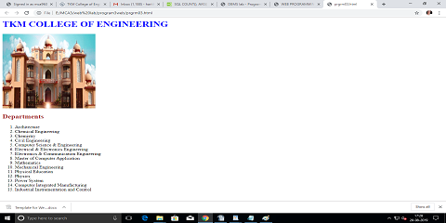

## 

## Figure 1:College department details using Inline css.

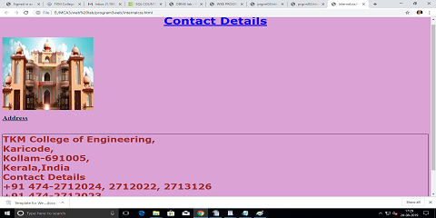

## Figure 2:Contact details using Internal css.

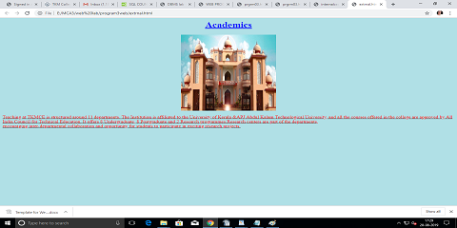

## Figure 3:Accademic details using External css.