Project Report
On

HOSPITAL MANAGEMENT SYSTEM


Submitted by
B Rohini
M Radhika
Under the guidance of
P UdayaSree
Department of Computer Science and Engineering
Rajiv Gandhi University of Knowledge and Technologies(RGUKT),
R.K.Valley, Kadapa, Andra Pradesh.
1
Rajiv Gandhi University of Knowledge Technologies
RK Valley, Kadapa (Dist), Andhra Pradesh, 516330
CERTIFICATE
This is to certify that the project work titled “ HOSPITAL MANAGEMENT
SYSTEM” is a bonafied project work submitted by B Rohini and
M Radhika the
COMPUTER SCIENCE AND ENGINEERING in partial fulfillment of requirements for the
award of degree of Bachelor of Technology in Computer science and engineering in 6th
Semester. For year 2021-22 carried out the work under the supervision
GUIDE
HEAD OF THE DEPARTMENT
P UdayaSree

P Harinadha

2
ACKNOWLEDGEMENT
The satisfaction that accompanies the successful completion of any task would
be incomplete without the mention of the people who made it possible and whose constant
guidance and encouragement crown all the efforts success.

I am extremely grateful to our respected Director,Prof. K. SANDHYA RANI for
fostering an excellent academic climate in our institution. I also express my sincere
gratitude to our respected Head of the Department Mr.T Harinadha for his encouragement, overall guidance in viewing this project a good asset and effort in bringing out this project.
I would like to convey thanks to our guide at college Ms. UdaySree for his guidance, encouragement, co-operation and kindness during the entire duration of the course and
academics.

My sincere thanks to all the members who helped me directly and indirectly in
the completion of project work. I express my profound gratitude to all our friends and
family members for their encouragement.

3

INDEX
S.NO
INDEX
PAGE NUMBER
1
Abstract
5
2
Introduction
6
3
purpose
7
4
Scope
7
5
Requirement Specification
8-9
6
Analysis and design
10-11
6.1
Usecase
12-14
7
Implementation and
System testing
15
8
Project code
9
Project Output
43-48
10
Conclusion
49
11
References
49

4
16-42

Abstract

Nowadays, Managing the hospital is one of the most difficult task. Maintaing a
data of Patients and medicines plays a vital role than running a hospital.

In this project We tried to develop a computer based Hospital Management System.
Our main intention is to allow this application to be used in Hospitals where a database
is required to store all the data regarding patients and medicines in the Hospital. Where
patients and medicines data can be edited based on the requirements.

The information is maintained in application instead of records or files. Many
patients will visit daily to Hospital. Using this system, it will help us to record al l those
data.
5
Introduction

RR Hospital Management System is web based technology which stores all the
Information of patients arrive to hospital and the drugs in the hospital.

Here mainly the admin is responsible to add users.And admin can view patients data,
Drug related information. The admin add users based on the role of admin or user. The user
can monitor the patients data such as adding and viewing, also add drugs and view Related information. To view the website they need to login according to their roles as User or admin. After that they need to logout.

• Admin
• User
Admin Module
Admin is the super user of the website who can manage everything on the website.
Admin can log in through the login page.
 Patient : In this section, the admin can see patients details .
 Drug : In this section, the admin can manage Drug Information (add, update, delete).
 user : In this section, the admin can Add users and view users.
User Module
 Patients : This section divided into two parts. One is to add the patients details and other is
to view patient list.
 Drug : Here user can add and view information about drugs.
6

Purpose

The main purpose of this Hospital management system to provide a platform where
Patients records can be stored in the computer data instead of physical records. Thus the data
can be retrived and modified. The daily information of drugs is also added.

Scope
Today we are using modern technology, maintaining data about anything became
virtual. Even kids are using the keypads instead of books. So the information stored in the computers other than physical files will save most of paper work. And using the information
in this format. By storing in database can be stored for a longtime and cant be lost. since it is
online. Application this can be viewed by admin anytime.
7
Requirement Specification
Hardware Configuration:
Client Side:
Ram
512 MB
Hard disk
10 GB
Processor
1.0 GHz
Server side:
Ram
1 GB
Hard disk
20 GB
Processor
2.0 GHz
Software Requirement:
Front end
HTML,CSS ,jquery,java script
Server side Language
PHP
Database Server
MYSQL
Web Browser
Firefox , Google Chrome or any compatible
browser
Operating System
Ubuntu,Windows or any equivalent OS
Software
xampp
8

APACHE
The Apache HTTP Server Project is an effort to develop and maintain an open-source
HTTP server for modern operating systems including UNIX and Windows. The goal of this
project to provide a secure, efficient and extensible server that provides HTTP services in
sync with the current HTTP standards. The Apache HTTP Server was launched in 1995
and it has been the most popular web server on the Internet since April 1996. It has celebrated
its 20th birthday as a project in February 2015.
PHP
•
PHP stands for PHP: Hypertext Preprocessor.
•
PHP is a server-side scripting language, like ASP.
•
PHP scripts are executed on the server.
•
PHP supports many databases (MYSQL, Informix,
Oracle, Sybase, Solid, Generic ODBC, etc.).
•
PHP is an open source software.
•
PHP is free to download and use.
MYSQL
•
MYSQL is a database server
•
MYSQL is ideal for both small and large applications

•
MYSQL supports standard SQL
•
MYSQL compiles on a number of platforms
•
MYSQL is free to download and use
•
How to access MySQL:
•
http://localhost/phpmyadmin

9

Analysis and Design
Analysis:
Early days most of the hospital managment is done by using phyical files and
records. As Technology is growing rapidly we are also moving to a technical world where
everything we want to be online. So with the help of t his project we are bringing the use
of technology in the field of management to store all the information relating to patients
and drugs. This will make the hospital to run smooth.
Only the Admin can do any modifications about users and authenicated only
change the details.

Disadvantage of old system:
Not user friendly : The present system not user friendly because data is not stored in
structure and proper format.
• Manual Control : All report calculation is done manually so there is a chance of getting
error.
• Lots of paper work : Visitors maintain in the register so lots of paper require storing details.
Time consuming
•
10

Design Introduction:
Design is the first step in the development phase for any techniques and principles
purpose of defining a device, a process or system in sufficient detail to permit its physical
for the realization. Once the software requirements have been analyzed and specified the
software design involves three technical activities - design, coding, implementation and
testing that are required to build and verify the software.
The design activities are of main importance in this phase, because in this activity,
decisions ultimately affecting the success of the software implementation and its ease of
maintenance are made. These decisions have the final bearing upon reliability and
maintainability of the system.
Design is the only way to accurately translate the customer’s requirements into the
finished software or a system.
Design is the place where quality is fostered in development. Software design is a
through which requirements are translated into a representation of a software. Software
design is conducted in two steps. Preliminary design is concerned with the transformation
of requirements into data.

UML Diagrams:
Actor : A coherent set of roles that users of use cases play when interacting with
the use cases. An observable result of value of an actor.

Actor

Use case : A description of sequence of actions, including variants, that a system
yields performs an observable result of value of an actor. Actor diagram
is drawed in an eclipse shape
Use case

11

UML stands for Unified Modeling Language. UML is a language for specifying,
visualizing and documenting the system. This is the step while developing any product
after analysis. The goal from this is to produce a model of the entities involved in the
project which later need to be built. The representation of the entities that are to be used in
the product being developed need to be designed.

USECASE DIAGRAMS:
Using Use case diagrams model behavior within a system helps the developers
understand of what the user require. The stick man represents what’s called an actor.
Use case diagram can be useful for getting an overall view of the system and clarifying
that can do and more importantly what they can’t do. Use case diagram consists of use
cases and actors and shows the interaction between the use case and actors.
•
• The purpose is to show the interactions between the use case and actor.
To represent the system requirements from user’s perspective.
An actor could be the end-user of the system or an external system.

USECASE DIAGRAM:
A Use case is a description of set of sequence of actions. Graphically it is
it is rendered as an ellipse with solid line including only its name. Use case diagram is a
behavioral diagram that shows a set of use cases and actors and their relationship. It is an
association between the use cases and actors. An actor represents a real-world object.
Primary Actor – Sender, Secondary Actor Receiver.
12
Login and logout
Admin:
View patients
Add and View
drugs
Add and view
Users (staff)
13
Admin Activities

Staff(user):
Login and logout
Add and view
Drugs
Add and view
Patients
14
UserActivities

Implementation and System Testing
After all phase have been perfectly done, the system will be implemented to the
server and the system can be used.
System Testing
The goal of the system testing process was to determine all faults in our project.
based on these was subjected to a set of test inputs and many explanations were made and
explanations it will be decided whether the program behaves as expected or not. Our Project
went through two levels of testing.
1. Unit testing
2 .Integration testing
Unit Testing
Unit testing is commenced when a unit has been created and effectively reviewed .In
ordet to test a single module we need to provide a complete environment i.e. besides the
the section we would require The procedures belonging to other units that the unit under test
calls Non local data structures that module accesses . A procedure to call the functions of the
unit under test with appropriate parameters.

Test for the admin and user module
Testing admin login form-This form is used for log in of administrator of the system.
In this form we enter the username and password if both are correct administration page will
open otherwise if any of data is wrong it will get redirected back to the login page and again
the details.
Integration Testing
In the Integration testing we test various combination of the project module by the
providing input.
The primary objective is to test the module interfaces in order t o confirm that no
errors are occurring when one module invokes the other module.
15
Code
index.php
<? php include "../../includes/header.php"; ?>
<link href="../../public/css/login.css" rel="stylesheet">
<!--Main Layout-->
<!--Intro Section-->
<section class="view intro-2">
<div class="mask rgba-stylish-strong h-100 justify-content-center align-items-center">
<div class="container">
<div class="row">
<div class="col-xl-5 col-lg-6 col-md-10 col-sm-12 mx-auto mt-lg-5">
<!--Form with header-->
<div class="mt-5 card wow fadeIn" data-wow-delay="0.4s">
<div class="card-body">
<form action="#" class="login" id="login">
<input type="hidden" name="type" value="login">
<!--Header-->
<div class="form-header blue">
<h1>RR HOSPITAL</h1>
<h3>Log In</h3>
</div>
<!--Body-->
<div class="md-form">
<input name="email" type="text" id="orangeForm-name" class="form-control">
<label for="orangeForm-name">Email</label>
</div>
<div class="md-form">
<input name="password" type="password" id="orangeForm-pass" class="form-control">
<label for="orangeForm-pass">Password</label>
</div>
<div class="text-center">
<button onclick="submitForm()" class="btn blue btn-lg">Sign In</button>
<hr>
16

<p class="text-white">Project BY<br> Rohini and Radhika</p>
</div>
</form>
</div>
</div>
<!--/Form with header-->
</div>
</div>
</div>
</div></section>
<!--Main Layout-->
<?php include "../../includes/footer.php"; ?>
<script>
function submitForm(e) {
event.preventDefault();
var loginInfo = $('.login').serialize();
$.ajax({
type: 'POST',
url: '../../includes/users/UsersController.php',
data: loginInfo,
success: function(resp) {
if (resp == "success") {
window.location.href = "../admin/admin.php";
} else if (resp == "manager") {
window.location.href = "user.php";
} else {
Swal.fire({
title: resp,
});
}
},
})
}
17
</script>
admin.php
<?php session_start(); ?>
<?php include "../../includes/dao.php"; ?>
<?php include "../../includes/header.php"; ?>
<?php include "../../includes/sidenav.php"; ?>
<!--Main Layout-->
<!-- Main navigation -->
<header>
<!--Navbar-->
<!-- Navbar -->
<!-- Full Page Intro -->
<div class="view jarallax" data-jarallax='{"speed": 0.2}' style="background-image: >
<!-- Mask & flexbox options-->
<div class="mask rgba-white-light d-flex justify-content-center align-items-center">
<!-- Content -->
<div class="container">
<!--Grid row-->
<div class="row">
<!--Grid column-->
<div class="col-md-12 white-text text-center">
<a class="indigo-text font-weight-bold">RR <br>HOSPITAL MANAGEMENT SYSTEM</a>
<div class="wow fadeInDown" data-wow-delay="0.3s">
</div>
</div>
<!--Grid column-->
</div>
<!--Grid row-->
</div>
<!-- Content -->
</div>
<!-- Mask & flexbox options-->
</div>
<!-- Full Page Intro -->
</header>
18
<!-- Main navigation -->
<!--Main Layout-->
<?php include "../../includes/footer.php"; ?>

sidenav.php
<!--- sidenav---------->
<body class="fixed-sn light-blue-skin">
<!--Double navigation-->
<header>
<!-- Sidebar navigation -->
<div id="slide-out" class="side-nav sn-bg-4 fixed">
<ul class="custom-scrollbar">
<!--Social-->
<!-- <li>
<ul class="social">
<li><a href="#" class="icons-sm fb-ic"><i class="fab fa-facebook-f"> </i></a></li>
<li><a href="#" class="icons-sm pin-ic"><i class="fab fa-pinterest"> </i></a></li>
<li><a href="#" class="icons-sm gplus-ic"><i class="fab fa-google-plus-g"> </i></a></li>
<li><a href="#" class="icons-sm tw-ic"><i class="fab fa-twitter"> </i></a></li>
</ul>
</li> -->
<!--/Social-->
<!--Search Form-->
<!-- <li>
<form class="search-form" role="search">
<div class="form-group md-form mt-0 pt-1 waves-light">
<input type="text" class="form-control" placeholder="Search">
</div>
</form>
</li> -->
<!--/.Search Form-->
<!-- Side navigation links -->
<li>
19
<?php if ($_SESSION['role'] == "admin") :
<h1>Admin</h1>
<?php endif; ?>
<?php if ($_SESSION['role'] != "admin") : ?>
<h1>User</h1>
<?php endif; ?>
<ul class="collapsible collapsible-accordion">
<div class="collapsible-body">
<ul>
<?php if ($_SESSION['role'] != "admin") : ?>
<li><a href="../patients/addPatient.php" class="waves-effect">Add Patient</a>
</li>
<?php endif; ?>
<li><a href="../patients/viewPatients.php" class="waves-effect">View Patients List</a>
</li>
</ul>
</div>
</li>
<li><a class="collapsible-header waves-effect arrow-r">
Drug<i class="fas fa-angle-down rotate-icon"></i></a>
<div class="collapsible-body">
<ul>
<li><a href="../presp/addPresp.php" class="waves-effect">Add Drug</a>
</li>
<li><a href="../presp/viewPresp.php" class="waves-effect">View Drugs</a>
</li>
</ul>
</div>
</li>
<?php if ($_SESSION['role'] == "admin") : ?>
<div class="collapsible-body"
<ul>
<li><a href="../users/addUser.php" class="waves-effect">Add User</a>
</li>
20

<li><a href="../users/viewUsers.php" class="waves-effect">View Users</a>
</li>
</ul>
</div>
</li>
<?php endif; ?>
</ul>
</li>
<!--/. Side navigation links -->
</ul>
<div class="sidenav-bg mask-strong"></div>
</div>
<!--/. Sidebar navigation -->
<!-- Navbar -->
<!-- SideNav slide-out button -->
<div class="float-left">
<a href="#" data-activates="slide-out" class="button-collapse"><i class="fas fa-bars"></i></a>
</div>
<!-- Breadcrumb-->
<div class="breadcrumb-dn mr-auto">
<p>Hospital Infomation System</p>
</div>
<ul class="nav navbar-nav nav-flex-icons ml-auto">
<li class="nav-item dropdown">
<i class="fas fa-user"></i> Account
</a>
<a class="dropdown-item" href="../index/index.php">Log Out [<?= $_SESSION['email'] ?>]</a>
</div>
</li>
</ul>

</body>
21

SQL used
-- phpMyAdmin SQL
SET SQL_MODE = "NO_AUTO_VALUE_ON_ZERO";
SET AUTOCOMMIT = 0;
START TRANSACTION;
SET time_zone = "+00:00";
--
-- Database: `rr`
-- Table structure for table `drug`
--
CREATE TABLE `drug` (
`drug_id` int(11) NOT NULL,
`name` varchar(11) DEFAULT NULL,
`expiry` date DEFAULT NULL,
`presp` varchar(256) DEFAULT NULL,
`price` int(30) DEFAULT NULL,
`qty` int(11) DEFAULT '0'
) ENGINE=InnoDB DEFAULT CHARSET=latin1;
--
-- Dumping data for table `drug`
--
INSERT INTO `drug` (`drug_id`, `name`, `expiry`, `presp`, `price`, `qty`) VALUES
(5, 'ARV', '2024-01-01', '10 Per day', 5000, -5),
(6, 'drug', '2023-01-01', '2 times a day', 5000, 0),
(7, 'Aspirin', '2023-05-29', '10 Per day', 5000, 0),
(8, 'Drug1', '2022-12-12', '2 times a day', 5000, 10);
-- --------------------------------------------------------
--
-- Table structure for table `growth`
--
CREATE TABLE `growth` (
`user_id` int(11) NOT NULL,
22

`weight` int(11) NOT NULL,
`height` int(11) NOT NULL,
`bmi` int(100) NOT NULL DEFAULT '0',
`headc` int(100) NOT NULL DEFAULT '0',
`gender` varchar(100) DEFAULT NULL,
`created` timestamp NOT NULL DEFAULT CURRENT_TIMESTAMP
) ENGINE=MyISAM DEFAULT CHARSET=latin1;
--
-- Dumping data for table `growth`
--
INSERT INTO `growth` (`user_id`, `weight`, `height`, `bmi`, `headc`, `gender`, `created`)VALUES
(11, 80, 100, 0, 0, NULL, '2022-05-29 08:50:41'),
(11, 100, 120, 0, 0, NULL, '2022-05-29 08:50:56'),
(11, 110, 140, 0, 0, NULL, '2022-05-29 08:51:08'),
(11, 120, 160, 0, 0, NULL, '2022-05-29 08:55:31'),
(11, 140, 180, 0, 0, NULL, '2022-05-29 08:56:04'),
(11, 140, 180, 0, 2, '0', '2022-07-09 14:18:03'),
(11, 140, 180, 0, 2, NULL, '2022-07-09 14:21:33'),
(11, 140, 180, 0, 2, NULL, '2022-07-09 14:22:56'),
(11, 140, 180, 0, 2, NULL, '2022-07-09 14:23:20'),
(11, 140, 180, 0, 2, 'male', '2022-07-09 14:35:09'),
(11, 140, 180, 0, 2, 'male', '2022-09-09 14:35:16'),
(11, 140, 180, 0, 2, 'female', '2022-09-09 14:35:44'),
(16, 20, 10, 11, 100, 'male', '2022-09-11 07:56:50'),
(16, 40, 20, 12, 300, 'male', '2022-09-11 07:57:11'),
(16, 50, 29, 20, 400, 'male', '2022-09-11 07:57:31');
-- ----------------------------------------------------------
-- Table structure for table `patients`
CREATE TABLE `patients` (
`user_id` int(11) NOT NULL,
`firstname` varchar(256) DEFAULT NULL,
`lastname` varchar(256) DEFAULT NULL,
`dob` date DEFAULT NULL,
23

`address` text,
`married` varchar(256) DEFAULT NULL,
`dor` date DEFAULT NULL,
`contact` varchar(256) DEFAULT NULL,
`referred` varchar(30) DEFAULT NULL,
` reason` varchar(100) DEFAULT NULL
) ENGINE=InnoDB DEFAULT CHARSET=latin1;
--
-- Dumping data for table `patients`
--
INSERT INTO `patients` (`user_id`, `firstname`, `lastname`, `dob`, `address`, `married`, `dor`)
(16, 'rani', 'p', '2002-01-01', 'P.O. Box 32153', 'married', '2022-09-9', 'Contact', 'kadapa', 'no');
-- -------------------------------------------------------
-- ----------------------------------------------------------
-- Table structure for table `tests`
--
CREATE TABLE `tests` (
`test_id` int(11) NOT NULL,
`test_name` varchar(100) NOT NULL,
`result` varchar(100) NOT NULL,
`user_id` int(11) NOT NULL
) ENGINE=InnoDB DEFAULT CHARSET=latin1;
--
-- Dumping data for table `tests`
--
INSERT INTO `tests` (`test_id`, `test_name`, `result`, `user_id`) VALUES
(1, 'Malaria', 'Positive', 16),
(2, 'Malaria', 'Positive', 16),
(3, 'Malaria', 'Positive', 16),
(4, 'Malaria', 'Positive', 16),
(5, 'AIDS', 'negative', 16),
(6, 'AIDS', 'negative', 16);
-- --------------------------------------------------------
24
--
-- Table structure for table `users`
--
CREATE TABLE `users` (
`user_id` int(11) NOT NULL,
`email` text NOT NULL,
`password` varchar(256) NOT NULL,
`role` varchar(256) NOT NULL
) ENGINE=InnoDB DEFAULT CHARSET=latin1;
--
-- Dumping data for table `users`
--
INSERT INTO `users` (`user_id`, `email`, `password`, `role`) VALUES
(1, 'rohini@gmail.com', '123', 'admin'),
(2, 'rohini@gmail.com', '1234', 'user'),
(3, 'radhika@gmail.com', '789', 'admin');
--
-- Indexes for dumped tables
--
--
-- Indexes for table `diagnosis`
--
ALTER TABLE `drug`
ADD PRIMARY KEY (`drug_id`);
--
-- Indexes for table `patients`
--
ALTER TABLE `patients`
ADD PRIMARY KEY (`user_id`);
--
-- Indexes for table `tests`
ALTER TABLE `tests`
ADD PRIMARY KEY (`test_id`);
25

-- Indexes for table `users`
--
ALTER TABLE `users`
ADD PRIMARY KEY (`user_id`);
--
-- AUTO_INCREMENT for dumped tables
-- AUTO_INCREMENT for table `drug`
ALTER TABLE `drug`
MODIFY `drug_id` int(11) NOT NULL AUTO_INCREMENT, AUTO_INCREMENT=9;
-- AUTO_INCREMENT for table `patients`
ALTER TABLE `patients`
MODIFY `user_id` int(11) NOT NULL AUTO_INCREMENT, AUTO_INCREMENT=17;
-- AUTO_INCREMENT for table `tests`
--ALTER TABLE `tests`
MODIFY `test_id` int(11) NOT NULL AUTO_INCREMENT, AUTO_INCREMENT=7;
-- AUTO_INCREMENT for table `users`
ALTER TABLE `users`
MODIFY `user_id` int(11) NOT NULL AUTO_INCREMENT, AUTO_INCREMENT=4;
COMMIT;
26
Adduser.php

<?php session_start(); ?>
<?php include "../../includes/dao.php" ?>
<?php include "../../includes/users/UsersController.php";
?>
<div class="container">
<?= $jumbo->getJumbo("Add User", "") ?>
<form method='POST' class='addUser' action='#' onsubmit="adduser()">
<input type="hidden" name="type" value="addUser" id="">
<div class='form-group'>
<label for='in_Email'>Email</label>
<input name='in_Email' id='in_Email' class='form-control' type='text' placeholder='Email'>
</div>
<div class='form-group'>
<label for='in_Password'>Password</label>
<input name='in_Password' id='in_Password' class='form-control' type='password'
placeholder='Password'>
</div>
<div class='form-group'>
<label for='in_Role'>Referred</label>
<select class='form-control browser-default' id='in_Role' name='in_Role' required>
<option value="user">User</option>
<option value="admin">Admin</option>
</select>
</div>
<div class='form-group'>
<input type="submit" value="Add User" class="btn btn-success">
</div>
</form>
<?php include "../../includes/footer.php"; ?>
<script>
function adduser(e) {
27

event.preventDefault();
var form = $('.addUser').serialize();
$.ajax({
type: 'POST',
url: '../../includes/users/UsersController.php',
data: form,
beforeSend: function() {
Swal.fire({
title: "Adding User",
type: "info",
onBeforeOpen: () => {
Swal.showLoading()
timerInterval = setInterval(() => {}, 100)
}
});
},
success: function(resp) {
if (resp == "success") {
Swal.fire({
title: "User added succesfully",
type: "success",
}).then(result => {
window.location.reload();
});
} else {
Swal.fire({
title: "Error",
text: resp,
type: "error",
}).then(result => {
window.location.reload();
});
}
28

})
}
</script>
Viewuser.php

<?php session_start(); ?>
<?php include "../../includes/dao.php" ?>
<?php include "../../includes/users/UsersController.php";
$patients = new User();
?>
<div class="container">
<?= $jumbo->getJumbo("View Users", "View Users List") ?>
<?php $patientsList = $patients->viewAllUsers(); ?>
<table class="table table-striped table-hover">
<thead>
<th>ID</th>
<th>email</th>
<th>role</th>
</thead>
<tbody>
<?php while ($row = $patientsList->fetch(PDO::FETCH_ASSOC)) {
?>
<tr>
<td><?= $row['user_id'] ?></td>
<td><?= $row['email'] ?></td>
<td><?= $row['role'] ?></td>
<?php } ?>
</div>
<?php include "../../includes/footer.php"; ?>

29

Addpatients.php

<?php session_start(); ?>
<?php include "../../includes/dao.php" ?>
<?php include "../../includes/patients/PatientsController.php";
?>
<div class="container">
<?= $jumbo->getJumbo("Add patient", "Add patients Details") ?>
<form method='POST' class='addP' action='#' onsubmit="addPatient()">
<input type="hidden" name="type" value="addPatient" id="">
<div class='form-group'>
<label for='in_Firstname'>Firstname</label>
<input name='in_Firstname' id='in_Firstname' class='form-control' type='text'
placeholder='Firstname' required>
</div>
<div class='form-group'>
<label for='in_Lastname'>Lastname</label>
<input name='in_Lastname' id='in_Lastname' class='form-control' type='text'
placeholder='Lastname' required>
</div>
<div class='form-group'>
<label for='in_Dob'>Dob</label>
<input name='in_Dob' id='in_Dob' class='form-control' type='date' placeholder='Dob' required>
</div>
<div class='form-group'>
<label for='in_Address'>Address</label>
<textarea name='in_Address' id='in_Address' class=' form-control' rows='5' placeholder='Address'
required></textarea>
</div>
<label for='in_Married'>Marrital Status</label>
<div class='form-group'>
<select name="in_Married" id="" class="form-control browser-default">
30
<option value="married">Married</option>

<option value="single">Single</option>
<option value="divorced">Divorced</option>
</select>
</div>
<div class='form-group'>
<label for='in_Contact'>Contact</label>
<input name='in_Contact' id='in_Contact' class='form-control' type='text' placeholder='Contact'
required>
</div>
<div class='form-group'>
<input type="submit" value="Add Patient" class="btn btn-success">
</div>
</form>
<?php include "../../includes/footer.php"; ?>
<script>
function addPatient(e) {
event.preventDefault();
var form = $('.addP').serialize();
$.ajax({
type: 'POST',
url: '../../includes/patients/PatientsController.php',
data: form,
beforeSend: function() {
Swal.fire({
title: "Adding Patient",
type: "info",
timer: 10000,
onBeforeOpen: () => {
Swal.showLoading()
timerInterval = setInterval(() => {}, 100)
}
});
31
},
success: function(resp) {

if (resp == "success") {
Swal.fire({
title: "Patient added succesfully",
type: "success",
}).then(result => {
window.location.reload();
});
else {
Swal.fire({
title: "Error" + resp,
type: "error",
}).then(result => {
window.location.reload();
});
}
},
})
}
</script>

Viewpatients.php

<?php session_start(); ?>
<?php include "../../includes/dao.php" ?>
<?php include "../../includes/patients/PatientsController.php";
$patients = new PatientsController();
?>
<div class="container">
<?= $jumbo->getJumbo("View patients", "View patients List") ?>
<?php $patientsList = $patients->viewAllPatients(); ?>
<table class="table table-responsive table-striped table-hover">
<thead>
<th>ID</th>
<th>First Name</th>
32

<th>Last Name</th>
<th>Date Of Birth</th>
<th>Address</th>
<th>Marital Status</th>
<th>Date Of Registration</th>
<th>Contact Number</th>
<th>Actions</th>
</thead>
<tbody>
<?php while ($row = $patientsList->fetch(PDO::FETCH_ASSOC)) {
?>
<tr>
<td><?= $row['user_id'] ?></td>
<td><?= $row['firstname'] ?></td>
<td><?= $row['lastname'] ?></td>
<td><?= $row['dob'] ?></td>
<td><?= $row['address'] ?></td>
<td><?= $row['married'] ?></td>
<td><?= $row['dor'] ?></td>
<td><?= $row['contact'] ?></td>
<td><a title="Delete Patient" class="delete btn btn-danger btn-sm fa fa-trash-o"
onclick="Delete(<?= $row['user_id'] ?>)"></a></td>
</tr>
<?php } ?>
</tbody>
</table>
</div>
<?php include "../../includes/footer.php"; ?>
<script>
function Delete(id) {
event.preventDefault();
Swal.fire({
title: "Are You Sure You want to Delete Patient with ID " + id + " ?",
33

text: "You won't be able to revert this!",
showCancelButton: true,
confirmButtonColor: "#3085d6",
animation: true,
cancelButtonColor: "#d33",
confirmButtonText: "Yes, Delete it!"
}).then(result => {
if (result.value) {
$.ajax({
type: "POST",
url: '../../includes/patients/PatientsController.php',
data: {
type: "deletePatient",
id: id
},
beforeSend: function() {
Swal.fire({
title: "Deleting Patient",
type: "info",
text: "Deleting Patient " + id,
icon: "info",
})
},
success: function(resp) {
if (resp = "success") {
Swal.fire({
text: "Patient Deleted",
type: "success",
showConfirmButton: true,
timer: 10000,
animation: true,
}).then(result => {
window.location.reload();
34
} else {

Swal.fire({
title: "Error",
text: "Something Went Wrong " + resp,
icon: "error",
button: "Try Again",
showConfirmButton: true,
}).then(result => {
window.location.reload();
});
}
}
});
}
});
}
function refer(e) {
event.preventDefault();
var form = $('.refer').serialize();
$.ajax({
type: 'POST',
url: '../../includes/patients/PatientsController.php',
data: form,
beforeSend: function() {
Swal.fire({
title: "Refering Patient",
type: "info",
timer: 10000,
onBeforeOpen: () => {
Swal.showLoading()
timerInterval = setInterval(() => {}, 100)
}
});
},
35
success: function(resp) {

if (resp == "success") {
Swal.fire({
title: "Patient Refered succesfully",
type: "success",
}).then(result => {
window.location.reload();
});
} else {
Swal.fire({
title: "Error" + resp,
type: "error",
}).then(result => {
window.location.reload();
});
}
},
})
}
</script>
<div id="publish" class="modal fade" tabindex="-1" role="dialog">
<div class="modal-dialog" role="document">
<div class="modal-content">
<div class="modal-header">
<h5 class="modal-title">Refer Patient</h5>
<button type="button" class="close" data-dismiss="modal" aria-label="Close">
<span aria-hidden="true">&times;</span>
</button>
</div>
<div class="modal-body">
<form class="refer" action="" onsubmit="refer()">
<input type="hidden" name="type" value="refer">
<input class="id" type="hidden" name="id" value="">
36
<input type="text" name="reason" class="form-control" placeholder="Reason for referal"
required>
<br>
<input type="text" name="name" class="form-control" placeholder="Hospital Refered"
required>
<input type="submit" class="btn btn-success">
</form>
</div>
<div class="modal-footer">
</div>
</div>
</div>
</div>
<script>
function modal(id) {
event.preventDefault();
$('.modal').modal('show');
$('.id').attr("value", id);
}

Adddrug.php
</script>

<?php session_start(); ?>
<?php include "../../includes/dao.php" ?>
<div class="container">
<?= $jumbo->getJumbo("Add Drug", "Add Drug") ?>
<form class='presp' role='form' action='#' onsubmit="addPrep()">
<input type="hidden" name="type" value="addPresp">
<div class='form-group'>
<label for='in_Name' class="fas fa-tablets prefix"> Drug Name</label>
<input name='in_Name' id='in_Name' class='form-control' type='text' placeholder='Name'
required>
</div>
<div class='form-group'>
<label for='in_Expiry' class="fas fa-calendar"> Expiry Date</label>
37

<input name='in_Expiry' id='in_Expiry' class='form-control' type='date' placeholder='Expiry'
required>
</div>
<div class='form-group'>
<label for='in_Presp' class="fas fa-prescription-bottle-alt prefix"> Prescription</label>
<input name='in_Presp' id='in_Presp' class='form-control' type='text' placeholder='Prescription'>
</div>
<div class='form-group'>
<label for='in_Price' class="fas fa-money-bill prefix"> Price</label>
<input name='in_Price' id='in_Price' class='form-control' type='text' placeholder='price'>
</div>
<div class='form-group'>
<label for='in_Qty' class="fas fa-sort-numeric-up prefix"> Quantity</label>
<input name='in_Qty' id='in_Qty' class='form-control' type='number' placeholder='Quantity'>
</div>
<div class='form-group'>
<input class='btn btn-success' type='submit' value="Add Prescription">
</div>
</form>
</div>
<?php include "../../includes/footer.php"; ?>
<script>
function addPrep(e) {
event.preventDefault();
evar presp = $('.presp').serialize();
$.ajax({
type: 'POST',
url: '../../includes/presp/PrespController.php',
data: presp,
beforeSend: function() {
Swal.fire({
title: "Adding Prescription",
type: "info",
timer: 10000,
38

onBeforeOpen: () => {
Swal.showLoading()
timerInterval = setInterval(() => {}, 100)
}
});
},
success: function(resp) {
if (resp == "success") {
Swal.fire({
title: "Drug added succesfully",
type: "success",
}).then(result => {
window.location.reload();
});
} else {
Swal.fire({
title: "Error" + resp,
type: "error",
});
}
},
})
}
</script>

Viewdrug.php

<?php session_start(); ?>
<?php include "../../includes/dao.php" ?>
<?php include "../../includes/presp/PrespController.php";
$drugs = new Presp();
?>
<div class="container">
39

<?= $jumbo->getJumbo("View Drugs", "View Drug List") ?>
<?php $drugsList = $drugs->getAllPresp(); ?>
<div class="row">
<div class="col-12 text-center">
<table class="table table-hover table-responsive-sm table-striped">
<thead>
<th>ID</th>
<th>Name</th>
<th>Prescription</th>
<th>Expiry date</th>
<th>Price</th>
<th>Quantity</th>
<th>Actions</th>
</thead>
<tbody>
<?php while ($row = $drugsList->fetch(PDO::FETCH_ASSOC)) {
?>
<tr>
<td><?= $row['drug_id'] ?></td>
<td><?= $row['name'] ?></td>
<td><?= $row['presp'] ?></td>
<td><?= $row['expiry'] ?></td>
<td>MWK <?= $row['price'] ?></td>
<td><?= $row['qty'] ?></td>
<td><button title="Delete Drug" class="delete btn btn-danger btn-sm fa fa-trash-o"
onclick="Delete(<?= $row['drug_id'] ?>)"></button>
<a href="updatePresp.php?id=<?= $row['drug_id'] ?>" title="Edit Drug" class="warning btn btn-
warning btn-sm fa fa-pencil"></a></td>
</tr>
<?php } ?>
</tbody>
</table>
</div>
40
</div>

<?php include "../../includes/footer.php";
<script>
function Delete(id) {
event.preventDefault();
Swal.fire({
title: "Are You Sure You want to Delete Drug with ID " + id + " ?",
text: "You won't be able to revert this!",
type: "warning",
showCancelButton: true,
confirmButtonColor: "#3085d6",
animation: true,
cancelButtonColor: "#d33",
confirmButtonText: "Yes, Delete it!"
}).then(result => {
if (result.value) {
$.ajax({
type: "POST",
url: '../../includes/presp/PrespController.php',
data: {
type: "deleteDrug",
id: id
},
beforeSend: function() {
Swal.fire({
title: "Deleting Drug",
type: "info",
text: "Deleting Drug " + id,
icon: "info",
})
},
success: function(resp) {
if (resp = "success") {
41
Swal.fire({

text: "Drug Drug”
type: "success",
showConfirmButton: true,
timer: 10000,
animation: true,
}).then(result => {
window.location.reload();
});
} else {
Swal.fire({
title: "Error",
type: "error",
text: "Something Went Wrong " + resp,
icon: "error",
button: "Try Again",
showConfirmButton: true,
}).then(result => {
window.location.reload();
});
}
});
}
});
}
</script>
42
Output

Project URL : http://localhost/index.php

Login page :
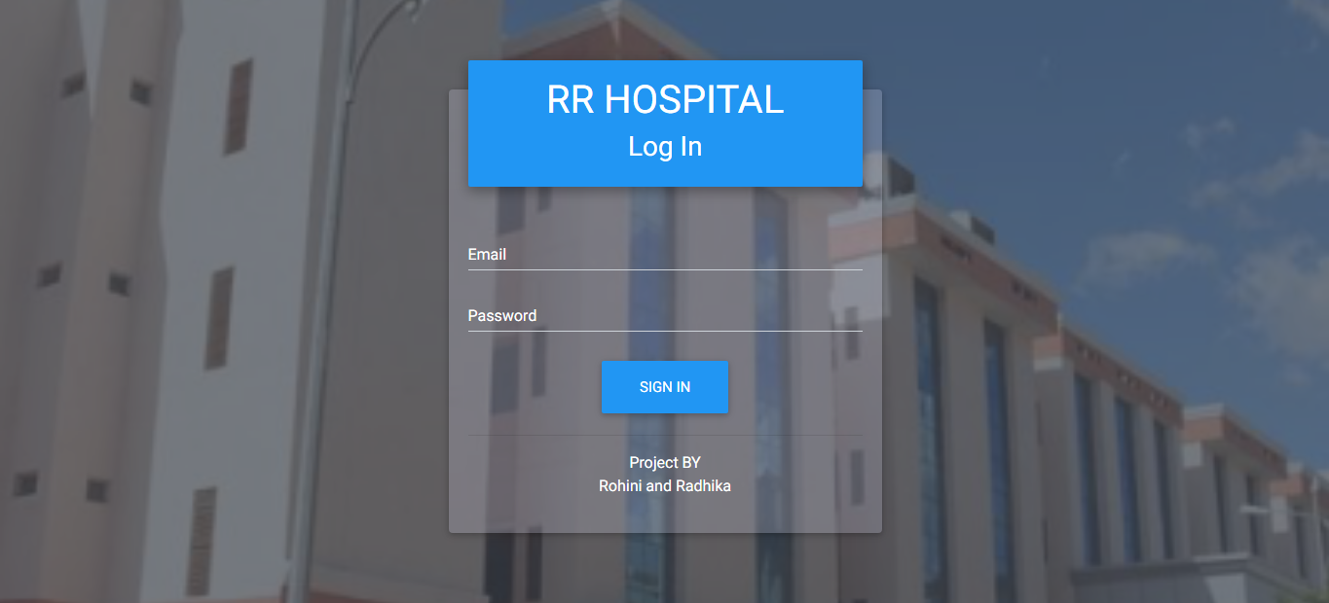

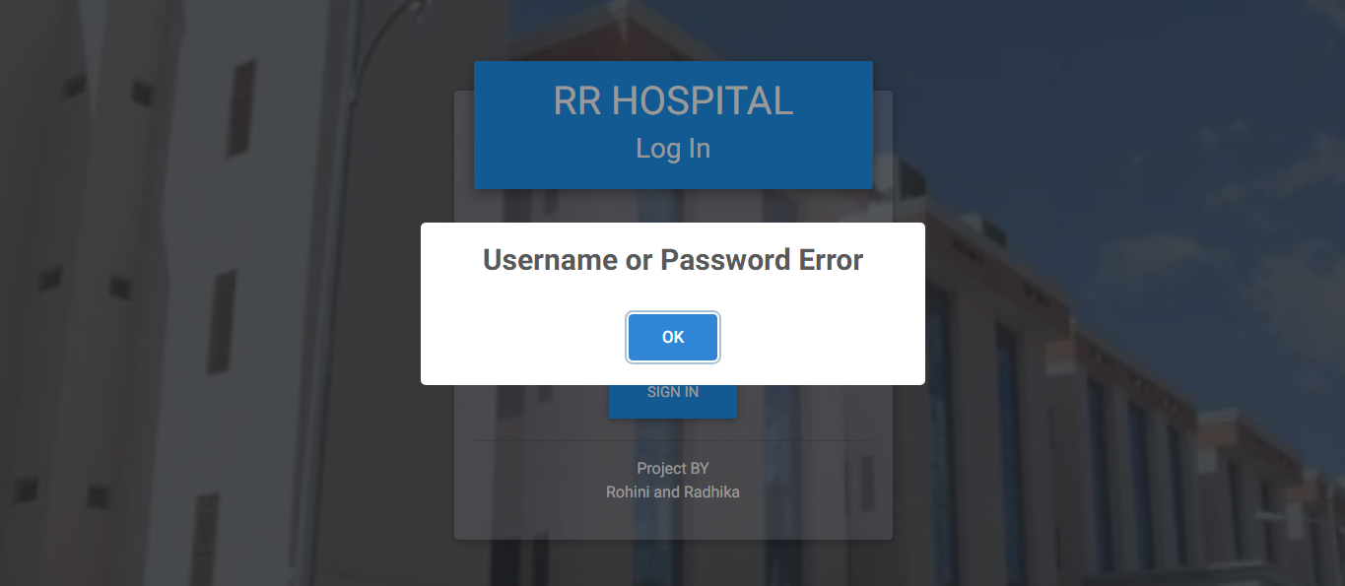
When entered incorrect username or password:
43

home page:
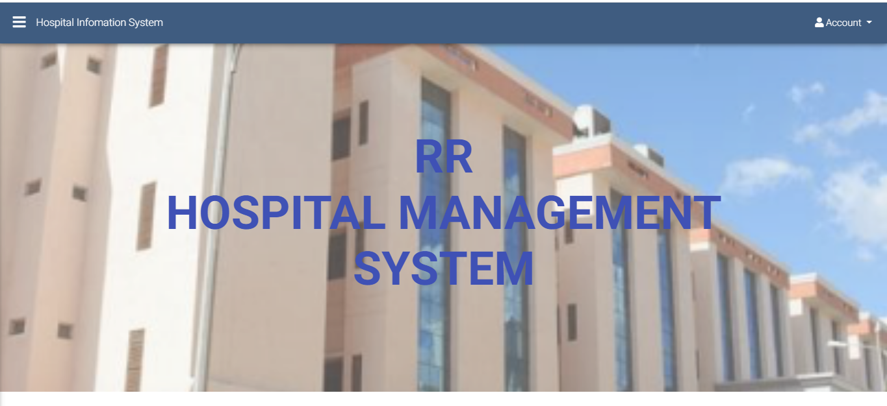
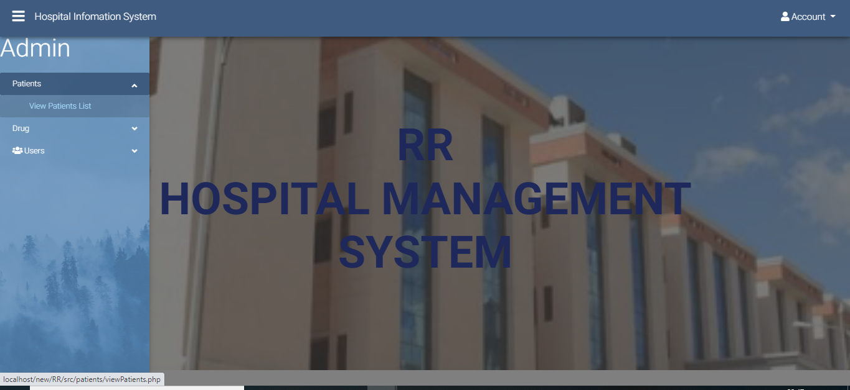
Admin page:
44

Admin can do:
view patients
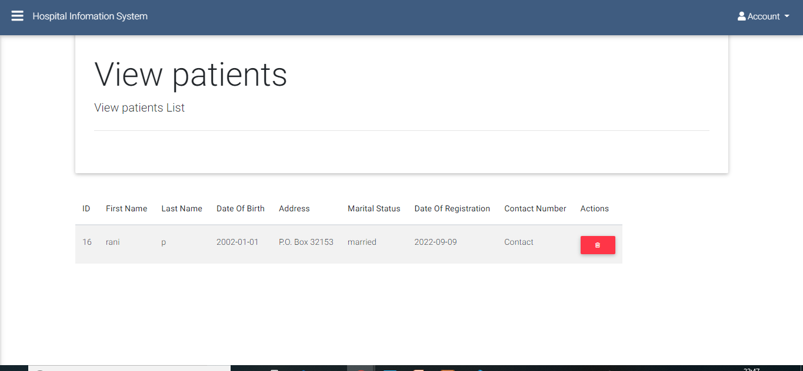
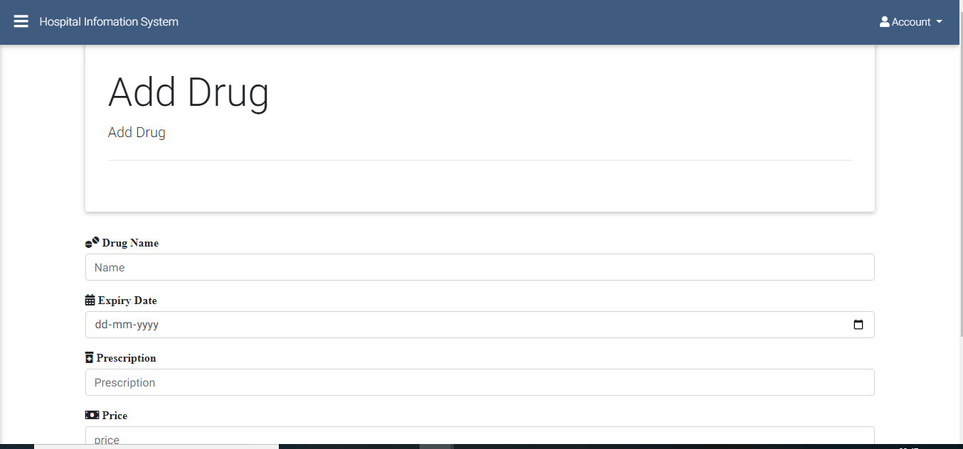
45
Add drug details

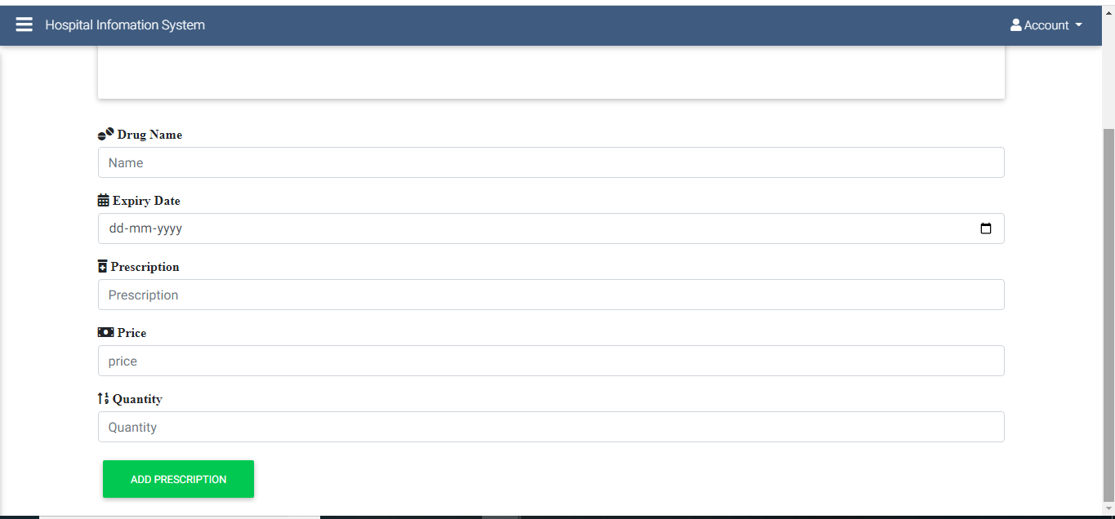
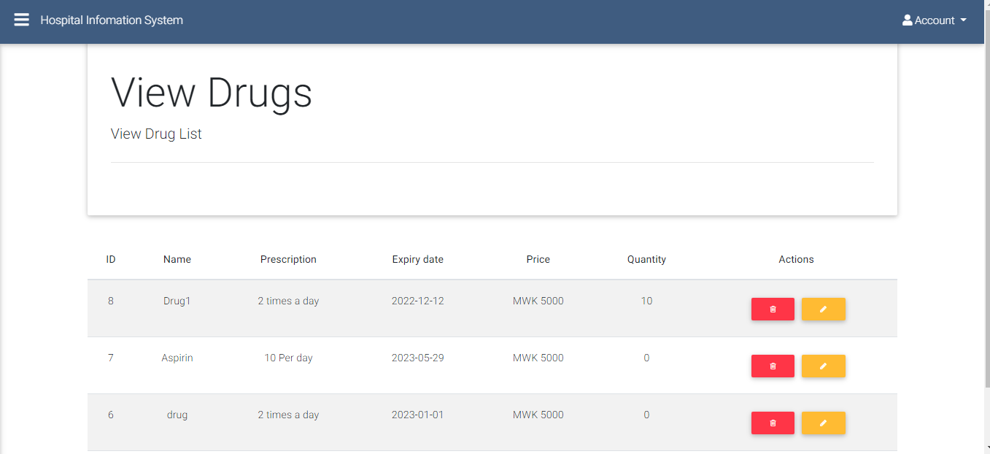
46
View drug

Add users and view users
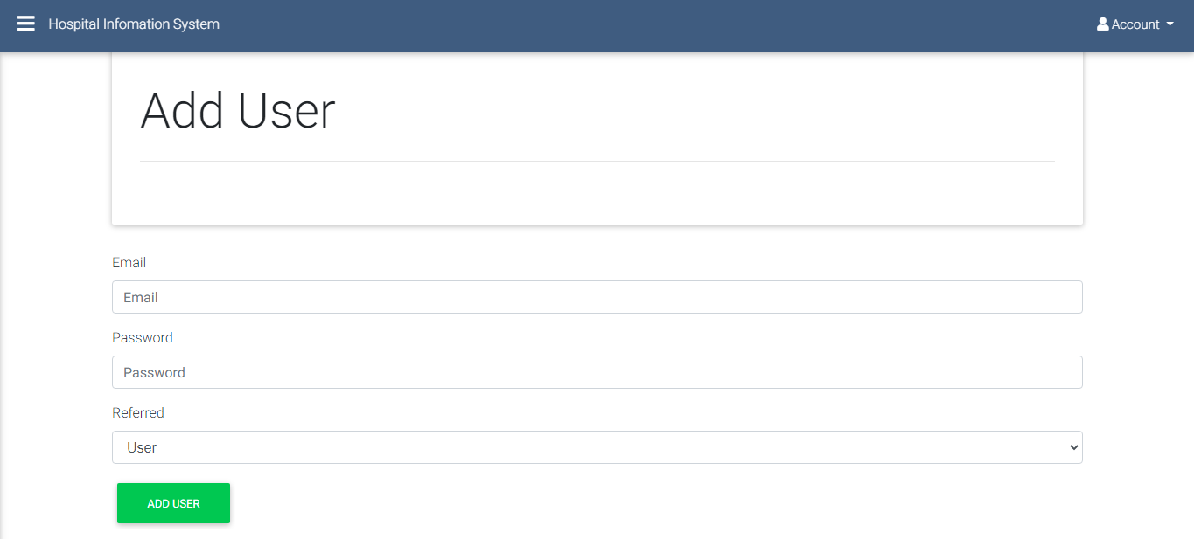
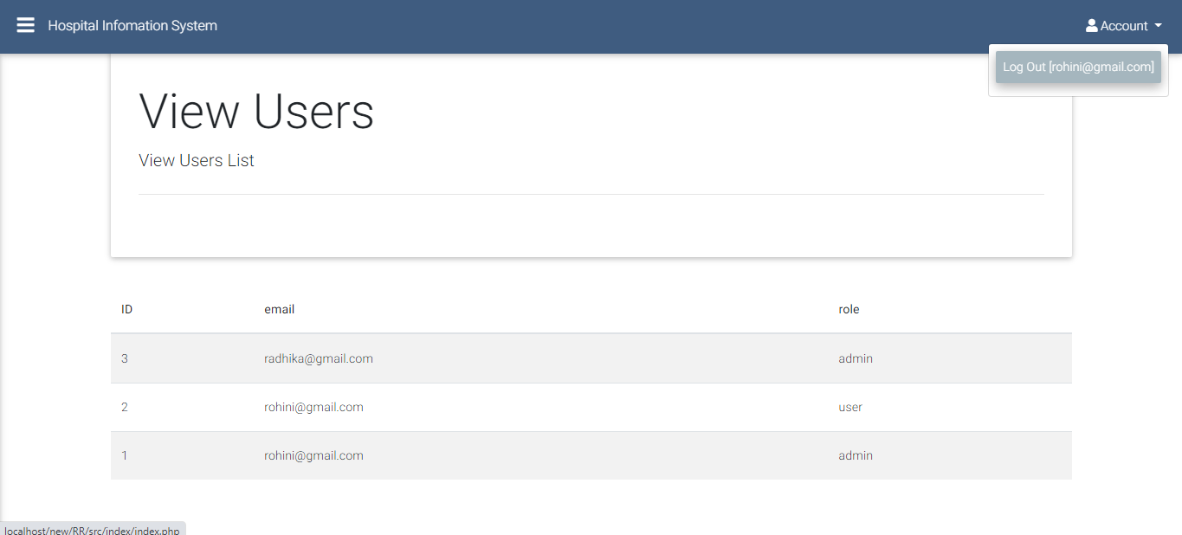
47

User can do:
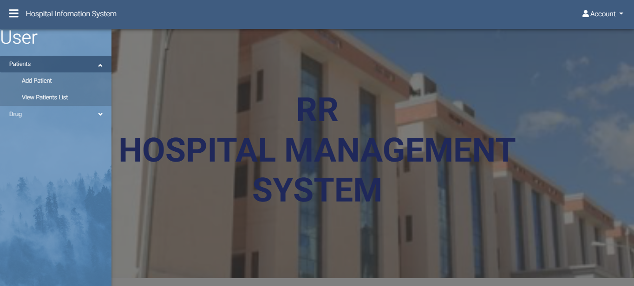
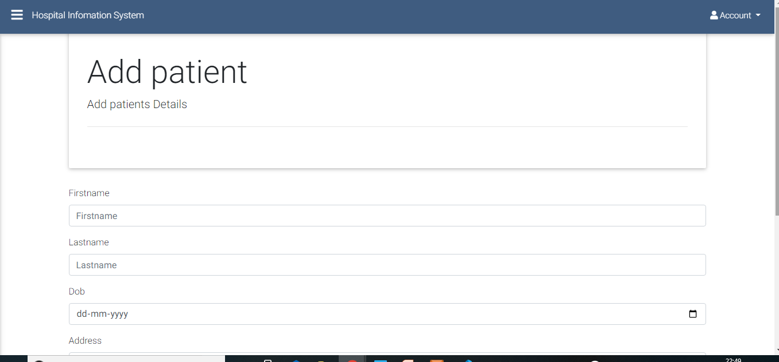
Add patients details and view patients details

48
conclusion

Hospital Management System is very much graceful and user friendly.
User have to register to the portal by giving their details to admin . The users are added by
admin are staff of hospital. They will all the records of patients and drugs(medicines). The
patient details can be viewed by admin Any time.

- Automation of the entire system improves the productivity.
- It provides a friendly graphical user interface
- It gives appropriate access to the authorized users depending on their permissions.
- It effectively overcomes the delay in communications.
- Updating of information becomes so easier.
- System security, data security and reliability are the striking features.
- The System has adequate scope for modification in future if it is necessary.

•
References
For PHP
https://www.w3schools.com/php/default.asp
https://www.sitepoint.com/php/
• https://www.php.net/

For MySQL
• https://www.mysql.com/
http://www.mysqltutorial.org

For XAMPP
https://www.apachefriends.org/download.html

************************THANKYOU**********************
49

