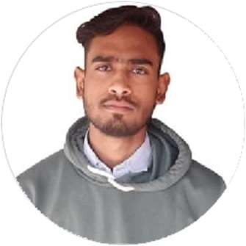Rahul Saxena

Student

Passionate and driven undergraduate student with a thirst for knowledge and a strong work ethic. Committed to continuous growth and eager to contribute my enthusiasm, creativity, and dedication to any project or team.

# EDUCATION

## Graduation(BCA)

### GITM lucknow

*08/2022 - Present*, *Lucknow*

## Intermediate

### Kendiya vidyalaya OEF

*04/2020 - 03/2021*, *kanpur*

## Highschool

### Kendriya Vidyalaya OEF

*04/2018 - 03/2019*, *Kanpur*

# WORK EXPERIENCE

**SKILLS**

C programming

Java

HTML

python

Kotlin

HTML

JavaScript

# PERSONAL PROJECTS

Quiz Website, Calculator, Personal Portfolio

# ORGANIZATIONS

none

**N/A**

# CERTIFICATES

Participated in Debugging Competition and problem solving at Goel institute .

# LANGUAGES

Hindi

*Limited Working Proﬁciency*

English

*Limited Working Proﬁciency*



[rahulsaxena23012004@gmail.com](mailto:rahulsaxena23012004@gmail.com)

7905157775

kanpur, India

linkedin.com/in/rahulsaxena2004

github.com/RaHuL79051

# INTERESTS

Application Development

Web Design