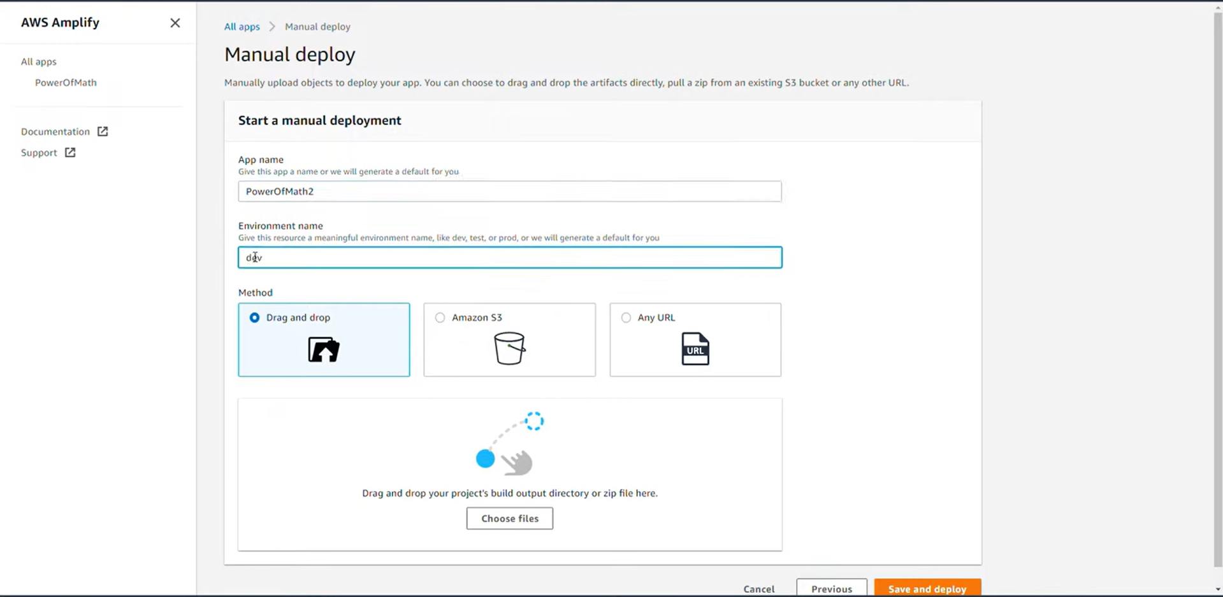  
  
Deploying html frontend for our web app.

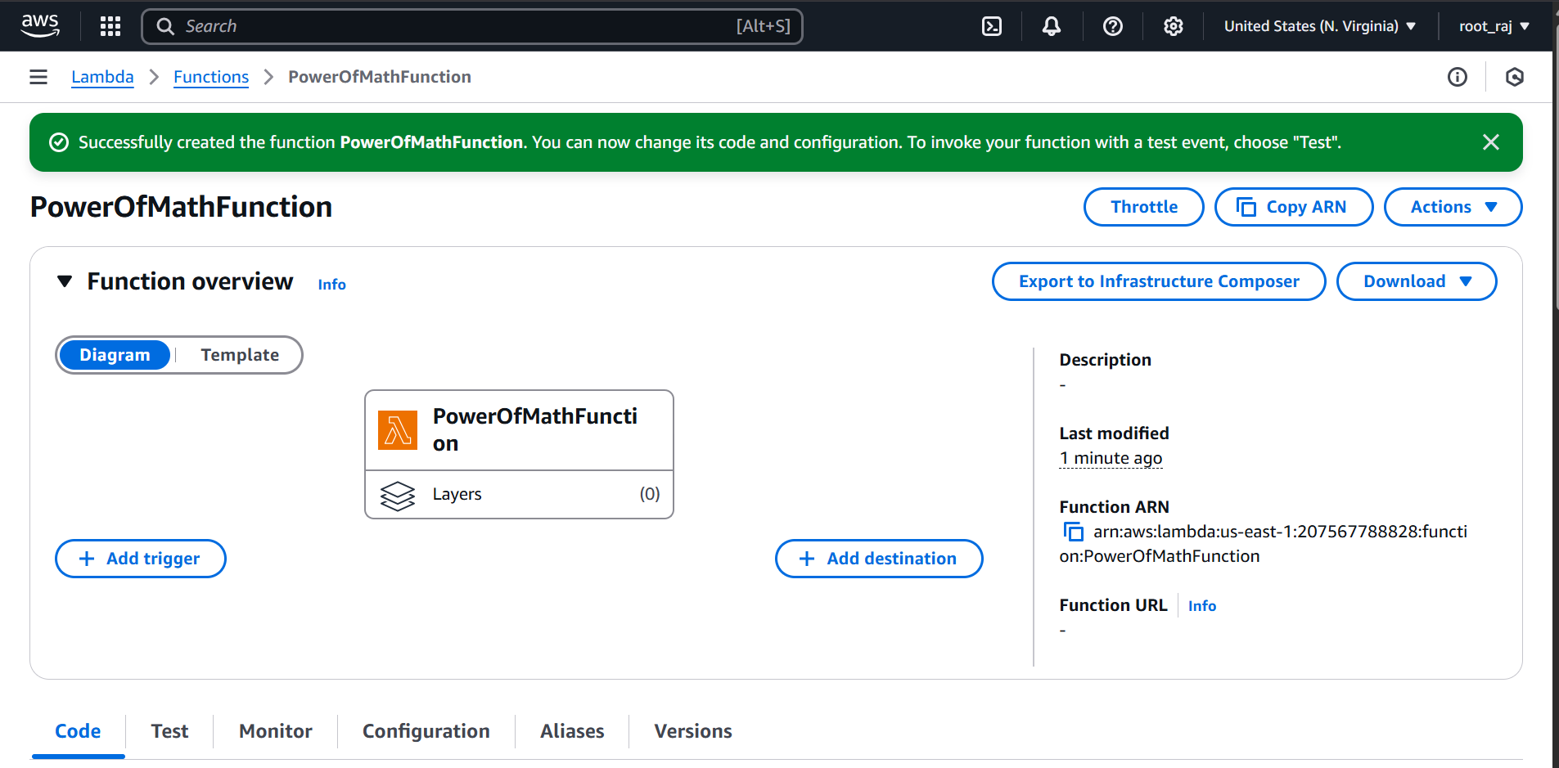

Created a lambda function.

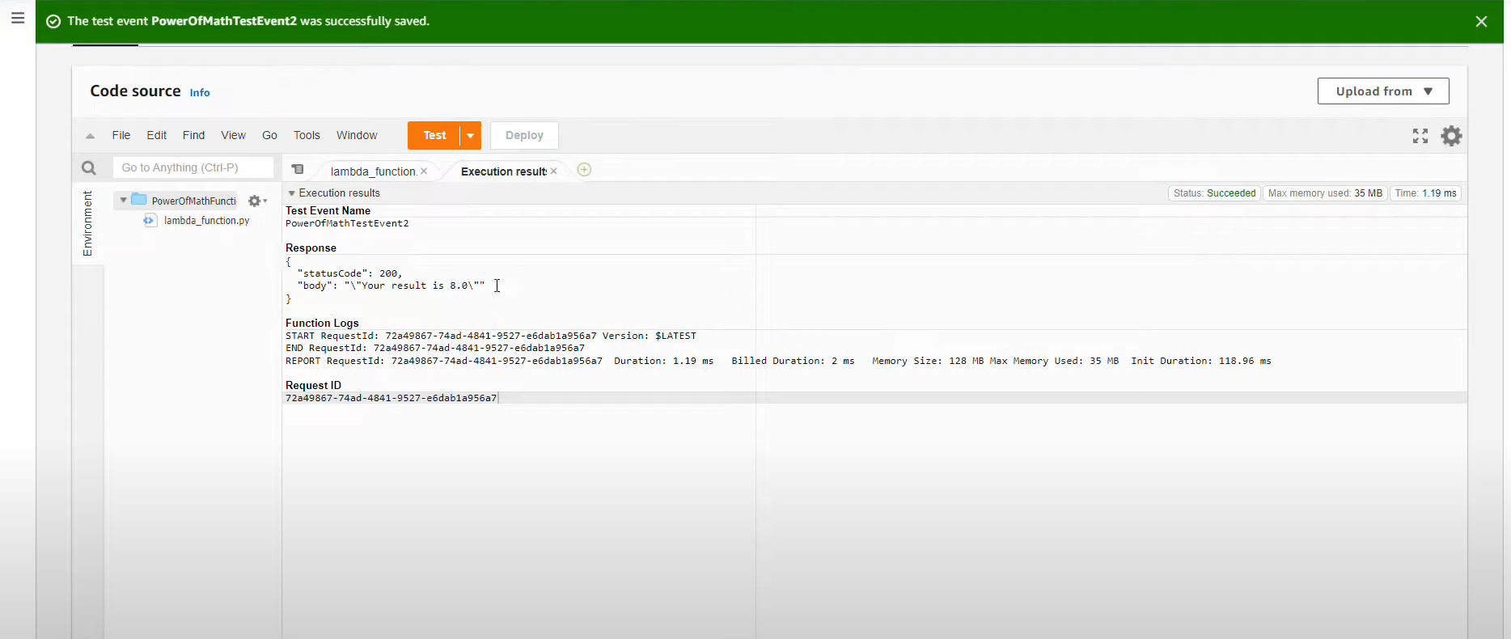  
  
Testing the lambda code.

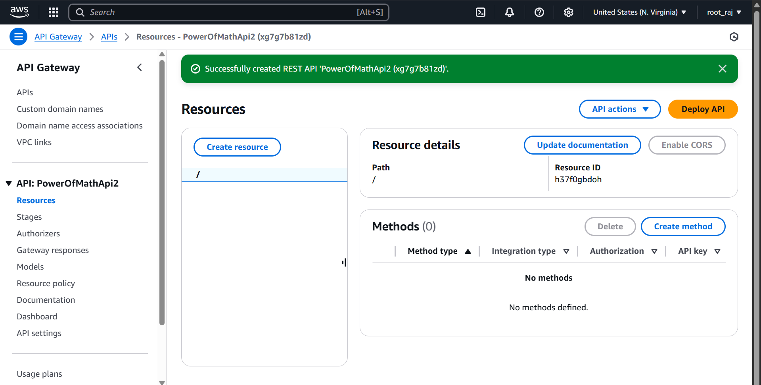  
  
Created Api gateway then enabled CORS.

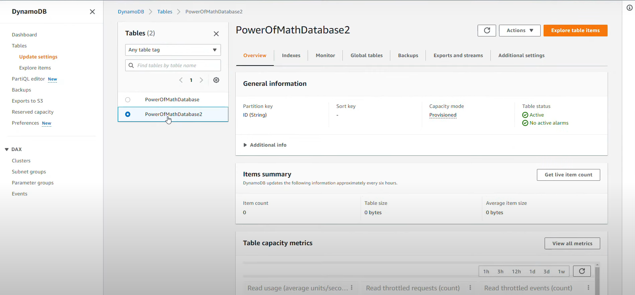  
  
Created a DynamoDB table for storing our values.

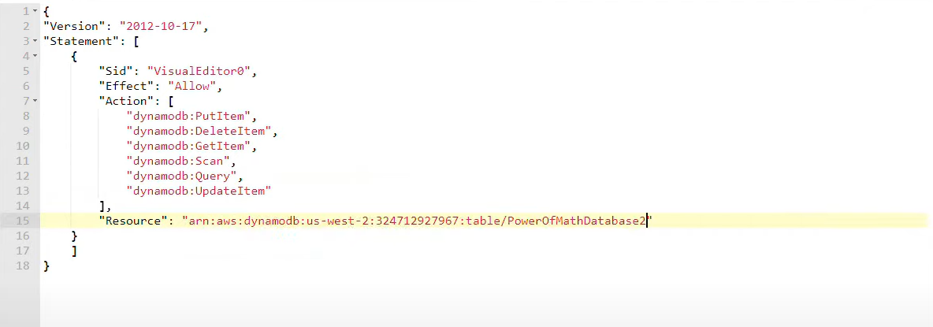  
  
Permissions for IAM role  
  
  
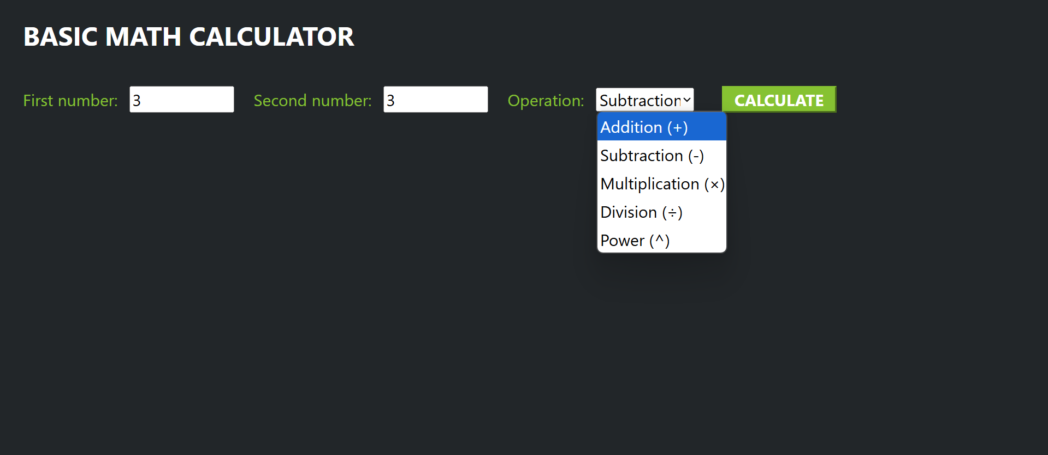  
Our Web App