The start of the modification takes place in \engine\battle\core.asm inside the method GiveExperiencePoints: >> .skip_exp_bar_animation. It calls PrintStatDifferences from \engine\pokemon\mon_stats.asm which is the main part that needs to be added along with the subroutines.

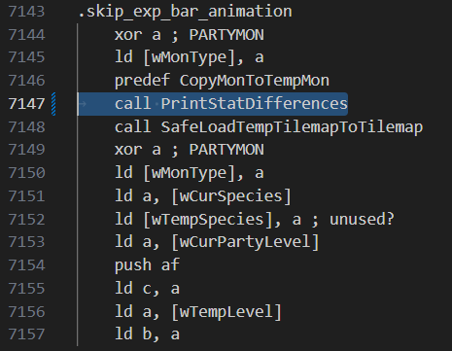

**Additional Key considerations:**

**Making sure to update "wStringBuffer3" with the pre level up stats. This is in \engine\battle\core.asm within the GiveExperiencePoints method as well:**

* **This has not been tested with Exp. Share!!**

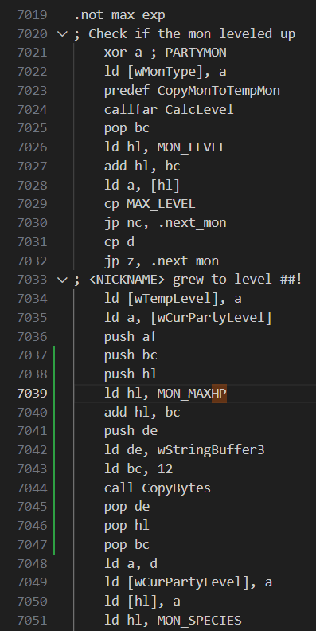

**Porting over Rangi42's "PrintNum" method for handling single digit numbers. This is found at \engine\math\print_num.asm**

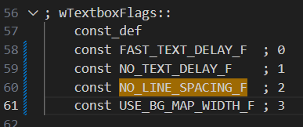

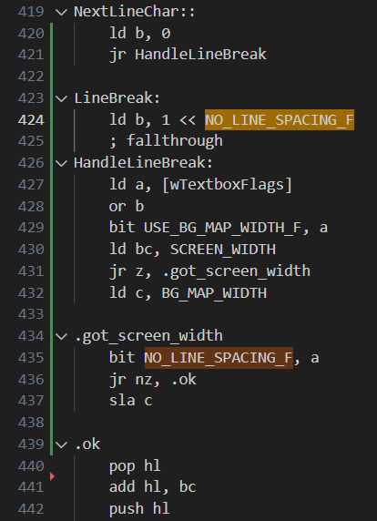

* **Its highly probable I may have left some small details out, but I hope this is helpful for whoever is interested!**

Phone calls to trigger swarms? Like Ardorin. Each phone number giver has a script to call for a swarm

Add second option page to add more things

Maybe change do not disturb to “Generic Calls”?

Add Porygon PCs and Chanseys in the ow

Don’t bother with vanilla compatibly and state that this is incompatible with stadium or vanilla

Add gsc swarms and the gramps in goldenrod to trigger daily. Add then to Nayru’s dex extra info pages.

Optimize phone calls. Remove trainers tell you junk about their pokemon fought xxx or lost or won or got away from xxx by keep gossip as they are useful for extra info

Add hidden power to stat screen after seeing an unown in their font and have the professor that upgrades your pokedex say that they’ve affected your pokemon and now there’s some odd writing on the 4th stat page. Hmm.. Doesn’t seem to do anything though” from Crystal Legacy

Or “Huh! What’s up with your pokemon? It seems making contact with the Unown have affected them! How odd? Now there’s some odd writing on one of their stat pages.. What could it mean? I wonder what other secrets the Ruins hold..?”

Also have the guy at lake of rage divinate what hidden power type your Pokémon have still like Idain

Add daily photo studio to increase happiness

Double check lucky number show

If I don't figure out Sour Crystal's Lucky Number show fix, gonna do a script like this for the guy at the counter, by if it’s fixed give this script to the director after the rocket event:

random 10 (or more depending)

ifequal 1 .firstprize pool ; rarer better items

Ifequal 2 .secondprizepool ; less rare items

Ifequal 3 .secondprizepool ; less rare items

writetext betterlucknix

set daily flag

closetext

end

.10percentchance

random 10

ifeequal 1 .1stprize

.

.

.

.

.

ifequal 10. .10thprize

set daily flag

closetext

end

.1stprize

script with master ball

set daily flag

closetext

end

.

.

.

.10thprize

so still 1 in 100 to get a masterball per day..or change the odds more

and remove that weird practically useless lucky number show for myself..not the repo

Add 10/11 encounter slots? Check the space this takes.