Функция, показывающая топ 5 самых дорогих заказов

ALTER FUNCTION [dbo].[MostExpensiveOrder]()

RETURNS TABLE AS

RETURN (SELECT TOP 5 Ticket.Total_Price, Ticket.ID_Order, Film.Name FROM Ticket INNER JOIN Orders ON

Ticket.ID_Order = Orders.ID_Order join Screening on Orders.ID_Screening = Screening.ID_Screening join

Film on Screening.ID_Film = Film.ID_Film

WHERE Ticket.ID_Order = Orders.ID_Order GROUP BY

Orders.ID_Order, Ticket.Total_Price, Ticket.ID_Order, Film.Name ORDER BY Ticket.Total_Price DESC)

Результат:

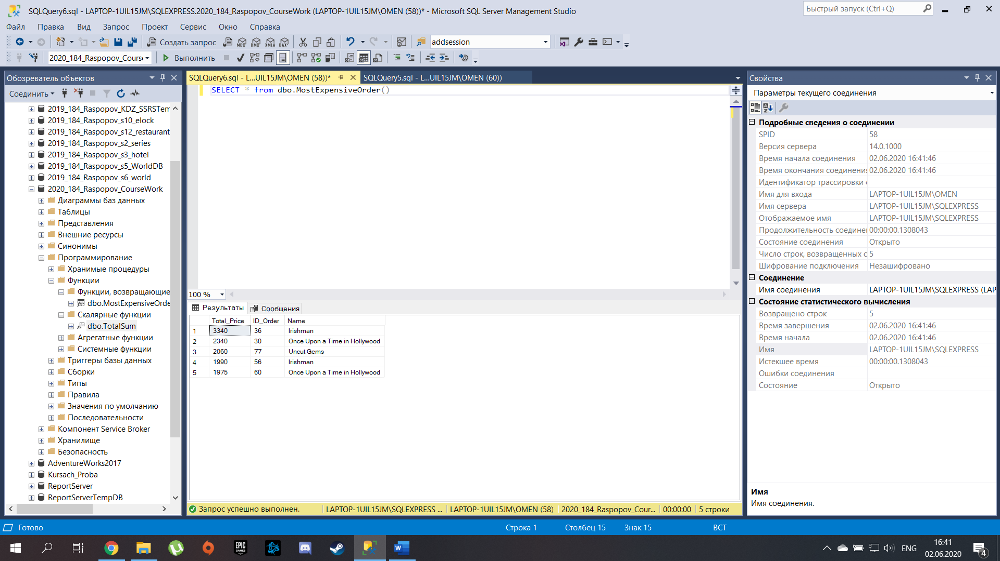

Функция, показывающая выручку за определенное время

ALTER FUNCTION [dbo].[TotalSum](@DateStart DATETIME, @DateEnd DATETIME) RETURNS

INT AS BEGIN

DECLARE @Revenue INT

SET @Revenue = (SELECT sum(Revenue) as RevByTime FROM

(SELECT Ticket.Total_Price*Count(Orders.ID_Order) as Revenue FROM

Ticket join Orders on Ticket.ID_Order = Orders.ID_Order join

Screening on Screening.ID_Screening = Orders.ID_Screening WHERE Time>=@DateStart AND Time<=@DateEnd

Group by Ticket.Total_Price)

as Table_1)

RETURN (@Revenue)

END

Результат:

