--запрос, показывающий средний заказ с использованием налички

SELECT SUM(Total_Price)/COUNT(*) AS Avg_price FROM Ticket join Orders

on Ticket.ID_Order = Orders.ID_Order WHERE Orders.Payment_Type = 'Cash'

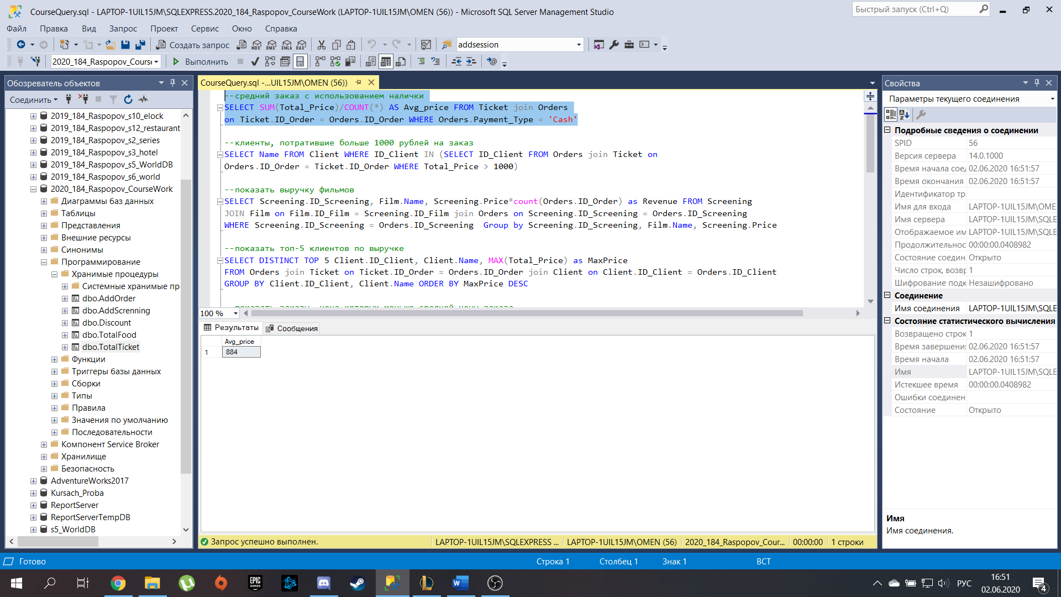

--клиенты, потратившие больше 1000 рублей на заказ

SELECT Name FROM Client WHERE ID_Client IN (SELECT ID_Client FROM Orders join Ticket on

Orders.ID_Order = Ticket.ID_Order WHERE Total_Price > 1000)

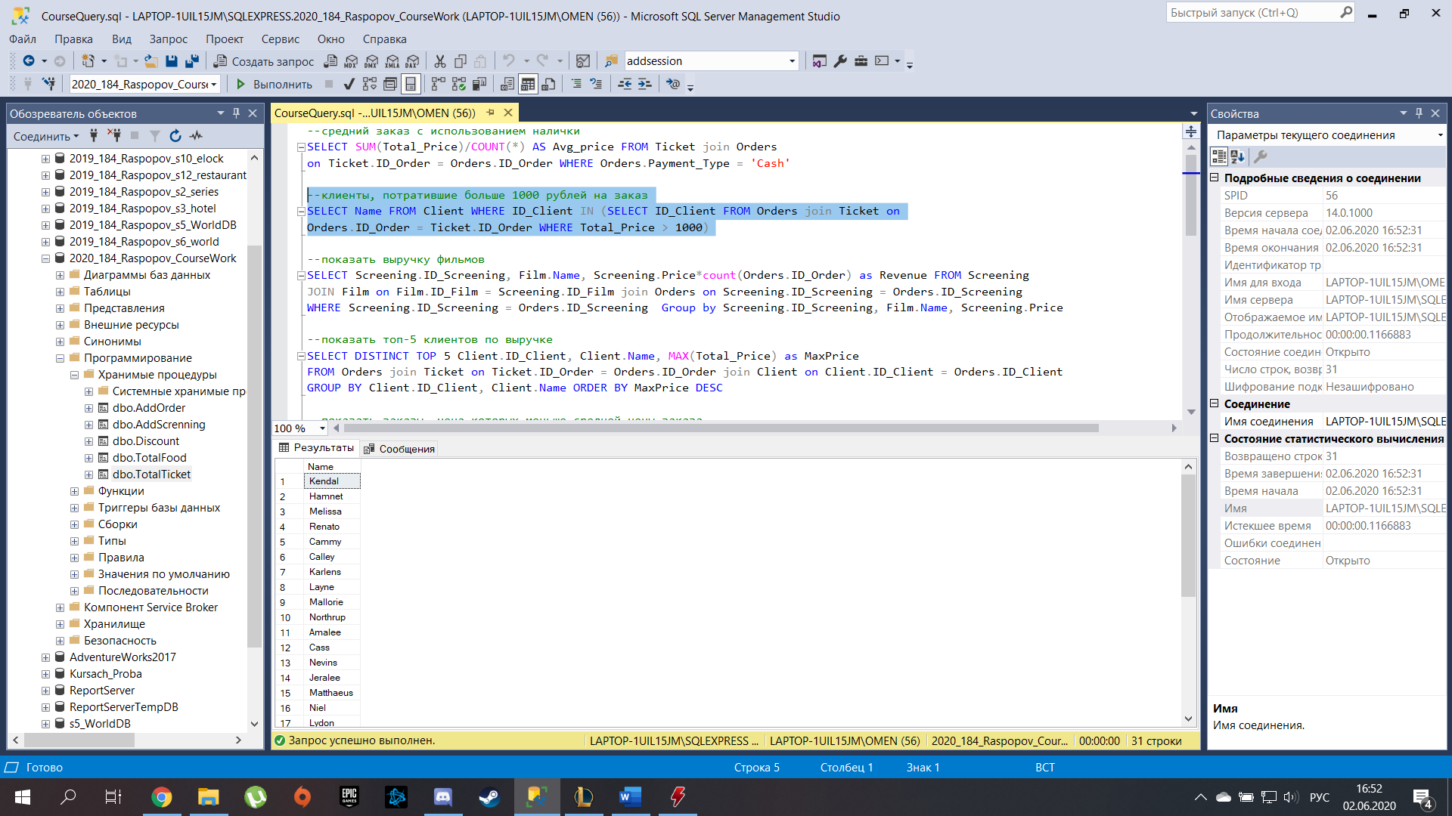

--запрос, показывающий выручку каждого сеанса

SELECT Screening.ID_Screening, Film.Name, Screening.Price*count(Orders.ID_Order) as Revenue FROM Screening

JOIN Film on Film.ID_Film = Screening.ID_Film join Orders on Screening.ID_Screening = Orders.ID_Screening

WHERE Screening.ID_Screening = Orders.ID_Screening Group by Screening.ID_Screening, Film.Name, Screening.Price

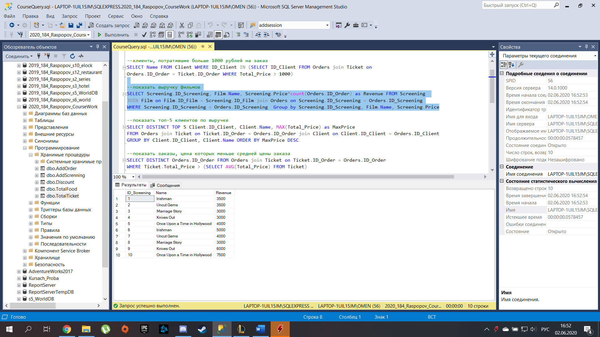

--запрос, показывающий топ-5 клиентов по выручке

SELECT DISTINCT TOP 5 Client.ID_Client, Client.Name, MAX(Total_Price) as MaxPrice

FROM Orders join Ticket on Ticket.ID_Order = Orders.ID_Order join Client on Client.ID_Client = Orders.ID_Client

GROUP BY Client.ID_Client, Client.Name ORDER BY MaxPrice DESC

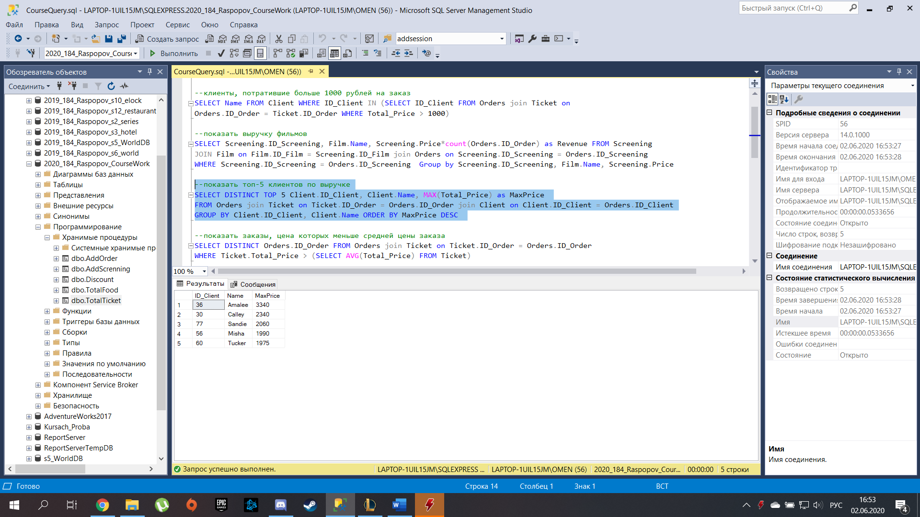

--запрос, показывающий заказы, цена которых меньше средней цены заказа

SELECT DISTINCT Orders.ID_Order FROM Orders join Ticket on Ticket.ID_Order = Orders.ID_Order

WHERE Ticket.Total_Price > (SELECT AVG(Total_Price) FROM Ticket)

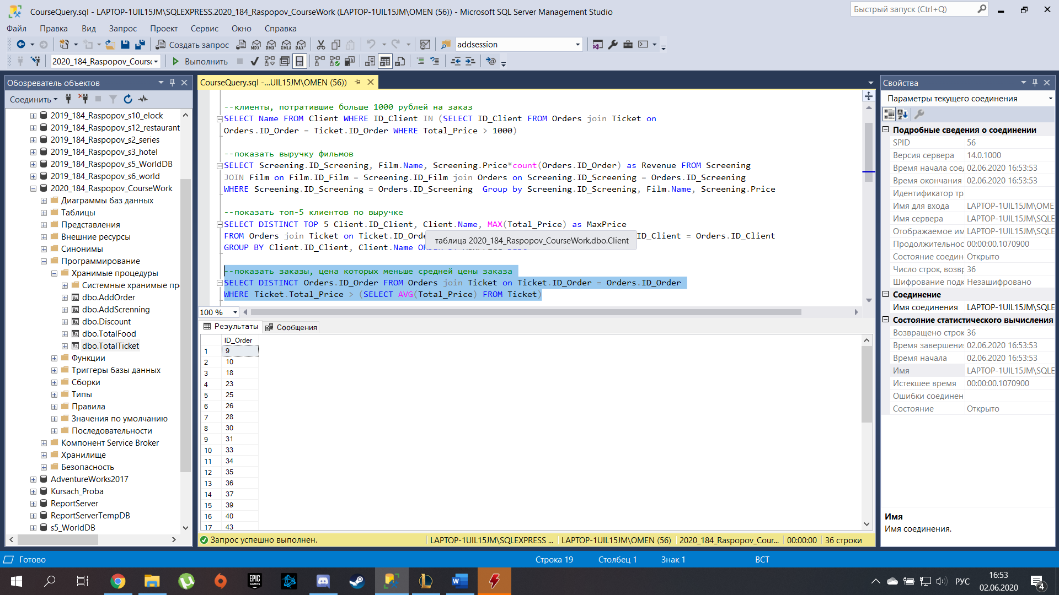

--запрос, показывающий максимальную стоимость заказа среди мужчин старше 18

SELECT MAX(Ticket.Total_Price) AS Max_price FROM Orders JOIN

Client ON Orders.ID_Client = Client.ID_Client join Ticket on Orders.ID_Order = Ticket.ID_Order

WHERE Client.Gender = 'M' and Client.Age > 18

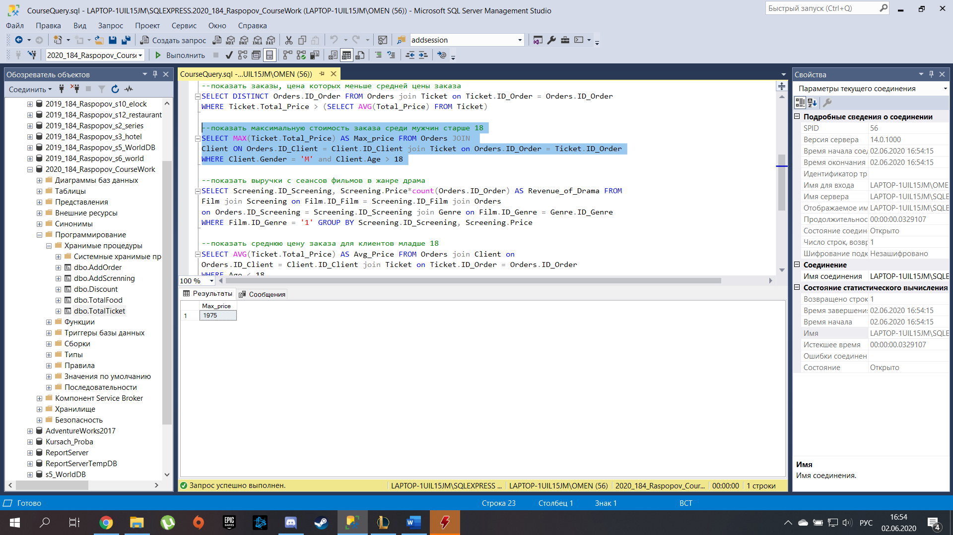

--запрос, показывающий выручку с сеансов фильмов в жанре драма

SELECT Screening.ID_Screening, Screening.Price*count(Orders.ID_Order) AS Revenue_of_Drama FROM

Film join Screening on Film.ID_Film = Screening.ID_Film join Orders

on Orders.ID_Screening = Screening.ID_Screening join Genre on Film.ID_Genre = Genre.ID_Genre

WHERE Film.ID_Genre = '1' GROUP BY Screening.ID_Screening, Screening.Price

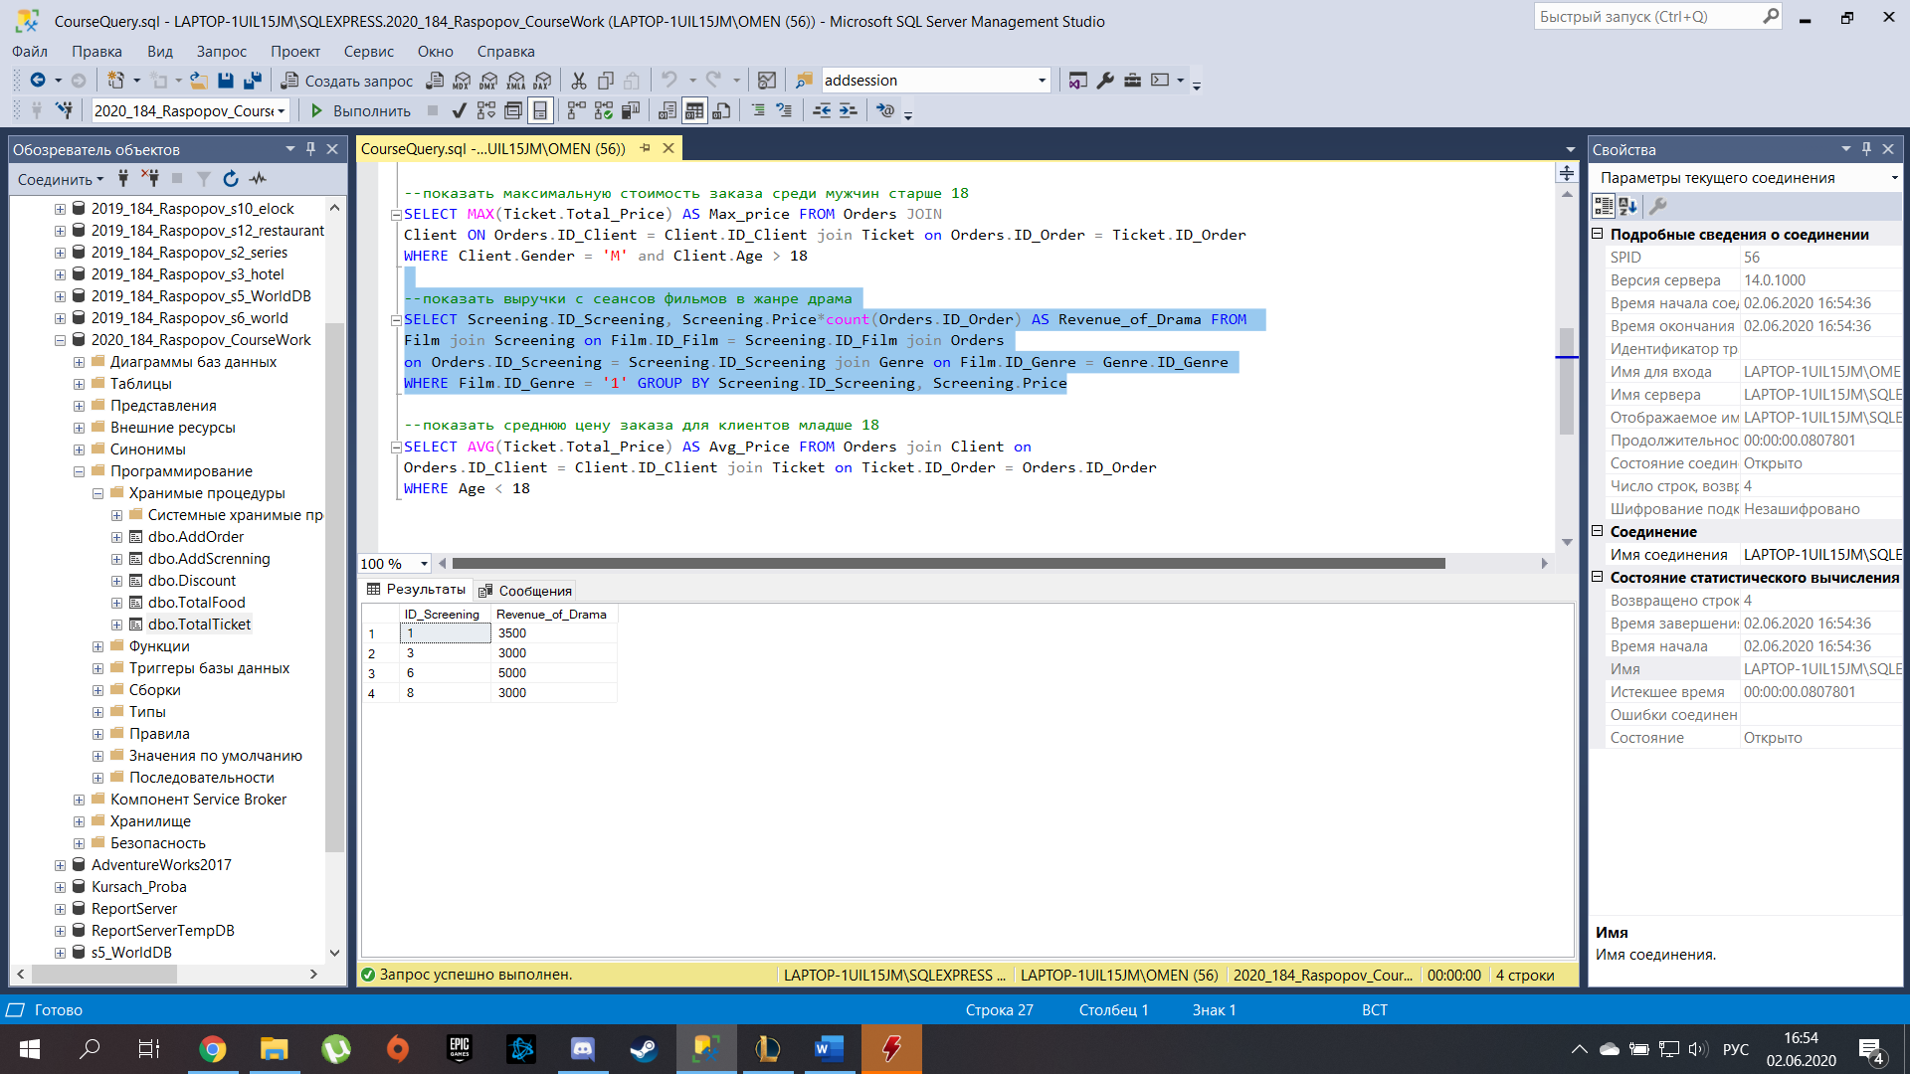

--запрос, показывающий среднюю цену заказа для клиентов младше 18

SELECT AVG(Ticket.Total_Price) AS Avg_Price FROM Orders join Client on

Orders.ID_Client = Client.ID_Client join Ticket on Ticket.ID_Order = Orders.ID_Order

WHERE Age < 18

