RebateNet: BiLSTM-CNN classification of hospitality beverage products
Rahul Singh*

Abstract
In retail businesses, there is a common challenge to standardise product naming conventions that come from various stock & inventory systems. Accurate product categorisation may drive commerciality in many ways: from improved management reporting, to increased systemic throughput, to efficient data-driven solutions such as inventory optimisation & demand forecasting, etc.
The general problem presents as “given a product name (i.e. a string of text), which category should it be placed under?”; for example, the product name “Plantronics USB Headset” should appear under the category of “Computer Peripherals”. An equally well known variant of this problem is where, in some instances, multiple levels of categories need to be inferred in a hierarchical fashion; for example the product name “Colgate” in a retail supermarket’s inventory should occur under “Personal Care → Oral Hygiene → Toothpaste”. Generally, there are several methods on resolving product naming inconsistencies, including obvious manual approaches, regex and fuzzy matching techniques based on naming patterns, and nowadays more advanced techniques inspired by language processing and Machine Learning.
The problem presented here is a further variant of the aforementioned hierarchical problem, providing an ML text classification solution for the hospitality industry’s beverage products based on a deep neural network. The minimum, elementary deep learning standard for any general text classification problem is the BiLSTM-CNN model, owing to its relatively small size, versatility, and intuitiveness. The implemented solution presents a slightly modified traditional BiLSTM-CNN which achieves acceptable results under the understood business constraints of inference time, interpretability, usability, ease of deployment and future maintainability.

Introduction

General problem forms
The general problem of product name classification is common in business settings^{[1, 2]}, presenting itself as requiring a mapping from textual names to discrete business categories:

Where the vector-valued function f maps product names represented in real space () to discrete categories, represented in strictly discrete space ().
A well-known variation of the problem involves hierarchical categories[3, 4, 5, 6], usually arising when inventories grow very large. The categories are usually functional, i.e. products are segregated on the basis of the general function they perform in increasing specificity, and moving down the chain filters out irrelevant products leaving only the most similar ones clustered together. For example, a product named “Logitech G416 Mechanical Keyboard” would be categorised under “Technology → Computers → Desktop → Peripherals → Keyboards”. Deeper categories appear as functions of the shallower ones, though a key aspect is that the subcategories are usually mutually exclusive:

Where the vector-valued function f recursively maps product names represented in real space () to discrete categories (), going deeper () with each iteration given the result of the previous iteration () as an additional input to f. Deeper categories can be thought of as functions of shallower ones^{[3]} because the final category of “keyboard” can only exist if, conditionally, the previous category is “peripherals”, which in turn can only exist if conditionally, the previous category is “desktop”.
A lesser-known variant of this problem involves classifying a product into more than one category – but not always hierarchically. For example, an ink well product named “Waterman Royal Blue”, while perhaps hierarchically classified as “Office/Stationary/Pens/Ink Pens/Refills”, would also need to be classified as “Glass bottle | Small | Ink Refill”:

Where the vector-valued function f maps product names represented in real space () to multiple separate discrete categories (). Each category need not be related to the other ones, and there may be more or less than 3 possible outputs. This scenario is a little nuanced:
- The alternative categories are not mandatorily mutually exclusive, nor functions of the previous one. There can be multiple glass bottles that are small in size, not limited to only ink wells. There can be multiple ink wells available that are not glass bottles, but are large ceramic containers. These alternative categories are thus properties of the product.
- The alternative categories can range in degree of disjointedness and mutual information. Glass bottles can either indeed include a size (small, medium, large), or can simply be a dimensionless “glass bottle”. In the latter case, size cannot be inferred from the fact that product is in a glass bottle. In the given example, ink wells are intuitively known to be small, so there is some mutual information shared between “Ink Refill” and “Small”, but none between “Ink Refill” and “Glass Bottle”.
- The alternative categories need not resonate with the function of the product, i.e. they are not mandatorily functional. A consequence of this occurrence is that the number of products in one of these categories can be quite small; for example, there might be thousands of glass bottles in a specific inventory, but only two of them might be small ink wells.
In Machine Learning, text classification problems are very well known, have been extensively studied at all levels of ML academia, and have a wide and deep amount of literature dedicated to them. They fall under the meta-domains of text, multi-class, and multi-output classification. The general text classification problem has been trivialised with the advent of recurrent neural networks; multi-class and multi-output classification problems have been known and studied since even before the advent of deep learning.
Before proceeding, a quick explanation of the latter two domains is necessary within this context. In multi-class, or multi-label, classification problems, there is only a single output with multiple labels (or a “depth”). For example, the general problem of product name classification tries to solve for a single output , however this single output can have multiple labels like “toothpaste”, “perfume”, “pencils”, etc. In multi-output classification problems, there is more than one output which can be multi-label. For example, an ink well can be a “glass bottle” or a “ceramic container”, it can be “small”, “medium”, or “large”, and it can be an “ink refill” or an “ink cartridge”. Multi-output problems try to solve for multiple outputs , each of which may or may not have multiple labels.

Specific problem
The business problem of interest is thus a multi-output, multi-label classification problem, requiring the classification of a given product name into three disjoint classes, i.e. taking a product name as input, three separate multi-label outputs need to be inferred. The products in question are beverages traded in the hospitality industry of Australia, and the outputs are the business-type of the beverage, its supplier (confusingly referred to as “brand”), and its business-category.
The source of the data is a transaction at a hospitality vendor, say a bar or hotel. These vendors receive rebate contracts from beverage suppliers, with the general terms being “sell X amount of litres of a specific product to be eligible for Y amount of dollars in rebates”. For example, a bar might receive a contract from one of its suppliers saying “sell 420,000 litres of cider to be eligible for a rebate amount of $0.30 per litre”. In order for these rebates to be accurately calculated, the kind of product sold over the counter in the bar needs to be accurately categorised.
In our domain, there are two main suppliers (aka “brand”) of beverages: Carlton United Breweries (or CUB), and Lion. The “type” and “category” of beverage have been decided purely on business logic, keeping in mind the end goal of accurate rebate estimation over a period of time. The explicit input is thus the name of the product sold at the bar, with an implicit input being the amount of product purchased in bulk from the bar’s supplier. There are 3 outputs to infer from a given name and litres combination: the supplier (“brand”), the type of beverage (“type”), and its category (“category”). Each output carries some mutual information about the rest, but are not hierarchical.

Dataset description
All data used for this project has been internally sourced. A couple of notable facts are that the amount of relevant data is relatively minimal compared to the general deep learning project, spanning around 945 usable records after preprocessing (~1600 before); and the quality of the data is abnormally subpar, containing multiple duplicates, irrelevant and incomplete product names, etc.
The data schema is defined as:
- Name: a string of characters.
- Litres: a floating point value.
- Category: a string of characters, 11 levels deep. One of the target outputs.
- Type: a string of characters, 3 levels deep. One of the target outputs.
- Brand: a string of characters, 2 levels deep. One of the target outputs.
With the data itself appearing to be semi-structured:
Table 1: Sample of the raw input data schema.
name | litres | type | category | brand
BR 4PINES RED XPA RK 49.5L 1X1 | 49.5 | Draught | Craft | CUB
BR Carlton Dry Hard 375ML CAN 4x6 SOO | 9 | Package | Package Beer and Cider | CUB
BR Fosters Lager CAN 375ml 4x6 | 9 | Package | Traditional Regular | CUB
CT Lexington Hill Margarita 12x300 B | 3.6 | Package | RTD | CUB
CT Lexington Hill Sangria RK 20L Keg | 20 | Draught | RTD | CUB
BR Frothy Refreshing Ale RK 49.5L 1x1 | 49.5 | Draught | New World Draught | CUB
WN Riot Wine FIZZ 20L 1X1 Keg | 20 | Draught | Wine | CUB
BR ASAHI SUPER DRY 5% RK 19L 1X1 IMP | 19 | Draught | Imported Premium | CUB
XXXX Dry 330 B24 CP | 7.92 | Package | Pack | Lion
Phead DNutter 49.5DINKEG | 49.5 | Draught | Tap | Lion
The data snippet represents a sample of the rawest form of the data, before any preprocessing has been applied. It’s worth noting that the “litres” component of the data is not directly available, hence being an “implicit” input. Inferring this from the product name is out of scope for the problem at hand, and all such values in this dataset were manually filled. As an example, the second record’s “litres” value was arrived at by multiplying , or 9 litres.

Data preprocessing and KDD
There are two aspects of the data worth diving into. The first involves the traditional inspection of class distributions and imbalance. In this dataset, there was a disproportionate amount of all classes across all output columns, the most severe (i.e. the most number of minority classes) being in “category”. In order to effectively model them, a couple of conclusions were reached:
- To facilitate stratifying our train and validation data splits, any records with less than 2 occurrences – marginal or conditional – must be removed. This is to ensure we have at least one instance of such minority records across both training and validation data splits. This can be, and was, further extended into removing all records that have less than N occurrences.
- To enrich the quality of training data, categories with very little records data must be relabelled into a broader category indicating their ambiguity. Aggregating minority records into a larger label changes distributions in two ways: first, minority records lose their individual identities and contribute to a label that is indeed statistically distinct enough to detect; secondly, the resulting broader label ensures the model is aware of such records – they’re just called something different, preserving information.
The first point was achieved by setting the threshold for minimum number of records required for a class to be considered – across all output columns – at 10. This was the optimal, empirical number that met both objectives of model performance and business utility, keeping in mind an already minimal dataset.
The second point was achieved by relabelling the following “category” values to “ambiguous”: “cider”, “imported premium”, “mid strength”, “new world draught”, “rtd”, “traditional regular”, “nan”, “wine”. The rationale behind this is twofold: first, these categories each had less than 20 occurrences across the entire dataset of ~1600 records, the least being “package” | “traditional regular” with just 1. Second, these categories completely skewed the conditional distribution of the other two target outputs, “brand” and “type”, since they are all “cub” products. This took the cardinality of “cub” records (viewed in terms of “category” and “brand”) to 10, versus just 2 for “lion”. With this approach, the cardinality of “cub” reduces from 10 to 4 with “lion” the same.
Table 2: The original, raw value counts of each output. Labels in yellow were aggregated into a surrogate class, “ambiguous”.
type | category | brand
package | pack | lion | 700
 |  | cub | 471
draught | tap | lion | 192
 | craft | cub | 106
package | rtd | cub | 31
postmix | postmix | cub | 30
draught | traditional regular | cub | 21
 | imported premium | cub | 16
 | cider | cub | 13
 | new world draught | cub | 13
 | nan | cub | 11
 | rtd | cub | 8
 | wine | cub | 8
 | mid strength | cub | 3
package | nan | cub | 5
 | traditional regular | cub | 1

Preprocessing this data was performed in two stages, categorised by whether or not the technique can be applied during ETL procedures, especially for live inference data feeds:
- The first stage involved the sequential application of regex filters and transformations, aimed at filtering out and separating purely textual information under “name” from alphanumeric information. For example, the removal of packaging information dictating the number of litres per unit beverage. This kind of preprocessing can be applied during ETL procedures since regex engines are practically supported by all major database drivers.
- The second stage involved standard textual preprocessing such as transforming all text to lowercase, removing and replacing specific NA values, removing duplicate records, and handling minority classes. This stage is specific to the problem at hand, and the level of dynamism precludes it from being neatly effected during ETL.
After all preprocessing, the number of valid records were reduced down from ~1600 to 945, the data had a much more efficient computational format, and the statistical distributions across output columns were much more stable.
Table 3: Sample of the preprocessed input data schema.
name | litres | type | category | brand
br four pines red xpa rk | 49.5 | draught | craft | cub
br carlton dry hard can soo | 9 | package | package beer and cider | cub
br fosters lager can | 9 | package | traditional regular | cub
ct lexington hill margarita b | 3.6 | package | rtd | cub
ct lexington hill sangria rk keg | 20 | draught | rtd | cub
br frothy refreshing ale rk | 49.5 | draught | new world draught | cub
wn riot wine fizz keg | 20 | draught | wine | cub
br asahi super dry rk imp | 19 | draught | imported premium | cub
xxxx dry b cp | 7.92 | package | pack | lion
phead dnutter dinkeg | 49.5 | draught | tap | lion

Table 4: Preprocessed value counts of each output.
type | category | brand
package | pack | lion | 367
 |  | cub | 305
draught | tap | lion | 115
 | craft | cub | 79
 | ambiguous |  | 41
package | ambiguous | cub | 23
postmix | postmix | cub | 15

We can quantify the effects of our preprocessing by measuring our data’s entropy. Marginal Entropy (measured in Shannons) of a random variable is a well known^{[7, 8, 9]} and widely used measure to capture the level of "information" or "uncertainty" inherent to the variable's possible outcomes:

A measure of zero means the outcome is determinate; the variable contains no uncertainty. If all outcomes are equally likely, then we have maximal uncertainty^{[10]}. Since we’re measuring this in Shannons, entropy ranges between for binary classification problems and for multi-label classification problems, where K is the number of classes for a random variable. In other words, for a binary classification problem where both classes are perfectly balanced (i.e. split 50-50), we can expect maximal entropy of ; which should be the case for “brand”. For problems with 3 labels, if they’re perfectly balanced (i.e. split 33-33-33) we should expect maximal entropy of , which we know isn’t the case for “type”. Finally, for “category” with 5 classes, the ideal split of (20-20-20-20-20) results in maximal entropy of , which we know shouldn’t be the case. Note that by definition, . The marginal entropy of each output column helps quantify their statistical stability in isolation:
Table 5: Marginal analysis of output columns.
Output column | Shannons
type | 0.92
brand | 1
category | 1.38

Quantitatively we can clearly see that “brand” is indeed the most balanced, followed by “category” which is 41% away from being balanced, and “type” which is 42% away from being balanced.
However, we can observe from our value counts that our outputs contain specific information that can inform the model of the label in another column (i.e. measuring their entropy in isolation is only half the picture). The Conditional Entropy (measured again in Shannons) of a random variable answers the question "how much more information do we need to describe random variable Y, given that we already know all of random variable X?"^{[10]}:

Measuring the bivariate conditional entropy of the dataset further quantifies the amount of shared information amongst our target columns:
Table 6: Bivariate, conditional analysis of output columns.
Output columns (Y|X) | Shannons | Reduction from marginal (Y)
type|category | 0.06 | -0.93
category|type | 0.52 | -0.62
brand|category | 0.71 | -0.3
category|brand | 1.08 | -0.21
brand|type | 0.98 | -0.02
type|brand | 0.9 | -0.02

We can see that quantitatively, “category” completely encodes “type” with an equivalently large reduction in entropy when looking at whether “type” encodes “category”. On the other hand, augmenting any of our output variables with “brand” results in minimal entropy collapse since “brand” itself presents maximal entropy.
The rationale behind computing dataset entropy is motivated by a usual approach in classification problems, which is to begin by fitting a small classifier to a subset of the data and attempt to have it overfit. Once accomplished and model architecture is somewhat finalised, incremental changes can be made to the amount of input data, the number of expected outputs, and the model architecture. The standard idea is to pick the most balanced representation of our data and begin with that.
For our purposes, it’s tempting to try and overfit on classifying just “brand” given it’s perhaps the most statistically balanced. However, we see that augmenting any of our output columns with “brand” does not result in enough cross-information sharing between any other output columns. Additionally, “type” has the least cardinality with just 3 labels versus “category” having 5. Purely for this reason, “type” has been chosen to fit first. This allows us to begin tackling the problem in a very effective manner, all constraints considered.

Textual knowledge representation
The second aspect of the data worth diving into relates to knowledge representation, and how we expect our model to statistically exploit the information present under “name”. When dealing with unstructured data in Machine Learning, one approach – especially for text processing – involves the use of “embeddings”^{[11]}: arbitrary spatial representations of data that, though randomly initialised, are optimised by the model during training such that their final form best captures all latent information required by the model for optimal performance. In other words, the model learns its own representation of its inputs without any human involvement necessary.
Traditionally, embeddings for a specific “unit” (aka token) of data (a single character, a word, a sentence, a video, etc.) are represented by arbitrary-dimensional, randomly initialised vectors. The choice of the number of embedding vector dimensions and token matters tremendously. Following from elementary linear algebra, the greater the embedding dimension, the less dense of a representation we get for our data, however, computationally, high dimensional embeddings also incur more storage and processing overhead. Tokens for textual data can be characters, words, sentences, paragraphs, documents, entire books, etc., each with their own pros and cons:
- Character embeddings highlight the properties of individual characters, relative to the task at hand, for the model. Their biggest benefit is that they allow for virtually infinite sequences to be processed without any risk of out-of-vocabulary (OOV) tokens, since all elementary linguistic units are addressed. Their biggest detriment is that they carry no semantic meaning, so attempting to interpret these as one would words will lead to nowhere^{[12, 13]}.
- Word embeddings highlight the properties of individual words relative to the task at hand for the model. The biggest benefit here is that since they capture a lot of semantic meaning in a given sentence (sequence of words), many problems are trivialised. The biggest detriment is they trade the capture of semantic information for the high risk of OOV tokens.
In general, the larger the token, the higher the dimensionality of the embedding ought to be^{[14]}, and it becomes much easier to run into OOV tokens. Representing characters as 2000-dimensional vectors is rather overkill, but 2000D vectors might not be enough to represent and differentiate an entire document as a token within a set of 100 documents. The way embeddings become so valuable in text processing requires a bit of explanation.

Embedding rationale
As an example, let’s assume we have the name “heineken larger”. We're going to take our sentence of interest, which is 15 characters in length having 10 unique characters, and replace each unique character with a randomly initialised 4D vector embedding^{[15]}. We then get the following:
Table 7: Sample character embeddings for an exemplary name, "heineken larger"
character | D1 | D2 | D3 | D4
h | -0.8 | 0.68 | -1.96 | -0.31
e | 1.2 | -0.56 | 0.86 | 0.11
i | 0.89 | -1.15 | -0.33 | -2.18
n | -0.57 | 0.27 | 1.49 | 1.11
e | 1.2 | -0.56 | 0.86 | 0.11
k | 1.31 | -0.72 | -0.95 | -0.21
e | 1.2 | -0.56 | 0.86 | 0.11
n | -0.57 | 0.27 | 1.49 | 1.11
 | -0.48 | 1.37 | -0.38 | -1.43
l | 2.17 | 1.06 | -1.71 | -0.28
a | -0.81 | -1.04 | 0.36 | -1.32
r | 1.05 | 0.87 | 0.21 | 1.55
g | -0.9 | -0.29 | -2.5 | -0.62
e | 1.2 | -0.56 | 0.86 | 0.11
r | 1.05 | 0.87 | 0.21 | 1.55

Every occurrence of a character is replaced by its embedding. We can represent the entire sentence now as a -dimensional data matrix instead of a matrix:
Table 8: Sample character embeddings for "heineken larger" flattened into a row-vector.
name | d1 | d2 | … | d60
heineken larger | -0.8 | 0.68 | ... | 1.55

Sending this representation of data into a neural net for training, under conventional thought, implies that each weight learned by the network is for a specific column. This is mathematically represented as an elementary linear algebraic transformation:

Where A is a matrix of weights multiplied by our input vector . As far embeddings are concerned, this is woefully inaccurate since embeddings are the weights for each character itself. In other words, each 4D vector assigned to a character is, in fact, the weight vector for that individual character, and the embeddings, as weights, get learned just like any other set of weights. Each character (or token) being given its own N-dimensional weight is how a model learns its own representation and feature set of the data it’s meant to process, and is how embeddings become such a valuable tool when dealing with neural networks. The embedding matrix is thus a hyperparameter, which in our example is a matrix; 10 unique characters, each with their own 4D embeddings.

Dataset character embeddings
For this dataset, character embeddings were chosen owing to the behaviour of the names. Each hospitality vendor journals transactions in a non-standard way, so OOV tokens are especially likely in this kind of setting; tokenising with characters alleviates this problem to a large degree. There is also acceptable statistical discrepancy between each output column when viewed in terms of characters:
Observably, the average name length per “type” label is around 20 characters. Additionally, while labels “package” and “draught” share the first 3 most frequent alphabets, the remaining alphabets are vastly different, emphasising separability. Label “postmix” is fundamentally different, making it the most separable.
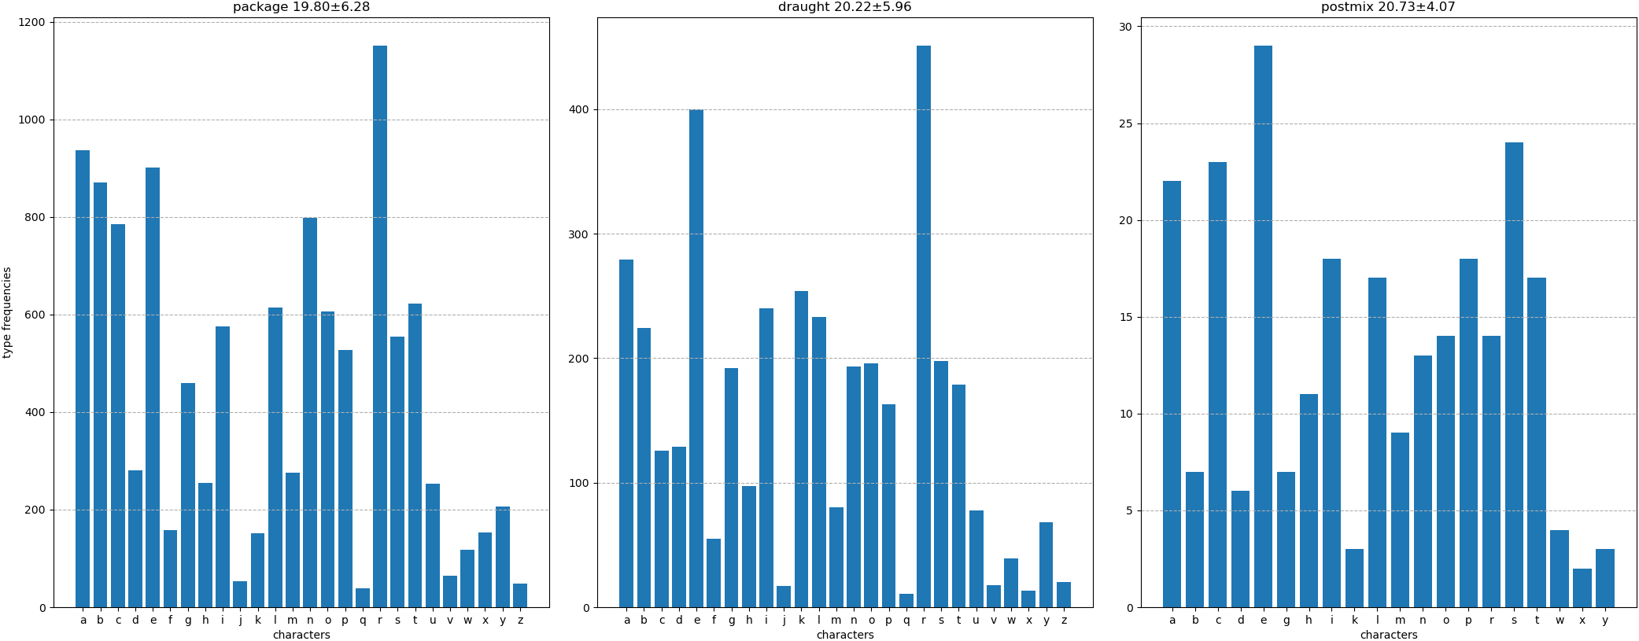Figure 1: Ordered character distributions of "name" relative to "type".
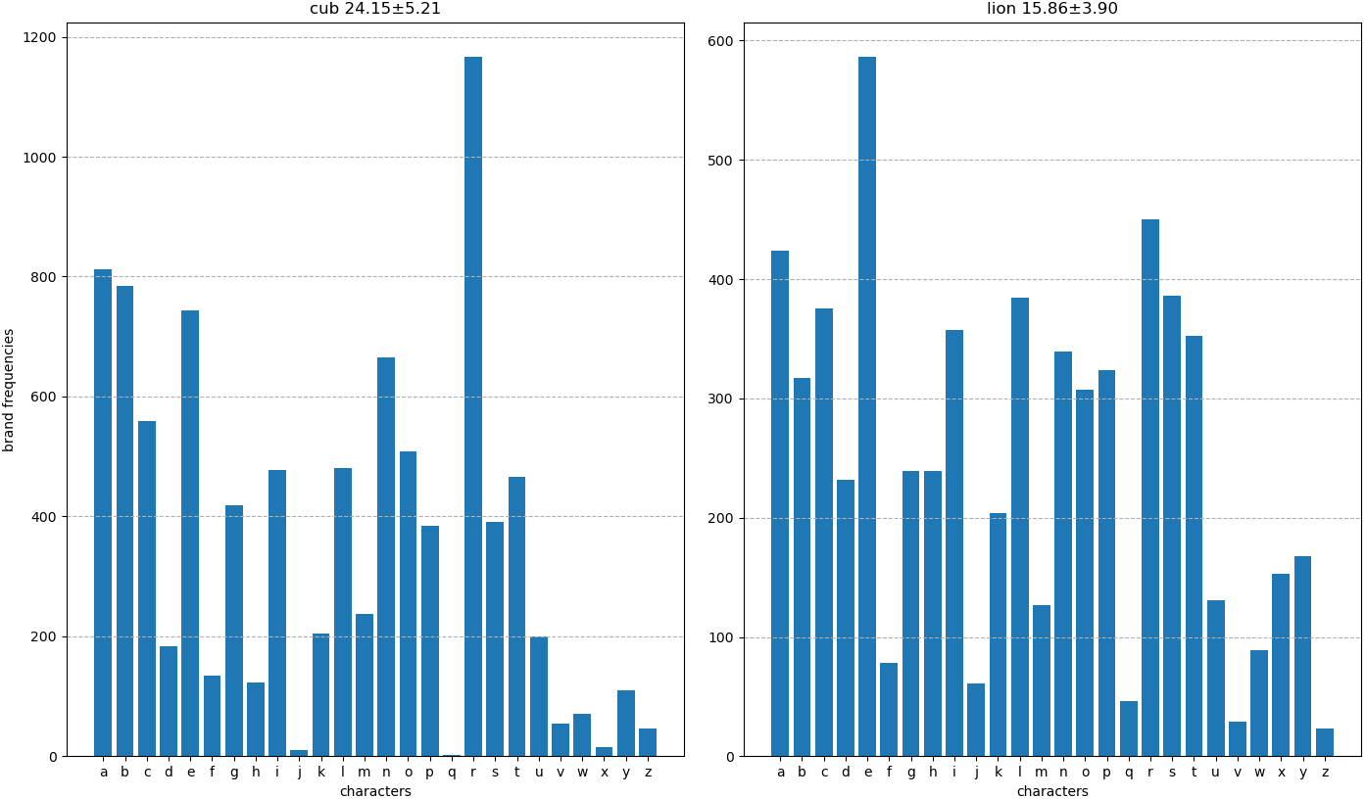Figure 2: Ordered character distributions of "name" relative to "brand".
For “brand” labels, the number of characters alone is evidently enough to separate the two classes. Label “cub” has an average length of 24 characters in a name, while “lion” has an average of 16. The top five most frequent characters are also different enough to emphasise separability.

Finally, for “category” labels, with the exception of “tap”, all other labels have very similar characteristics. This conclusion emphasises the insight we gleaned from measuring its marginal entropy - “category” as an output column is difficult to infer in isolation.
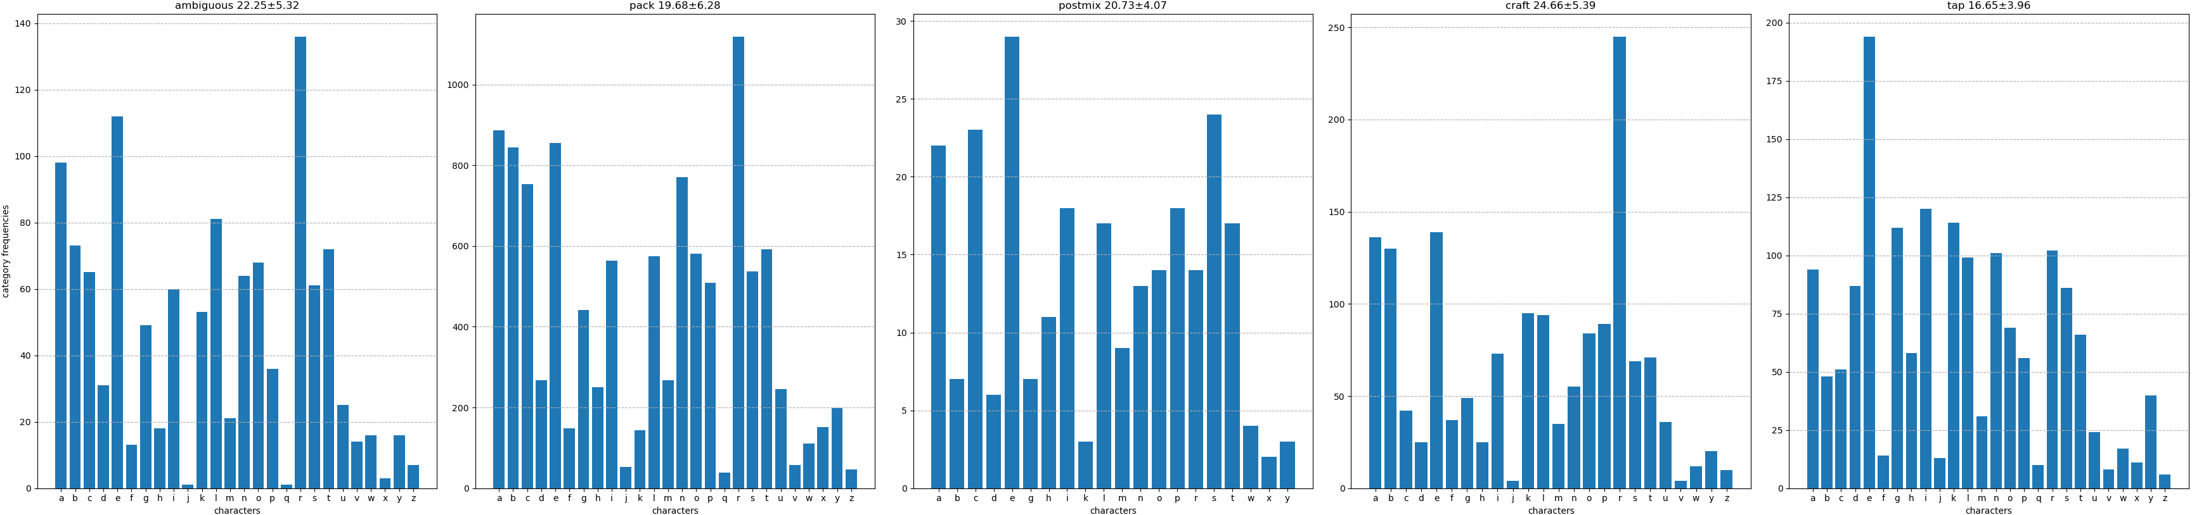Figure 3: Ordered character distributions of "name" relative to "category".
Finally, over the entire dataset, the following character-level statistics were observed:
Unique characters | 27
Minimum name length | 6
Mean name length | 20
Median name length | 19
Modal name length | 18
Maximum name length | 41

Word embeddings were explored as well, indeed trivialising the problem, however the inherently confusing and non-standard nature of the names quickly ran into OOV errors. Furthermore, there are words in “name” with absolutely no semantic meaning, for example “xxxx”, “br”, “din”, etc.

Litres information
Our other input column, “litres”, gives us a finer-grained view at our model’s decision surface. It can be argued here that “litres” enriches the input data the most, since – especially when viewed in relation with each output columns’ conditional value counts in table 4 – there are medians here that exclusively appear in just one output, for example “postmix”, “draught” and “craft”/“tap”, etc.:
 | Mean | Median | Max | Min | Std
type
draught | 46.29 | 49.5 | 50 | 1.25 | 10.34
package | 8.68 | 8.28 | 79.2 | 0.33 | 3.95
postmix | 9.7 | 10 | 15 | 4.5 | 3.74
brand
cub | 17.89 | 9 | 79.2 | 0.33 | 17.55
lion | 18.15 | 9 | 49.5 | 3.96 | 17.22
category
ambiguous | 25.49 | 15 | 49.5 | 0.33 | 20.8
craft | 48.39 | 49.5 | 50 | 19.5 | 5.78
pack | 8.76 | 8.35 | 79.2 | 3.3 | 3.96
postmix | 9.7 | 10 | 15 | 4.5 | 3.74
tap | 48.29 | 49.5 | 49.5 | 8 | 5.96

Evidently, using “litres” in conjunction with character embeddings can effectively highlight enough statistical discrepancy between each target column such that discriminating between each group becomes an almost-trivial problem. We can visually depict this further by looking at the histograms of “litres” relative to each target column’s labels:
Under “type” specifically, almost every label is distinct. This supplements our decision of fitting on “type” first, which we took when inspecting the data’s conditional entropy.
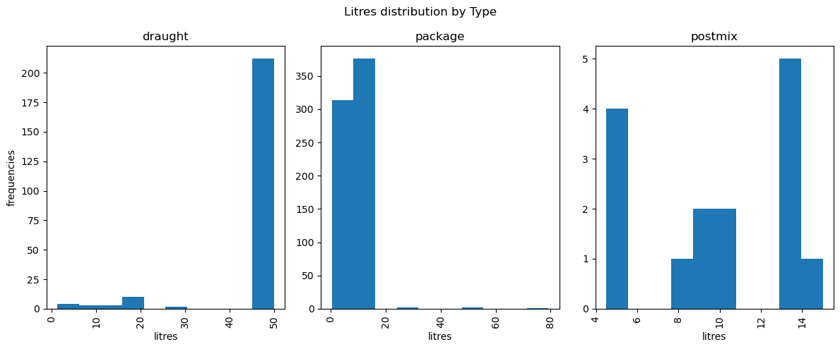Figure 4: "litres" distribution for each label under "type".
Under “brand”, being the most balanced target column, it’s no surprise that there is high similarity. This is also reflected in the summary statistics for the “litres” column.
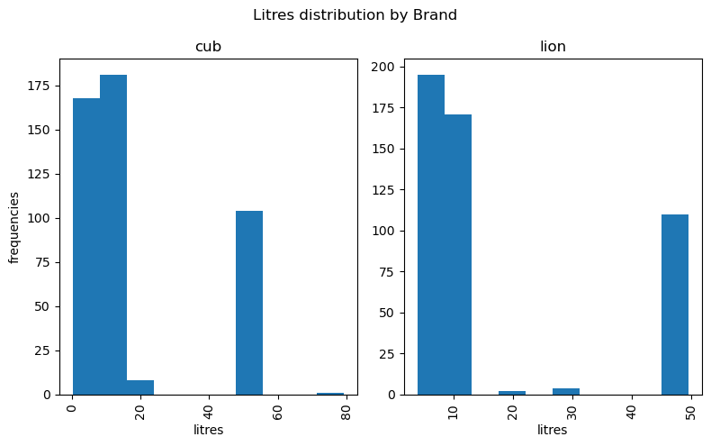Figure 5: "litres" distribution for each label under "brand".
For “category”, we’ve already inferred from value counts that “craft” and “tap” are conditionally “draught”, which is reflected here; we can also glean this from the summary statistics. The distance between each distribution can also be quantified using the Hellinger distance^{[16, 17]}:
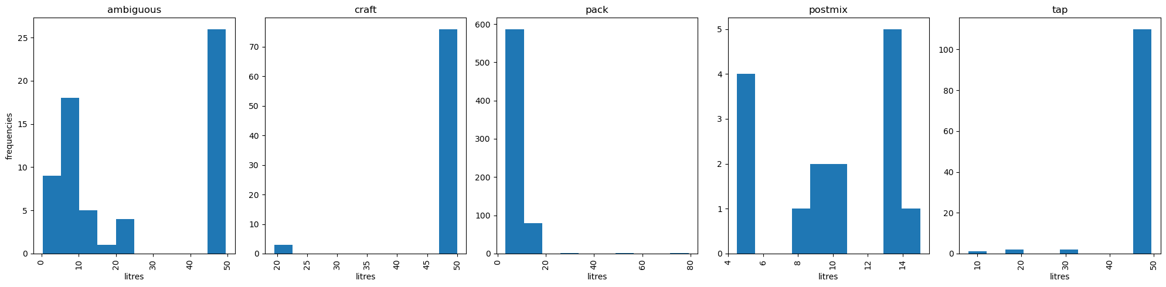Figure 6: "litres" distribution for each label under "category".

In our case, equivalent to the 2-norm of the difference of the square roots of the probability vectors:

The Hellinger distance returns a symmetric distance in where zero indicates complete similarity between probability measures, i.e. and one indicates complete dissimilarity.
Table 9: The Hellinger distance for each output column's labels in relation to every other one.
type
 | draught | package | postmix
draught | 0 | 0.36 | 0.63
package | 0.36 | 0 | 0.64
postmix | 0.63 | 0.64 | 0
brand
 | cub | lion
cub | 0 | 0.21
lion | 0.21 | 0
category
 | ambiguous | craft | pack | postmix | tap
ambiguous | 0 | 0.29 | 0.27 | 0.6 | 0.26
craft | 0.29 | 0 | 0.43 | 0.67 | 0.1
pack | 0.27 | 0.43 | 0 | 0.6 | 0.41
postmix | 0.6 | 0.67 | 0.6 | 0 | 0.66
tap | 0.26 | 0.1 | 0.41 | 0.66 | 0

Note the zero diagonal and symmetric triangles. Here too we can see that “category” labels “craft” and “tap” have nerly 0 dissimilarity; “postmix” is vastly different across all other labels; a lot of “ambiguous” labels are very similar to “pack”, “craft” and “tap”; and “brand” is still very stable.
Our strategy thus far has been backed by our data’s underlying statistics: there is enough variation inter- and intra-output column, given “name” and “litres”, to not only distinguish between “brand”, “category” and “type” in isolation, but to also distinguish within their labels. We also know that some output column labels can inform on another output column’s labels, which we can use to our advantage during our training strategy.

Model description
The BiLSTM-CNN model is well known in Machine Learning^{[18, 19, 20, 21, 22, 23]} for its powerful capabilities in sequence processing and related tasks, such as text processing, pattern recognition, gene sequencing, etc. Its many strengths stem from two key aspects:
- The foundational bidirectional LSTM layer, which processes each input sequence in both directions: left to right in the forward layer, and right to left in the backward layer. Each layer outputs an optimised set of weights for each embedding dimension, the final output being an interleaved concatenation of the two sets of weights.
- The convolutional layer, which is passes an arbitrarily sized kernel over the bidirectional LSTM outputs, extracting spatial feature maps that emphasise local portions of the input sentence that should contribute the most to classification. This is similar in function to the recent Transformer, however the biggest difference is that convolutional networks (CNNs) capture excellent local dependencies in a sequence while Transformers capture excellent global dependencies. Transformers also require exponentially more data to train correctly, and given the data we have under “name”, make little sense.
The bidirectional LSTM is a slightly more refined version of the LSTM (Long Short Term Memory)^{[24, 25, 26]} network, which itself is a much more refined version of the elementary Recurrent Neural Network (RNN)^{[27, 28, 29]}. The key aspect of RNNs is their ability to perceive time, given their recurrent fashion of processing inputs. Each layer not only outputs its weights separately, but also passes on its latent state to the next layer after it, achieving temporal continuity.
The convolutional layer is the building block of Convolutional Neural Networks (CNNs)^{[30]}, and has been very well studied in Machine Learning for its prowess in spatial data processing, for example with images or videos. Convolutional layers take a signal as input and apply a series of kernels across the signal. The input signal is assumed to have “channels” – for RGB images, the input is shaped , where H and W are the height and width of the image in pixels, and 3 represents the number of colour channels. For sequential data like text with embeddings, the input is shaped , where L is the length of the sequence (sentence) and E is the embedding dimension. The kernels are convolved with the input across all channels, and the input is abstracted into a lower-dimensional feature map. CNNs are also known as Space Invariant Artificial Neural Networks (SIANNs) based on the shared-weight architecture.
Much like RNNs and their descendants learning their own representations of their inputs by optimising embeddings, CNNs also learn their own representations of inputs by optimising kernel weights and refining their feature maps. Thus, in the entire model pipeline, the only human involvement is the requirement of preprocessing the data into a valid computational format that emphasises domain knowledge a certain way, such that that knowledge representation is maximised for the model to begin its processing.
Our following discussion will be specific to the architecture used for RebateNet, and not the general BiLSTM-CNN architecture.

Bidirectional LSTM
In the image, the embedding inputs are represented as the N-dimensional vectors containing elements . Specifically, the first character embedding is the first set of three red boxes of elements ; the second character embedding is the next set of three red boxes containing elements , etc. Each embedding is sent into its own LSTM layer, one for each direction and each step of the input sequence. The LSTM layers process their inputs and return a set of weights, depicted by the coloured squares on the bottom of the image. These are then concatenated to form an interleaved set of output weights. The horizontal arrows leading from one LSTM unit to the next indicate state transfer, where each unit passes on its hidden state to the next in line. The specific internal workings of an LSTM layer are out of scope for this discussion.
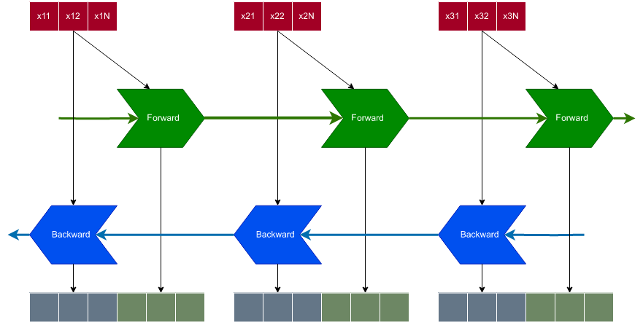Figure 7: A basic bidirectional LSTM architecture
Intuitively, this data transformation can be understood as digitally “reading” a sequence of inputs, where the sequence is a set of N-dimensional vectors representing sequential data. This foundational portion of the model is tasked with reading its input name and identifying which characters should contribute the most to a given target class. The key aspect of an LSTM is that it can identify and retain temporal dependencies in the input sentence whilst also alleviating the vanishing gradient problem.

Convolutional Layers
The convolutional layer requires a little more explanation. The outputs of the BiLSTM layer are interleaved weights from both the forward and backward directions. This is still a “raw” output, where the model so far has only seen each character in relative isolation. Convolutional layers in text processing have been shown to consistently outperform “barebones” models since their kernels can not only be used to reduce dimensionality, but also identify salient portions of the inputs that greatly contribute to further downstream processing. These feature maps are abstract representations of different portions of the input signal, with the weights of each kernel ensuring that only those regions get picked that enrich the data the most. Usually convolutional layers’ feature map outputs passed on to pooling layers that further reduce dimensionality by picking either only the maximum output values, average output values, or minimum output values, however for our purposes the amount of data precludes us from using pooling.
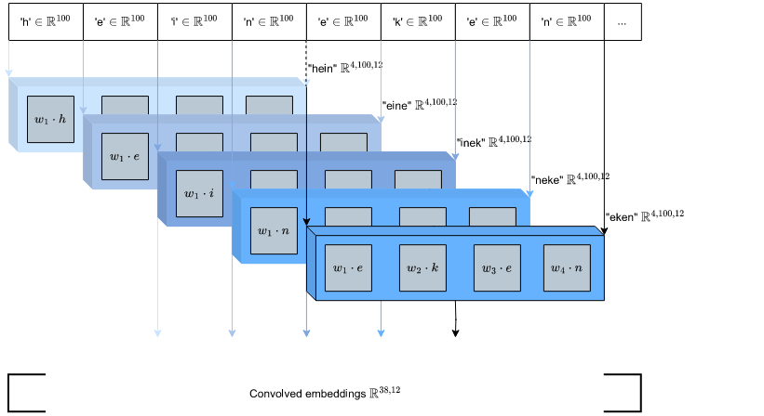Figure 8: A 1D convolutional layer with a kernel size of 4 and stride of 1.
In the image, each character in a box represents the concatenated BiLSTM output for that character. If each character embedding is a 100D vector and the LSTM layers filter the number of dimensions down to 50, a concatenated set of outputs will be shaped , where Nc is the number of characters in a sequence. In other words, a input is internally filtered down to a matrix, but since we have two directions concatenating outputs, the output is still .
The convolutional layer receives the concatenated input from the BiLSTM and begins applying its filter (kernel) over the sequence. For our purposes, a kernel size of 4 has been chosen since the average number of words in a name is 4, implying the convolutional filter is looking at 4-grams of characters. The weights for each of the 4 components within each kernel are learned, and as the kernel is convolved over the inputs, it transforms them from 100D vectors per character to 12D vectors per 4-gram. These feature maps are then passed on downstream. To casually phrase this phase of the model, “this is where the magic happens”.

ELU activation
The feature maps from the convolutional layer are passed through an Exponential Linear Unit^{[31]} activation function, which has numerous benefits:
- The ELU is a symmetric, continuous and infinitely differentiable function that keeps mean activations close to zero. This alleviates further the vanishing gradient problem, and also performs implicit batch normalisation.
- The ELU derivative is non-contractive, saturating non-linearly to a negative value when the argument is small while linearly activating positive arguments. Saturation means a small derivative propagates, decreasing the variation and information sent forward.
- The ELU’s exponential nature prevents plateauing and permits much faster convergence. Its minimal negative plateau allows it to pass on more robust and stable data representations with smaller medians.
- The ELU’s exponential nature also contributes to active noise suppression and low-complexity feature representation.
The aim of activation functions is to introduce nonlinearity into the model, since it’s very well known and understood that without activation functions, deep neural networks collapse into a single linear model, since all subsequent linear transformations of an input can be represented by a single transformation matrix owing to linear function composition. Incorporating specifically the ELU into this section of the model achieves two objectives:
- So far, the model has simply read and “understood” its input text. Humans performing such a classification task read their input, understand it, and then re-read it again in order to pick up on portions of a name that contain the most information, suppressing noisy portions. The ELU contributes to simulating noise suppression.
- Due to the ELU’s nature of unbounded maximal activation, it functions as surrogate max pooling, alleviating our problem of being unable to use explicit max pooling due to our limited data. Max pooling, in its rawest form, is also a linear transformation requiring its own activation afterwards. The ELU subsumes all these actions into a neat single operation, which is especially helpful given our limited dataset.
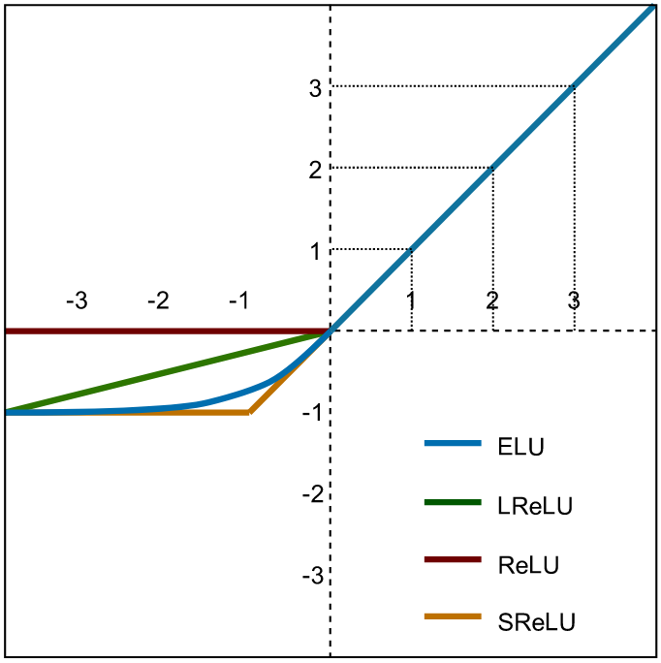Figure 9: Various activation functions.
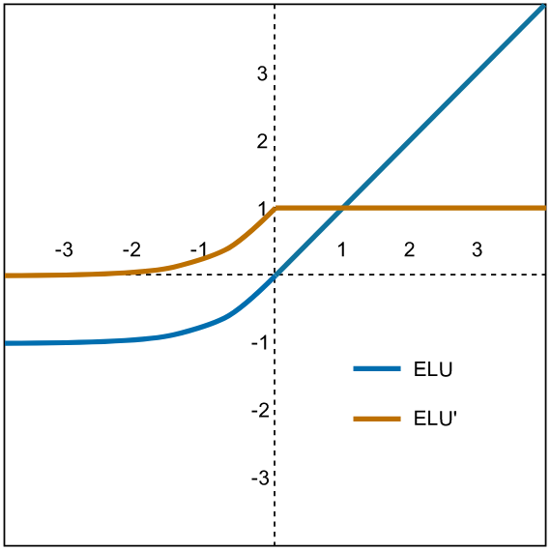Figure 10: The ELU and its gradient.

Final dense layer and activation
The activated outputs from the convolutional layer are flattened and passed onto a final dense layer that processes each and every data point simultaneously. Dense layers are used when associations can exist between any one feature and any other feature for each data point, and are explicitly necessary in situations where all of the output of a model up to a certain point needs to be processed simultaneously. The best explanation as to why dense layers are so crucial to maximal performance is through contradiction: without a dense layer, all we would receive after a convolutional layer are feature maps that have high interrelatedness and local structure, but no global perspective. This portion of the model is also where the “litres” input column is accepted and passed in.
At their core, dense layers are simply linear transformations of the input tensors with their real advantage being the activation function used on their outputs. The final dense layer in RebateNet is activated with a Leaky Rectified Linear Unit, or LReLU, function. A Rectified Linear Unit^{[32, 33, 34]} is ridge function, which is any mathematical function that can be written as a composition of a univariate function with an affine transformation:

The ReLU is such a ridge function given by an identity affine transformation – it simply returns the positive part of its argument, zero otherwise:

However, the ReLU in its raw form is inherently problematic for, amongst many reasons, the fact that it can irrecoverably kill portions of the model. Returning zero effectively sets all future gradients to zero such that no other input to that section of the model can reactivate itself; in other words, if the ReLU responds with a series of zeroes for some inputs, the model will eventually never consider inputs to that section. A well known solution is to introduce a small positive scaling of negative inputs, such that gradients are kept alive – this is known as the “Leaky” ReLU^{[35]}:

Multi-head output
The problem calls for 3 explicit outputs given a singular textual input (litres notwithstanding). To facilitate this, the outputs from the fully-connected dense layer are split into 3 distinct output “heads”, with each one responsible either for outputting the “type”, “brand”, or “category” the current name is thought to be. Such architectures are very commonly used in image processing and computer vision, especially when multiple different regions of an image need to be addressed: do we have a cat in an image? One output head would perform object detection, looking for a cat-shaped set of pixels; while the other head performs image classification, identifying whether the region of pixels represents a cat or a dog.
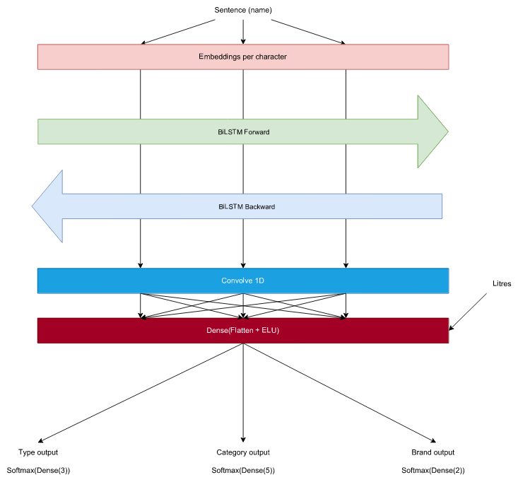Figure 11: Simplified block diagram of RebateNet.
In multi-label output scenarios, common Machine Learning convention states that the Softargmax function from statistical mechanics is best suited for processing outputs. The vector-valued Softargmax returns a probability distribution that’s proportional to the exponentials of its K inputs. The standard Softargmax^{[36]} , where , is defined as:

And is clearly nothing more than normalised exponentials. This activation function is specifically used in cases where the number of output labels is equal to or exceeds 2 (it can be shown that the Softargmax is a generalisation of the sigmoid)^{[50]}.
Once the Softargmax probabilities for each output have been computed, in order to arrive at a final singular value as output for “type”, “brand” and “category”, we simply take the maximum value of the output probability vector and begin computing loss gradients.
Each output “head” is itself a miniature dense layer, sporting the number of perceptrons equal to the number of classes it’s responsible for predicting. Up to this point, all of our data has been processed simultaneously or in conjunction with other regions of itself. From here onwards, the data needs to be segregated into different classes, which is why each output head is independent.

Final architecture
The final architecture of RebateNet is, thus, a simple BiLSTM-CNN model with a Dense layer towards the end, before multi-head output classification occurs. The text processing engine runs on character embeddings, giving us the following architectural diagram. Names are tokenised into their characters and embedded into 100D vectors, where the maximum name length is fixed at 41 characters, then processed in both directions by a BiLSTM layer, convolved into feature maps, densely processed, and finally classified into 3 separate outputs stemming from a single input. A fixed length of 41 characters is an artefact of computational costs for sequence processing models: though capable of processing virtually infinite sequences, computational resource allocation is necessary beforehand to ensure acceptable processing times and reproducibility. In cases where sequence lengths absolutely cannot be known beforehand, windowing is the most common option.
It’s important to notice that even though “type” and “brand” outputs are collected at the end after their respective Softargmax layers, they still feed into the “category” output head since “category” depends on “type” and “brand”. The reasoning for this is encapsulated in the conditional value counts of table 4: there are “type” and “brand” labels that directly inform “category”, so their participation in the decision making are crucial.
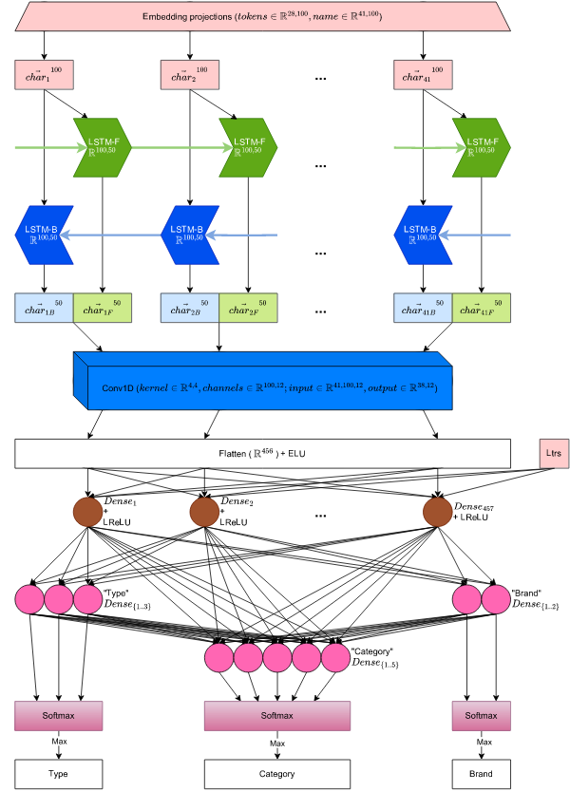Figure 12: RebateNet final architecture.

Training Strategy
The data strategy of exploiting character-level statistical discrepancies between all possible target labels is thus far a validated approach, especially when coupled with “litres”. In order to effectively train the optimising model to identify such discrepancies, three objectives were identified and achieved:
- Adaptive stochastic optimisation was preferred owing to its speed of convergence. Specifically, the AMSGrad^{[37]} variant of Adam was used, which uses the maximum of past squared gradients rather than the exponential average. The motivation behind using the maximum of past squared gradients instead of an exponential moving average of gradients is because sometimes Adam, after converging to a suboptimal solution, gets stuck in the minima even if large informative gradients come in. This is specifically because of its exponential decay minimising their effects.
- In order to leverage the mutual information present across all output columns and their labels, a summative loss strategy was adopted. This requires a little bit of an explanation into summative loss, and the different loss and training strategies that are available.

Summative loss training
The training of a neural network is governed by backpropagation, which is grounded in college-level calculus. Gradients flow in the backward direction of dataflow in a network such that weights, with respect to the inputs, change in accordance with how much error the network’s outputs have made. There are two computational reverse-mode partial differentiation passes made when training a traditional neural network:
- The forward pass, where data (in this case, our character embeddings and “litre” information) flows from input to output, resulting in some classification of a name into “type”, “brand” and “category” classes. This is not guaranteed, especially on the first iteration, to yield a correct answer since the network has not been “trained”.
- The backward pass, where the error of the network is computed, calculated as what the expected output was versus the output the network has provided. In regression problems, i.e. where target values are continuous, error metrics such as Root Mean Square Propagation (RMSE) or Mean Absolute Error (MAE) are used; in classification problems, i.e. where target values are discrete, error metrics such as Binary Cross Entropy (BCE), Cross Entropy (CE), Hamming Distances, etc. are used. The difference in output – as calculated by the error metric – governs how much the network needs to update and change its weights in order to reduce the error.
Updating weights is governed by reverse auto-differentiation, which is an extremely well studied area in computational mathematics. Calculating gradients for a neural net is done by finding the partial gradient of each weight with respect to its input, using the amount of output error as the function value to optimise. Partial gradients only consider inputs for an output that actually affect it. As such, the backward pass can be accomplished in multiple ways^{[38, 39, 40]} since the autodiff graph can identify which inputs affect which outputs, especially for multi-output neural networks:
- The error for a set of heads (1 or more, but not all) are summed and differentiated over the network. The output head(s) left out then have their loss summed and differentiated over the network. This is the case of different loss pathways, usually used for multiple optimisers.
- The error for a set of heads (1 or more, but not all) are summed and differentiated over the network. The network then has some parameters frozen, usually the parameters that affect critical outputs; the remaining losses are calculated, summed, and differentiated over the network. This is the case of parameter freezing, usually used for transfer learning.
- The error for all heads are summed and differentiated over the network, without any parameters being frozen. In this case, all outputs are responsible for a combined loss. This is the regular approach for multi-output training.
The loss strategy for multiple outputs is important to understand correctly. Either the entire network is affected because one out of our 3 heads yielded an incorrect result, or only that output head is affected with the others remaining static. In other words, if “type” and “brand” – which have been statistically verified to be easy to classify – give correct outputs but “category” misfires, we can either penalise only the “category” output head by freezing all other parameters and differentiating “category”, or we can penalise the entire network for the fault of one.
The only time the different training options are distinct from one another is when different learning rates, or optimisers, are in play. This is because differentiating over one set of output heads and then following with the second, without freezing parameters and using the same optimiser, collapses the system into just differentiating over the entire summative loss. Different learning rates are useful when different outputs have wildly varying objective functions; for example, “category” loss might vary rapidly with input, but be small in magnitude, while “brand” loss might vary a little but be large in magnitude. In this case, “brand” dominates the common summative approach, so an adaptive optimiser will choose a large learning rate – keeping them separate means each output head gets its own learning rate.
In our case, unless we use different optimisers with different learning rates or aggressively freeze parameters, all training strategies collapse into a single strategy of summative loss over the entire network since we have multiple outputs from one set of inputs. During training, 2 approaches were tried: overall summative loss and parameter freezing.

Weighted loss
It can be seen that there is still a minor issue of minority classes, where some records only occur 15 times relative to others that occur over 200 times. The issue of class imbalance is very well known in Machine Learning with multiple techniques available. The discussion here will be specific to the techniques used in this project.
The first technique is weighted random sampling, where inverse class weights are used to determine the inverse probability distribution of each class occurring^{[41]}. This is then used to sample records from the dataset, effectively increasing the number of times minority versus majority records are seen:

This was part of the initial approach, however there is some nuance here^{[42]}: owing to our small dataset and the nature of weighted random sampling, the network is still prone to optimising its weights such that in order to achieve maximal performance, it selects the majority class every single time. This is possibly due to the magnitude of the gradient for a majority misclassification still being greater than the magnitude for a minority misclassification, since the minority classes only contribute to a 1.5% weightage of the dataset. In other words, even though minority records are seen more times such that the dataset appears balanced, they simply do not carry enough information in their gradients since they’re still a minority.
An alternative approach is that of weighted loss, where the dataset is sampled normally without surrogate probabilities, but class weights are used to compute the overall network’s loss. In this scenario, the network isn’t seeing balanced data, but is very heavily penalised for misclassifying minority classes, implying a much more severe gradient update^{[42, 43]}.
The weighted loss approach yielded the most results. Note that attempting to combine the two will not yield adequate training performance, as the combination of a seemingly balanced dataset with severe penalisation can skew network performance in favour of purely minority classes. The final class weights used for this project are as follows:
Table 10: Class weights for RebateNet Cross Entropy Loss functions.
 | weight
type
draught | 1.34
package | 0.45
postmix | 21
brand
cub | 1.02
lion | 0.98
category
ambiguous | 2.95
craft | 2.39
pack | 0.28
postmix | 12.6
tap | 1.64

Loss choice
The function was chosen to be Cross Entropy Loss^{[44]}, effectively asking our model to optimise and find a set of weights that minimises the difference between the probability distributions of “name” and “litres”, relative to our target output columns “type”, “brand”, “category”. This follows directly from our original intuition that there is shared information between our target output columns. The cross-entropy between two distributions can be given by an isolated form, or in terms of the KL Divergence:

Where is the marginal entropy of distribution p. Class weights are incorporated per sample in the loss function, i.e. records in the output tensor labelled as categories with the heavier weights (minorities) will result in a much greater loss gradient for those records than those with lighter weights (majorities).
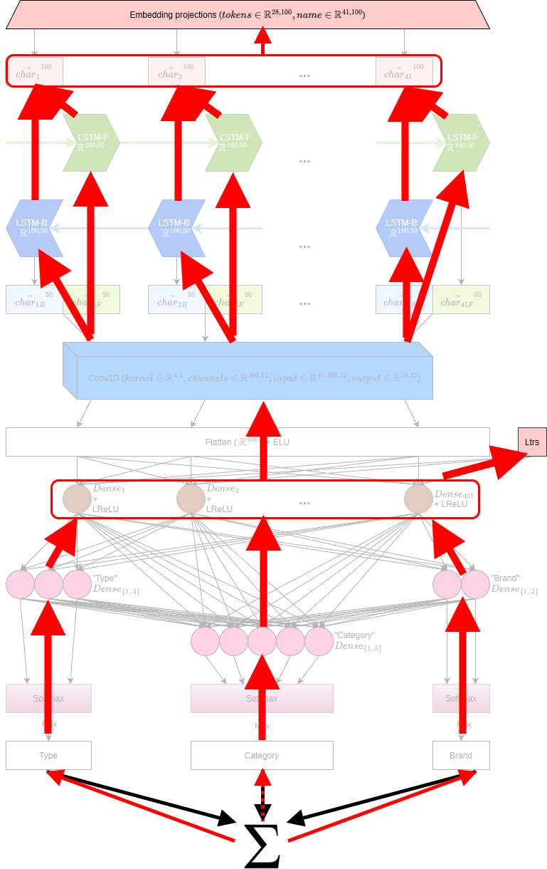Figure 13: RebateNet simplified gradient flow. Red boxes included to reduce the number of arrows required, and indicate multiple parameters.
The image depicts the flow of summative loss gradients through the network in a simplified fashion. Each output head is responsible for its own contribution of loss with respect to its separate inputs. There is something exquisitely interesting here regarding how multi-output losses are handled that encapsulates the beauty of applied mathematics.

Multi-output loss computation
Focusing only on loss computation for “type” in isolation, it can be noticed from the gradient pathways that if “type” were to misfire and yield an incorrect result, its loss gradients will update the model’s weights in such a way that the weights for “litres” and the embeddings will change, relative only to the loss from “type” for that epoch. Consequently, during the next forward pass, the updated weights for the embeddings and “litres” will affect not just “type”, but “brand” and “category” as well. How do we know that optimising for type also facilitates optimising for “brand” and “category”? It might so happen that our model’s decision surface is at a minima for “type” where “brand” and “category” are at their maxima, implying the only viable global minimum is the average loss between all 3 objective functions.
Indeed, that was very much the case during multiple exploratory training sessions, where the total loss of the network (summative) never reduced from its original value. What happens in the general case however, is something like this:
- The 3 outputs are simultaneously output by the network; this is also the general case with architectures such as GoogLeNet and VGG.
- Each output has its loss computed individually, then the losses are summed into a total loss value.
- The total loss value is backpropagated, wherein the partial derivatives of each output are computed with the autodiff graph and weights are adjusted. This brings us back to the premise of this section: “what if one output’s optima doesn’t align with the other?”
- In the next forward pass, the updated weights influence all the branches the same. If this is better or worse than the previous epoch depends purely on whether the other outputs are useful and able to be optimised – if the outputs do not have aligned minima, there will be no global minima reached^{[45]}.
There are a few caveats to this, as always:
- If network parameters are frozen and separate outputs are trained in isolation, it can very easily interfere with the overall optimisation effort. For example, if we train on all inputs, compute the loss for “type” and “brand”, then freeze every gradient node except for “category” gradients and attempt to optimise, there’s a good chance the network will never optimise since it’s just not possible to.
- If the input data and corresponding outputs are indeed useful – as it is in our case, where our input data shares a lot of mutual information between output columns – it’s likely that there is a global optimum somewhere that the network will strive to reach. We also observed the effects of this when adding in “brand” as an output in addition to type (and “category”) increased overall performance, enriching the input data.
Equally likely is the occurrence of multiple local minima relative to combinations of output columns, which is an issue depending on the use-case. In either case, the weights and their gradient computations and effects are purely mathematical. It’s simply the way partial derivatives (and optimisations) work in theory, that carries over to practice and that we see here.

Training approach
As mentioned, problems such as this one in Machine Learning are usually tackled by attempting to overfit a specific subset of data before scaling up the data input/model. In this scenario, training was originally designed to overfit “type”, which it did immediately. “brand” was included next along with a second output head, which also overfit and revealed something fascinating: the performance of “type” was increased by the inclusion of “brand”. Combined losses for “type” and “brand” meant that when “brand” misfired while “type” was correct (and the other way around), the gradients calculated actually enriched the network’s perception of its inputs.
Since “category” was the most statistically messy column to deal with, the original approach with it was to transfer the weights of the original network applicable for “type” and “brand” to a new network with an extra output head, freeze all parameters except for those affected by “category”, and differentiate losses that way. This yielded the worst performance. The next approach was not in transferring the weights, but learning them from scratch while still keeping “category” frozen. This too yielded atrocious performance.
The final approach for “category” was to simply use overall summative loss and differentiate it entirely over the network, which yielded stellar results and also enriched the performance of both “type” and “brand” again, cementing the fact that all 3 outputs are required for the optimal performance of one another.

Model and training loop implementation
The final model was implemented in PyTorch with the following abridged parameter setup and training loop. Note that there is no explicit Softargmax function involved in RebateNet, since the PyTorch loss functions for Cross Entropy Loss include it internally^{[46]}. The following image depicts the model’s performance per training epoch, wherein we can clearly see that there are moments where “category” is optimised for at the expense of “brand” and “type” (and likewise for the other combinations of output columns):

### Parameter setup ###
RebateNet(
(embedding): Embedding(28, 100, padding_idx=0)
(bilstm): LSTM(100, 50, batch_first=True, bidirectional=True)
(conv_1d): Conv1d(100, 12, kernel_size=(4,), stride=(1,))
(flatten): Flatten(start_dim=1, end_dim=-1)
(ELU_activation): ELU(alpha=1.0)
(FC_1): Linear(in_features=457, out_features=50, bias=True)
(LReLU_activation): LeakyReLU(negative_slope=0.01)
(type_linear): Linear(in_features=50, out_features=3, bias=True)
(brand_linear): Linear(in_features=50, out_features=2, bias=True)
(category_linear): Linear(in_features=55, out_features=5, bias=True)
)

loss function for `type`: CrossEntropyLoss()
loss weights: tensor([1.3404, 0.4532, 21.0000])

loss function for `brand`: CrossEntropyLoss()
loss weights: tensor([1.0205, 0.9803])

loss function for `category`: CrossEntropyLoss()
loss weights: tensor([2.9531, 2.3924, 0.2812, 12.6000, 1.6435])

optimiser for the full network: Adam (
amsgrad: True
betas: (0.9, 0.999)
capturable: False
differentiable: False
eps: 1e-08
foreach: None
fused: None
lr: 0.001
maximize: False
weight_decay: 0
)

### Training loop ###
torch.manual_seed(1337)
np.random.seed(1337)
rnet.train()
for epoch in range(100):
for record in rebates_train_dl:
rnet.zero_grad()
out = rnet(record["name"], record["litres"])
loss_type = type_criterion(
out["out_type"],
record["type"].long()
)
loss_brand = brand_criterion(
out["out_brand"],
record["brand"].long()
)
loss_category = category_criterion(
out["out_category"],
record["category"].long()
)
loss_total = loss_type + loss_brand + loss_category
loss_total.backward()
optimiser.step()

For comparison, training with word embeddings resulted in this training evolution:
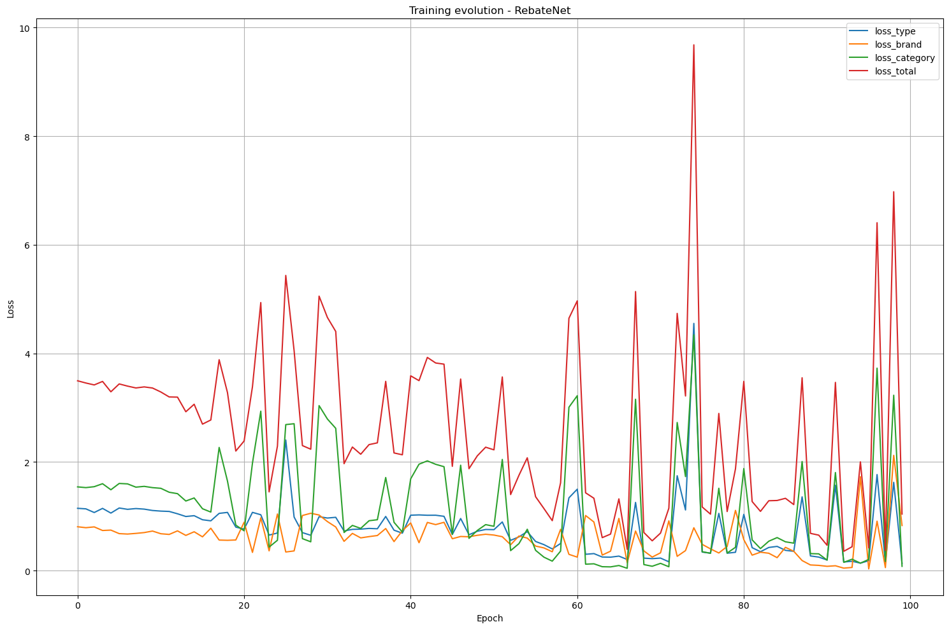Figure 14: RebateNet training evolution over time, for all 100 epochs (0-99).
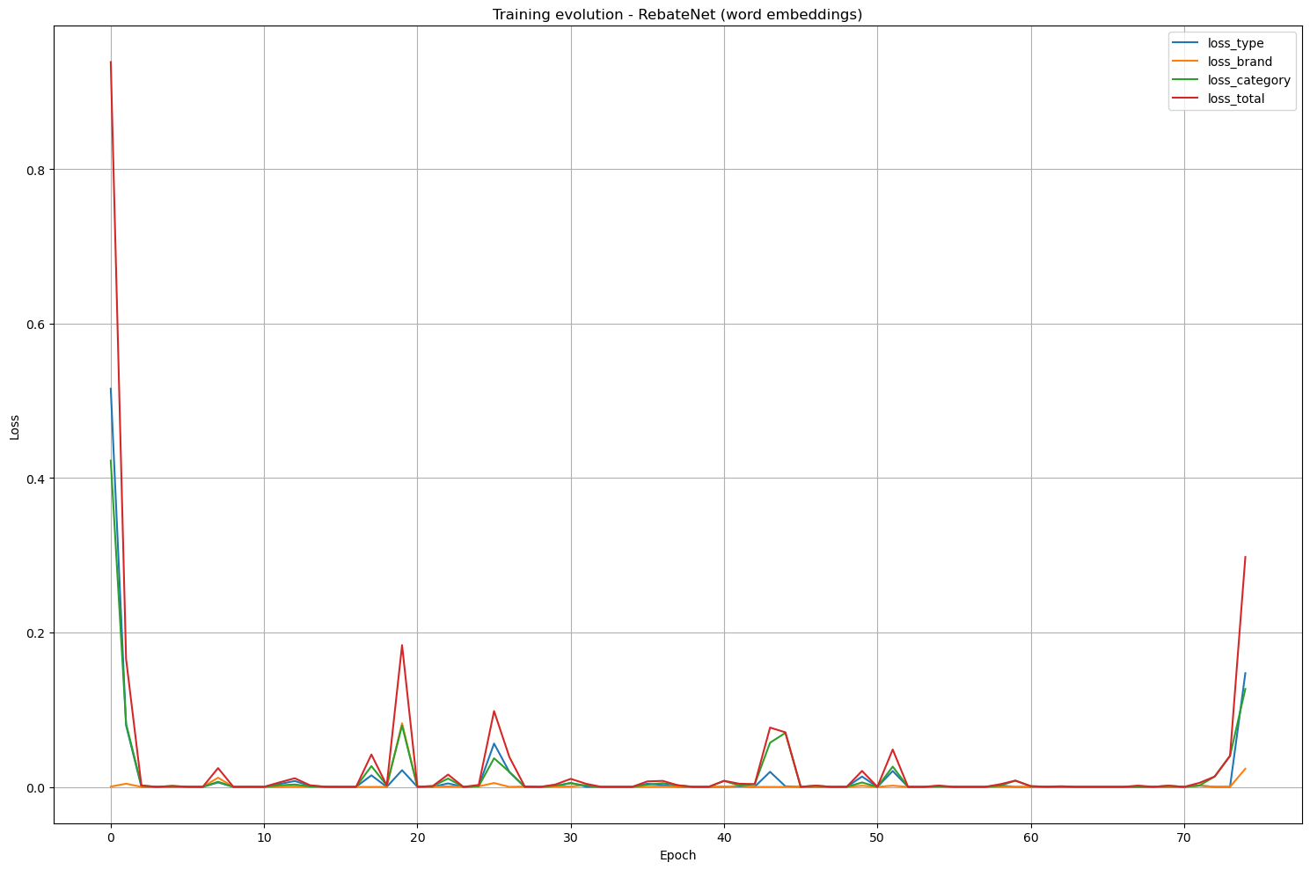Figure 15: RebateNet training evolution with word embeddings over time, for all 75 epochs (0-74).
We can immediately observe two things:
- The model with word embeddings trained in 75 epochs, compared to 100 for characters.
- The model with word embeddings immediately optimised into its minima and stayed there.
This kind of performance affirms that word embeddings do indeed enhance optimisation efforts owing to whatever semantics they’ve been able to capture from “name”. As mentioned though, the model with word embeddings performed somewhat worse than the one with character embeddings, and definitely succumbs to OOV errors. While there are ways to combat OOV errors such that only known tokens are used and others ignored, it is arguably easier to simply default to character embeddings, especially for this kind of project where it’s known the text corpus contains very little semantic information.

Results

Measurement metrics
Given the fact that we have minority classes to consider in our results, the most appropriate metric for estimating model efficacy is a macro-weighted F1 score. Being a harmonic mean of reciprocals, the F1 score penalises low recall and precision scores severely, emphasising that each category present in a dataset needs to be considered equally. Recall, also known as Sensitivity, is intuitively defined as the number of correct results out of all correct results; or the number of true positives over the sum of all true positives and false negatives:

Precision, also known as Positive Predictive Value, is intuitively defined as the number of correct results out of all results; or the number of true positives over the sum of all true positives and false positives:

The F1 score is the harmonic mean of the reciprocals of the two:

Therefore, a lower Recall or Precision will reflect in the F1 score, which is how we can account for minority misclassification.

Validation
The complete training time from start to finish was 5 minutes and 36 seconds, with validation testing taking less than 100ms. The results are encouraging:
Table 11: RebateNet validation results.
 | Precision | Recall | F1 Score | Support
type
draught | 1.00 | 0.93 | 0.96 | 249
package | 0.98 | 1.00 | 0.99 | 733
postmix | 1.00 | 1.00 | 1.00 | 18
accuracy |  |  | 0.98 | 1000
macro avg | 0.99 | 0.98 | 0.98 | 1000
weighted avg | 0.98 | 0.98 | 0.98 | 1000
brand
cub | 0.99 | 1.00 | 1.00 | 505
lion | 1.00 | 0.99 | 1.00 | 495
accuracy |  |  | 1.00 | 1000
macro avg | 1.00 | 1.00 | 1.00 | 1000
weighted avg | 1.00 | 1.00 | 1.00 | 1000
category
ambiguous | 0.95 | 0.93 | 0.94 | 59
craft | 1.00 | 0.90 | 0.95 | 93
pack | 0.98 | 1.00 | 0.99 | 711
postmix | 0.82 | 1.00 | 0.90 | 18
tap | 1.00 | 0.91 | 0.95 | 119
accuracy |  |  | 0.98 | 1000
macro avg | 0.95 | 0.95 | 0.95 | 1000
weighted avg | 0.98 | 0.98 | 0.98 | 1000

The most balanced output column, “brand”, was easily classified almost perfectly, with the same following for “type”. The “category” output column, whilst falling short of near-perfect performance, in fact excelled at identifying all possible minorities from the training dataset. We can clearly infer this not just by the absolute score, but also by observing the Support of the validation set – the number of times that record was seen when running validation.
While there are signs of majority slip, i.e. instances where majority classes still skew the model towards selecting only their class, which we can see as “pack” being 99% correct and “postmix” being 90%, this amount of bias is a non-issue given the overall quality of the solution. We can also see an effect between “type” “postmix” informing on “category” “postmix” under all 3 metrics.

Inference
The model trained on 945 records. Inference on 190 records of live, completely unseen data, was completed in an average of 500ms, the amount of manual preprocessing time notwithstanding. Most of the manual preprocessing time for live data went in removing records that were not actual beverage products, but were instead products like beer guns, kegs, screwdrivers, etc. The least amount of time went in applying the regex filters and filling in “litres” values. The total amount of manual preprocessing time for inference was 1.5 hours, resulting in a total inference time of ~1.5 hours that scales non-linearly with the number of records.
Out of the 190 records queued for live business inference, 102 records were part of the training set owing to questionable data management practices employed by the external data vendor. Controlling these products and removing them from the inference set was infeasible, since this data is effectively streaming into the model, and filtering out these records would require much more work than necessary for this project. Leveraging their presence revealed a consistent 90% accuracy rate, since out of the 102 known products, 92 were classified perfectly in accordance with training data while 10 were misclassified.
All live data that inference was run on was passed over to our Subject Matter Expert of the internal commercial team for further review, who also kindly reviewed the classification of data that was part of the training set. The final tally across all 190 products was an overall 90.30% of correct classification; 16 records were incorrectly classified, 149 were correctly classified, and 25 were unknown by both the model and the SME.
Out of the 16 records incorrectly classified, 3 were assigned the correct conditional category owing to the ambiguity between “craft” and “tap” given “draught”, but the wrong final label. Accounting for this type of error, we have a total 152 correctly classified products, which is a 92.12% hit rate including minority classes.
The objective of this project, however, is not achieving a high level of classification accuracy, but in reducing the amount of manual effort required for this kind of task. The original estimate of manual effort was based on precedent, where the same SME had to classify 900+ products, requiring around 20 hours. The review process on the other hand was completed in 2 hours, equating to an original effort of 45 products an hour, against an AI-assisted effort of 95 products an hour – more than twice the time saved.

Ablation Analysis
To further understand how the model performs, an ablation analysis was carried out relative to the original model:
- The convolutional layer was removed.
- The “litres” input was excluded.
- The number of embedding dimensions was halved.
- The number of embedding dimensions was doubled.
- The ELU activation function was removed.
- The ELU activation function was replaced with ReLU.
- The final dense layer’s Leaky ReLU activation function was removed.
The following results were observed:
Table 12: RebateNet ablation analysis concise results.
 |  | Original model | No Conv1D | No Litres | Half embeds | Double embeds | No ELU | ELU → ReLU | No LReLU
Runtime |  | 00:05:36 | 00:05:00 | 00:04:40 | 00:04:52 | 00:09:20 | 00:07:42 | 00:04:42 | 00:04:38
Type  F1 | draught | 0.96 | 0.82 | 0.81 | 0.89 | 0.80 | 0.87 | 0.85 | 0.87
Type  F1 | package | 0.99 | 0.94 | 0.93 | 0.96 | 0.93 | 0.95 | 0.95 | 0.95
Type  F1 | postmix | 1.00 | 0.77 | 0.92 | 0.81 | 0.80 | 0.84 | 0.89 | 0.50
Type  F1 | Mean | 0.98 | 0.85 | 0.89 | 0.89 | 0.84 | 0.89 | 0.90 | 0.77
Brand  F1 | cub | 1.00 | 0.99 | 0.99 | 0.98 | 0.99 | 0.99 | 0.99 | 0.99
Brand  F1 | lion | 1.00 | 0.99 | 0.99 | 0.98 | 0.99 | 0.99 | 0.99 | 0.99
Brand  F1 | Mean | 1.00 | 0.99 | 0.99 | 0.98 | 0.99 | 0.99 | 0.99 | 0.99
Cat  F1 | ambig | 0.94 | 0.87 | 0.82 | 0.77 | 0.70 | 0.75 | 0.64 | 0.78
Cat  F1 | craft | 0.95 | 0.88 | 0.93 | 0.90 | 0.85 | 0.89 | 0.86 | 0.89
Cat  F1 | pack | 0.99 | 0.94 | 0.93 | 0.96 | 0.92 | 0.94 | 0.95 | 0.95
Cat  F1 | postmix | 0.90 | 0.69 | 0.80 | 1.00 | 0.67 | 0.84 | 0.89 | 0.50
Cat  F1 | tap | 0.95 | 0.69 | 0.69 | 0.77 | 0.65 | 0.75 | 0.73 | 0.74
Cat  F1 | Mean | 0.95 | 0.81 | 0.83 | 0.88 | 0.76 | 0.84 | 0.82 | 0.77

The results reinforce known Machine Learning theory. In these kinds of problems, the removal of a convolution layer objectively contributes to reduced performance since salient portions of the input data cannot be detected by sequential parsing, as is done by LSTMs. While dense layers can perhaps infer some of what a convolutional layer would highlight anyway, it detracts from their generalisability – this can be seen by the fact that “no conv1d” has the 2nd-worst performance for “postmix”.
The exclusion of “litres” as an input feature also harms performance, specifically for “tap”. We’ve seen that “tap” and “craft” are almost the same in terms of their “litres” distribution (which is also supported by a nearly-zero Hellinger distance), but since we’re excluding “litres”, we only have “name” to go by. However, even the character distributions for “name” show that “craft” and “tap” are dissimilar enough in terms of top 5 characters; so this is perhaps an artefact of “craft” having almost twice the class weight of “tap”, causing the network to favour “craft” over “tap”. In fact, “tap” has a character distribution that most resembles “lion”, but the class weight for “lion” is also minimal within its group, accentuating this artefact.
Halving the embedding size is evidently not as severe as expected save for “ambiguous” and “tap”, though doubling the embedding size not only took almost twice as longer to train, but also resulted in worse overall performance owing to the lack of sufficient data we have for effective training. This is especially the case for “ambiguous”, “postmix” and “tap”.

Parameter Visualisations

Character embeddings
Interesting information can be gleaned by inspecting a trained model’s embeddings, especially for large vocabularies. Specifically for character embeddings however, distinct clusters of data points isn’t to be expected since there is only one embedding per character. The embeddings of RebateNet have been visualised using Uniform Manifold Approximation and Projection (UMAP)^{[47]}, which is a very powerful collection of theories from differential geometry. The intuitive explanation is rather simple: we have high dimensional data that needs to be approximated in lower dimensions.
High dimensional data has a probability distribution of finding each point at a certain position compared to the others. Lower dimensional data has the same probability distribution, but a smaller number of dimensions. UMAP approximates the two using a topological graph, and attempts to minimise the cross-entropy between them. RebateNet has 100-dimensional character embeddings that we would like to visualise in 2-dimensional space. UMAP thus provides us with the following representation:
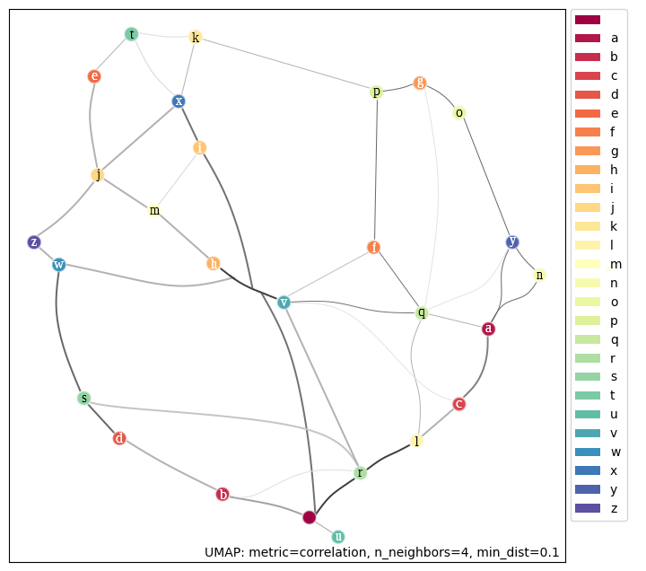Figure 16: RebateNet character embeddings visualised.
UMAP assumes that the high dimensional data is uniformly distributed on a Riemannian manifold, and approximates its high dimensional representation using a topological graph, where edge weights represent the likelihood of whether a point is connected to its nearest neighbour or not, using a similar process to approximate the lower dimensional representation. The minimal cross-entropy representation is then returned. In the image, darker linkages indicate stronger edge weights and thus, likelihoods. We can see that the characters ‘r’ and ‘l’ share perhaps the strongest bond, while ‘g’ and ‘q’ share perhaps the weakest (not counting unconnected characters). We can also see the most common patterns in names “br” and “can” sporting their own connections here. A name like “Victoria” from Victoria Bitter also shares direct connections between each of its characters.

Weights and feature maps
We can also inspect the BiLSTM output weights and Convolutional feature maps for specific names in the dataset. Taking the name “br four pines freshy refresh ale ngb prom” as an example input and sending it through the embedding, bi-lstm and convolutional layers), we can observe how the weights of each character changes at each stage. Throughout the visualisation, it’s important to keep in mind that each dimension of a vector (100, 12, etc.) is completely non-intuitive and arbitrary.
Starting with the embeddings for each character in the exemplary name, we can see that the embedding layer simply returns the 100D character embeddings for each unique character in the name:
Those embedding weights per character are received by the bidirectional LSTM layer, by both their forward and backward components. The LSTM layer returns an interleaved tensor of output weights, which we can inspect to find how each character in the name is being read by the network:
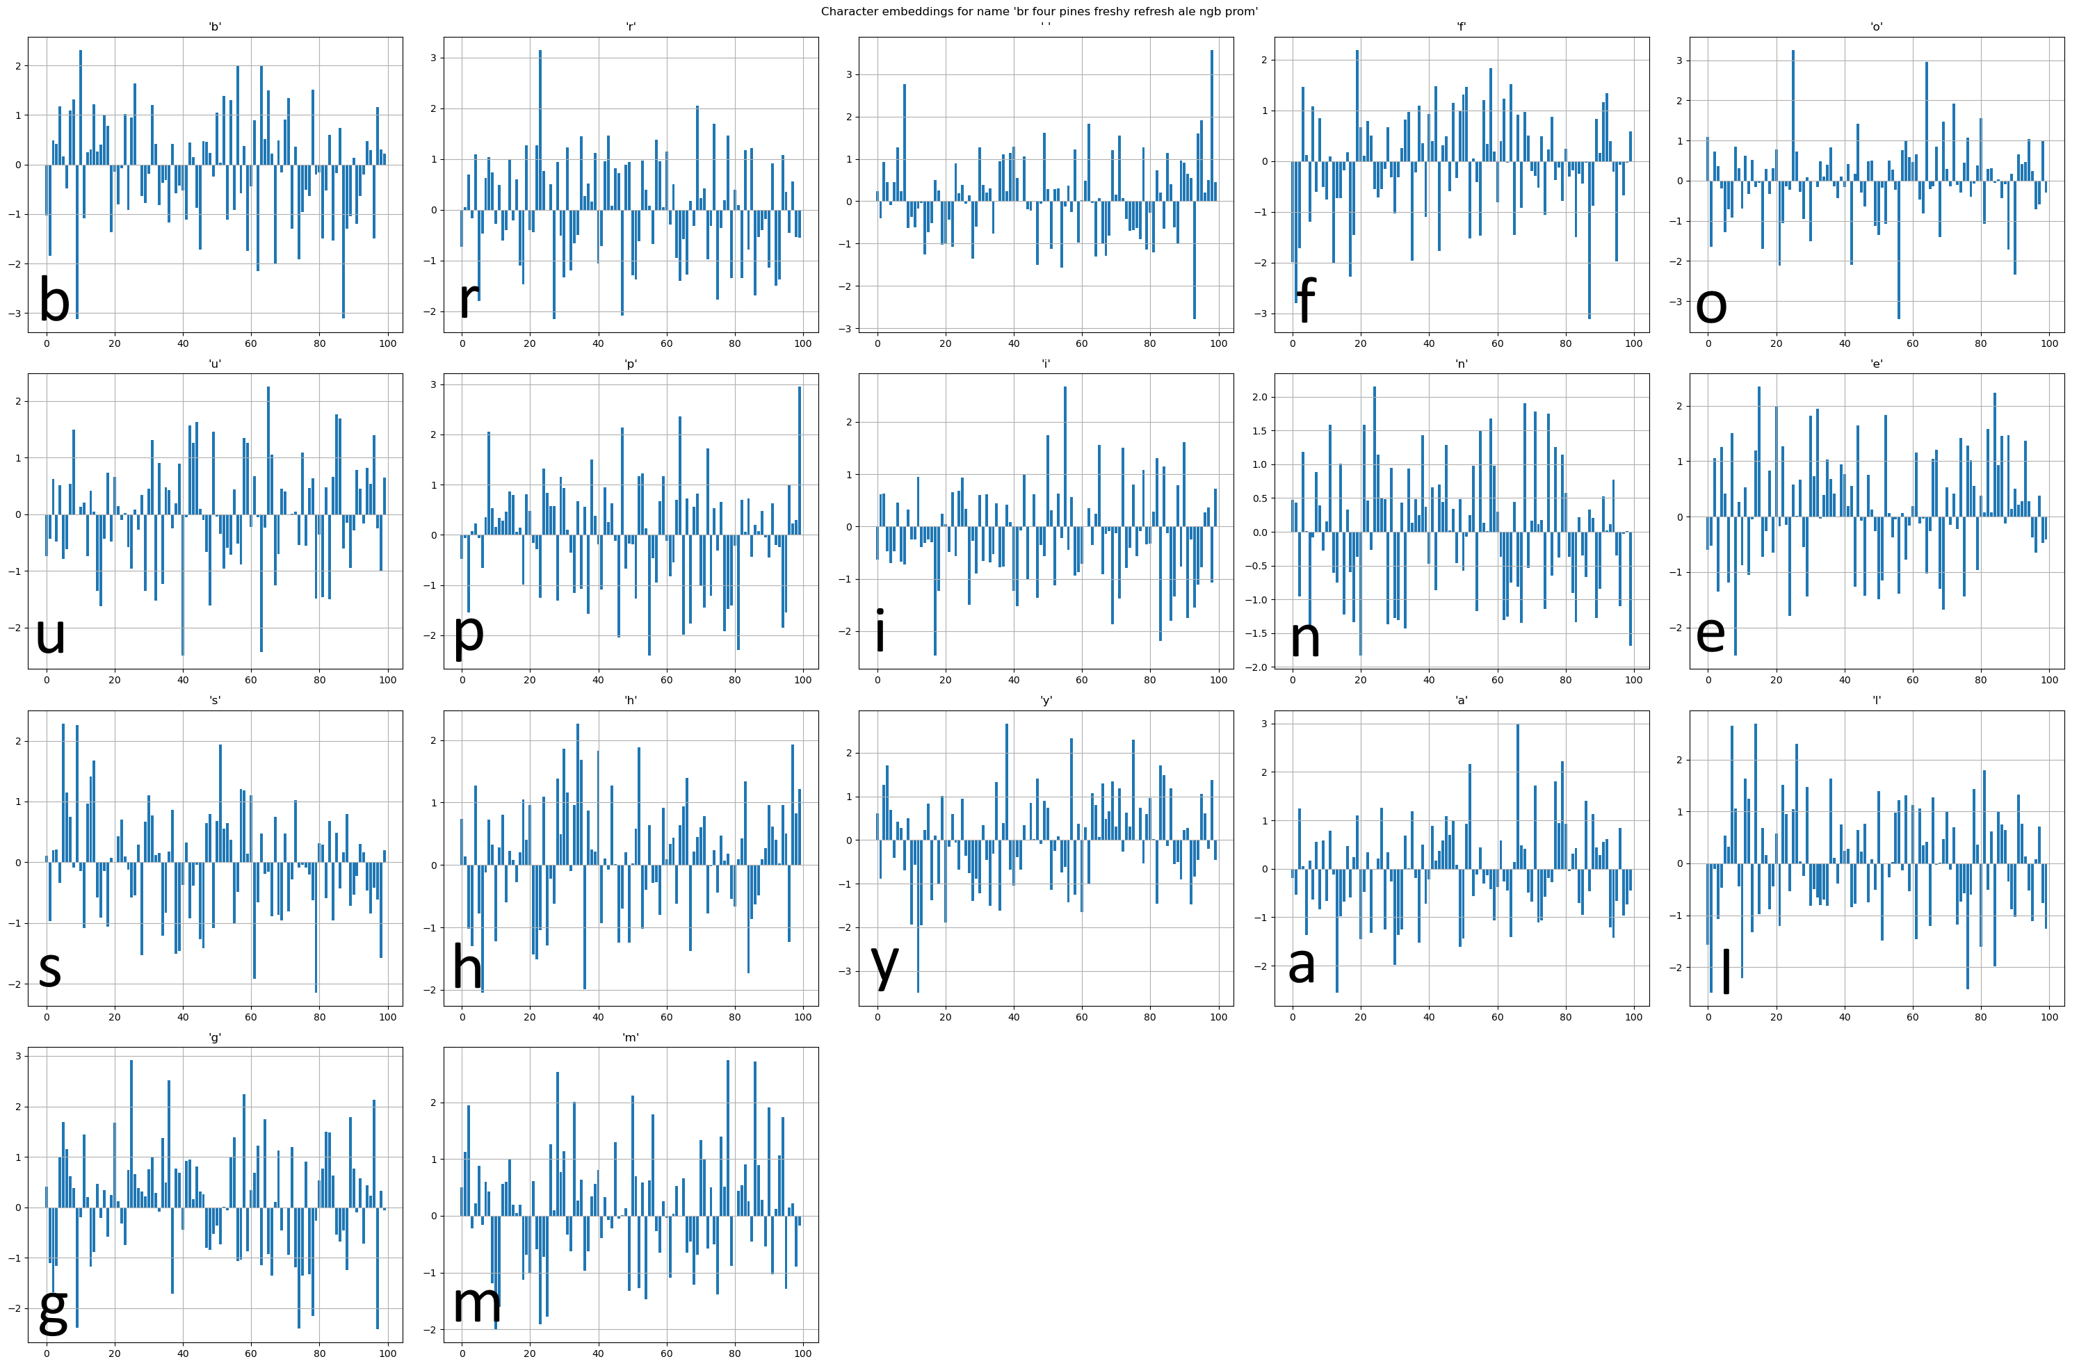Figure 17: Embedding visualisation for the name "br four pines freshy refresh ale ngb prom". Each bar chart is a 100D plot of the embeddings for each unique character.
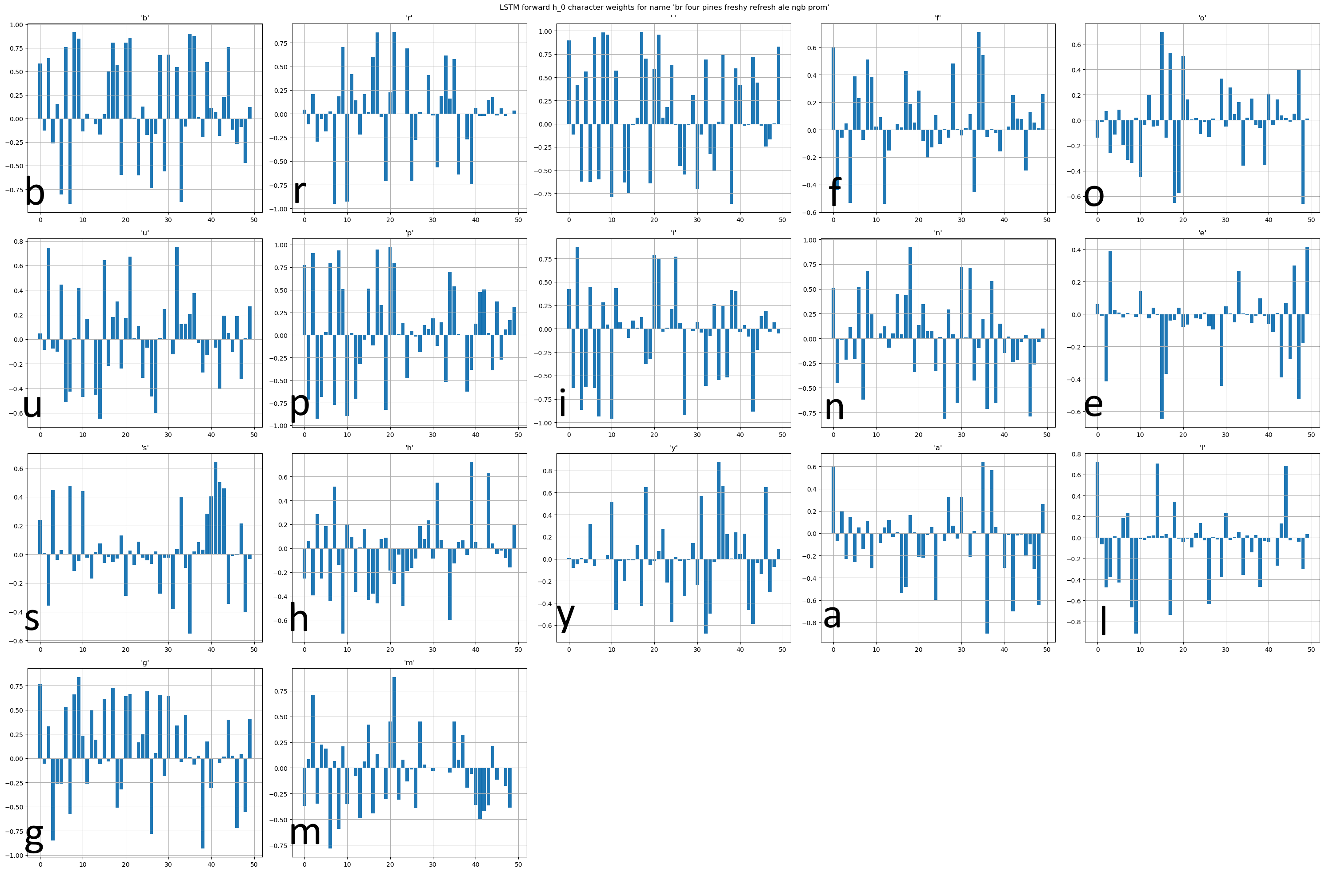Figure 18: Forward LSTM weights for each character.
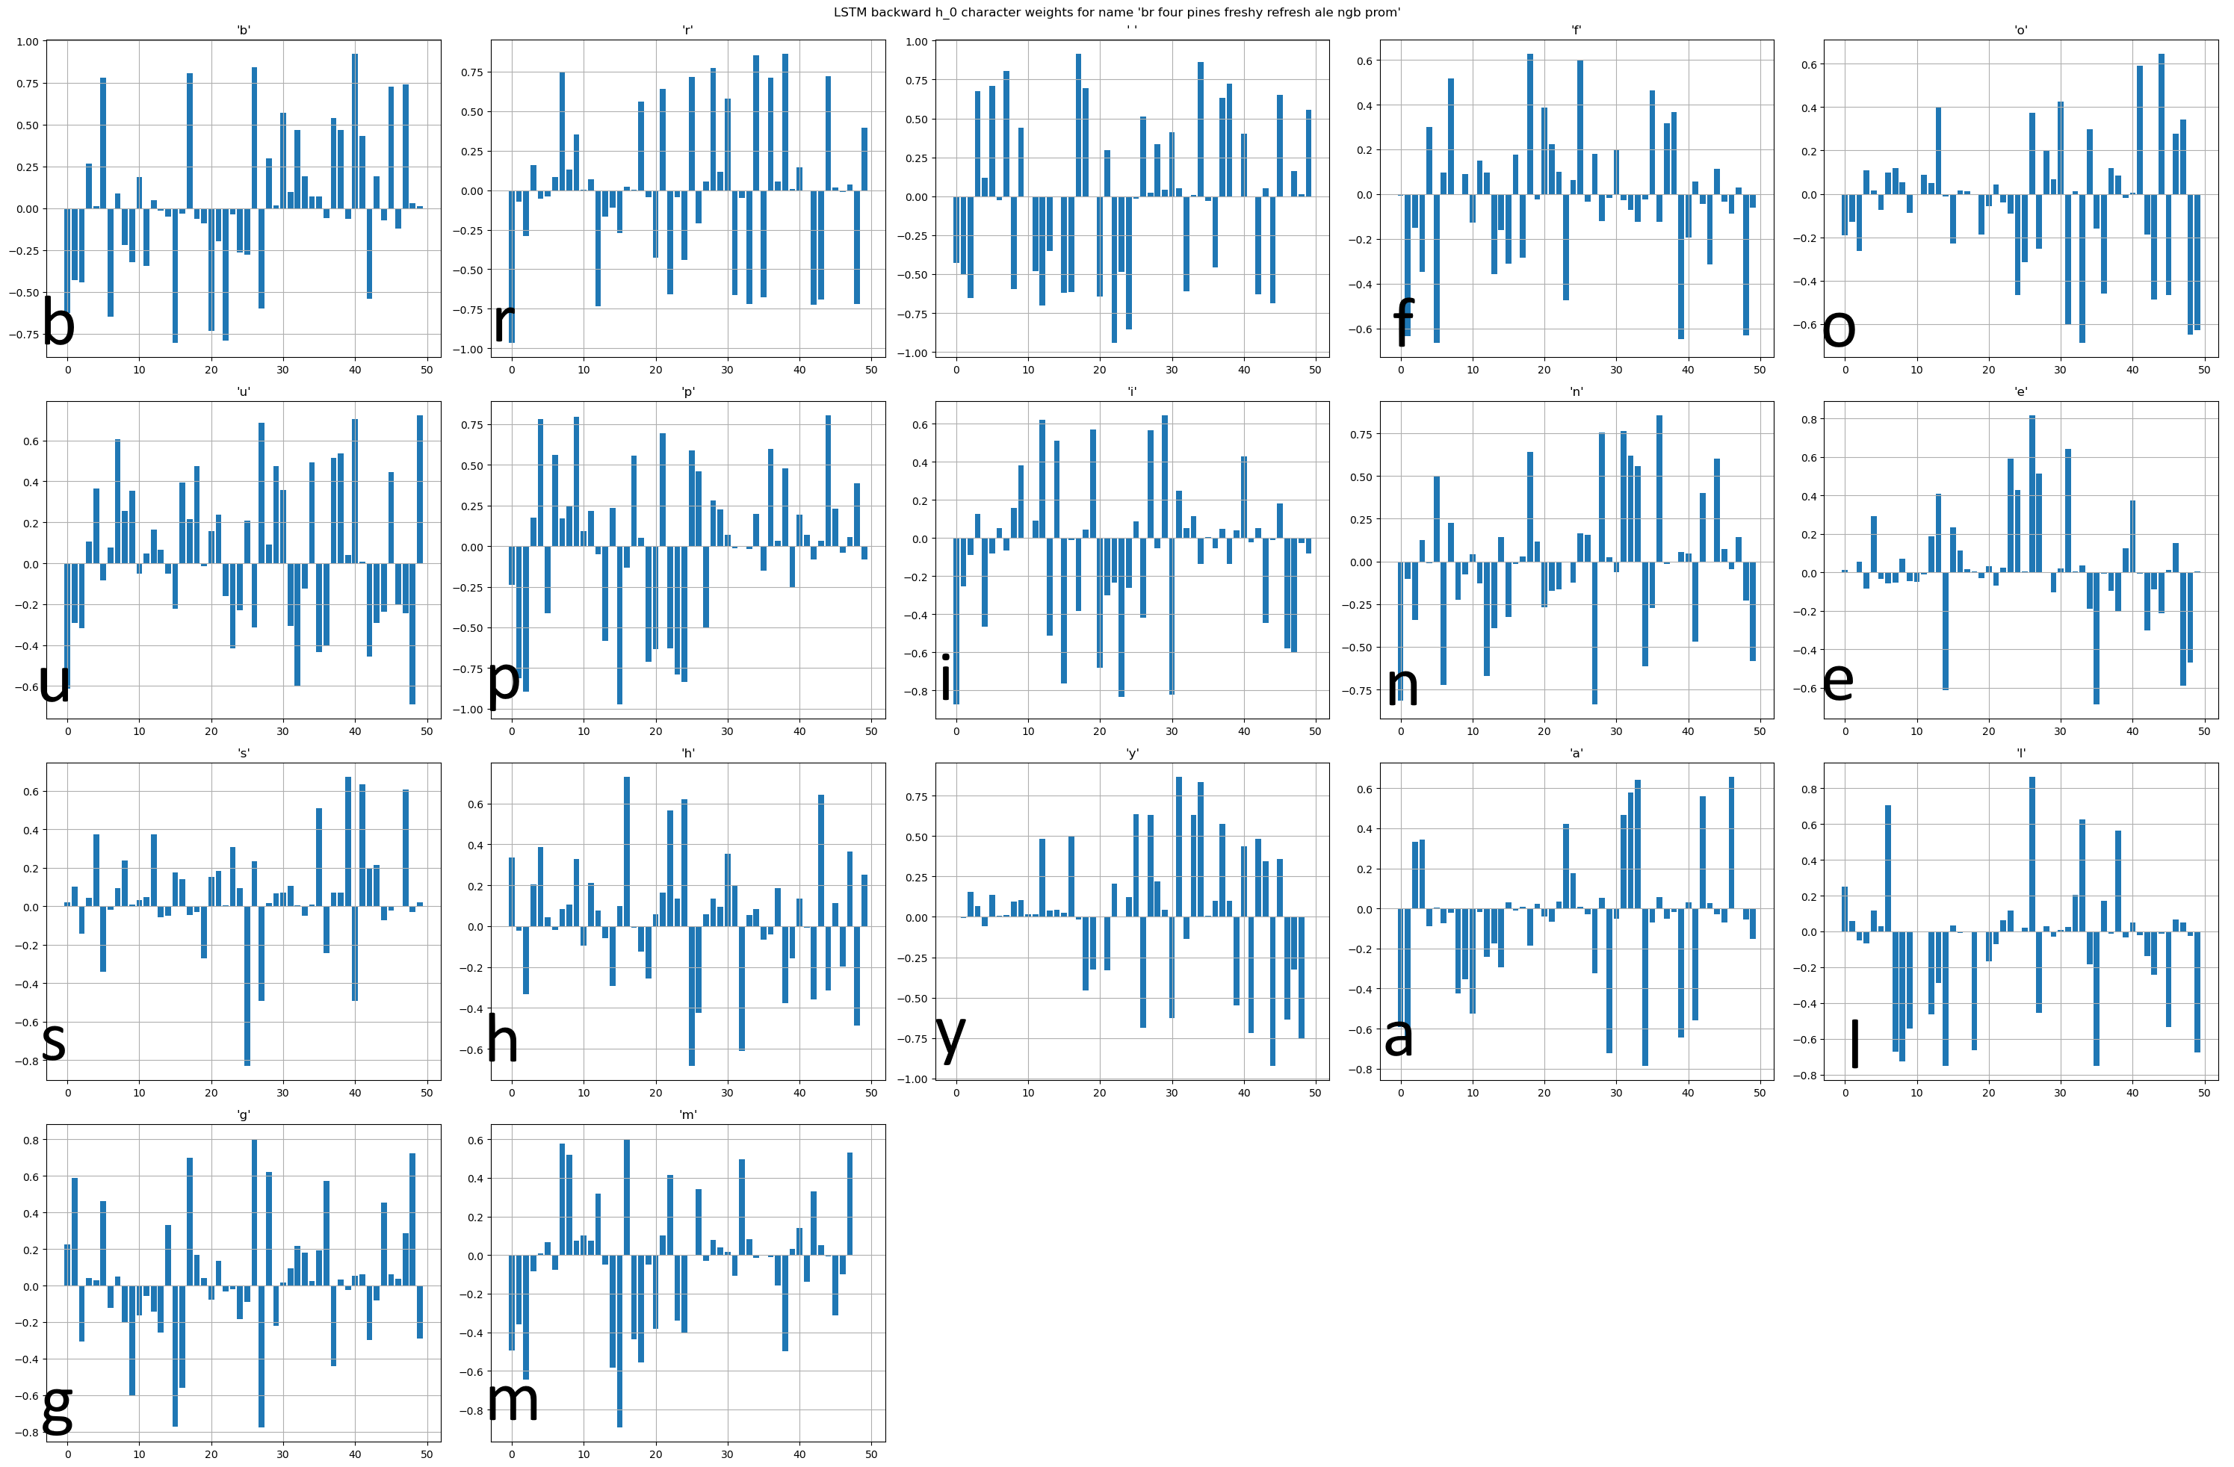Figure 19: Backward LSTM weights for each character.
We can observe that the forward portion of the LSTM is trying to emphasise the most on characters ‘b’, ‘’, and ‘s’ while suppressing the inputs of ‘a’, ‘i’ and ‘m’. Conversely, the backward portion of the LSTM emphasises ‘b’, ‘e’, ‘s’ and ‘y’ while suppressing ‘p’, ‘a’, ‘i’ and ‘m’. The interleaved weights will thus look like:
Where again, we can see very strong weights being assigned to ‘b’, ‘’, ‘e’ and ‘s’ with suppressant effects over ‘a’, ‘i’ and ‘m’.
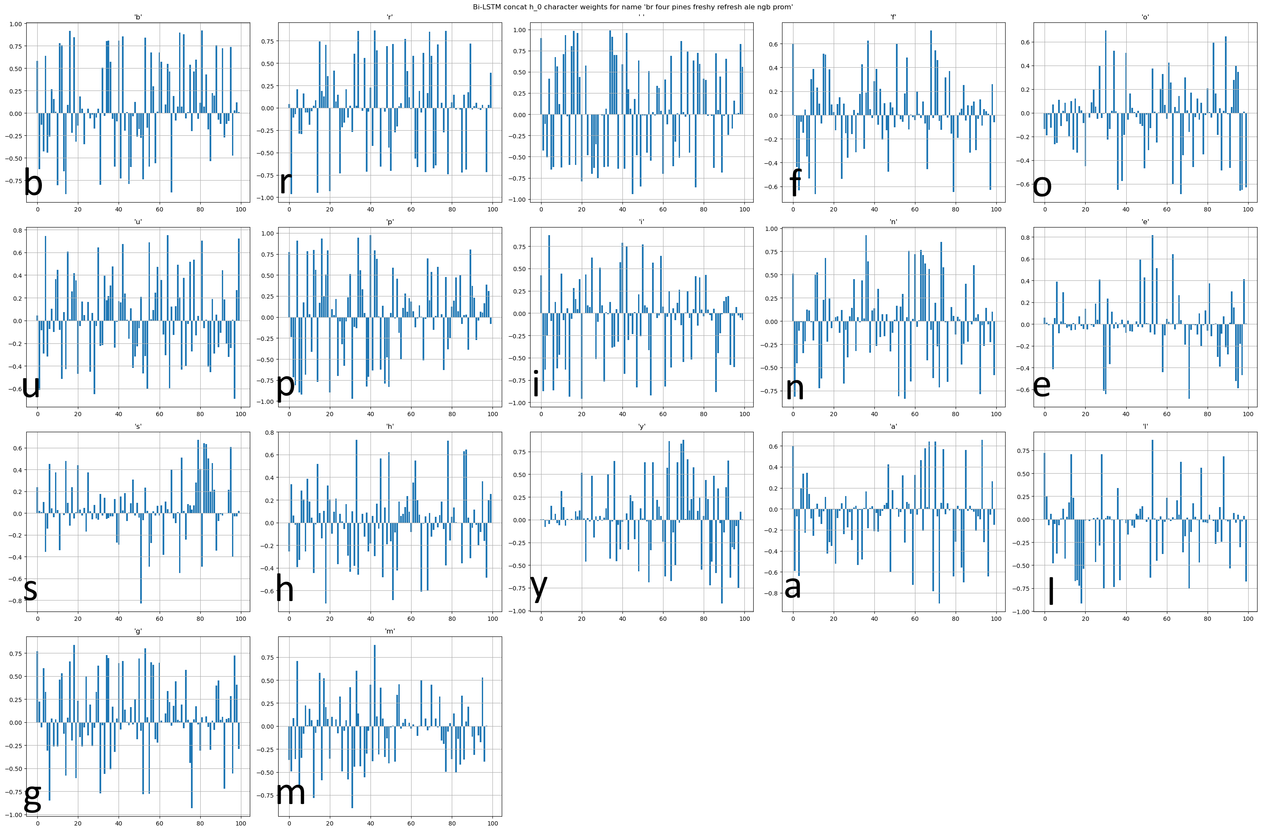Figure 20: Interleaved forward and backward LSTM weights per character.
The convolutional layer receives this tensor of weights and, in an effort to reduce the matrix down to , picks up signals 12 times from every set of 4 characters, skipping over 1 character with each iteration. Referencing the convolutional layer image, one kernel convolves 4 characters with a stride of 1; and there are 12 kernels. In other words, a tensor of kernels shaped is convolved over the input to yield a condensed feature map. This can be intuitively thought of as a human reading the input name again, searching for specific words that are 4 characters long in order to make sense of its structure. The human will subconsciously pay attention to certain portions of the name and suppress other regions, resulting in a mental “feature map” of the name.
The kernels themselves are not especially impressive. Yellow coloured regions represent the highest weight with navy-blue regions representing the lowest weight. The kernels simply collect latent information from each region of the input signal (i.e., each set of 4 characters), accentuating some portions of the signal while attenuating others. Note that they do not change with a different name, having been trained already.

We can inspect the output weights and feature map of the ELU-acitvated convolutional layer as well. The weights will be of significantly reduced dimension compared to the LSTM outputs:
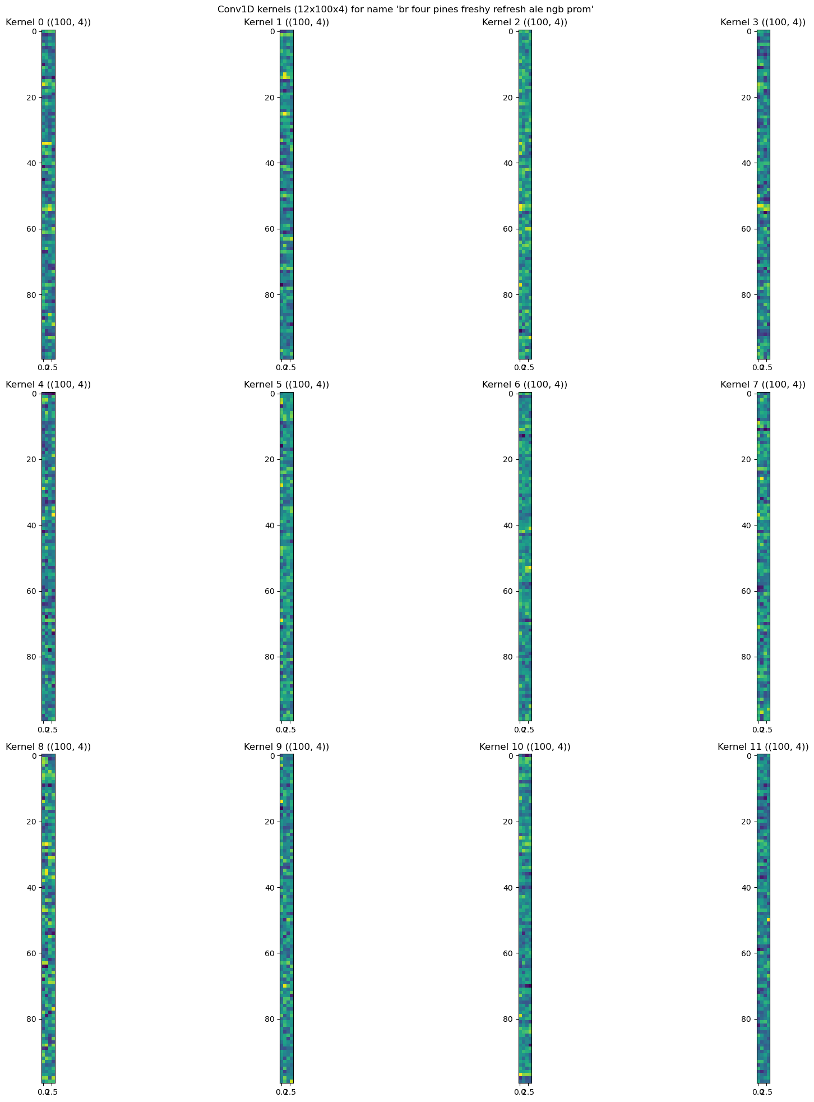Figure 21: RebateNet's trained 12 convolutional kernels, sized 100 rows by 4 columns.
Finally, we can also look at the final feature map output by the convolutional layer. This is the result of convolving each 4-gram signal over the input with the given weights per 4-gram:
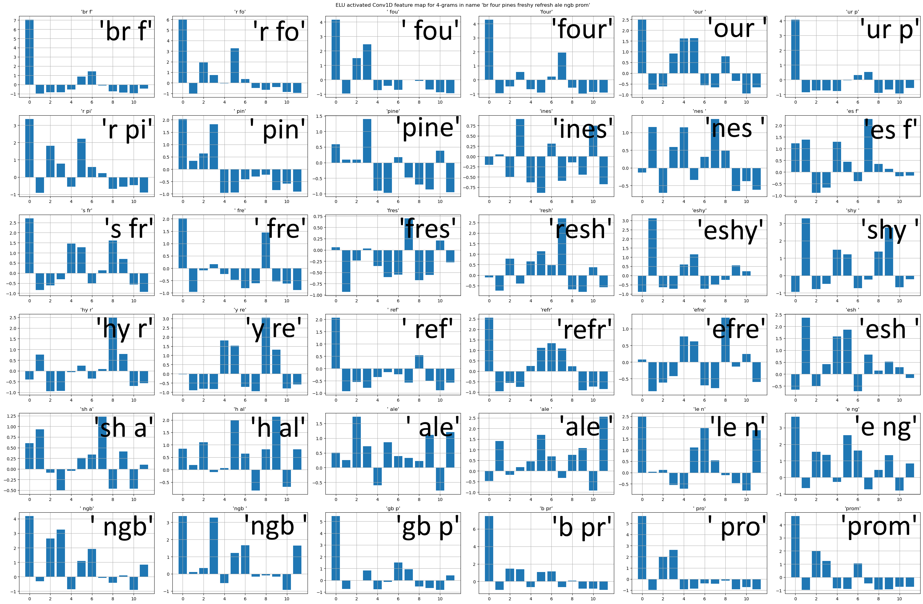Figure 22: ELU-activated convolutional weights over 4-grams over characters.
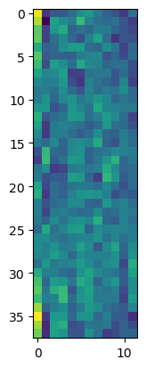Figure 23: Convolutional feature map.
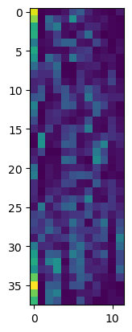Figure 24: ELU-activated convolutional feature map.
Clearly the ELU activation function accentuates the first dimension of 4-grams ‘br f’, ‘r fo’, ‘ fou’, ‘four’; and ‘gb p’, ‘b pr’, ‘ pro’, ‘prom’. Those are the 4-grams that contribute the absolute most to understanding the name “br four pines freshy refresh ale ngb prom”. The ELU activated weights for the name that perform such noise suppression look like:
Looking at another name for comparison, “ep brook ginger beer spiced lime can”, we can observe a very intuitive set of effects. The character embeddings show large amounts of weights given to ‘’, ‘r’, ‘k’, and ‘g’ with suppressant weights for ‘p’, ‘b’, and ‘c’ while the feature maps accentuate the signals given by 4-grams ‘p br’, ‘ bro’, and ‘broo’, ‘er b’, ‘beer’, ‘iced’, ‘me c’ and ‘can’, which one would expect to also be picked up by a human:
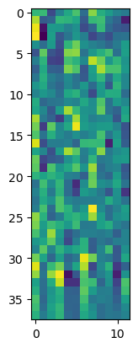Figure 25: Feature map for "ep brook ginger beer spiced lime can"
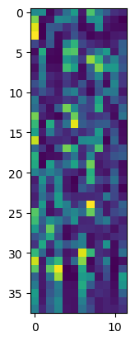Figure 26: ELU-activated feature map for "ep brook ginger beer spiced lime can"
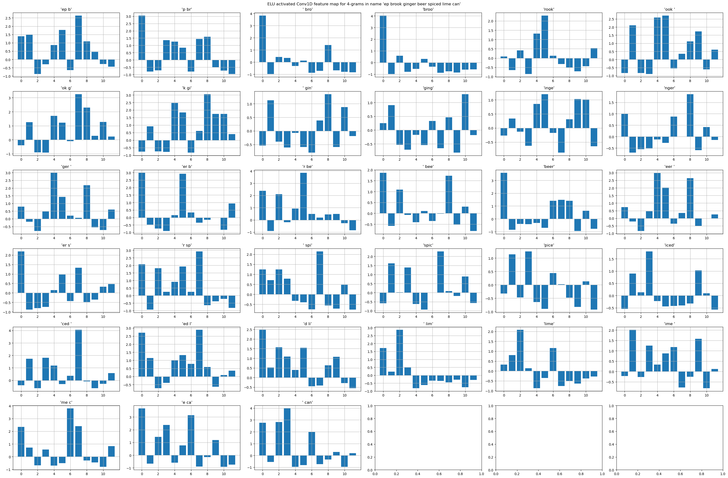Figure 27: ELU-activated convolutional weights for "ep brook ginger beer spiced lime can".

Conclusion
This submission tackles the business problem of semi-disjoint text classification with a common BiLSTM-CNN model, providing two main contributions:
- The business contribution is a reduction in manual effort by over half the initial time taken for the equivalent task.
- The academic contribution is the usage of the ELU activation function as a surrogate for convolutional max pooling.

Future Scope
RebateNet is not an all-encompassing model, and was never intended to be one. As its source data dynamically shifts and evolves over time, so too will the model be required to. One definite method of enriching input data is first running it through a Named Entity Recognition algorithm to expose obvious textual features like beverage names, then sending both the original data as well as the NER outputs through RebateNet. This should accomplish something along the following lines: in a name like “fa brookvle union gingr beer rk”, NER should strive to extract “ginger beer” as its output. Given a name like “ep somersby watermelon cider bottle”, NER should highlight “cider”. Such additional data representation would also allow the incorporation of word embeddings at a more abstract level, enhancing output quality.

Bibliography and References
- Daphne Koller et. al., Hierarchically Classifying Documents Using Very Few Words, ICML 1997: Proceedings of the Fourteenth International Conference on Machine Learning, pp. 170-178, July 1997.
- NAVER Engineering, Auto-classification of NAVER Shopping Product Categories using TensorFlow, TensorFlow Blog, 20 May 2019.
- Hadi Jahanshahi et. al., Text Classification for Predicting Multi-level Product Categories, 31st Annual International Conference on Computer Science and Software Engineering, arXiv, 02 September 2021.
- Aixin Sun et. al., Hierarchical text classification and evaluation, Research Collection School of Computing and Information Systems, Singapore Management University, November 2001.
- Roger Stein et. al., An Analysis of Hierarchical Text Classification Using Word Embeddings, arXiv, 06 September 2018.
- Ye Liu et. al., Enhancing Hierarchical Text Classification through Knowledge Graph Integration, ACL 2023, July 2023.
- Sriram Vajapeyam, Understanding Shannon’s Entropy metric for Information, arXiv, 24 March 2014.
- Gilberto Espinosa-Paredes, Fractional-Order Models for Nuclear Reactor Analysis, ISBN 978-0-12-823665-9, 2020.
- Wikipedia: Entropy (Information Theory), last accessed 16 November 2023.
- Frank Keller, Formal Modelling in Cognitive Science lecture notes, School of Informatics, University of Edinburgh, 06 March 2006.
- Tomas Mikolov et. al., Efficient Estimation of Word Representations in Vector Space, arXiv, 07 September 2023.
- Tal Perry, Character Level NLP, Lighttag, last accessed 16 November 2023.
- Max Woolf, Embeddings for Deep Learning and Automatic Text Generation, 04 April 2017.
- Spiridion The Sun Rotator, How to Determine the Embedding Size, AI StackExchange, 07 July 2023.
- Hacks for AI, How to Adopt Embeddings for Categorical Features in Tabular Data using PyTorch, 23 November 2022.
- Wikipedia: Hellinger Distance, last accessed 16 November 2023.
- Encyclopedia of Math: Hellinger Distance, last accessed 16 November 2023.
- Khaleda Sathi et. al., Attention-assisted hybrid 1D CNN-BiLSTM model for predicting electric field induced by transcranial magnetic stimulation coil, Nature 2494, 13 February 2023.
- Yuecong Min et. al., Visual Alignment Constraint for Continuous Sign Language Recognition, ICCV 2021, 18 August 2021.
- Jimut Bahan Pal, Deceiving computers in Reverse Turing Test through Deep Learning, arXiv, 01 June 2020.
- Chao Wu et. al., Camera-Conditioned Stable Feature Generation for Isolated Camera Supervised Person Re-Identification, CVPR 2022, 04 April 2022.
- Liqun Shan, CNN-BiLSTM hybrid neural networks with attention mechanism for well log prediction, Journal of Petroleum Science and Engineering, Volume 205, October 2021.
- Gregor Wiedemann, Transfer Learning from LDA to BiLSTM-CNN for Offensive Language Detection in Twitter, GermEval 2018, 14th Conference on Natural Language Processing (KONVENS 2018), September 2018.
- Sepp Hochreiter, Long Short-Term Memory, Neural Computation 9(8):1735-80, December 1997.
- Xiangang Li, Constructing Long Short-Term Memory based Deep Recurrent Neural Networks for Large Vocabulary Speech Recognition, arXiv, 11 May 2015.
- Wikipedia: Long Short-Term Memory, last accessed 16 November 2023.
- Ahmed Tealab, Time series forecasting using artificial neural networks methodologies: A systematic review, Future Computing and Informatics Journal, Volume 3, Issue 2, pp. 334-340, December 2018.
- Stephen G. Brush, History of the Lenz-Ising Model, Reviews of Modern Physics 39, pp. 883, 01 October 1967.
- Wikipedia: Recurrent Neural Network, last accessed 16 November 2023.
- Wikipedia: Convolutionall Neural Network, last accessed 16 November 2023.
- Djork-Arne Clevert, Fast and Accurate Deep Network Learning by Exponential Linear Units (ELUs), ICLR 2016, 22 February 2016.
- Kunihiko Fukushima, Neocognitron: A Self-Organizing Neural Network Model for a Mechanism of Visual Pattern Recognition, Competition and Cooperation in Neural Nets pp 267–285, 01 October 2011.
- Kunihiko Fukushima, Visual Feature Extraction by a Multilayered Network of Analog Threshold Elements, IEEE Transactions on Systems Science and Cybernetics, Volume 5, Issue 4, October 1969.
- Sven Behnke, Hierarchical Neural Networks for Image Interpretation, LNCS volume 2766, ISBN 978-3-540-40722-5, 18 November 2003.
- Andrew L. Maas et. al., Rectifier Nonlinearities Improve Neural Network Acoustic Models, Stanford University, ICML 2013, last accessed 16 November 2023.
- Wikipedia: Softmax Function, last accessed 16 November 2023.
- Sashank J. Reddi et. al., On the Convergence of Adam and Beyond, ICLR 2018, 19 April 2019.
- Vijay Dubey, A model with multiple outputs, PyTorch discussion forums, November 2017.
- Joshua Clancy, Multiple outputs, losses, and optimizers, PyTorch discussion forums, May 2020.
- Jvans, What does the parameter retain_graph mean in the Variable's backward() method?, StackOverflow, 16 October 2017.
- Valentin Calomme, Weighted loss functions vs weighted sampling, Data Science Stack Exchange, 05 June 2020.
- Mastafa Foufa, Address class imbalance easily with Pytorch Part 2, TowardsDataScience, 11 May 2020.
- K. Frank, WeightedRandomSampler vs Weighted CrossEntropyLoss for imbalanced Dataset, PyTorch discussion forums, April 2020.
- Wikipeda: Cross-Entropy, last accessed 16 November 2023.
- Baptiste Pouthier, How is a multiple-outputs deep learning model trained?, StackOverflow, 22 July 2019.
- PyTorch Documentation: Cross Entropy Loss, last accessed 16 November 2023.
- Leland McInnes et. al., UMAP: Uniform Manifold Approximation and Projection for Dimension Reduction, arXiv, 18 September 2020.
- Kjetil B. Halvorsen, Intuition of the Bhattacharya Coefficient and the Bhattacharya distance?, Statistics StackExchange, 07 August 2017.
- Xian, Differences between Bhattacharyya distance and KL divergence, Statistics Stack Exchange, 27 December 2014.
- Franck Dernoncourt, Softmax vs Sigmoid function in Logistic classifier?, Statistics Stack Exchange, 01 January 2017.

Appendix

Preprocessing regex and operations
The first stage of preprocessing involved the sequential application of the following regex filters and transformations. Note that the regex is given in accordance with common UNIX syntax s///g:
Table 13: Sequential regex filters applied during stage 1 of preprocessing.
No. | Description | Regex
1 | Remove all “ML” suffixes if followed by a digit. | /(?<=\d)ML//
2 | Remove all “X” or “x” characters if followed by a space or a digit. | /(?<= |\d)[Xx]+//
3 | Remove all “ml”, “MLT” suffixes if followed by a digit. | /(?<=\d)[mlMLT]+//
4 | Replace the words “tra” with “xtra”; a side effect caused by (2). | /tra/xtra/
5 | Replace the words “pa” with “xpa”; a side effect caused by (2). | /pa/xpa/
6 | Replace the variants of brand name “4 pines” with alphabets. | /(4PINES)|(4PINE)|(4 PINES)|(4 PINE)|(4P)|(4 P)/four pines/
7 | Replace the variants of brand name “5 seeds” with alphabets. | /(5 seeds)|(5 Seeds)|(5seeds)|(5Seeds)/five seeds/
8 | Remove all non-alphabetical characters, including spaces. | /[^a-zA-Z ]//
9 | Replace the remaining variants of brand name “lashes” with its alphabetical equivalent of “one fifty lashes”; a side effect caused by (8). | /(lashes)|(lash)|(lashe)/one fifty lashes/
10 | Replace the remaining variants of brand name “bells” with its alphabetical equivalent of “seven bells”; a side effect caused by (8). | /bells/seven bells/
11 | Finally, recalculate the first field in the CSV so that spaces are squeezed. | cat data.csv | awk ‘{$0=$0} NF;’ >> data.csv

The second stage of preprocessing was performed in Python, and involved the following steps:
- Remove all rows where “litres” is null.
- Strip and transform all text to lowercase.
- Replace the “category” label “n/a” with the label “unknown”, since “n/a” is a valid category.
- Cast all columns to their appropriate computational data types.
- Remove all duplicate rows relative to “name” and “litres”. Rows where “name” and “value” are both the same – regardless of “type”, “brand” or “category” – are slated for removal.
- Replace “category” labels deemed ambiguous with the literal word “ambiguous”.
- Remove rows that have less than a set threshold number of occurrences across all conditional combinations of our target columns, “type”, “brand” and “category”.
The corresponding code as part of the dataloader for training data looks like this:
df_original = (df.copy(deep = True))
df_preproc = (df_original
.drop(columns = "code",
index = np.where(df_original["litres"].isnull())[0])
.apply(lambda x: (x
.str.strip()
.str.lower()
if x.dtype == "object"
else x))
.fillna({"category": "unknown"})
.astype({"litres": "float",
"type": "category",
"brand": "category",
"category": "category"})
.drop_duplicates(subset = X_names, ignore_index = True)
.replace({"category": {c: "ambiguous"
for c in ambiguous_X}}))
df_preproc = (df_preproc
.drop(index = (np
.where(df_preproc
.groupby(Y_names,
observed = True)
.transform("count")
.iloc[:, 0]
.le(MIN_RECORDS))[0]
.tolist()))
.apply(lambda x: (x
.cat
.remove_unused_categories()
if x.dtype == "category"
else x))
.sort_values(by = "name",
key = lambda x: x.str.len(),
ascending = False)
.reset_index(drop = True)
.to_dict(orient = "series"))
### -------------------------- preproc X -------------------------- ###
X_inputs = {X: df_preproc[X] for X in X_names}
X_inputs["name"], token_vocab = process_names(
use_chars
)
X_inputs["litres"] = (X_inputs["litres"]
.sub(X_inputs["litres"].mean())
.div(X_inputs["litres"].std())
.to_numpy())
### -------------------------- preproc Y -------------------------- ###
Y_outputs = {Y: df_preproc[Y] for Y in Y_names}
Y_outputs, labelEncoders = encode_targets()
class_weights = compute_class_weights()

The corresponding code as part of the dataloader for inference data looks like:
df_original = (df_infer.copy(deep = True))
df_preproc = (df_original
.apply(lambda x: (x
.str.strip()
.str.lower()
if x.dtype == "object"
else x))
.astype({"litres": "float"})
.dropna()
.sort_values(by = "name",
key = lambda x: x.str.len(),
ascending = False)
.reset_index(drop = True)
.to_dict(orient = "series"))
train_label_encs = train_dataset._view_label_encoders()
train_token_vocab = train_dataset._view_tokenised_vocab()
train_use_chars = train_dataset._view_use_chars_boolean()
### -------------------------- preproc X -------------------------- ###
X_names = list(train_dataset._view_inputs().keys())
X_inputs = {X: df_preproc[X] for X in X_names}
X_inputs["name"] = process_names(X_inputs["name"],
train_dataset)
X_inputs["litres"] = (X_inputs["litres"]
.sub(X_inputs["litres"].mean())
.div(X_inputs["litres"].std())
.to_numpy())

With the obvious checks to ensure that the maximum length of inference names is less than or equal to the maximum length of training names, which in our case is 41 characters.

Relationship between the Hellinger distance, Bhattacharyya distance, and the Kullback-Leibler divergence
The Bhattacharyya distance is defined as:

And can be turned into the Hellinger distance as:

The main difference between the three is that the Bhattacharyya and Hellinger distances are metrics, while the KLD is not^{[48]}. The Bhattacharyya distance between probability distributions P, Q measures and angle in radians on a geodesic connecting P and Q, which is symmetric. The KLD measures the information difference in bits when going from Q to P, assuming discrete distributions. A connection between the Hellinger distance the Kullback-Leibler divergence can be given by^{[49]}:

Relationship between the Softargmax and the Sigmoid
In cases where the number of output labels is equal to 2, for example in our dataset we have “brand” as being either “cub” or “lion”, common convention is to use a scalar-valued sigmoid:

However, we can choose between two or more classes in two ways. Let’s take the example of classifying “type”, where there are 3 possible classes: either the model can output 3 probabilities, indicating whether label 1, 2, or 3 is the most likely; or it can perform One-Versus-Rest (OVR) classification where it picks binary combinations indicating whether a product is “label 1 or not label 1”, “label 2 or not label 2”, “label 3 or not label 3”, etc. It should be noted that OVR is slightly more complicated to not only implement, but visualise the decision boundaries of as well since there are multiple combinations of output classes possible.
This is all worth noting because it can be shown that the Sigmoid is a special case of Softargmax^{[50]}, or that Softargmax is a generalisation of the sigmoid, with the binary two class scenario yielding the following, where is the Softargmax representation written slightly differently:

Because the Softargmax is a generalisation of the sigmoid, binary classification models – instead of outputting a single number – can be redesigned to output two numbers, one for each class, WLOG.

Word embedding results
 | Precision | Recall | F1 Score | Support
type
draught | 0.91 | 0.88 | 0.90 | 239
package | 0.96 | 0.97 | 0.97 | 749
postmix | 1.00 | 1.00 | 1.00 | 12
accuracy |  |  | 0.95 | 1000
macro avg | 0.96 | 0.95 | 0.95 | 1000
weighted avg | 0.95 | 0.95 | 0.95 | 1000
brand
cub | 1.00 | 1.00 | 1.00 | 473
lion | 1.00 | 1.00 | 1.00 | 527
accuracy |  |  | 1.00 | 1000
macro avg | 1.00 | 1.00 | 1.00 | 1000
weighted avg | 1.00 | 1.00 | 1.00 | 1000
category
ambiguous | 0.86 | 0.76 | 0.81 | 58
craft | 0.89 | 1 | 0.94 | 83
pack | 0.95 | 0.97 | 0.96 | 726
postmix | 1 | 1 | 1 | 12
tap | 0.88 | 0.78 | 0.82 | 121
accuracy |  |  | 0.93 | 1000
macro avg | 0.92 | 0.9 | 0.91 | 1000
weighted avg | 0.93 | 0.93 | 0.93 | 1000

As mentioned, word embeddings did not yield comparable results to character embeddings, despite the training time being significantly less and words being theoretically more expressive than characters. This is perhaps attributable to the lack of semantic meaning that can be adequately captured from “name”, or there simply isn’t enough data to optimise word embeddings of any dimension.

* rahuls@quantaco.co, peer reviewed by Alen Bukashev (alenb@quantaco.co)

