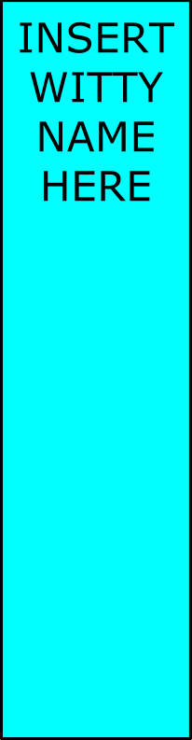

Insert Witty Name Here

Sunny Day Care Web Application



Documentation

Copyright © 2015 Insert Witty Name Here

Joshua Sigloch Tyberius Enders

Josée Giron Christopher Leamon

**Introduction**

Hello we are Insert Witty Name Here, a small software development company located in Aurora CO. A local daycare facility called Sunny Daycare hired us to build them a program that would provide essential services for the daycare including all necessary information for the day care and to facilitate all day to day business as well. This includes basic data for all employees that will use the system, demographic and billing data for the daycares client's, and demographic and personal data for the children at the daycare. Sunny Daycare also wanted to have an events calendar built in to the program that would save and notify other people of events through e-mail, a means of recording complaints to be accessed later and alerts for both billing and security purposes.

**System Overview**

The system will be an easy to use program that will record necessary information for every person involved in the daycare, handle billing and the every day check in and check out. Making the program easy to use is one of the key points since it's likely that the employees that will use the system at the daycare have little to no experience on a computer. We will use a simple login screen than the number of things a person can do will depend on their level of access to the system. A level 1 person would be able to log a child in or out, register a new child or client, look up a child or client and post events on to the calendar; a level 2 person would also be able to post up incidents and reports; a level 3 person would have the added abilities to post that a bill has been paid and update the client and child information; and a level 4 person would be able to do all that and add on new employees to the system and be able to view employee incidents as well.

Aside from making the interface easy to use we also made it easier through the way that information is handled as well. With the child registration their allergies and any restrictions they may have are put in and is displayed when the child is checked in and checked out. The same thing is done when an incident is filed against the child or one of the people that picks the child up and for billing as well. The information as all shown in the login and logout screen for the daycare provider to stay on top of the information. The search module also makes it easy for the user to find any information that is needed on the client and child; and for the level 4 users it makes it easy to find any information on any of the employees there.

With the above program we have been given 11 weeks to build the program, test it and make sure it was in good working order and to write the user's manual to help the users at the daycare. The first step in designing the program is to find what all of the requirements are and we found this out by talking with both the client and talking amongst ourselves. We came up with a list of all of the different inputs and outputs that would be needed for the system. All of the different inputs and outputs in picture 1a below. We also decided to do the program in a web app where we use MySql for the database, HTML5 webpage for the face of the program and PHP to control everything and put in the content.

**Design**

The overall design for the program has been focused on having all of the functionality that the daycare wanted while making the program easy to use at the same time. Keeping the functions in mind we are also keeping in mind that some of the users are people that have zero experience on a computer

-DB Design

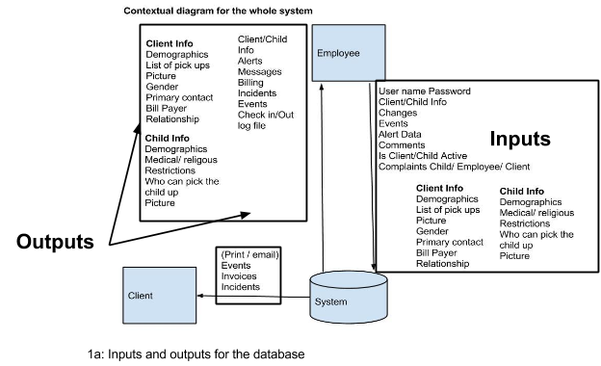

The database is structured using MySQL, a free open source database that works very well with JavaScript, HTML5 and PHP. The diagram below shows all of the different entities that are involved in the database and what their connections are as well. The Employee entity and the Employee Incident entity are the only parts that are not connected to all of the entities in the system. The two entities that everything else in the database flows off of is the child element and the client element. The client is the main thing that make a lot of the calls, brings and child and sets the child standards. The child is what a day care is about in the first place and a large part of the program and database is tailored just for the child. Than off of the client you have the entire billing structure keeping track of the child's hours and amount that has been paid. Than the relationship that is only on the child module is the medical informations and other restrictions. Something that the child entity, client entity, and the employee entity has is the Alert and Incident entities attached to them.

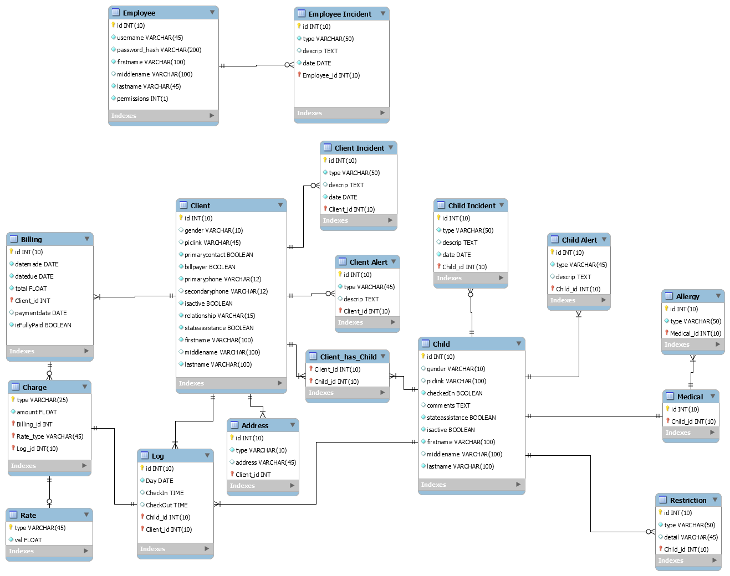

1b: ERD (Entity Relationship Diagram)

**Client Entity**

With the client entity the main thing is to ensure correct input of their demographic information. The client's full name address and the child that they are allowed to pick up.

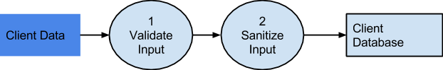

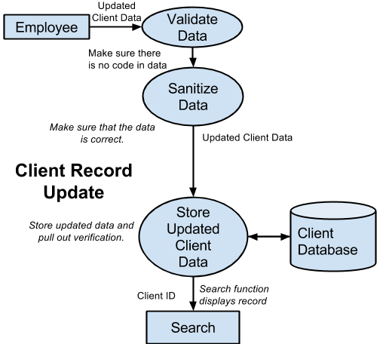

---Employee

The employee entity is composed entirely of a person's full name, username, password and

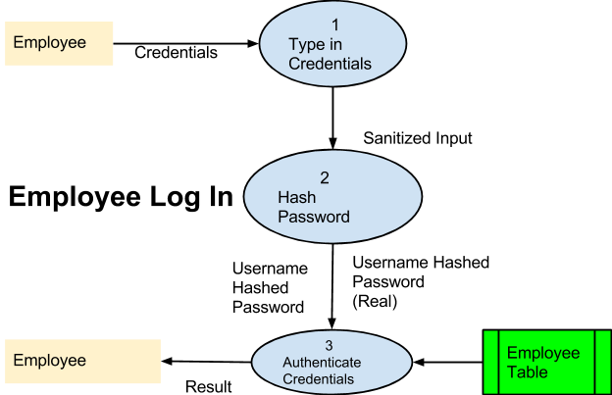

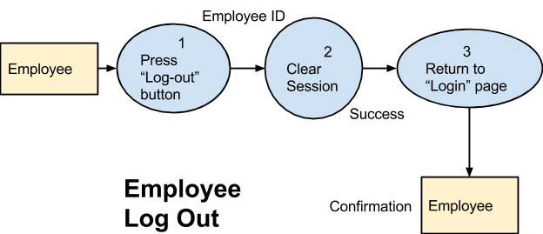

---Children

The system need their full name, demographic information, medical information focusing on allergies and medication and other restrictions like religious, diet and other restrictions.

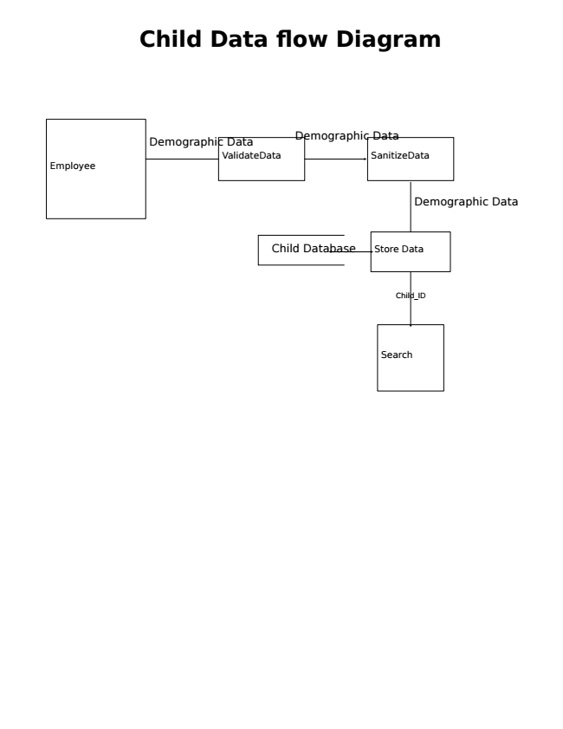

---Medical

Medical pertains to any kind of handicap or medical condition the child may have.

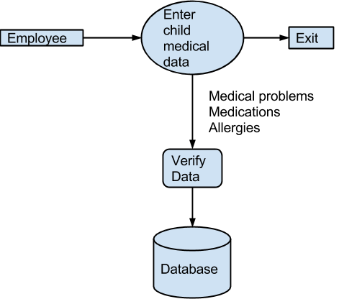

---Food

Has to do with any kind of food restrictions the child may have, due to medical, religious or dietary reasons.

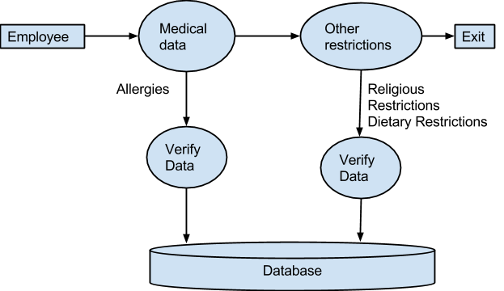

---Allergies

Any kind of allergies the child may have, the daycare needs to know about.

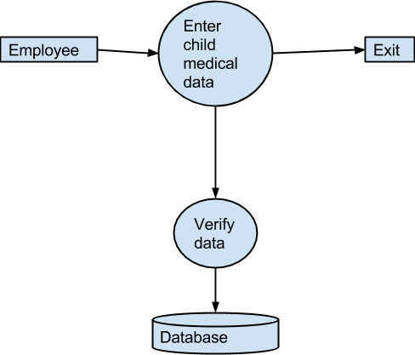

---Billing

Tracking what the client has been charged, what they've paid and the running total.

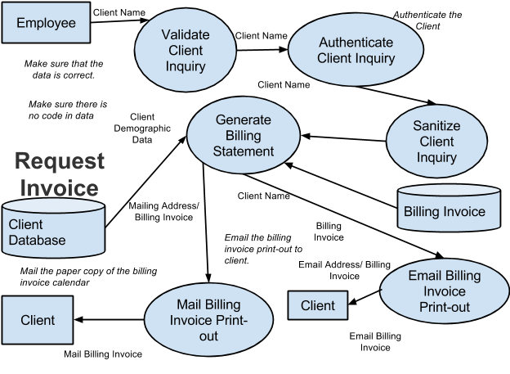

---Alerts

Used for billing that's way past due, multiple small complaints against a child or client, or a major complaint that sometimes calls for calling the cops.

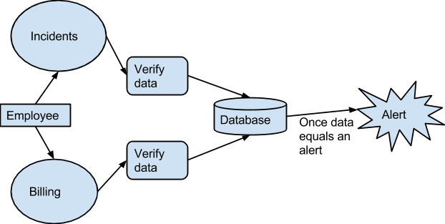

---Incidents

Made for entering a quick incident.

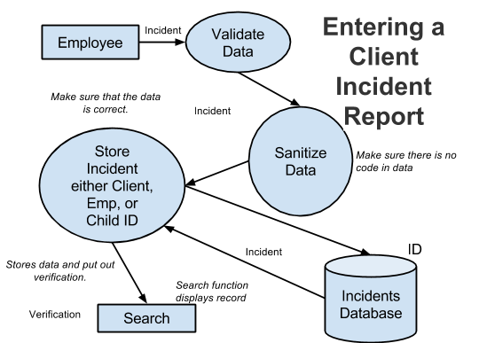

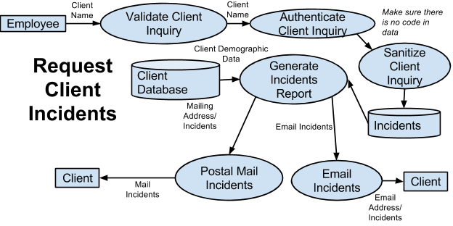

---Events

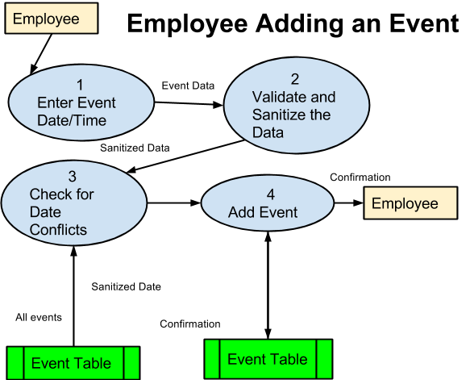

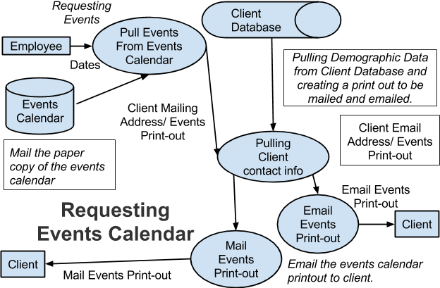

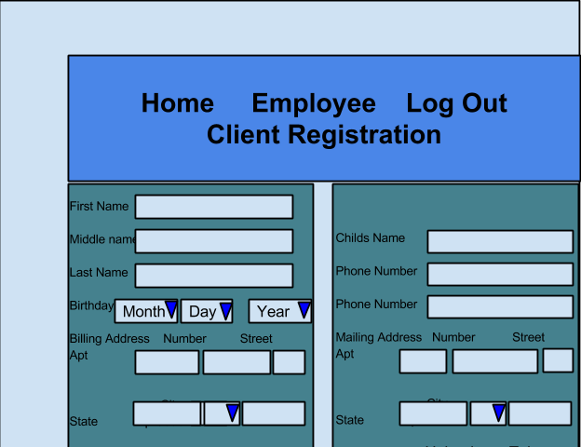

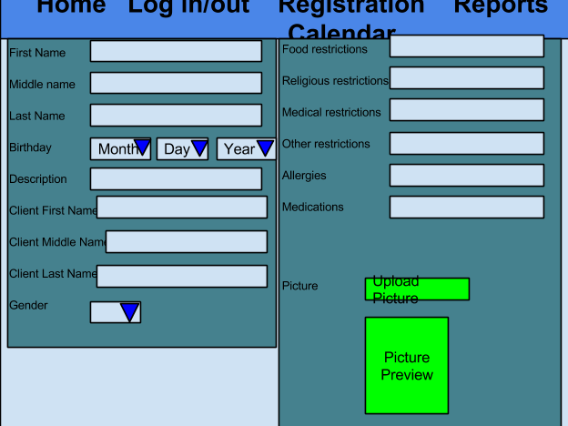

Build

-Setup software on teams computers

Have used the Github software, Notepad++, HTML kit,

--Setup version control

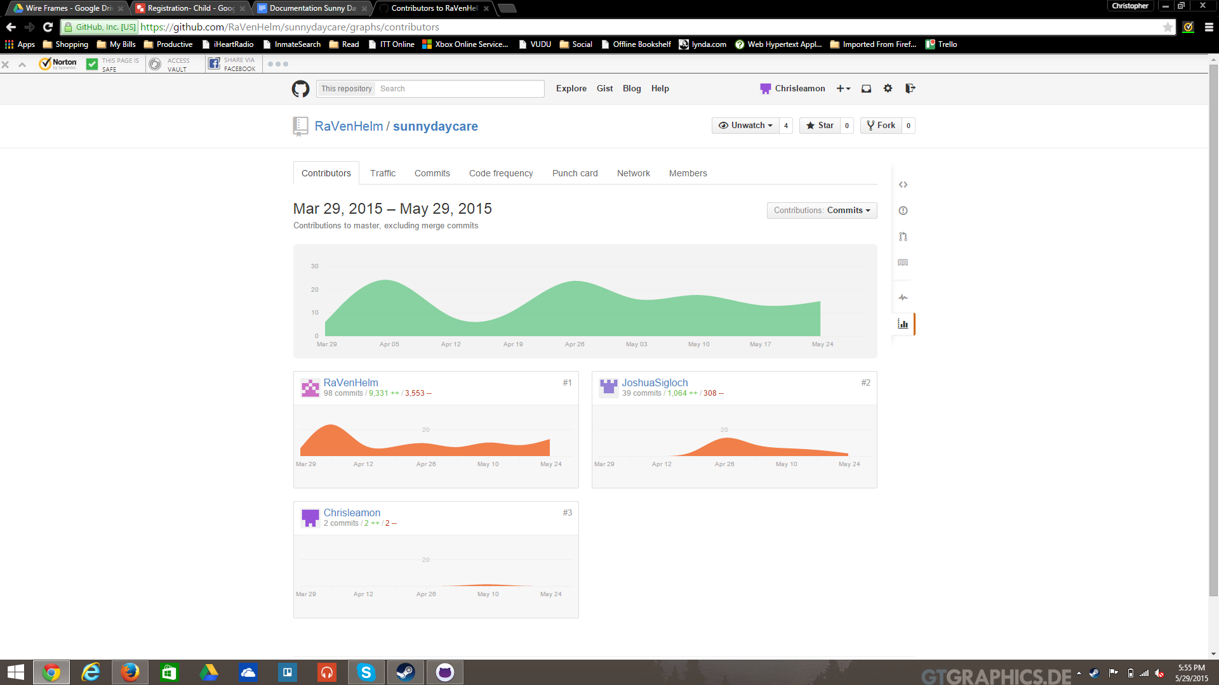

5.0 System Manual—organized into sections and alphabetically

6.0 Testing Documents; see testing documents.

6.1 Testing Plans: It should include all the possible testing, such as unit testing plan,

module testing plan, and system testing plan. If automated testing tools are

used, their test plans should be included as well.

7.0 User/Administration Manual

7.1 User: It should be from a user’s perspective of the application of the system. It

should describe how the user initiates use of the system and forms the user will

7.2 Administrator: It should describe the installation procedure, the required

encounter. It should list error messages with description and explanation of any

error recovery procedures, which you may get from the analysis document.

environment, as well as how to add or delete users from the system.

8.1 Insert graphs or other items to fully complement your system.