

**User Manual**

sunnydaycare.com

People that will have access to the program are going to be the Owner, COM (Chief Operations Manager), Human Resources, the Accountant, Secretary, the individual child care providers, the security officer and the onsite nurse.

**Chapter 1**

1.1 Employee login

1.2 Employee homepage

1.3 Security Levels

**Chapter 2**

2.1 Child Check In

2.2 Child Check Out

**Chapter 3**

3.1 Register a new Client

3.2 Register a new Child

**Chapter 4**

4.1 Client Lookup

4.2 Child Lookup

**Chapter 5**

5.1 Events

**Chapter 6**

6.1 Child Incidents

6.2 Client Incidents

**Chapter 7**

**7.1** Update Client Information

**7.2** Update Child Information

**Chapter 8**

**8.1** Create client Billing

**8.2** View billing statements

**8.3** Make a payment

**Chapter 9**

9.1 Register Employee

Chapter 1

**1.1**

**Employee Login**

* Go to a browser( Google Chrome,IE, Firefox)
* Type in the url employee/Sunnydaycare.com
* click in username field
* Type in username
* Click in the password field
* Type in password
* Click Login button

**1.2**

**Employee Homepage**

The **Employee Homepage** page will have a list of options. Depending on what Level of employee security you are.

**1.3**

Security Level 1

* Check in/Check out
* Register a new client
* Register a new child
* Client lookup
* Child lookup
* Events

Security Level 2

* Check in/Check out
* Register a new client
* Register a new child
* Client lookup
* Child lookup
* Events
* Incidents
* Billing

Security Level 3

* Check in/Check out
* Register a new client
* Register a new child
* Client lookup
* Child lookup
* Events
* Incidents
* Billing
* Update client information
* Update child information

Security Level 4

* Check in/Check out
* Register a new client
* Register a new child
* Client lookup
* Child lookup
* Events
* Incidents
* Billing
* Update client information
* Update child information
* create a new Employee
* View employee incidents
* Edit Employee

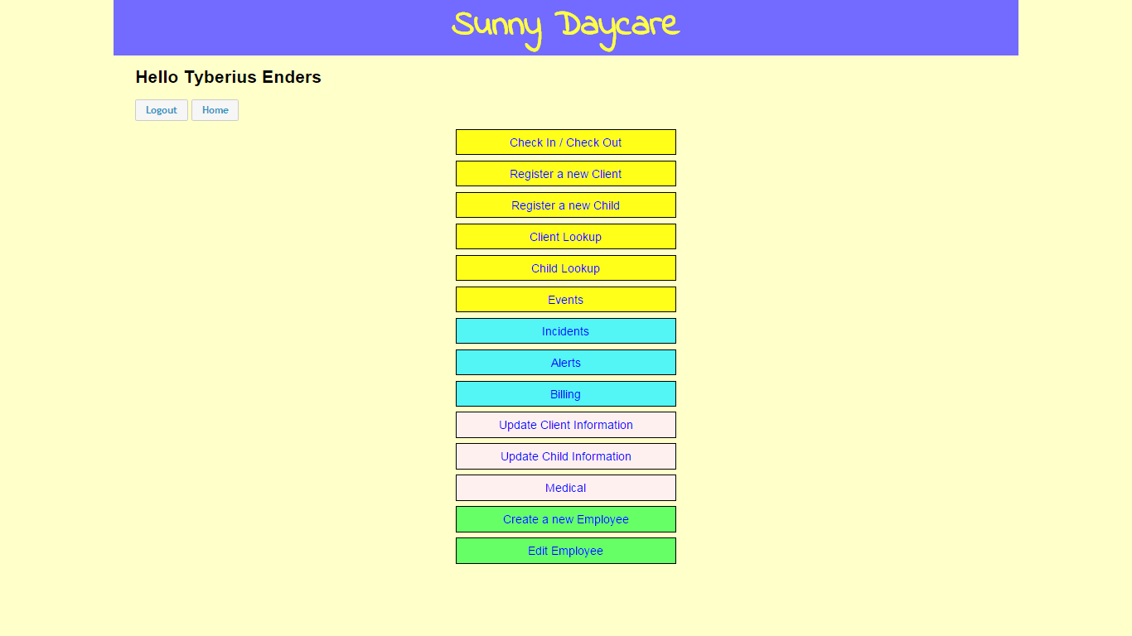

**Chapter 2**

**2.1**

**Check In**

* Click on the Check in/check out link button
* Click in the first name field
* Type in the Child’s first name or first letter of their first name
* Click in the middle name field
* Type in child middle name or first letter of their middle name ***“Optional”***
* Click in the last name field
* Type in the Child’s last name or first letter of their last name
* Click on the “Search” button

Once you have found the child you are searching for…

* Click on the Check in button
* who is checking in the child tab will automatically show up.
* Click on “Select from this list” drop down button

(This will pull up a list of clients who can drop off child.

* Click on the individual who is checking in the child
* Click on the submit button
* A message will notify that the child has been checked in.

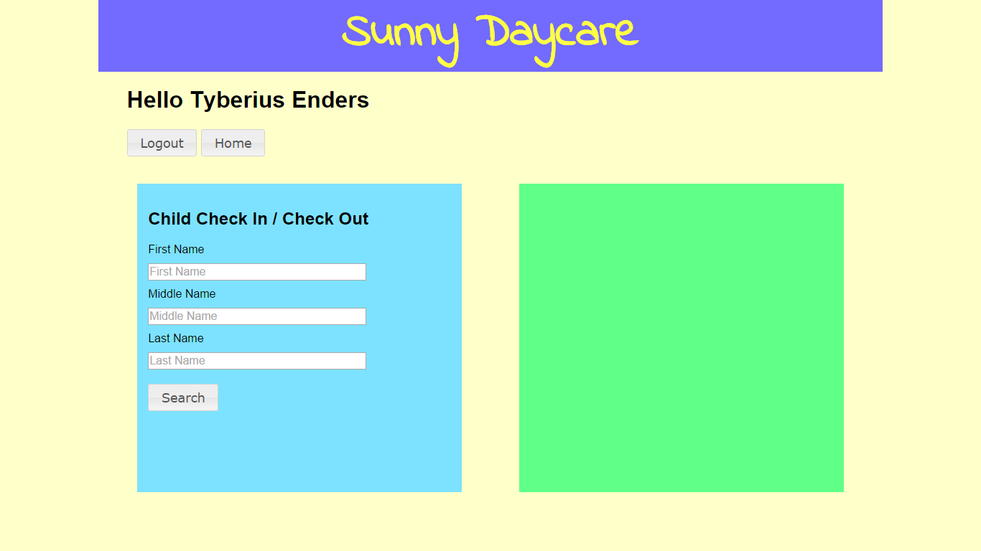

**2.2**

**Check out**

* Click on the Check in/check out link button
* Click in the first name field
* Type in the Child’s first name or first letter of their first name
* Click on the middle name field
* Type in child middle name or first letter ***“Optional”***
* Click on last name
* Type in the Child’s last name or first letter of their last name
* Click on “Search”

Once you have found the child you are searching for…

* Click on the Checkout button
* Who is checking in the child tab will automatically show up.
* Click on “**Select from this list**” drop down button(This will pull up a list of clients who can drop off child.
* Click on the individual who is checking out the child
* Click on the submit button
* A message will notify that the child has been checked out.

.

**Chapter 3**

**3.1**

**Register a new Client**

* Go to the employee menu page
* Click on the “register a client” link button

This will bring you to the Register a Client page

* Click in the first name field
* Type in the Client’s first name
* Click in the middle name field **(Optional)**
* Type in the Client’s middle name **(Optional)**
* Click in the last name field
* Type in the Client’s last name
* Click on “Gender” drop down button

(This will pull up a list of Genders.)

* Click on the gender the client is.
* Click on “Relationship” drop down button

(This will pull up a list of Relationships to the child.)

* Click on the primary contact box to Check mark .

(If the client is the Primary contact.)

* Click on the primary phone number field.
* Type in the Client’s phone number
* Click on the bill payer box to Check mark .

(If the client is the bill payer.)

* Click in the mailing address field.
* Type in the Client’s mailing address.
* Click in the billing address field
* Type in the billing address
* Click on the State Assistance box to Check mark .

(If the client is on State Assistance.)

* Click on the Register Button.
* A notification will pop up saying “ Successfully Registered”

**3.2**

**Register a new Child**

* Go to the employee menu page
* Click on the “Register a Child” link button

This will bring you to the Register a Child page

* Click in the first name field
* Type in the Child’s first name
* Click in the middle name field **(Optional)**
* Type in the Child’s middle name **(Optional)**
* Click in the last name field
* Type in the Child’s last name
* Click in the Birthday field
* Click on the month,day, & year.

A Calendar will pop up, Keep in mind we only accept children 6 weeks and older.

* Click on “Gender” drop down button

(This will pull up a list of Genders.)

* Click on the gender the Child is.
* Click on the Allergies field
* Allergies box will pop up
* Type in child’s allergies
* Click add
* Click in the type and detail field for Medical
* Type in the types and details of medical info.
* Click in the Section/Description field for Restrictions
* Type in child restriction
* Click on Client field

(List all clients that can pick up child.)

* Click in the first name field
* Type in the Client’s first name
* Click in the middle name field **(Optional)**
* Type in the Client’s middle name **(Optional)**
* Click in the last name field
* Type in the Client’s last name
* Click on the Register Button.
* A notification will pop up saying “ Successfully Registered”

**Search**

**Chapter 4**

**Client Lookup**

**4.1**

* Click on the Client Lookup link button
* Click in the first name field
* Type in the Client’s first name or first letter of their first name
* Click on the middle name field
* Type in Client’s middle name or first letter ***“Optional”***
* Click on last name
* Type in the Client’s last name or first letter of their last name
* Click on the “Search” button
* The Client will show up on the right side of the page

**Child Lookup**

**4.2**

* Click on the Child Lookup link button
* Click in the first name field
* Type in the Child’s first name or first letter of their first name
* Click on the middle name field
* Type in Child’s middle name or first letter ***“Optional”***
* Click on last name
* Type in the Child’s last name or first letter of their last name
* Click on “Search”
* The Client will show up on the right side of the page

**Events**

**Chapter 5**

**Creating Events**

**5.1**

* Click on Events link button
* A Calendar will pop up
* Click on a day you want to create an event
* An “Add an event” will pop up
* Click on the Title field
* Type in the title of the event
* Click on the Date field
* A Calendar will pop up
* Click on the day and month of the event
* Click on the time field
* Type in the time field
* Click on the Description field
* Type in the description of the event
* Click on the add button
* A message will appear “Event Added”
* Click on the green boxes to display the events

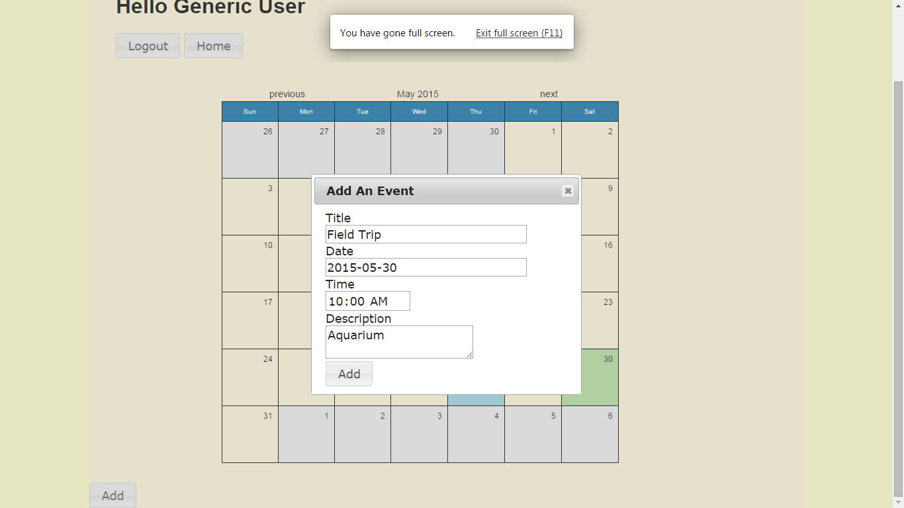

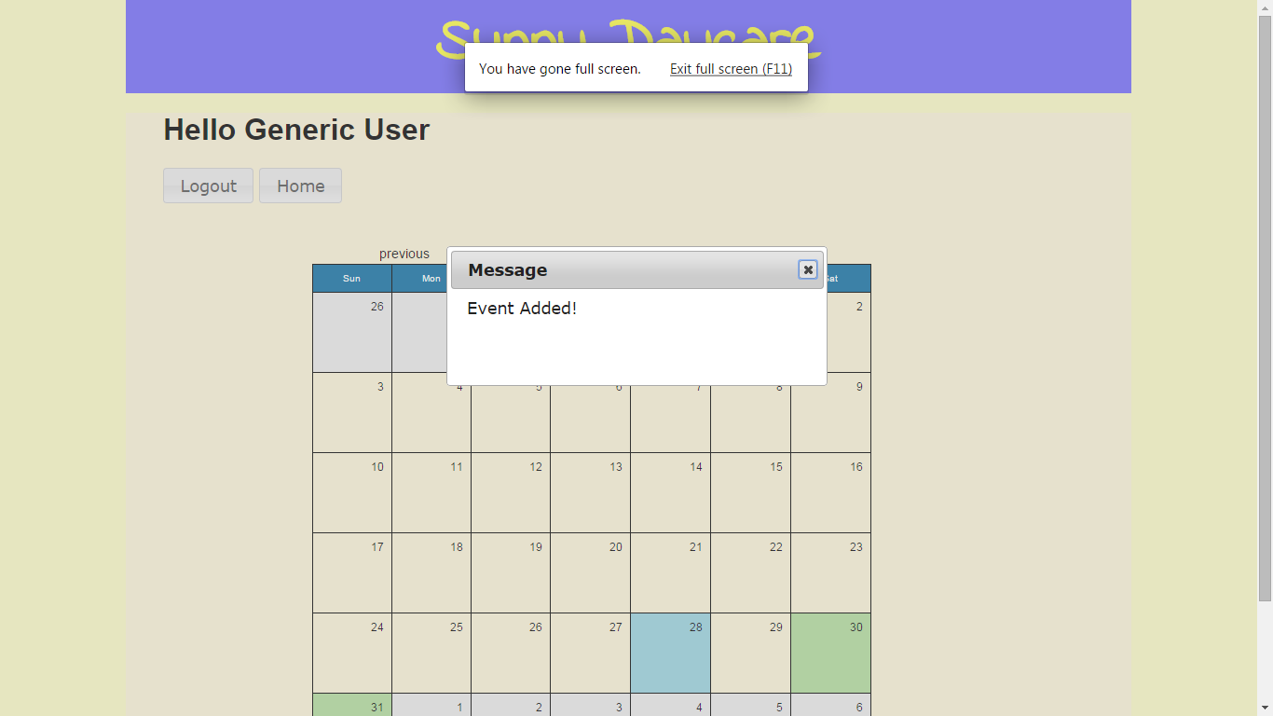

**Incidents**

Chapter 6

**Child Incidents**

**6.1**

* Go to the employee menu page
* Click on the “Incidents” link button
* Click in the first name field
* Type in the Child’s first name
* Click in the middle name field **(Optional)**
* Type in the Child’s middle name **(Optional)**
* Click in the last name field
* Type in the Child’s last name
* Click on the “Search” button

-The Child name will show up on the right side.

* Click on the child’s name
* A message box will pop up

-Stating if child has had an incident or not.

**Client Incidents**

**6.2**

* Go to the employee menu page
* Click on the “Incidents” link button
* Click in the first name field
* Type in the Client’s first name
* Click in the middle name field **(Optional)**
* Type in the Client’s middle name **(Optional)**
* Click in the last name field
* Type in the Client’s last name
* Click on the “Search” button

-The Client’s name will show up on the right side.

* Click on the Client’s name
* A message box will pop up

-Stating if the Client has had an incident or not.

**Chapter 7**

**Update Client Information**

**7.1**

* Go to the employee menu page
* Click on the “Update Client Information” link button
* Click in the first name field
* Type in the Client’s first name
* Click in the middle name field **(Optional)**
* Type in the Client’s middle name **(Optional)**
* Click in the last name field
* Type in the Client’s last name
* Click on the “Search” button

-The Client’s name will show up on the right side.

* Click on the Client’s name

-The Client’s data will pop up

* Click on a field and update what is needed to updated.
* Click on the update button.
* A message box will pop up

-Stating the client data has been saved.

**Update Child Information**

**7.2**

* Go to the employee menu page
* Click on the “Update Child Information” link button
* Click in the first name field
* Type in the Child’s first name
* Click in the middle name field **(Optional)**
* Type in the Child’s middle name **(Optional)**
* Click in the last name field
* Type in the Child’s last name
* Click on the “Search” button

-The Child’s name will show up on the right side.

* Click on the Child’s name

-The Child’s data will pop up

* Click on a field and update what is needed to updated.
* Click on the update button.
* A message box will pop up

-Stating the child data has been saved.

**Chapter 8**

**Billing**

**Creating Client Billing**

**8.1**

* Go to the employee menu page
* Click on the “Billing” link button
* Click in the first name field
* Type in the Client’s first name
* Click in the middle name field **(Optional)**
* Type in the Client’s middle name **(Optional)**
* Click in the last name field
* Type in the Client’s last name
* Click on the “Search” button
* Click on the Client’s name
* A Client Data box will appear with start date & End date
* Click in the field for start date
* A Calendar will appear click on date
* Click in the field for end date
* A Calendar will appear click on date
* Click on the “Submit” button
* A message will appear w/ dates & amount due

**8.2**

**View billing statements**

* Go to the employee menu page
* Click on the “Billing” link button
* Click in the first name field
* Type in the Client’s first name
* Click in the middle name field **(Optional)**
* Type in the Client’s middle name **(Optional)**
* Click in the last name field
* Type in the Client’s last name
* Click on the “Search” button
* Click on the Client’s name
* Click on view billing statements
* Click on Invoice button

-Invoice info will appear

* Click on the print button

-If wanting a printed copy

- A copy of the invoice will appear

* Click on the top left button “Go back to the viewing page

**8.3**

**Make a payment**

* Go to the employee menu page
* Click on the “Billing” link button
* Click in the first name field
* Type in the Client’s first name
* Click in the middle name field **(Optional)**
* Type in the Client’s middle name **(Optional)**
* Click in the last name field
* Type in the Client’s last name
* Click on the “Search” button
* Click on the Client’s name
* Click on make a payment button

-Date made, Date due, Amount due, amount to pay will appear

* Click in the Amount to pay field
* Type in the Amount
* Click on the Pay button
* A message will appear “Payment Successful”

**Chapter 9**

**Register Employee**

**Register Employee**

**9.1**

* Go to the employee menu page
* Click on the “Register Employee” link button
* Click in the first name field
* Type in the Employee’s first name
* Click in the middle name field **(Optional)**
* Type in the Employee’s middle name **(Optional)**
* Click in the last name field
* Type in the Employee’s last name
* Click on the username field
* Type the username
* Click on the Password field
* Type in the password
* Click on the verify password field
* Type in the password again
* Click in permissions field
* Type in level of permission
* Click on the Register button
* A message will appear “Success! Employee *** *** is created”

