VELLORE INSTITUTE OF TECHNOLOGY, CHENNAI

DIGITAL ASSIGNMENT II PROJECT REPORT

Bolt Tightness Detection and XR-Assisted Inspection Using RGB Camera

Course / Subject | Sensors and Signals
Programme | B.Tech in Mechatronics and Automation
Faculty | Dr. Eswaran M
Academic Year / Semester | 2026 / 3rd Semester
Student 1 | Bagavanth Raam G — 25BMH1081
Student 2 | Lakshan Surya S — 25BMH1212
Submission Date | 21/10/2026

Project Website: https://bolt-tightness-detector.onrender.com/
(or)
Scan the below given QR:
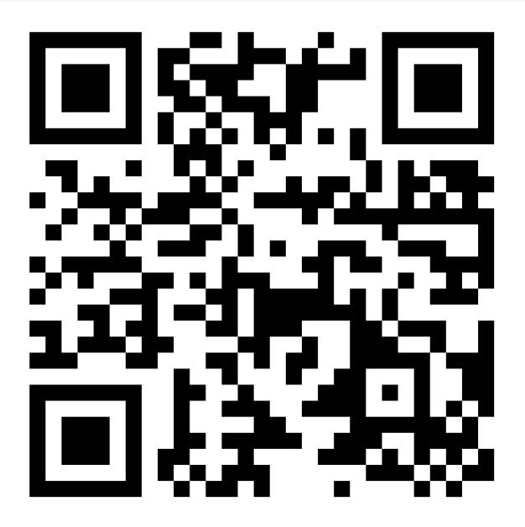

Title of the Work
Project Title: Bolt Tightness Detection and XR-Assisted Inspection Using RGB Camera.
Objective: To develop a camera-based workflow that analyses images of bolted joints and presents a bolt-condition result through a web application, with a CAD/XR representation intended to support visual inspection and verification. The system is designed to indicate tight, loose, or uncertain conditions where supported by the implemented model and its confidence threshold.

Problem Statement
Bolted joints are widely used in mechanical assemblies, machines, vehicles, and structural connections. A bolt that has loosened can be difficult to identify by unaided visual inspection, particularly when many fasteners must be checked repeatedly. Manual inspection can be slow and can vary between inspectors. This project explores a software-assisted inspection approach that uses RGB images and image-processing or machine-learning methods to identify bolt regions and estimate their condition. A CAD assembly and a planned XR view provide a digital representation of the joint for inspection. The measurable outcomes to validate are bolt detection, condition classification, response time, and consistency across repeated images. A visual image alone does not directly measure applied torque or clamping force; therefore, the output must be treated as a visual estimate unless independently validated against a torque or tension reference.

Comparative Analysis of Existing Solutions
The following comparison is based on published vision-based research methods. Reported figures belong to the cited studies and are not results of this student project. Parameter columns compare the sensing approach, main analysis method, and reported validation context.

 | Approach / Reference |  | Key method |  | Sensing |  | Analysis |  | Validation context |  | Strength |  | Limitation / gap
 | Huynh et al. (2019) [1] |  | RCNN bolt detection + Hough line transform |  | RGB images |  | Bolt-angle estimation |  | Lab girder and bridge images |  | Smartphone/UAV image workflow |  | Angle estimate depends on view angle and visible geometry
 | Zhang et al. (2020) [2] |  | Deep-learning-based bolt loosening detection |  | Images/webca m |  | Faster R-CNN |  | 300-image dataset; webcam demo |  | Automated feature learning |  | Dataset and operating conditions affect generalisation
 | Image-based graphical model [3] |  | Synthetic bolt images + deep learning |  | Synthetic and real images |  | R-CNN / image analysis |  | Lab joint and historical bridge |  | Reduces need for large manually labelled datasets |  | Synthetic-to-real domain gap remains
 | Vision-based splice connection method [4] |  | Faster R-CNN, perspective correction, adaptive edges |  | RGB / field images |  | Bolt angle + outlier analysis |  | Lab and bridge application |  | Handles perspective and lighting variation |  | Still sensitive to image quality and reference state
 | Gong et al. (2022) [5] |  | Faster R-CNN + keypoint detection |  | RGB images |  | Exposed bolt length measurement |  | Multiple bolt sizes / conditions |  | Quantitative  length-based method |  | Needs keypoints and camera geometry
 | Qi et al. (2022) [6] |  | Two-step vision framework |  | UAV images |  | Faster R-CNN + Gaus sian/perspective/Houg h |  | Field images; 1,200 samples for detector |  | Supports remote inspection |  | UAV viewpoint and image resolution can constrain accuracy
 | Marked bolts with YOLOv5 [7] |  | Detects circular markers on bolt and nut |  | RGB images with markers |  | Relative marker rotation |  | 200 labelled images |  | Clear rotation reference; high reported precision/recall in study |  | Requires markers and is not a direct torque measurement
 | Key-point detection  + synthetic data [8] |  | Synthetic dataset and keypoint model |  | Synthetic / RGB |  | Keypoint-based angle estimate |  | Virtual and physical test setup |  | Addresses  data-generation burden |  | Simulation fidelity and real-world transfer need checking
 | Smartphone application framework [9] |  | Two-step image-based looseness detection |  | Smartphone / field images |  | Bolt detection then geometric estimation |  | Mobile workflow |  | Practical acquisition interface |  | Camera positioning and inference reliability must be validated
Contour extraction method (2026) [10] |  | YOLOv5 + perspective correction + Canny/contours |  | RGB images |  | Bolt contour and slope/angle |  | Reported as a computer-vision framework |  | Interpretable geometric pipeline |  | Multiple processing stages may be sensitive to image quality

Identified Research / Application Gap. Published methods show that camera images can support bolt localisation and visual estimation of loosening, but reliability depends on viewpoint, illumination, bolt geometry, reference conditions, and representative training data. Many research pipelines focus on a specific angle, marker, or measured geometric feature. This project’s application-oriented goal is to connect a web-based detection workflow with a CAD representation and
XR-assisted inspection. The integration is a project direction, not a claim that XR independently measures torque or that the current model has achieved research-paper accuracy.

Novelty of the Work

Proposed feature | Difference from existing work | Expected benefit / evidence needed
Web-based bolt-condition workflow | Project exposes a browser-accessible interface for the bolt-tightness workflow rather than requiring every user to run the analysis environment locally. | Simpler demonstration and access; verify with repeatable sample inputs and recorded outputs.
CAD assembly paired with image analysis | A 3D plate-and-fastener assembly is prepared in Unity and a screw dataset exporter was configured to produce JSON data for backend analysis. | Connects physical fastener concepts with a digital representation; evidence requires a working end-to-end integration demo.
XR-assisted inspection direction | Inspection results are intended to be associated with the corresponding bolt in a digital/XR view. | May improve spatial interpretation; requires an implemented and tested XR overlay before claiming completion.
Uncertain-result handling | DA1 proposes TIGHT / LOOSE / UNCERTAIN indications and confidence output where the model supports them. | Can avoid overconfident labels; document threshold and test false-positive/false-negative cases.

Proposed Solution
The intended users are students, technicians, and inspectors who need a convenient first-pass visual check of bolted joints. The input is an RGB image of the bolt and surrounding plate. The processing pipeline receives the image, prepares it for analysis, detects or isolates bolt regions, extracts visual features or model predictions, and produces a condition estimate. The web interface provides a convenient point of access to the detection workflow. A CAD model represents the plate and four screw/washer positions; Unity is being used to prepare the digital assembly and export screw-related metadata. XR visualisation is an intended integration layer for displaying the inspection result in context.

System data flow

Physical bolted joint
↓ RGB camera captures reflected visible light
Image acquisition and preprocessing
↓
Bolt localisation / visual feature analysis / model inference
↓
Condition estimate: TIGHT / LOOSE / UNCERTAIN (if supported)
↓
Web interface + result record
↔
CAD / Unity screw metadata → XR visualisation (integration/validation required)
Figure 1. Proposed system architecture. The diagram describes the intended data flow; it does not imply that every integration stage has been fully validated.

Methodology – Implementation of the Proposed Solution

Step / phase | Implementation activities | Output / deliverable
1. Requirements & design | Define the use case as camera-based visual inspection; select RGB imaging; define tight/loose/uncertain as intended result labels; design a bolted plate assembly. | Problem definition, system architecture and target labels.
2. Hardware/software setup | Use a smartphone or other RGB camera for image capture and a computer for development/testing. Prepare the CAD plate-and-fastener assembly and a Unity project with AR/XR-related packages. | Image capture setup, CAD assembly, Unity project.
3. Development & integration | Prepare bolt images/data; develop the web-facing detection workflow; configure the Unity CAD assembly and ScrewDataExporter with the assembly root and four screws; export screw metadata to JSON for backend review. | Web application and screw_dataset.json export; backend integration status to be confirmed.

Step / phase | Implementation activities | Output / deliverable
4. Testing & validation | Test known tight and loose examples under controlled lighting and camera distance; compare predictions against a manually verified or torque-tool reference; record confusion matrix, response time, and uncertain cases. | Test log and performance metrics; no numerical accuracy is claimed until measured.
5. Refinement / demonstration | Improve camera positioning, lighting, preprocessing and confidence thresholds; connect per-bolt results to the matching CAD/XR location and repeat tests. | Demonstration with documented limitations and a prioritised next-step list.

Hardware Elements and Justification

Hardware element / specification | Role in system | Justification | Contribution
RGB camera (smartphone/webcam) | Captures reflected visible light from bolt and plate. | Non-contact and widely available; captures geometry and surface appearance.  Accuracy depends on focus, resolution, angle and lighting. | Digital image for bolt detection and visual inference.
Computer / laptop | Runs development tools, web testing and image analysis. | Suitable for programming, dataset inspection and integration work. | Supports model/backend execution and evaluation.
Bolted plate assembly (CAD  / physical reference) | Represents the joint and fastener arrangement. | Provides a repeatable geometry for development; CAD is not itself a force sensor. | Defines bolt locations and supports mapping to the digital model.
Torque wrench or calibrated reference (validation only) | Provides a physical comparison for selected test samples. | Needed if the project is to validate actual tightening torque rather than visual appearance alone. | Ground-truth labels for a stronger evaluation; not stated as already used.

Software Elements and Justification

Software / tool / algorithm | Role | Justification | Contribution
Bolt Tightness Detector web application | Browser-facing interface for the project. | Allows a user to access the detection workflow through a URL. | Demonstration and user interaction; specific live behaviour should be verified.
Python / backend  image-processing or ML stack (as applicable) | Image handling and model inference. | Common environment for image processing and machine learning; exact libraries/model should match implementation. | Converts image input into an estimated bolt condition.
Unity 6 project | Imports and organises CAD assembly; supports XR development. | Useful for 3D scene setup and interactive visualisation. | Digital assembly for mapping results to screw locations.
AR Foundation / XR Plug-in Management (planned/installed in Unity project) | Provides AR/XR integration framework. | Supports target-device XR setup where compatible. | Potential display of results in a spatial context; end-to-end operation remains to be demonstrated.
ScrewDataExporter C# script / JSON | Exports screw-related transform or object metadata. | Portable structured data can be passed to the backend developer. | Creates screw_dataset.json for downstream mapping/analysis.

Expected Outputs and Validation Plan

Expected outcome | How it will be tested / measured | Success criterion
Bolt region detected | Use labelled test images with bolts at known positions; calculate precision/recall or IoU if a detector is implemented. | Predefine a target before testing; report measured values, not estimates.
Condition classification | Compare tight/loose predictions against independently verified labels; compute confusion matrix, precision, recall and F1. | Report performance by class and number of test samples.
Stable camera-based output | Repeat captures at controlled distance, angle and illumination, then vary one condition at a time. | Document cases where output changes or becomes uncertain.
Web application usability | Run a documented set of image uploads/requests and check returned result and errors. | All planned test cases complete with results recorded.
CAD/XR result mapping | Compare each backend bolt identifier with its intended screw in the Unity assembly. | All four screw positions mapped correctly in a repeatable demo.

Work Progress – Evidence and Product Snapshots
The DA1 report records the problem definition, RGB camera selection, CAD assembly preparation, and image-dataset preparation as completed, with backend integration described as almost completed and XR visualisation planned. The project work context also indicates that the CAD assembly was imported into Unity, the ScrewDataExporter component was configured for four screws, and a JSON dataset file was exported. These are implementation-progress notes, not evidence of validated detection accuracy.

Milestone / task | Status | Evidence / observation | Next action
Problem definition and sensor selection | Completed (DA1) | RGB camera selected as passive optical sensor. | Keep acquisition conditions consistent.
CAD plate and fastener assembly | Completed / prepared | Plate, four screws and four washers represented in CAD/Unity project. | Confirm model dimensions and bolt identity mapping.
Image dataset preparation | Completed (DA1 statement) | DA1 states tight and loose bolt images were collected/generated. | Document dataset size, class balance, source and labels.
Web detection workflow | Developed / status to verify | Project URL supplied:  https://bolt-tightness-detector.onrender.com/ | Capture genuine screenshots and record test inputs/outputs.
Unity screw metadata export | Completed per project progress | ScrewDataExporter configured with assembly root and four screws; JSON file exported. | Share JSON with backend teammate and document schema.
XR result visualisation | In progress / planned | DA1 listed XR visualisation as planned. | Connect result identifiers to 3D screws and test on target device.

Figure 1. Web application interface

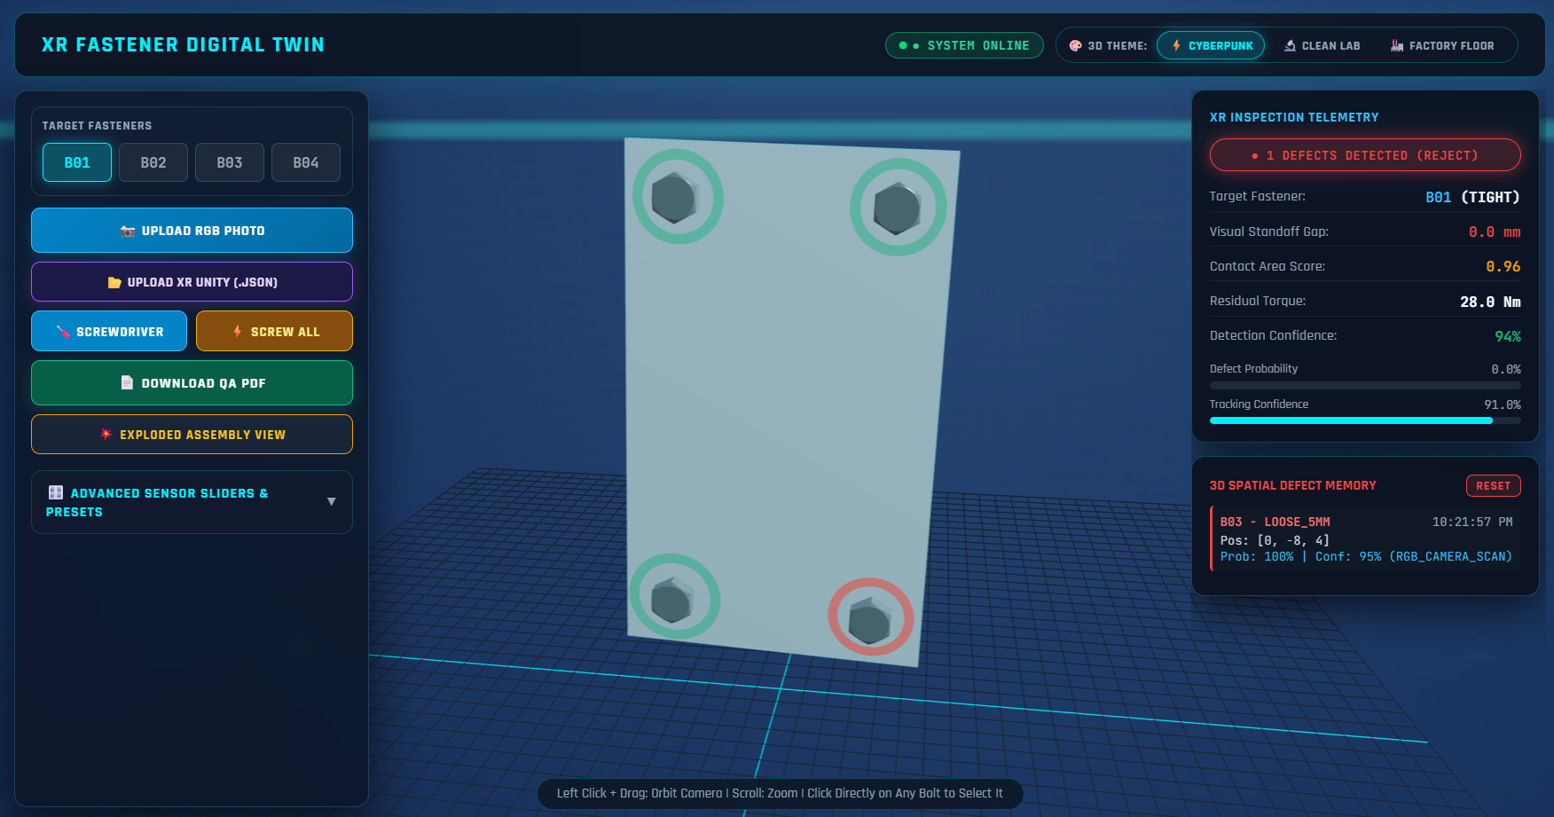

Figure 2. Unity CAD assembly and screw dataset export

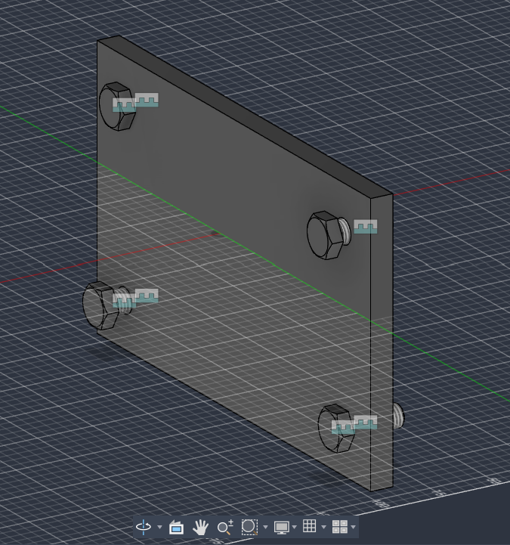

Figure 3. Detection test / output

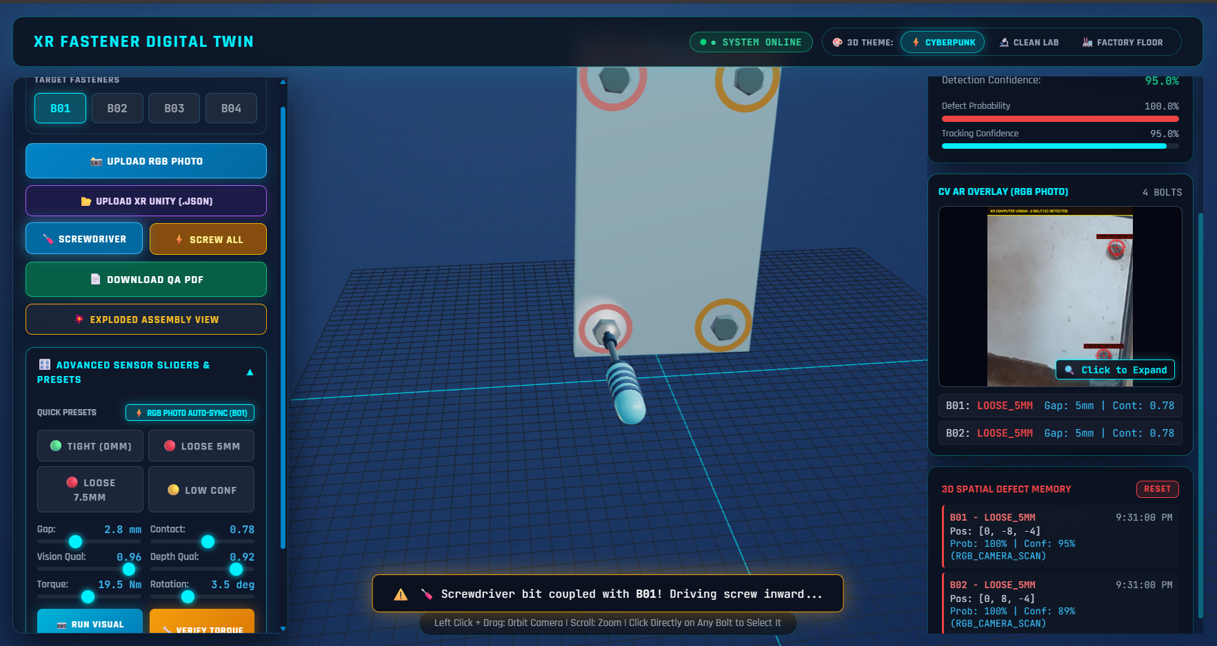

Current Results, Challenges and Next Steps
Results achieved so far. The DA1 documentation defines the camera-based problem and system architecture and reports the RGB camera, CAD assembly, and image-dataset preparation stages as completed. The development notes indicate that a browser-based project has been deployed at the supplied URL and that Unity screw metadata has been exported to JSON for backend collaboration. The supplied materials do not include a quantitative evaluation, a labelled test log, a measured accuracy, or proof of a completed XR overlay; therefore, no accuracy or real-time performance value is claimed here.
Challenges / limitations. Lighting variation, camera angle and distance, blur, occlusion, reflections, incorrect bolt localisation, class imbalance, and confidence-threshold selection can affect image-based inference. Most importantly, visible appearance is not a direct measurement of torque or bolt preload. The system requires independent reference labels and tests under controlled and varied conditions. XR integration also requires stable mapping between backend bolt identifiers and the correct 3D screw objects.
Next steps. (1) Capture and insert genuine screenshots of the deployed interface, Unity assembly, exported JSON and actual test outputs. (2) Document dataset size, image sources, class definitions and train/validation/test split. (3) Validate predictions against a reliable physical reference where feasible. (4) Report per-class precision, recall, F1-score, confusion matrix and response time. (5) Integrate backend results with the four Unity screw objects and test the XR display on the

intended device. (6) Record failure cases and state the system's intended use as a preliminary inspection aid, not a replacement for certified torque verification.

References
- T.-C. Huynh, J.-H. Park, H.-J. Jung, and J.-T. Kim, “Quasi-autonomous bolt-loosening detection method using vision-based deep learning and image processing,” Automation in Construction, vol. 105, 102844, 2019. https://doi.org/10.1016/j.autcon.2019.102844
- Y. Zhang, X. Sun, K. J. Loh, W. Su, Z. Xue, and X. Zhao, “Autonomous bolt loosening detection using deep learning,” Structural Health Monitoring, 2020. https://doi.org/10.1177/1475921719837509
- “Bolt-Loosening Monitoring Framework Using an Image-Based Deep Learning and Graphical Model,” Sensors, vol. 20, no. 12, 3382, 2020. https://doi.org/10.3390/s20123382
- “Vision-based autonomous bolt-looseness detection method for splice connections: Design, lab-scale evaluation, and field application,” Automation in Construction, 2021. https://www.sciencedirect.com/science/article/pii/S092658052100042X
- H. Gong, X. Deng, J. Liu, and J. Huang, “Quantitative loosening detection of threaded fasteners using vision-based deep learning and geometric imaging theory,” Automation in Construction, vol. 133, 104009, 2022. https://doi.org/10.1016/j.autcon.2021.104009
- Y. Qi et al., “A two-step computer vision-based framework for bolt loosening detection and its implementation on a smartphone application,” Structural Health Monitoring, 2022. https://doi.org/10.1177/14759217211049995
- “Vision-Based Detection of Bolt Loosening Using YOLOv5,” 2022. https://pmc.ncbi.nlm.nih.gov/articles/PMC9319482/
- “Bolt Loosening Detection Using Key-Point Detection Enhanced by Synthetic Datasets,” Applied Sciences, vol. 13, no. 3, 2023. https://doi.org/10.3390/app13032020

