FISHERMAN’S LOCATION TRACKING SYSTEM USING IOT

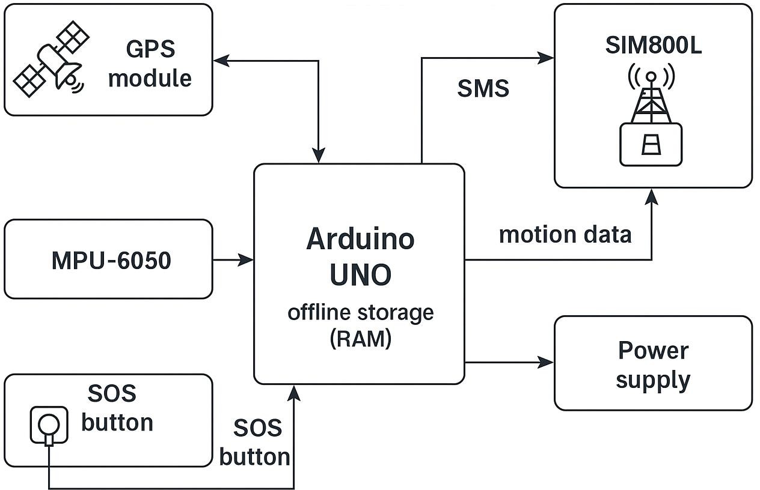
BLOCK DIAGRAM

