IOT BASED DEEP SEA FISHERMEN LOCATION TRACKING AND MONITORING SYSTEM

A PROJECT REPORT
Submitted by

MOHAMMED WAQAS K | 110121205030
PRIYADARSHINI P | 110121205043
RAABIYA N | 110121205044
NANDHINI K | 110121205305

In partial fulfillment for the award of the degree
of

BACHELOR OF TECHNOLOGY
IN INFORMATION TECHNOLOGY


AALIM MUHAMMED SALEGH COLLEGE OF ENGINEERING
AVADI
ANNA UNIVERSITY: CHENNAI 600 025
MAY 2025

ANNA UNIVERSITY, CHENNAI – 600 025

BONAFIDE CERTIFICATE

Certified that this project report “IOT BASED DEEP SEA FISHERMEN LOCATION TRACKING AND MONITORING SYSTEM” is the Bonafide work of “MOHAMMED WAQAS (110121205030), PRIYADARSHINI P (110121205043), RAABIYA N (110121205044), NANDHINI
(110121205305)” who carried out the project work under my Supervision.

SIGNATURE SIGNATURE
DR. R. LAVANYA M.E., Ph.D. DR.R. LAVANYA M.E., Ph.D.
ASSISTANT PROFESSOR ASSISTANT PROFESSOR
HEAD OF THE DEPARTMENT SUPERVISOR

INFORMATION TECHNOLOGY INFORMATION TECHNOLOGY
AALIM MUHAMMED SALEGH AALIM MUHAMMED SALEGH
COLLEGE OF ENGINEERING COLLEGE OF ENGINEERING
MUTHAPUDUPET, AVADI-IAF, MUTHAPUDUPET, AVADI-IAF,
CHENNAI-600055 CHENNAI-600055

CERTIFICATE OF EVALUATION

COLLEGE NAME: AALIM MUHAMMED SALEGH COLLEGE OF ENGINEERING
BRANCH: INFORMATION TECHNOLOGY
SEMESTER: VIII
PROJECT TITLE: IOT BASED DEEP SEA FISHERMEN LOCATION TRACKING AND MONITORING SYSTEM
NAME OF THE: DR. R. LAVANYA M.E., Ph.D.
SUPERVISOR ASSISTANT PROFESSOR

NAME OF THE STUDENT REGISTRATION NUMBER
MOHAMMED WAQAS K 110121205030
PRIYADARSHINI P 110121205043
RAABIYA N 10121205044
NANDHINI K 110121205305

The report of this project is submitted by the above students in partial fulfillment for the award of Bachelor of Technology in Information Technology of Anna University are evaluated and confirmed to report of the work done by the above students during the academic year 2024-2025.
This report work is submitted for the University practical (Project work IT3811) held on…………………….

INTERNAL EXAMINER EXTERNAL EXAMINER

ACKNOWLEDGEMENT

Thinking in the way of expressing gratitude, First and Foremost, we thank the Divine Grace, who is our refuge and strength. We would like to express our heartfelt thanks to our Beloved Parents who sacrificed their presence for our better future.
We take this opportunity to express our sincere gratitude to the respected Founder Alhaj Late Janab Dr. S. M. Shaik Nuruddin, the Chairperson Hajiyani S. S. Hasheeba, and the Honourable Secretary and Correspondent Janab H. Mohamed Salegh for their blessings and grace in making the project a great success.
We take this opportunity to put forth our deep sense of gratitude to Principal

Prof. Dr. P. MARIMUTHU B.E., M.E., Ph.D., FIE., MISTE, Aalim
Muhammed Salegh College of Engineering, Chennai.

We are especially thankful to our project guide and Head of the Department, Dr. R. LAVANYA M.E., Ph.D, Department of Information Technology, Aalim Muhammed Salegh College of Engineering, Chennai, for her valuable guidance, consistent support, and motivation throughout the project. Her mentorship and expertise were instrumental in shaping the outcome of our work.

Finally, we extend our heartfelt thanks to our families, faculty members, and friends for their constant encouragement, support, and assistance during every stage of this project. Their presence and kind words helped us stay focused and committed to achieving our goals.

ABSTRACT

Deep-sea fishing is a vital source of livelihood for many communities, but it also comes with significant risks due to limited communication and the absence of real-time tracking systems. In such unpredictable and isolated marine environments, even minor delays in response during emergencies can lead to life-threatening situations. To address this critical issue, this project proposes a smart, IoT-based safety system designed to enhance the security and survivability of deep-sea fishermen.The system primarily utilizes a GPS module to fetch the precise geographic coordinates of the fishing vessel and a GSM module to transmit this information to shore authorities via SMS at fixed intervals, typically every 10 seconds. In case of emergencies, a push-button SOS feature enables fishermen to send immediate distress signals. Furthermore, the integration of a motion sensor (MPU6050) allows the system to detect abnormal boat movement or inactivity and automatically trigger an SOS alert when needed.

One of the notable features of the system is offline data logging, which ensures GPS coordinates are stored in memory when GSM connectivity is lost. This stored data is automatically transmitted once the GSM signal is restored, providing uninterrupted location updates. The system is powered by a battery and starts operating automatically as the boat powers on, requiring minimal manual intervention. Overall, this project offers a low-cost, practical, and scalable solution for real-time monitoring and emergency communication. Its use of widely available electronic components and efficient software logic makes it suitable for deployment in real-world maritime conditions, significantly improving the safety and emergency responsiveness for deep-sea fishermen.

TABLE OF CONTENT

CHAPTER NO. | TITLE PAGE | NO.
1 | ABSTRACT  LIST OF FIGURES  LIST OF ABBREVIATION INTRODUCTION | iv vii viii  1
 | 1.1 BACKGROUND | 2
 | 1.2 AIM | 3
 | 1.3 OBJECTIVES | 3
2 | LITERATURE REVIEW | 4
3 | PROBLEM STATEMENT | 18
4 | PROPOSED SYSTEM | 21
 | 4.1 ADVANTAGES OF PROPOSED SYSTEM | 21
5 | BLOCK DIAGRAM /  CIRCUIT DIAGRAM | 22
 | 5.1 HARDWARE AND SOFTWARE REQUIREMENT | 23
 | 5.1.1 HARDWARE REQUIREMENT | 23
 | 5.1.2 SOFTWARE REQUIREMENT | 23
6 | HARDWARE DESCRIPTION | 24
 | 6.1 ARDIUNO UNO | 24
 | 6.1.1 PRODUCT DESCRIPTION | 24
 | 6.1.2 FEATURES | 26
 | 6.1.3 APPLICATION | 26
 | 6.2 GPS MODULE | 26
 | 6.2.1 PRODUCT DESCRIPTION | 27
 | 6.2.2 FEATURES | 27
 | 6.2.3 APPLICATIONS | 28
 | 6.3 GSM MODULE | 29
 | 6.3.1 PRODUCT DESCRIPTION | 29
 | 6.3.2 FEATURES | 19
 | 6.3.3 APPLICATIONS | 30
 | 6.4 POWER SUPPLY | 30
 | 6.4.1 PRODUCT DESCRIPTION | 31

    - FEATURES 31
    - APPLICATIONS 31
  - MPU6050 MOTION SENSOR 32
    - PRODUCT DESCRIPTION 33
    - FEATURES 33
    - APPLICATIONS 33
  - PUSH BUTTON 34
    - PRODUCT DESCRIPTION 34
    - FEATURES 35
    - APPLICATIONS 35
- SOFTWARE DESCRIPTION 36
  - ARDIUNO UNO 36
  - LIBRARIES USED 37
    - ELECTRONIC CATS MPU6050 LIBRARY 37
    - EEPROM LIBRARY 37
    - TINY GPS++ LIBRARY 37
  - SOFTWARE LOGIC OVERVIEW 37
- WORKING MODEL 41
- CONCLUSION AND FUTURE ENHANCEMENT 44
  - CONCLUSION 44
  - FUTURE ENHANCEMENT 45
- APPENDICES 46
  - SAMPLE CODING 46
  - OUTPUT SCREENSHOT 54
- REFERENCES 61

LIST OF FIGURES

FIGURE NO. | FIGURE NAME | PAGE NO.
3.1 | ESTIMATED FISHERMEN DEATH | 18
3.2 | ESTIMATED FATALITIES | 19
3.3 | ESTIMATED LIVES SAVED | 19
5 | BLOCK DIAGRAM | 22
6.1 | ARDIUNO UNO | 25
6.2 | GPS MODULE(NEO-6M) | 27
6.3 | GSM MODULE(SIM800L) | 29
6.4 | BATTERY | 30
6.5 | MPU6050 | 32
6.6 | PUSH BUTTON | 34
10.2.1 | OVERVIEW OF THE SYSTEM | 55
10.2.2 | WHEN THE BOARD TILTED | 56
10.2.3 | DETECTION OF TILT | 57
10.2.4 | SOS BUTTON GOT PRESSED | 58
10.2.5 | GPS LOCATION UPDATION | 59
10.2.6 | ALERT MESSAGE SEND TO RESCUE TEAM | 60
 | FAMILY MEMBER

LIST OF ABBREVIATION

IOT | Internet of Things
GPS | Global Positioning System
GSM | Global System for Mobile Communications
SMS | Save Our Souls / Emergency Alert Signal
EEPROM | Electrically Erasable Programmable Read-Only Memory
IDE | Integrated Development Environment
MPU6050 | Motion Processing Unit (Accelerometer + Gyroscope)
UNO | Arduino UNO Microcontroller Board

CHAPTER 1 INTRODUCTION

Fishing is one of the oldest and most vital economic activities in the world, providing livelihood and food security for millions of people across coastal regions. Among the different types of fishing, deep-sea fishing is particularly risky due to the harsh and unpredictable nature of the sea. Fishermen who operate far from the coast are often exposed to dangers such as bad weather, mechanical failures, navigation errors, and even medical emergencies, all while being out of communication range. These risks are further magnified by the lack of real-time tracking and emergency alert systems, especially for small-scale and traditional fishermen who cannot afford expensive satellite-based safety solutions.
Over the years, several advancements have been made in maritime navigation and tracking. However, many of these systems are either too costly, require constant internet connectivity, or demand complex user interaction, making them inaccessible for rural fishing communities. In most cases, these fishermen depend on basic tools like VHF radios or mobile phones, which are not reliable in the deep sea due to signal loss or limited range. As a result, even minor incidents can turn into life-threatening situations if timely help does not reach the fishermen.
With the rapid growth of the Internet of Things (IoT), it is now possible to create smart systems using low-cost microcontrollers and sensors that can collect and transmit data in real time. IoT has already transformed sectors like agriculture, healthcare, and logistics - and its application in maritime safety holds great potential. By integrating GPS and GSM technologies into a small, portable device, real-time monitoring and emergency communication can be made available even in remote marine areas.
This project presents an IoT-based solution designed specifically to enhance the safety of deep-sea fishermen. The system uses a GPS module to continuously collect the vessel’s location, while a GSM module is used to send the coordinates to shore authorities via SMS at regular intervals. A push-button SOS feature is provided for the fisherman to send emergency alerts manually. Additionally, a motion sensor (MPU6050) detects unusual boat activity, such as prolonged stillness or tilting, and automatically triggers an SOS alert without manual intervention.The system also addresses a critical issue: GSM network unavailability. During such instances, the GPS data is temporarily logged into memory using EEPROM.
1

Once the network is restored, the stored data is transmitted to ensure that no important location information is lost. All operations are managed by an Arduino UNO microcontroller, chosen for its cost-effectiveness, availability, and ease of programming. The entire setup is battery-powered and designed to operate automatically with minimal human intervention.
This project provides a reliable, scalable, and affordable way to improve the safety of fishermen during deep-sea fishing operations. By combining hardware, software, and real-time monitoring, it bridges the technological gap faced by fishing communities and enhances their chances of survival during emergencies.

BACKGROUND
The global fishing industry plays a crucial role in ensuring food supply and employment, particularly in developing countries like India where millions rely on fishing as their primary source of income. Coastal communities in Tamil Nadu, Kerala, Andhra Pradesh, and other regions face the daily challenge of venturing into the deep sea without proper safety and communication equipment. While advanced commercial ships may have high-end satellite systems, the majority of small and medium-scale fishermen depend on basic tools that are neither reliable nor capable of handling emergency scenarios.
Accidents at sea are not uncommon. Reports of missing fishermen, capsized boats, and delayed rescues are frequent, especially during the monsoon and cyclone seasons. In many cases, families and coastal guards are unable to trace the location of fishermen due to the lack of real-time data. The delay in communication and the inability to send or receive emergency alerts lead to unnecessary loss of life.
Previous attempts to address this issue have focused on either manual tracking using mobile phones or bulky satellite trackers, both of which are either ineffective or too costly for regular use. IoT presents a unique opportunity to design systems that are compact, affordable, and capable of working with existing mobile networks. By using a combination of sensors, microcontrollers, and communication modules, safety devices can now be made accessible to fishermen at a fraction of the cost of traditional systems.
This background highlights the urgent need for a real-time, low-cost safety mechanism for fishermen. It forms the foundation for the development of the proposed IoT-based tracking and alert system described in this project.

AIM
The primary aim of this project is to design and develop a low-cost, IoT-based tracking and emergency alert system for deep-sea fishermen, enabling real-time location monitoring and timely communication with shore authorities during emergencies, even in areas with limited GSM network connectivity.

OBJECTIVE

    - To develop a portable system that can track and transmit real-time GPS coordinates of fishing vessels.
    - To implement a GSM-based communication method for sending periodic location updates via SMS.
    - To include a manual SOS button for fishermen to trigger emergency alerts.
    - To integrate a motion sensor (MPU6050) that can detect abnormal movements and trigger automatic SOS.
    - To implement data logging using EEPROM to store GPS data during GSM signal loss.
    - To extract and process GPS data efficiently using the TinyGPS++ library for accurate location tracking.
    - To ensure the system operates with minimal user intervention and is suitable for real- world maritime deployment.

CHAPTER 2 LITERATURE REVIEW
A number of research efforts have been made to develop intelligent tracking and monitoring systems for maritime and safety applications. This chapter discusses selected literature that contributes to the understanding and development of location-based monitoring systems using IoT, GPS, and communication technologies.

Enhanced Target Ship Tracking with Geometric Parameter Estimation for Unmanned Surface Vehicles
Author(s): Jungwook Han Published in: IEEE, March 4, 2021 Introduction and Background
With the rapid development of autonomous navigation systems for marine vessels, the importance of accurate tracking and collision avoidance has grown significantly. Unmanned Surface Vehicles (USVs), which are often deployed for surveillance, search-and-rescue, and environmental monitoring, require real-time, reliable tracking of surrounding vessels to ensure both operational success and safety.
Traditional marine tracking systems rely heavily on Automatic Identification Systems (AIS) and radar sensors. However, AIS data can sometimes be unavailable or deliberately turned off, especially in unauthorized zones. Moreover, radar reflections can be affected by environmental noise, vessel shape, and movement. In this context, the research conducted by Jungwook Han addresses a critical gap: how to track surrounding vessels effectively using geometric estimations, even in the absence of consistent AIS input.This paper proposes a novel approach that enhances the existing radar-based ship tracking systems by estimating the geometric properties of target vessels. The approach is tailored for autonomous systems that need to interpret raw radar data with minimal external aid.

Research Objective and Scope
The objective of the study is to improve target tracking accuracy for USVs by introducing a geometric parameter estimation algorithm. The proposed method allows the onboard system to estimate a target ship’s orientation, length, and width based on radar echo returns.

This level of detail can significantly improve trajectory prediction and reduce false alarms during close encounters.
Key aims of the paper include:
- Enhancing real-time target tracking without full AIS reliance
- Improving recognition accuracy of nearby vessels
- Applying geometric modeling to noisy and limited radar data
- Supporting autonomous operation for USVs in both dense and sparse marine environments.

System Design and Methodology
The tracking system consists of several modules:
- Radar Sensor Module: Collects raw echo returns from surrounding vessels.
- Echo Processing Unit: Cleans noise, applies filtering, and extracts useful patterns.
- Geometric Estimation Module: Estimates the heading angle, length, and width of the target ship based on the distribution of radar points.
- Kalman Filter-Based Tracker: Uses estimated vessel dimensions to track movement trajectory more accurately.
Unlike standard radar tracking, this system does not rely on point clustering or simplistic bounding box approaches. Instead, it applies angle and shape modeling, enabling the detection system to better understand a ship’s posture in water and predict its path.
A critical innovation in this paper is the use of linear regression and feature estimation techniques to derive geometric characteristics from low-resolution radar data- something conventional methods struggle with in poor visibility or noisy condition.

Results and Performance Evaluation
The proposed method was tested in simulated marine environments and compared against traditional radar-based tracking methods. Key findings include:
- A reduction in average tracking error by more than 20% compared to basic centroid tracking
- The ability to estimate ship dimensions within a 10-15% margin of error
- Improved tracking continuity, even when radar returns were sparse or obstructed
- A smoother path prediction curve, reducing erratic motion estimation

These results validate the geometric approach and highlight its potential for integration in autonomous ship navigation systems.

Strengths and Limitations Strengths:
- Provides an intelligent fallback when AIS is unavailable
- Works effectively in cluttered or signal-blocked environments
- Can be embedded into autonomous marine platforms
- Offers better situational awareness through geometric understanding

Limitations:
- The system still depends heavily on radar resolution; poor-quality hardware may degrade results
- High-speed vessels or highly dynamic traffic environments may introduce estimation delays
- Implementation on a low-cost microcontroller may not be feasible due to computation needs.

Understanding
This paper provides a forward-thinking enhancement to traditional marine vessel tracking by focusing on the geometric analysis of radar signals. For marine safety and unmanned vessel autonomy, such methods represent a critical step toward self-reliant navigation systems. While the paper targets advanced USV operations, the concept of improving tracking accuracy in low-data environments resonates strongly with safety systems for human-operated fishing vessels as well.

Although our project uses GPS and motion sensors rather than radar, this paper supports the value of accurate real-time tracking and autonomous threat detection which aligns well with the goals of our IoT-based alert system for fishermen.

A Ship Detection and Tracking Algorithm for an Airborne Passive Interferometric Microwave Sensor
Author(s): Hailiang Lu, Hao Li, Liangbing Chen, Yayun Cheng
Published in: IEEE Journal of Selected Topics in Applied Earth Observations and Remote Sensing, March 17, 2021

Introduction and Background
The demand for real-time maritime surveillance systems has increased significantly due to growing concerns around illegal fishing, border violations, smuggling, and search-and- rescue operations. While conventional radar and AIS-based tracking systems have proven to be reliable under standard conditions, they suffer major drawbacks in adverse weather, signal jamming, or when vessels operate without AIS.
This paper explores an innovative approach that uses passive microwave interferometric sensors deployed on airborne platforms to detect and track vessels on the ocean surface. Unlike active radar systems, passive sensors measure natural emissions from the sea surface and ships, providing reliable data even in low-light or cloudy conditions.The authors propose a robust ship detection algorithm tailored to handle high-noise, low-contrast images commonly associated with passive microwave sensing. Their approach significantly improves the ability to track small and medium vessels that are often missed by traditional methods.

Research Objective and Scope
The main goal of the study is to develop a complete detection-and-tracking pipeline that can be implemented on airborne passive microwave sensors, with the following specific objectives:
- Suppress sea clutter to clearly distinguish vessels
- Identify potential ship targets using region-based segmentation
- Accurately track moving vessels across sequential image frames
- Maintain performance in harsh environmental conditions such as storms or nighttime The scope of this research is especially important for surveillance missions over vast and remote oceanic areas, where active radar systems are either impractical or too costly.

System Design and Methodology
The methodology comprises four core components:

Clutter Suppression 7

The system starts by preprocessing the raw brightness temperature images (which represent emitted microwave signals) to remove sea clutter. This step is essential because the passive sensor records both the ocean and ship signals together.

Ship Detection
The cleaned images are then subjected to adaptive thresholding and region-growing segmentation, a method that expands areas with similar intensity to identify continuous regions that could represent ships.

Geometric Filtering
The algorithm then applies geometric shape filtering to discard noise and irrelevant regions. Only those blobs with ship-like dimensions and aspect ratios are retained.

Multi-Frame Tracking
Detected ships are tracked across sequential frames using a correlation-based motion model. The algorithm estimates the direction and speed of each target to ensure consistency and reduce false positives.This integrated pipeline allows ships to be reliably detected and tracked even in noisy, low-resolution data environments.

Results and Evaluation
The authors tested their system using real data collected from passive sensors mounted on aircraft during maritime surveillance missions. The performance of their algorithm was measured against standard methods.

Key findings include:
    - High detection accuracy with a significant reduction in false alarms
    - Capable of detecting ships with minimal brightness contrast against sea background
    - Maintained target tracking over multiple frames with over 90% accuracy
    - Demonstrated successful tracking during low-light and high-wind scenarios
These results validate the robustness of their model and its practical viability in field applications.

Strengths and Limitations Strengths:
    - Works in poor visibility conditions (e.g., cloudy weather, night)
    - Passive sensors are safer and more power-efficient than radar
8

    - Accurate tracking without requiring any emission from the target ship
    - Suitable for stealth and humanitarian monitoring operations

Limitations:
    - Requires airborne infrastructure (e.g., drones or aircraft) to capture images
    - Lower spatial resolution than radar or optical sensors
    - Computational complexity may limit real-time deployment on small embedded systems

Understanding
This research demonstrates an alternative approach to traditional marine tracking by using passive microwave sensors and advanced image processing techniques. The strength of this paper lies in its ability to detect and track vessels in non-cooperative, signal-challenged environments - a valuable feature for both security and rescue applications.
In the context of our project, although we do not use remote sensing, this study reinforces the importance of multi-stage detection systems and the need to ensure tracking robustness in unpredictable marine conditions. The paper also highlights the importance of reducing false positives and preserving detection accuracy - both of which are key concerns in the emergency alert system we’re building.

5. Deep framework for Eddy detection and tracking from satellite sea surface height Authors: Xin Sun, Meng Zhang, Junyu Dong
Published in: IEEE Geoscience and Remote Sensing Letters, October 14, 2020

Introduction and Background

Ocean eddies are large, rotating water masses that significantly influence marine navigation, biological productivity, and climate systems. Tracking and analyzing these eddies in real-time is essential for both environmental science and maritime safety. Traditional methods of eddy detection rely heavily on handcrafted mathematical models and edge- detection techniques, which often fail to generalize across global ocean conditions and large datasets. In this paper, the authors propose a deep learning framework to automate the detection and tracking of eddies from satellite-derived Sea Surface Height (SSH) data. The integration of artificial intelligence, particularly Convolutional Neural Networks (CNNs), into geophysical applications is a growing trend due to its ability to handle complex spatial patterns with minimal human intervention.

The proposed model provides a scalable and efficient solution for analyzing high-resolution satellite imagery, marking a significant departure from conventional methods that require constant tuning and expert input.

Objective and Scope
The primary objective of the study is to develop a fully automated and globally applicable system for detecting and tracking oceanic eddies using only SSH data. The framework is designed to:
- Learn complex eddy patterns directly from satellite images
- Identify eddy centers, boundaries, and rotational direction
- Maintain tracking over consecutive time steps
- Eliminate reliance on manually engineered features
The system is trained and validated using real-world satellite datasets covering different ocean basins and seasons, ensuring high adaptability and robustness.

Model Architecture and Methodology
The deep framework includes the following key components:

Input Preprocessing
  - SSH data is extracted from remote sensing satellites and normalized.
  - Frames are converted into image-like arrays to be used as CNN inputs.

Eddy Detection Network
  - A CNN is trained to recognize eddy features such as circular shape, rotational symmetry, and intensity gradients.
  - Unlike classical edge-detection, the CNN learns feature representations automatically, improving accuracy and adaptability.

Tracking Module
  - Detected eddies are assigned unique IDs and tracked frame-to-frame.
  - A temporal coherence algorithm ensures continuity by comparing spatial overlap and predicted motion vectors.

Evaluation Metrics
  - Detection is evaluated using precision, recall, and Intersection over Union (IoU).
  - Tracking accuracy is assessed based on trajectory length and object consistency over time.

The model outperforms traditional detection methods, including Okubo-Weiss parameter- based algorithms and handcrafted rules.

Results and Validation
The model was tested on multiple ocean regions, including the North Atlantic and Pacific.
Results indicate:
  - High detection accuracy with over 92% recall
  - Strong generalization across seasons and locations
  - Improved tracking robustness over long sequences
  - Reduced false positives compared to traditional algorithms
Visual outputs from the model show accurate contouring of eddy boundaries and consistent identification of cyclonic vs. anticyclonic rotations.

Strengths and Limitations Strengths:
  - Fully automated detection and tracking with no need for manual feature design
  - High adaptability across different ocean conditions and spatial resolutions
  - Effective in both short-lived and long-term eddy monitoring
  - Model can be retrained or fine-tuned with minimal labeled data

Limitations:
  - Requires access to historical SSH datasets and computational resources
  - Lacks direct integration with environmental parameters such as temperature or salinity
  - Not intended for real-time edge computing or low-power devices

Understanding
This paper highlights the power of deep learning in geospatial and environmental data analysis, particularly for oceanographic phenomena. The authors successfully develop a reliable, end-to-end framework for detecting and tracking eddies - a task previously dependent on complex, manual processes.
While our project is centered on IoT and GPS-based systems rather than satellite data, this paper reinforces the importance of automated pattern recognition and the value of temporal tracking in dynamic environments.

It also demonstrates how modern tools like CNNs can outperform traditional methods when dealing with noisy or complex data - a principle that can influence how we structure real-time alert logic in safety systems.

- Border and Weather Alert Security System for Fishermen Author(s): D. Mythily et al.
Published in: IEEE SmartTechCon, May 2020

Introduction and Background
Fishermen in coastal regions, especially in countries with maritime borders like India, face two significant challenges while operating at sea - unintentional border crossings and unexpected extreme weather conditions. These challenges often lead to legal conflicts, loss of life, and destruction of fishing vessels.
This paper addresses these critical issues through the development of a low-cost embedded system capable of monitoring the location of fishermen and issuing early warning alerts for both weather hazards and maritime boundary violations. The approach aligns with the growing demand for affordable and scalable marine safety technologies that can serve rural and economically weaker fishing communities.
By incorporating location tracking and environmental monitoring into a single system, the proposed solution provides real-time information to fishermen, thereby enhancing decision- making and increasing survivability during high-risk situations.

Objective and Scope
The main objective of this paper is to design and implement a security system that:
- Warns fishermen when they are nearing or crossing international maritime borders
- Sends SMS alerts to authorities and family members during emergencies
- Provides weather-related warnings to prevent fishermen from being caught in cyclonic conditions
- Operates automatically and is easy to use without the need for high technical literacy The system is targeted specifically at traditional fishing boats that lack modern equipment or internet connectivity, making the use of GSM-based SMS communication ideal for reliability and accessibility.

System Architecture and Methodology
The proposed system includes a set of carefully chosen modules that are interfaced with a microcontroller. The components are as follows:

GPS Module
Used to constantly monitor the location of the boat in real-time. If the boat approaches a geo-fenced border (defined by latitude and longitude limits), the system triggers an alert.

GSM Module
Utilized for sending alert messages to:
  - Coastal security officials
  - Fishermen’s family members
  - Other registered emergency contacts

Weather Sensor Suite
A set of sensors (such as temperature, barometric pressure, and humidity sensors) that monitor environmental changes. The system is programmed with threshold values that indicate approaching storms or cyclones.

Microcontroller
Acts as the control unit. It continuously processes sensor data, checks GPS boundaries, and manages SMS transmission.
The embedded program operates on a continuous loop, ensuring live monitoring of both the vessel's position and the weather conditions around it.

Results and Performance Analysis
The authors developed and tested the prototype under simulated maritime conditions. Key results include:
  - Accurate detection of border crossing zones with less than 2% false alarm rate
  - Real-time SMS alerts delivered within 5-7 seconds of breach or emergency detection
  - Weather alerts successfully issued based on sensor inputs compared to predefined thresholds
  - Easy operability tested with fishermen who had no prior exposure to smart devices The system maintained stable performance even with basic mobile network signals and was tested with a typical GSM SIM card, ensuring real-world usability.

Strengths and Limitations Strengths:
  - Practical design suited for small boats and low-resource fishermen
  - Combines both safety (weather alert) and legal protection (border alert)
  - Utilizes common components like GSM and GPS, keeping the cost low
  - Portable and battery-powered, enabling standalone deployment

Limitations:
  - Does not store historical data or provide continuous tracking to a remote base
  - Weather alerting depends on threshold logic rather than real-time satellite feeds
  - Lacks motion or accident detection (e.g., man overboard or capsize sensing)

Understanding
This paper presents a real-world solution to the longstanding problem of fisherman safety in coastal and border regions, combining simplicity with effectiveness. By focusing on GSM-based communication and threshold-driven alert logic, the authors create a solution that does not rely on internet access, cloud services, or expensive equipment.
Although the system does not include advanced motion or data logging mechanisms, it aligns closely with the goals of our project. It validates the effectiveness of GPS-based zone detection and GSM alerts, two core pillars of our IoT-based emergency system. Their work supports the idea that low-cost embedded solutions can dramatically increase safety for vulnerable populations at sea.

- Location Monitoring System for Sailboats by GPS Using GSM/GPRS Technology Author(s): Rosa M. Woo-García, V. Herrera-Nevraumont
Published in: IEEE Latin America Transactions, July 6, 2022

Introduction and Background
Marine navigation for small sailboats is often conducted without the aid of modern, real-time tracking systems due to cost and complexity. However, emergencies at sea - such as equipment failure, weather changes, or loss of direction - require timely assistance, which is only possible if the vessel's location can be accurately tracked and shared. This paper presents a lightweight and low-cost GPS-GSM-based location monitoring system designed for small boats and yachts, with a focus on real-time location reporting through wireless communication. The proposed system is engineered to send the vessel's coordinates to a remote monitoring

center at regular intervals. It acts as a mobile tracking system that doesn't require continuous internet connectivity, making it ideal for long-distance sailing, solo travelers, and safety-critical operations.

Objective and Scope
The core objectives of this study are to:
- Provide real-time geolocation monitoring for sailboats using GPS technology
- Enable GSM/GPRS-based transmission of location data without satellite dependency
- Offer location logs even during temporary signal losses
- Create a portable, cost-effective solution that can run on limited power sources
The scope of the system is limited to near-shore and mid-sea zones where GSM coverage exists. It is designed to operate independently on the sailboat, with no need for constant user interaction or additional computing devices.

System Components and Architecture
The system is composed of basic yet essential components that work in coordination:

GPS Receiver (u-blox module)
Captures satellite signals and generates the latitude and longitude of the boat at regular time intervals.

GSM/GPRS Module (SIM800L/SIM900)
Handles the transmission of data through SMS or packet-based GPRS. The system prefers SMS for robustness, falling back to GPRS for periodic updates if configured.

Microcontroller
Acts as the control center - most likely an Arduino or a low-power microcontroller that reads GPS data, formats it, and sends it via GSM using AT commands.

EEPROM
Incorporated as optional non-volatile memory to store location data during GSM signal loss, ensuring no data is lost.

Battery-Powered Setup
Runs entirely on a 12V rechargeable battery, optionally supported by solar charging.
The design prioritizes low power usage and independence from a central server, making it very suitable for individual boaters.

Software and Communication Logic
The system is programmed to:
  - Parse GPS NMEA sentences using a string parser or TinyGPS++ equivalent
  - Check for GSM signal strength before sending
  - If signal is valid, format an SMS like:
LAT: 13.1475, LON: 80.0589 - Time: 12:35 PM
  - If the GSM network is not available, the data is logged into EEPROM
  - When connectivity resumes, stored logs are retrieved and transmitted
This logic ensures minimum data loss, efficient SMS utilization, and continuous monitoring without manual input.

Results and Performance
The prototype system was tested in real sailing environments over coastal routes.
Evaluation metrics included:
  - GPS accuracy (average error < 5 meters)
  - SMS delivery time (under 10 seconds per message)
  - GPRS fallback success rate
  - Power efficiency (operation for over 12 hours on a single charge)
The system maintained real-time communication in most test scenarios and demonstrated resilience during signal fluctuations.

Strengths and Limitations Strengths:
  - Lightweight and portable design
  - Affordable components with low power draw
  - Does not require continuous internet connectivity
  - Supports both SMS and GPRS modes

Limitations:
  - GSM coverage is a must - fails completely in deep sea
  - Lacks motion sensing or SOS capability
  - SMS format has character limits; may not support extended metadata

Understanding

This paper introduces a practical and tested model for GPS tracking of sailboats using GSM technology. It successfully balances cost, efficiency, and reliability in situations where satellite communication is too expensive or unnecessary. The inclusion of EEPROM for data logging adds robustness to the system, especially in signal-dead zones.
While our project expands further by adding motion detection (MPU6050) and automated SOS functionality, this paper’s core GPS-GSM architecture shares significant similarities. It validates our design decision to rely on SMS-based GPS updates as a reliable mode of communication in maritime environments.

CHAPTER 3
PROBLEM STATEMENT
The fishing community, particularly those involved in deep-sea ventures, continues to face significant life-threatening risks due to the absence of effective real-time tracking and emergency communication systems. Despite advancements in marine technology, a large percentage of small-scale fishermen still rely on outdated safety measures or lack any form of alert mechanism altogether.
According to recent estimates, the number of fishermen deaths due to delayed rescue operations remains consistently high. Between 2020 and 2024, more than 650 fishermen are estimated to have lost their lives because emergency help could not reach them in time. In 2022 alone, the death toll peaked at 145 deaths, highlighting the urgent need for responsive systems that can communicate distress instantly.

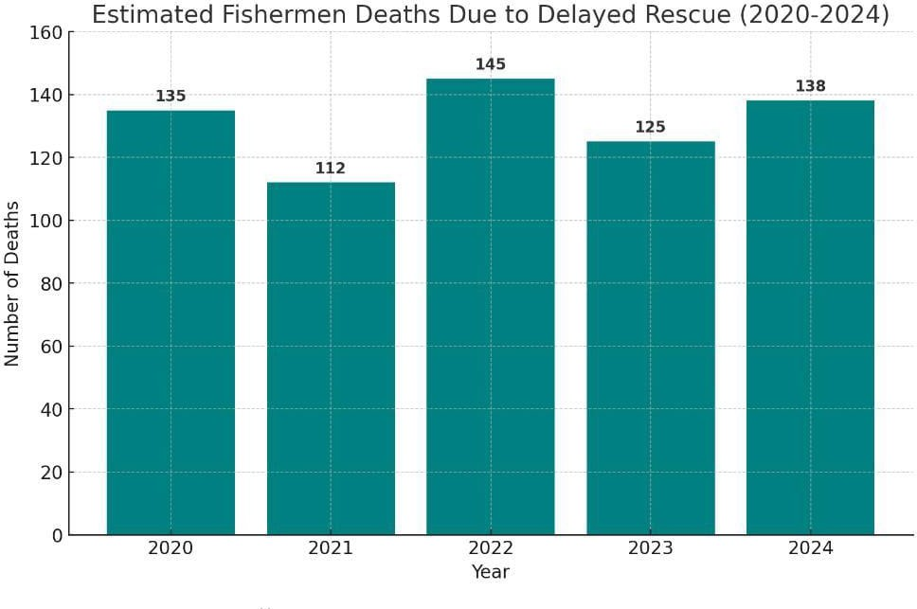

Fig.3.1
Additionally, a breakdown of fatalities among Tamil Nadu fishermen shows that the majority of deaths - over 800 cases - were due to Sri Lankan Navy-related incidents, followed by natural disasters like Cyclone Ockhi (74 deaths), Cyclone Thane (39 deaths), and Cyclone Gaja (52 deaths). These figures expose the vulnerability of fishermen in both political and climatic scenarios.

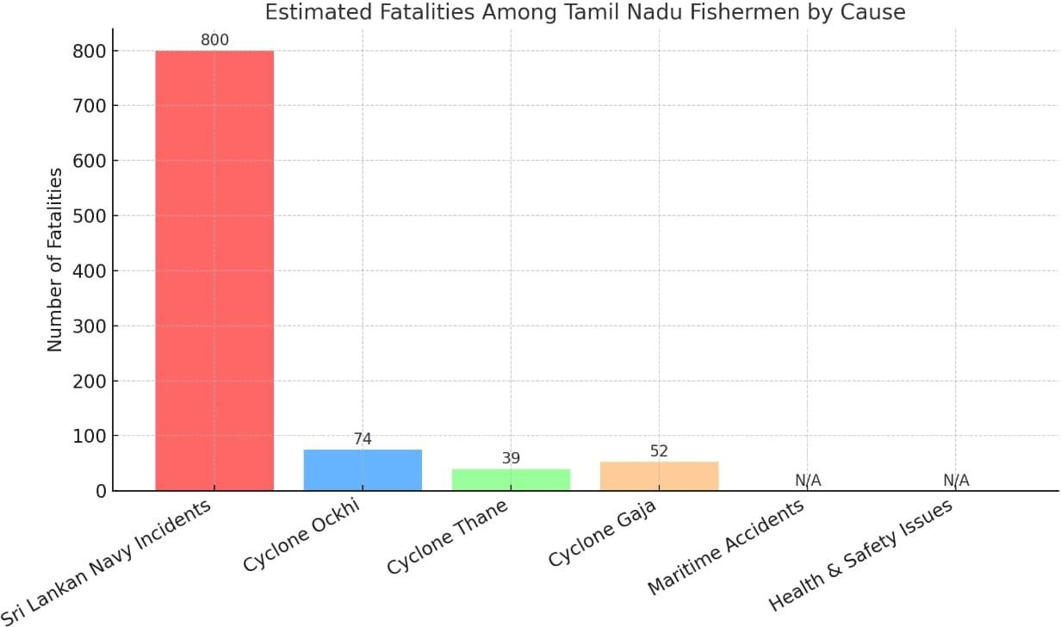

Fig.3.2
In contrast, projections suggest that timely rescue systems could save over 100 lives per year, as seen in the estimated lives saved graph from 2020 to 2024. Despite modest improvements, the data emphasizes that without proactive and automated safety solutions, the fatality numbers will continue to fluctuate dangerously.
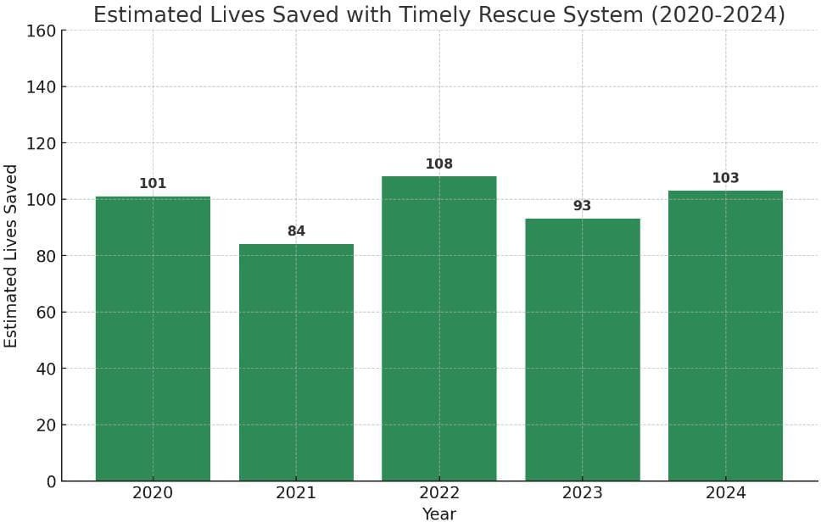

Fig.3.3

The current problem is twofold:
Lack of real-time location tracking in deep-sea areas with weak or no mobile network coverage.
Absence of automated emergency alerts, especially when the fisherman is unable to manually seek help.

This project aims to bridge that gap by proposing an affordable, IoT-based solution that not only tracks fishermen in real-time using GPS but also sends emergency alerts automatically through GSM and motion-triggered mechanisms, while incorporating offline data storage during signal outages.

CHAPTER 4
PROPOSED SYSTEM
The proposed system is designed to improve the safety and monitoring of deep-sea fishermen by leveraging IoT technology. It integrates multiple hardware modules and sensors to provide real-time tracking, emergency alerting, and data backup capabilities. The core components include a GPS module (NEO-6M) fetches real-time coordinates, which are then parsed and converted to readable format using the TinyGPS++ library and a GSM module (SIM800L) for sending location data and emergency messages via SMS to shore-based authorities at regular intervals. To enhance the system’s responsiveness, an SOS push button is provided that allows the fishermen to manually trigger emergency alerts. Additionally, the system is equipped with an MPU6050 motion sensor that detects abnormal boat movement or prolonged stillness. If such conditions are identified, the system automatically sends an SOS alert without the need for manual input. A critical feature of the system is its ability to store GPS data when GSM connectivity is unavailable. This is achieved using EEPROM memory in the Arduino UNO microcontroller. Once the GSM connection is re-established, the stored data is automatically transmitted, ensuring no loss of location tracking. The Arduino UNO manages all module interactions and executes the embedded software logic to ensure reliable, real-time operation. The entire system is powered by a battery and designed to start automatically when the fishing boat is powered on, minimizing the need for manual handling.This system provides a robust, user-friendly, and cost-effective safety solution tailored specifically for fishermen who operate in challenging and remote marine environments.

4.1 ADVANTAGES OF THE PROPOSED SYSTEM
Real-Time Tracking: Continuously monitors the fisherman’s location using GPS and sends updates via SMS to authorities.
Emergency Alert Capability: Provides both manual and automatic SOS alerts, ensuring timely assistance during emergencies.
Offline Data Logging: Stores GPS data during GSM network failures and transmits it once the network is restored.
Low Cost and Accessibility: Uses affordable, easily available components like Arduino UNO, making it suitable for small-scale fishermen.
Automated Operation: Starts automatically and functions with minimal manual input, reducing complexity for users. 21

CHAPTER 5 BLOCK DIAGRAM

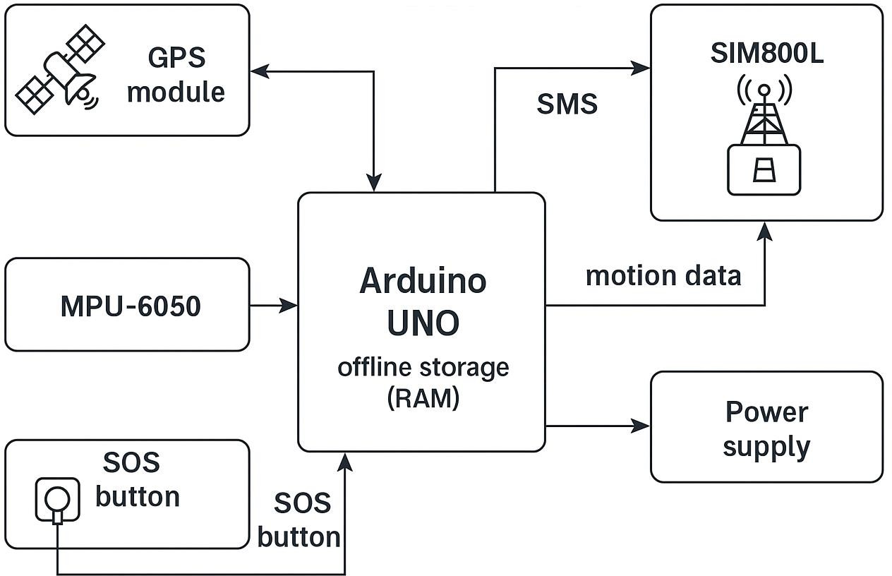

Fig.5 Block Diagram
____________________________________________________________________________________________

CIRCUIT DIAGRAM

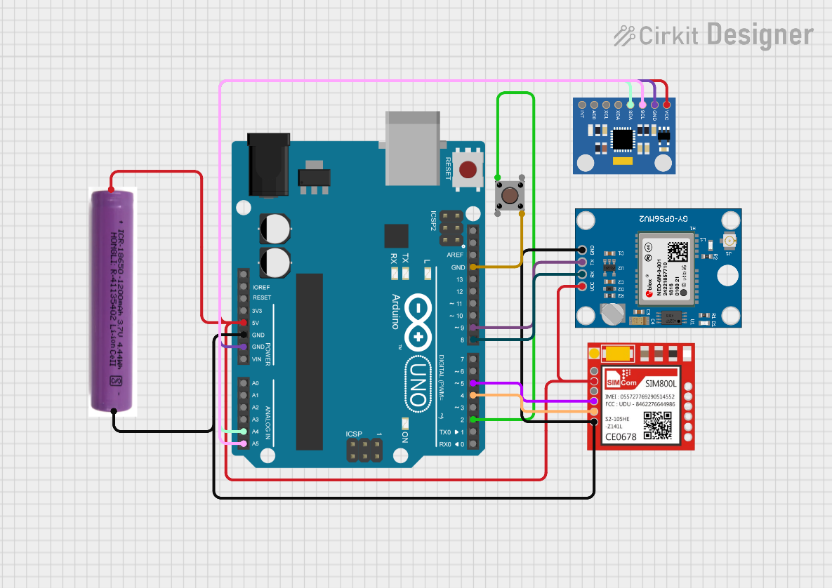

Fig.5.0 Circuit Diagram

HARDWARE AND SOFTWARE REQUIREMENTS

    - HARDWARE REQUIREMENTS
      - Arduino UNO
      - GPS Module (NEO-6M)
      - GSM Module (SIM800L)
      - Power Supply (Battery)
      - MPU6050 Sensor
      - Push Button (SOS)

SOFTWARE REQUIREMENTS
      - Arduino IDE
      - Libraries: Electronic cats, MPU6050, EEPROM, Tiny GPS ++

  - Arduino UNO

CHAPTER 6 HARDWARE DESCRIPTIONS

The Arduino UNO is one of the most popular and widely used microcontroller boards in the field of embedded systems and IoT-based project development. Developed by the Arduino.cc team, it is an open-source platform designed to simplify electronics prototyping. The board is based on the ATmega328P microcontroller and is well-known for its user-friendly environment and easy integration with a variety of sensors, modules, and actuators. Its plug- and-play functionality, compatibility with USB, and support from a vast community make it ideal for beginners and professionals alike.
In this project, the Arduino UNO acts as the central control unit responsible for
managing all the components, including the GPS module, GSM module, MPU6050 motion sensor, and the SOS button. It is used to process the GPS data, check network status, handle memory operations, monitor sensor inputs, and send alert messages via GSM. It operates in real-time, executing predefined logic with high efficiency. One of the major reasons for choosing Arduino UNO in this project is its simplicity, cost-effectiveness, and the availability of well-documented libraries that reduce development time. Since the Arduino IDE supports this board directly, code uploading and testing become extremely convenient, making it an excellent fit for this real-time safety system.

PRODUCT DESCRIPTION
The Arduino UNO is built around the ATmega328P microcontroller chip, which provides 32 KB of flash memory, 2 KB of SRAM, and 1 KB of EEPROM. It runs at a clock speed of 16 MHz, which is sufficient for handling sensor data processing and real-time decision making in small to medium-scale IoT projects. The board includes 14 digital I/O pins (6 of which can be used as PWM outputs), and 6 Analog input pins for reading Analog sensor values. It also features onboard LEDs, a reset button, a power jack, a USB interface for programming, and an ICSP header for external programming or advanced use.
Communication protocols such as UART (Serial), I2C, and SPI are supported, which makes it compatible with modules like GPS (UART), MPU6050 (I2C), and GSM (UART). The board operates on 5V and can be powered via USB or an external power supply. It is capable
24

Of multitasking basic operations, responding to interrupts, and executing looped logic continuously. In this project, it manages inputs from the GPS and motion sensor, makes logical decisions based on motion and button states, logs data during GSM failure using EEPROM, and sends SMS alerts using AT commands through the GSM module.The board’s reliability and open hardware architecture make it suitable for deployment in harsh field environments like marine conditions, where minimal intervention and robust performance are crucial.

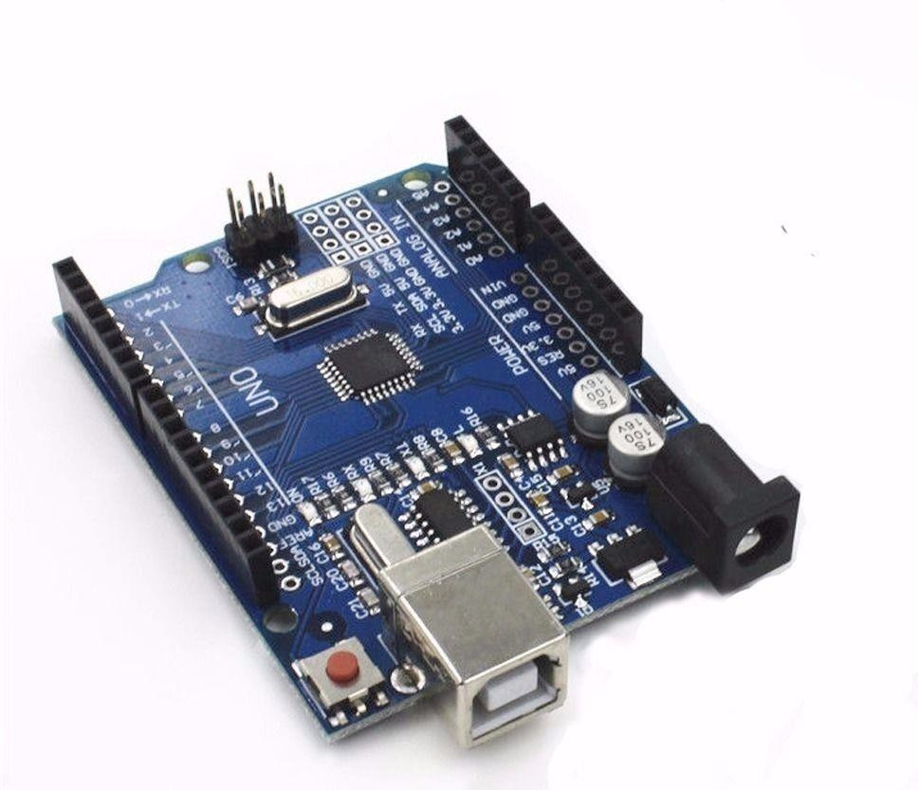

Fig.6.1 Arduino UNO

FEATURES
      - Based on ATmega328P microcontroller
      - 14 digital I/O pins, 6 Analog input pins
      - 16 MHz operating speed
      - Supports UART, SPI, and I2C communication
      - Built-in EEPROM and USB support
      - Compatible with Arduino IDE and open-source libraries

APPLICATIONS
      - Real-time embedded control systems
      - IoT-based sensor monitoring projects
      - Robotics and automation
      - Educational electronics and prototyping

GPS Module (NEO-6M)
The GPS module is a vital component for any location-based system, especially in applications where real-time tracking and remote monitoring are essential. The NEO-6M GPS module from u-blox is a compact and highly accurate device that receives satellite signals and calculates geographic location data such as latitude, longitude, altitude, and time. It works globally and is widely adopted in embedded systems due to its ease of use, low power requirements, and fast satellite acquisition time.
In this project, the NEO-6M GPS module is responsible for fetching the real-time coordinates of the fishing boat. This data forms the core of the system’s tracking functionality, as it allows authorities to monitor the exact location of fishermen in open waters. The GPS module ensures high-precision readings, which are crucial for sending reliable updates and triggering accurate emergency alerts. Its compatibility with basic serial communication protocols makes it a suitable fit for Arduino-based IoT applications.

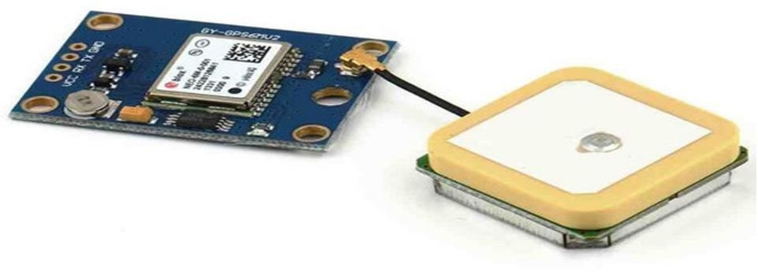

Fig.6.2. GPS Module (NEO-6M)

PRODUCT DESCRIPTION
The NEO-6M operates on the u-blox 6 positioning engine and communicates with microcontrollers using UART protocol. It requires a power supply of 3.3V to 5V and has a default baud rate of 9600. The module comes with a built-in ceramic antenna or may be connected to an external active antenna for improved reception. LED that indicates GPS lock status and a small EEPROM chip for storing configuration settings.
In this project, the GPS module is connected to the Arduino UNO via serial pins. The Arduino IDE is used as the development platform for coding and compiling the logic that retrieves and processes GPS data. Instead of using external GPS libraries like TinyGPS++, this project employs basic serial reading functions to extract raw NMEA sentences and parse them as needed. The coordinates are then used for SMS transmission or logged in memory when GSM is unavailable. The simplicity of using the NEO-6M, combined with direct serial communication and Arduino programming, makes it a practical and efficient component for real-time location tracking in marine environments.

FEATURES
      - u-blox 6 high-performance positioning engine

      - UART serial interface, 9600 baud rate (default)
      - Accurate to within 2.5 meters
      - Power supply: 3.3V–5V
      - LED status indicator
      - Supports passive and active antennas

APPLICATIONS
      - Vehicle and boat tracking
      - Navigation systems
      - Remote geolocation monitoring
      - Emergency location-based alert systems

GSM Module (SIM800L)
The GSM module is a critical component in IoT communication systems, enabling wireless transmission of data over mobile networks. GSM stands for Global System for Mobile Communications, and it is widely used for sending and receiving messages (SMS), making voice calls, and connecting to mobile internet services. The SIM800L module, developed by SIMCom, is one of the most compact and cost-effective GSM/GPRS modules available for embedded applications. It supports quad-band GSM networks, allowing it to operate in almost any country with a 2G network. In this project, the SIM800L is used to transmit GPS coordinates and emergency alerts via SMS to pre-registered shore-based authorities. The module is responsible for establishing a mobile connection using a standard SIM card and communicating with the Arduino UNO through serial communication using AT commands. Its reliability, compact design, and low power requirements make it well-suited for safety-critical marine applications where real-time communication is essential.

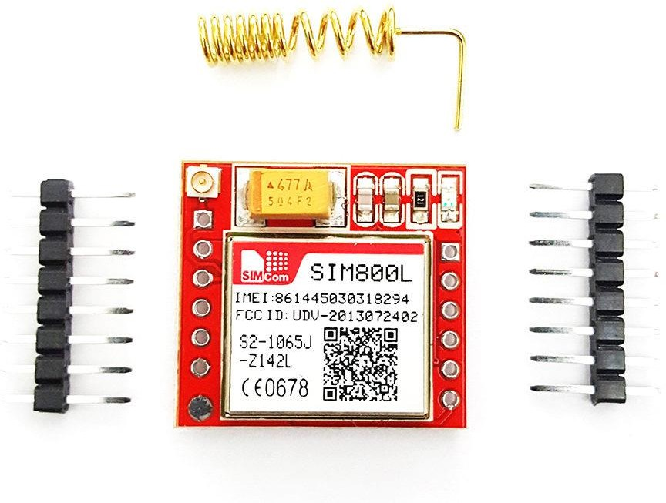
Fig.6.3 GSM Module (SIM800L)

PRODUCT DESCRIPTION
The SIM800L GSM module operates on a voltage range of 3.7V to 4.2V and communicates with the microcontroller through UART (serial) interface at a baud rate of 9600 bps (by default). It supports sending and receiving SMS, making and receiving voice calls, and GPRS data transmission. A standard SIM card is inserted into the module, and a small external antenna is used to ensure better signal reception, especially in low-coverage areas like offshore waters. In this project, the GSM module is responsible for sending periodic location updates (retrieved from the GPS module) to shore-based authorities every 10 seconds. It also sends SOS messages when triggered by either the push button or the motion sensor. The Arduino UNO sends AT commands to the SIM800L module to handle these operations. If the GSM network is unavailable, the Arduino logs the data into EEPROM and automatically transmits it once the signal is restored. The module's ability to operate with basic commands and its compatibility with low-power systems makes it an ideal choice for field-based, real-time alert systems.

FEATURES
      - Quad-band GSM/GPRS: 850/900/1800/1900 MHz
      - Supports SMS, voice calls, and GPRS data
      - Compact and lightweight design

      - Operates on AT command set
      - Serial communication via UART
      - External antenna for extended range

APPLICATIONS
      - Remote alert and communication systems
      - SMS-based control and monitoring
      - IoT and embedded security solutions
      - Emergency communication in isolated areas

POWER SUPPLY (BATTERY)
A stable and reliable power supply is one of the most important aspects of any embedded or IoT-based system, especially when deployed in outdoor or mobile environments. In the context of deep-sea fishing, where access to constant electricity is unavailable, the system must rely on a portable power source that can operate for extended periods without interruption. For this project, a rechargeable battery module is used to ensure uninterrupted power supply to all components-including the Arduino UNO, GPS module, GSM module, motion sensor, and SOS button.


Fig.6.4. Battery (Power Supply)

The battery used in this project is a Lithium-Ion (Li-Ion) cell, known for its high energy density, lightweight construction, and rechargeability. These batteries are capable of supplying consistent voltage output, making them ideal for powering microcontroller-based circuits. A properly rated voltage regulator or power management module is used to ensure that the voltage remains within safe operating limits for each component. This power supply system ensures that the device remains active throughout the duration of the fishing operation, even in cases of extended usage or poor weather conditions.

PRODUCT DESCRIPTION
The rechargeable battery module typically provides an output voltage of 3.7V (for single-cell modules), depending on the model used. The battery module is selected based on the total current consumption of all devices in the circuit, ensuring enough backup for at least 6–8 hours of operation. In some versions of the system, a battery monitoring circuit is added to prevent deep discharge and overcharging, improving safety and battery lifespan.
In the project setup, the battery is connected to the power input of the Arduino board, which in turn powers the connected modules. This portable design allows the system to be installed on a fishing boat without relying on the boat’s main power system. Additionally, the entire hardware setup can be enclosed in a waterproof casing to protect the electronics from marine exposure while still maintaining consistent power delivery from the battery.

FEATURES
      - Rechargeable and portable
      - Lightweight and compact
      - Provides continuous power to the system
      - Compatible with voltage regulators
      - Long battery backup (6-8 hours depending on load)

APPLICATIONS
      - Remote IoT systems
      - Marine and off-grid electronics

      - Wearable or mobile embedded devices
      - GPS and GSM-powered location systems

MPU6050 Motion Sensor
The MPU6050 is a highly integrated motion tracking device that combines a 3-axis gyroscope and a 3-axis accelerometer into a single compact module. It is widely used in robotics, drones, mobile devices, and IoT applications that require motion detection, orientation sensing, and gesture recognition. This sensor captures both angular velocity and linear acceleration, making it suitable for detecting movement, tilt, stillness, vibration, and sudden orientation changes.
In this project, the MPU6050 plays a critical safety role. It continuously monitors the motion of the fishing boat, and when it detects abnormal conditions-such as sudden tilting, abrupt stops, or long periods of stillness-it automatically triggers an SOS signal. This is especially useful when fishermen are unconscious or unable to press the SOS button manually. Its ability to work in real-time and respond to physical changes in movement adds an intelligent automation layer to the emergency alert system. Because it communicates using the I2C protocol, it can be easily interfaced with the Arduino UNO without using many GPIO pins.
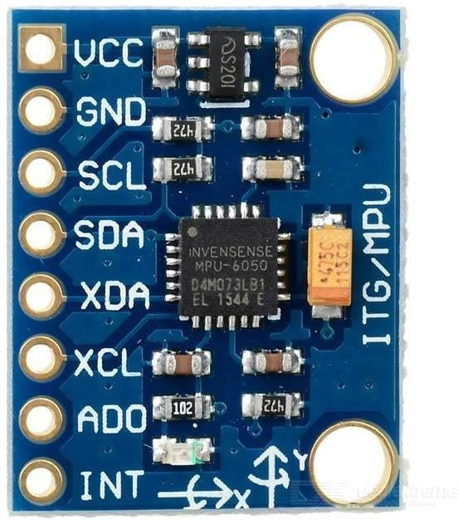

Fig.6.5. MPU6050

PRODUCT DESCRIPTION
The MPU6050 sensor module is based on MEMS (Micro-Electro-Mechanical Systems) technology. It contains a Digital Motion Processor (DMP) that processes motion-related data onboard before sending it to the microcontroller. It operates at 3.3V and communicates with Arduino via the I2C bus (using the SDA and SCL pins). The module can detect acceleration in three axes (X, Y, Z) and rotational movement (pitch, roll, yaw), making it suitable for tilt sensing and motion-triggered automation.
In this project, the sensor is initialized and calibrated through the Arduino IDE using the Electronic Cats MPU6050 library. The Arduino constantly reads acceleration and gyroscope values, and if a predefined threshold is crossed-such as excessive tilt or a flat-line stillness-it considers the condition critical and triggers the GSM module to send an SOS alert. This approach eliminates the dependency on manual interaction during emergencies and adds a layer of intelligence to the safety system.

FEATURES
      - 3-axis gyroscope and 3-axis accelerometer in one chip
      - I2C communication interface
      - Digital Motion Processor (DMP) for onboard processing
      - Operating voltage: 3.3V
      - Compact, low-power design

APPLICATIONS
      - Tilt and fall detection
      - Inertial navigation systems
      - Auto-triggered safety systems
      - Motion tracking in wearable and mobile devices

Push Button (SOS Trigger)
The push button is one of the simplest and most widely used input devices in electronic systems. It is a mechanical switch that allows the user to close or open an electrical circuit by applying physical pressure. In embedded systems, push buttons are commonly used for starting, stopping, resetting, or triggering specific actions.
In this project, the push button serves as the manual emergency alert system - also referred to as the SOS button. It enables fishermen to instantly trigger an alert message to shore-based authorities by simply pressing the button. This is particularly useful in emergency situations such as boat malfunction, medical issues, or encountering bad weather. The button offers a quick, direct way to notify rescuers without needing complex interaction with the device. It is connected to one of the digital I/O pins on the Arduino UNO, and its state is constantly monitored in the main program loop.

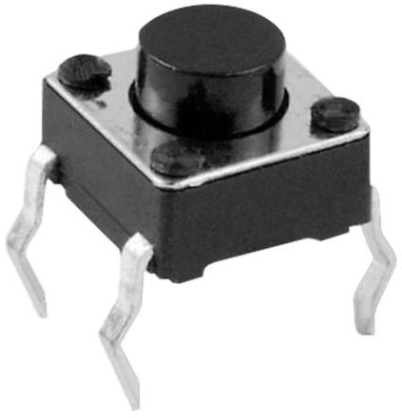

Fig.6.6. Push Button

PRODUCT DESCRIPTION

The push button used in this project is a single-pole, normally open (SPNO) tactile switch that closes the circuit when pressed and opens it upon release. It is small, lightweight, and operates on a digital HIGH/LOW signal, making it easy to interface with microcontrollers. The button is typically connected in a pull-down or pull-up resistor configuration to ensure accurate reading of its pressed or unpressed state.
In this application, the Arduino UNO is programmed to detect when the button is pressed. Upon detection, it immediately sends an SMS containing the boat’s current GPS coordinates via the GSM module. This message acts as an SOS alert, enabling the rescue team or coastal authorities to respond quickly. The button is installed in a location that is easily accessible to the fishermen for fast and hassle-free use during an emergency.

FEATURES
      - Simple and reliable mechanical switch
      - Compact and durable
      - Digital input (ON/OFF)
      - Easy to integrate with microcontrollers

APPLICATIONS

      - Emergency alert systems (SOS)
      - Reset or trigger operations in embedded devices
      - Start/stop controls
      - Human-machine interface (HMI)

CHAPTER 7

SOFTWARE DESCRIPTION

The software component of this project is responsible for managing the flow of data between hardware modules, processing sensor inputs, and automating the decision-making logic. All programming and system development were done using the Arduino Integrated Development Environment (IDE), which is an open-source platform that supports code writing, compiling, and uploading to Arduino boards.
The software logic was developed in the C/C++ based Arduino language, and is responsible for:
      - Receiving GPS data
      - Checking GSM signal availability
      - Sending SMS messages
      - Logging data to EEPROM when GSM is not available
      - Reading motion sensor data
      - Triggering automatic or manual SOS alerts
The project makes use of several important libraries to interact with connected modules and simplify development.

Arduino IDE
The Arduino IDE is a user-friendly platform that allows developers to write code in a simplified programming environment. It supports a variety of boards and libraries and offers serial monitor capabilities for real-time debugging and testing. The code is written in a structure consisting of setup () and loop () functions, which are used to initialize components and execute the main logic repeatedly.
In this project, the Arduino IDE was used to:
- Write and compile the program
- Upload code to the Arduino UNO via USB
- Monitor GPS and GSM output via the Serial Monitor
- Debug logic in real-time during development

Libraries Used

Electronic Cats MPU6050 Library
This library allows easy interaction with the MPU6050 sensor. It supports both accelerometer and gyroscope data reading and simplifies initialization, calibration, and data filtering.

EEPROM Library
The EEPROM library is used to read and write data into the Arduino’s internal non- volatile memory. In this project, it is used to log GPS coordinates when GSM connectivity fails. Stored data is sent later when the signal is restored.

TinyGPS++ Library
Used to parse and extract latitude and longitude from the raw NMEA sentences received from the NEO-6M GPS module. It simplifies location extraction and conversion to decimal degrees format.

SOFTWARE LOGIC OVERVIEW
The software logic plays a pivotal role in the functioning of the IoT-based Fisherman Tracking and Emergency Alert System. It is responsible for coordinating all hardware modules, collecting and processing data, taking logical decisions based on sensor readings, managing memory, and ensuring continuous communication. The software is written in the Arduino programming language (a simplified version of C/C++) and compiled using the Arduino IDE. This logic is divided into three core layers:
- Initialization and Setup
- Main Operational Loop
- Exception Handling and Fail-Safe Mechanisms

Initialization and Setup
Upon powering the system, the setup() function is executed once. This block handles:

  - Initializing serial communication with the GPS and GSM modules (using Serial.begin() and SoftwareSerial).
  - Starting I2C communication for the MPU6050 motion sensor via the Wire.h and Electronic Cats MPU6050 library.
  - Configuring input and output pins: the push button as input, and other signal pins as needed.
  - Loading any previously stored EEPROM values (if needed) for debugging or continuity.
  - Checking the GSM module’s initial connection to ensure the SIM card is recognized and the module is ready for communication.
The GPS is also started during setup, and the TinyGPS++ library is initialized to begin parsing incoming NMEA sentences for live location data.

Main Operational Loop
The loop() function is the heart of the software and runs repeatedly throughout the device’s operation.

GPS Data Handling
  - The Arduino continuously reads serial data from the NEO-6M GPS module.
  - The TinyGPS++ library parses the raw NMEA strings into structured data: gps.location.lat()
gps.location.lng()
  - This data is stored in global variables for use across functions.

GSM Communication and SMS Transmission
  - Every 10 seconds, a timer-based check is used to determine if it's time to send location updates.
  - If GSM signal is available (checked via AT command response), the system sends an SMS using a format like:
Latitude: 13.1475
Longitude: 80.0589
  - The SMS is sent to pre-configured emergency contacts.

SOS Button Monitoring
  - A digital pin monitors the push button status.
  - If the button is pressed (logical HIGH), an immediate SOS message is sent with the current GPS data, overriding the 10-second timer.

Motion Sensor Logic (MPU6050)
  - The MPU6050 sensor continuously reports accelerometer and gyroscope data.
  - Threshold conditions are defined:
If no movement is detected for a set period
If abnormal tilting is recorded (e.g., a sudden roll)
  - When such conditions are met, the system interprets this as a possible accident or emergency and automatically sends an SOS message.

EEPROM Data Logging and Retrieval
The software also handles situations where GSM communication fails:

GSM Failure Detection
  - If the GSM module does not respond (e.g., AT command fails), the system logs the GPS data to EEPROM memory.
  - A simple index-based system is used to write new entries without overwriting old data.

Data Retrieval and SMS Queue
  - When GSM is restored, the Arduino reads back stored GPS data from EEPROM.
  - Each entry is formatted and sent via SMS sequentially.
  - Once confirmed, the EEPROM memory can be cleared or reset for future storage. This feature ensures zero data loss, even in remote sea locations with poor mobile coverage.

Fail-Safe Conditions
To improve system reliability, several fail-safes are coded:
  - If GPS data is not valid, no SMS is sent, and the system waits for the next cycle
  - If memory usage exceeds limit, a reset or overwrite mechanism can be triggered

The software is designed to:
  - Function in real-time with high responsiveness
  - Handle both normal and emergency operations

  - Work even when certain modules (like GSM) temporarily fail
  - Provide minimal delay and accurate tracking

The logic uses modular, interrupt-free design, allowing the system to be efficient, robust, and low-power -suitable for marine deployment.

CHAPTER 8 WORKING MODEL

The working model of the proposed IoT-based Deep-Sea Fisherman Tracking and Emergency Alert System has been developed with a focus on practical implementation, real- time communication, and enhanced safety features. The system is centered around an Arduino UNO microcontroller, interfaced with various modules such as the NEO-6M GPS module, SIM800L GSM module, MPU6050 motion sensor, EEPROM for data logging, and a manual SOS push button. The primary goal of the system is to ensure continuous tracking of the fisherman’s location, enable immediate emergency alerts, and provide reliable data storage during GSM network failure.

System Initialization
When the system is powered on (usually via a battery), the Arduino UNO begins by initializing all the connected components. This includes:
  - Establishing serial communication with the GPS and GSM modules.
  - Configuring I2C communication for the MPU6050 motion sensor.
  - Initializing internal EEPROM for data logging.
  - Setting pin modes for the push button and sensor inputs.
The GPS module starts scanning for satellites to retrieve real-time location data, while the GSM module prepares to connect to the mobile network to enable SMS communication.

Real-Time GPS Data Collection and Processing
The NEO-6M GPS module continuously receives satellite signals and generates NMEA sentences, which are processed by the Arduino using the TinyGPS++ library. This library efficiently extracts:
  - Latitude
  - Longitude
The extracted coordinates are stored in variables for periodic transmission. This data is also stored temporarily in EEPROM if the GSM module fails to send it due to lack of network coverage.

Data Transmission via GSM Module
The SIM800L GSM module is used for sending SMS messages to a pre-configured contact number (e.g., coastal authority or family member). Every 10 seconds, the system sends an SMS containing the latest latitude and longitude.
The communication occurs through AT commands, which are sent from Arduino to the GSM module using serial communication.

Emergency Alert Triggering
The system supports both manual and automatic SOS triggering:
  - Manual SOS: A push button is connected to a digital pin on the Arduino. When pressed, it immediately sends an SOS message with the current GPS location.
  - Automatic SOS: The MPU6050 motion sensor continuously monitors acceleration and orientation. If it detects an abnormal tilt, long stillness, or sudden impact (indicating a possible accident), it auto-triggers an SOS.
This dual-layer alert mechanism ensures that help can be summoned even if the fisherman is unconscious or unable to interact with the device.

Offline GPS Data Logging
During times when the GSM module cannot send data (due to low signal or no network), the Arduino writes GPS data to its internal EEPROM. This ensures no data is lost. Once the GSM signal is restored, the system automatically reads the stored coordinates from EEPROM and transmits them via SMS.This feature makes the system highly reliable, even in deep-sea conditions where mobile coverage is often spotty or intermittent.

Power Supply and Automation
The entire setup is powered by a rechargeable battery. The system is designed to start automatically when the battery is connected. This design choice reduces manual errors and simplifies usage, especially for those unfamiliar with electronics.
Optional enhancements like solar panels or battery level monitoring can further improve long- term use.

System Overview Flow
The simplified flow of the system operation is as follows:
- Power on the system
- Initialize all modules
- Continuously fetch GPS data
- Check GSM signal:
  - If available → send SMS
  - If not → log data to EEPROM

- Monitor motion and button input
- Trigger SOS (automatic or manual if conditions match)
- Auto-send saved data when GSM is restored

This working model ensures continuous location tracking, timely alert generation, and data reliability. Its modular design, affordable components, and real-world applicability make it suitable for fishermen in remote sea regions. The system prioritizes automation, low power usage, and durability - making it not only a technical solution but a socially relevant one.

CHAPTER 9
CONCLUSION AND FUTURE ENHANCEMENT

CONCLUSION
This project aimed to address one of the most critical challenges faced by deep-sea fishermen-the lack of real-time communication and safety mechanisms while venturing far from the coast. The proposed IoT-based solution successfully demonstrates a practical, low- cost, and efficient system for real-time location tracking and emergency alerting. By integrating hardware components such as the GPS module (NEO-6M), GSM module (SIM800L), MPU6050 motion sensor, and a manual SOS button, the system ensures that fishermen can be continuously monitored and that immediate alerts can be triggered during emergencies.

The Arduino UNO served as the central controller, handling data collection, decision- making, and communication tasks. It coordinated input from the GPS and motion sensor, assessed GSM network availability, and either transmitted data via SMS or stored it in EEPROM for later transmission. This dual-mode capability ensures that the system functions even in environments with weak or no GSM signal, enhancing its reliability. Additionally, the automatic SOS functionality using motion detection provides a significant safety advantage in situations where manual interaction is not possible.

From a usability perspective, the system is designed for simplicity and portability. Once powered on, it operates autonomously, requiring minimal input from the user. This is especially beneficial in a marine environment where user attention is primarily focused on fishing activities. Moreover, the use of widely available and low-cost components ensures that the system is accessible to small-scale and traditional fishermen who cannot afford commercial tracking systems. In conclusion, the developed model successfully meets its objectives by offering real-time tracking, emergency communication, offline data logging, and automated safety alerts. It serves as a meaningful technological intervention for improving maritime safety and has the potential to save lives by enabling faster rescue responses. This project not only showcases the effective application of IoT in real-world problems but also emphasizes the importance of low-cost, scalable solutions in addressing societal needs.

FUTURE ENHANCEMENT
While the current system fulfils its intended purpose effectively, there are several areas where it can be enhanced to increase its reliability, functionality, and user adaptability in real- world deployments.

One of the major limitations of the present system is its dependence on GSM networks. In some deep-sea locations, GSM coverage is non-existent or highly unstable. To overcome this, future versions of the system can be equipped with satellite communication modules that allow SMS or low-bandwidth data transfer through satellite networks, ensuring global coverage. This would significantly improve the system's effectiveness, even in the most remote marine areas.Power consumption is another area that can be optimized. The addition of a solar- powered charging unit could extend battery life indefinitely during daylight hours and reduce the need for frequent recharging. This is especially beneficial for long-duration fishing expeditions. Moreover, the incorporation of battery monitoring features using voltage sensors could inform users about low power levels and prevent unexpected shutdowns.

To further enhance user interaction and data management, a mobile application or web dashboard can be developed. This would allow families or authorities to view real-time boat location on a map, receive alerts instantly, and access historical travel data. Integration with cloud platforms could also enable automatic data backup and advanced analytics for monitoring fishing routes and safety trends.

From a safety perspective, the system can be upgraded by adding water-level sensors or temperature sensors, which can alert users about flood risks or environmental hazards. An onboard buzzer or LED indicator could give immediate feedback to fishermen when the system detects abnormal activity or sends an SOS alert. In summary, the current model provides a solid foundation for improving deep-sea fisherman safety, but with additional enhancements in connectivity, power management, user interface, and environmental sensing, it has the potential to evolve into a comprehensive maritime safety and monitoring platform.

CHAPTER 10 APPENDICES

SAMPLE CODING
#include <SoftwareSerial.h> #include <TinyGPS++.h> #include <Wire.h>
#include <MPU6050.h> #include <EEPROM.h>

// GSM and GPS Serial
SoftwareSerial gsmSerial(10, 11); // RX, TX for GSM SoftwareSerial gpsSerial(4, 3); // RX, TX for GPS

// Libraries and Variables TinyGPSPlus gps; MPU6050 mpu;

int16_t prevAx = 0, prevAy = 0, prevAz = 0; unsigned long lastMPUCheckTime = 0;
const unsigned long mpuCheckInterval = 500; // Check every 500ms

unsigned long lastGPSTime = 0;
const unsigned long gpsInterval = 10000; // 10 seconds

const int buttonPin = 5;

double latitude = 0.0; double longitude = 0.0;

bool alertSent = false;
bool gsmConnected = false; // Track GSM status

int eepromAddress = 0; // EEPROM write pointer

// Function Declarations void sendStoredData();
void storeData(double lat, double lng, char eventType); String makeAlertMsg(String event, double lat, double lng); void sendSMS(String number, String message);

void setup() { Serial.begin(9600); gpsSerial.begin(9600); gsmSerial.begin(9600);

Wire.begin(); mpu.initialize();

pinMode(buttonPin, INPUT_PULLUP);

Serial.println(" Fisherman's Safety System Initialized."); Serial.println(" Waiting for GPS & GSM signals...");

}

}

void loop () {
// Read GPS Data
while (gpsSerial.available()) { gps.encode(gpsSerial.read());
}

unsigned long currentTime = millis();
if (currentTime - lastGPSTime >= gpsInterval) { lastGPSTime = currentTime;

Serial.println(" GPS Location Update:");

if (gps.location.isValid()) { latitude = gps.location.lat(); longitude = gps.location.lng(); Serial.print(" Latitude: "); Serial.println(latitude, 6); Serial.print(" Longitude: "); Serial.println(longitude, 6);
}

else {
Serial.println(" GPS signal is wainting not fixed yet..... Using fallback location..."); latitude = 13.1475;
longitude = 80.0589;

Serial.print(" Latitude (Fallback): "); Serial.println(latitude, 6);

Serial.print(" Longitude (Fallback): "); Serial.println(longitude, 6);
}
}
// MPU Data for Tilt Detection int16_t ax, ay, az, gx, gy, gz;
mpu.getMotion6 (&ax, &ay, &az, &gx, &gy, &gz);

// GSM Connectivity Check gsmSerial.println("AT"); delay (500);
if (gsmSerial.available()) {
String response = gsmSerial.readString(); if (response.indexOf("OK") != -1) {
if (!gsmConnected) { gsmConnected = true;
Serial.println(" GSM Network Reconnected!");
Serial.println(" ending stored data (recovered from offline mode)..."); sendStoredData();
eepromAddress = 0; // Reset pointer after sending
}
} else {
gsmConnected = false;
}
} else {
gsmConnected = false;
}
}

// Tilt Alert Detection

// MPU Data for Tilt Detection (Sudden Change Detection) unsigned long currentMillis = millis();
if (currentMillis - lastMPUCheckTime >= mpuCheckInterval) { lastMPUCheckTime = currentMillis;

int16_t ax, ay, az, gx, gy, gz; mpu.getMotion6(&ax, &ay, &az, &gx, &gy, &gz);

int deltaAx = abs(ax - prevAx); int deltaAy = abs(ay - prevAy); int deltaAz = abs(az - prevAz);

// Set your own thresholds here (tweak based on real-world testing)
if ((deltaAx > 8000 || deltaAy > 8000 || deltaAz > 8000) && !alertSent) { Serial.println("⚠ Sudden Tilt Detected! Possible emergency situation!"); if (gsmConnected) {
sendSMS("+916385116645", makeAlertMsg("Sudden Tilt", latitude, longitude));
} else {
Serial.println("⚠ GSM offline. Storing Tilt Alert in EEPROM..."); storeData(latitude, longitude, 'T');
}
alertSent = true;
}

// Reset Alert (Optional: Add a cooldown timer if needed)
if (deltaAx < 3000 && deltaAy < 3000 && deltaAz < 3000) { alertSent = false;
}

// Update previous values prevAx = ax;
prevAy = ay; prevAz = az;
}

// Reset Tilt Alert
// if (abs(ax) < 12000 && abs(gy) < 10000 && abs(az) > 14000) {
// alertSent = false;
// }

// Button Alert Detection
if (digitalRead(buttonPin) == LOW) {
Serial.println(" EMERGENCY BUTTON PRESSED by the fisherman!"); if (gsmConnected) {
sendSMS("+916385116645", makeAlertMsg("Button", latitude, longitude));
} else {
Serial.println(" GSM offline. Storing Button Alert in EEPROM..."); storeData(latitude, longitude, 'B');
}
delay(1000);
}

delay(500);
}

// Store Data in EEPROM

void storeData(double lat, double lng, char eventType) { if (eepromAddress + 9 > EEPROM.length()) {
Serial.println(" EEPROM Memory Full! Cannot store more data.");

return;
}

EEPROM.put(eepromAddress, lat); eepromAddress += sizeof(double); EEPROM.put(eepromAddress, lng); eepromAddress += sizeof(double); EEPROM.write(eepromAddress, eventType); eepromAddress += 1;

Serial.println(" Data stored in EEPROM (Offline Mode).");

}

// Send Stored Data from EEPROM void sendStoredData() {
int addr = 0;

bool dataFound = false;

while (addr + 9 <= EEPROM.length()) { double lat, lng;
char eventType; EEPROM.get(addr, lat); addr += sizeof(double); EEPROM.get(addr, lng); addr += sizeof(double);

eventType = EEPROM.read(addr);

addr += 1;

if (!isnan(lat) && !isnan(lng)) {
String event = (eventType == 'T') ? "Tilt Alert" : "Button Alert";
String message = " Recovered Alert: " + event + " at Lat: " + String(lat, 6) + ", Long: " + String(lng, 6);
sendSMS("+916385116645", message);
Serial.println(" Recovered " + event + " sent successfully."); dataFound = true;
}
}

if (dataFound) {
Serial.println(" All missed location alerts sent successfully.");
} else {
Serial.println(" No offline data found to send.");
}
}

// Format Alert Message
String makeAlertMsg(String event, double lat, double lng) {
return " Emergency Alert: " + event + " at Lat: " + String(lat, 6) + ", Long: " + String(lng, 6);
}

// Send SMS via GSM
void sendSMS(String number, String message) { gsmSerial.println("AT+CMGF=1");
delay(500);

gsmSerial.print("AT+CMGS=\""); gsmSerial.print(number); gsmSerial.println("\""); delay(1000);

gsmSerial.print(message); delay(500);
gsmSerial.write(26); // Ctrl+Z to send delay(5000);

Serial.println(" SMS Sent: " + message);
}

OUTPUT SCREENSHOTS

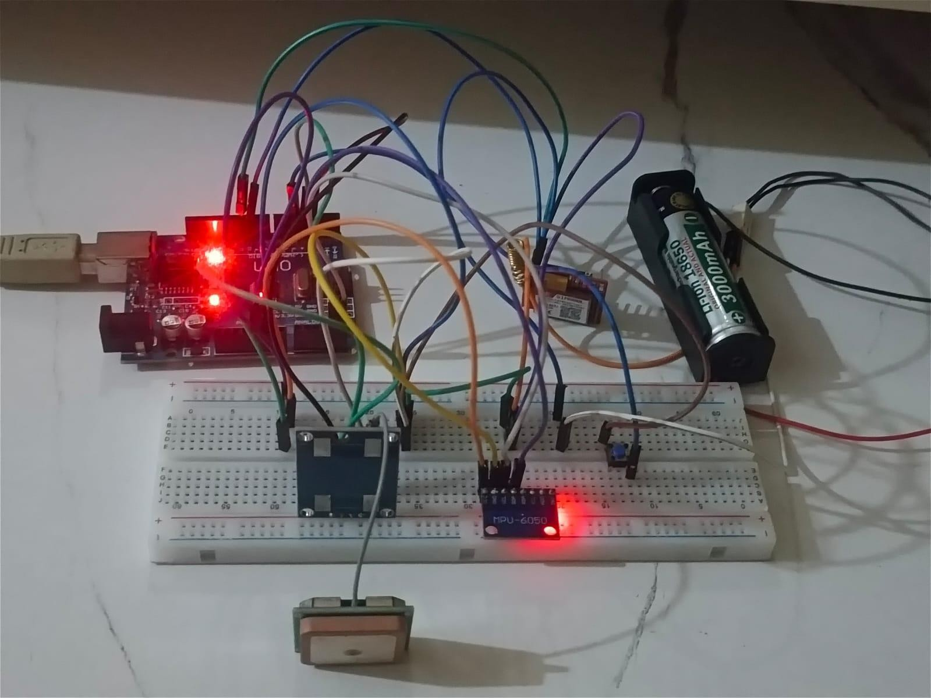

Fig.10.2.1 Overview of the System

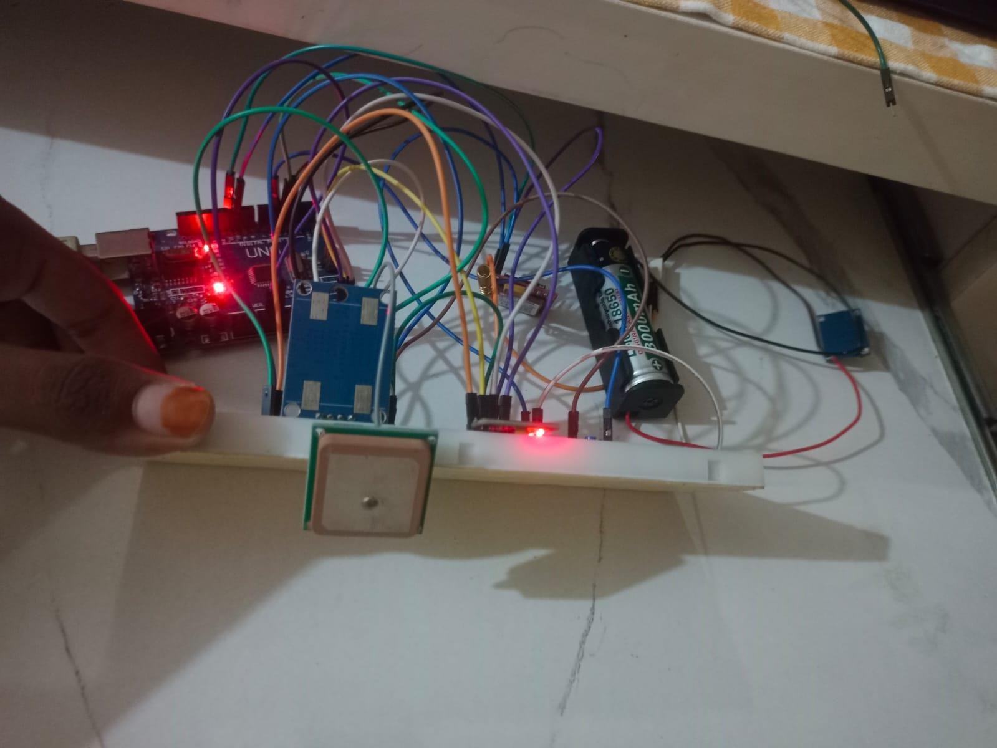

Fig.10.2.2 When the board Tilted

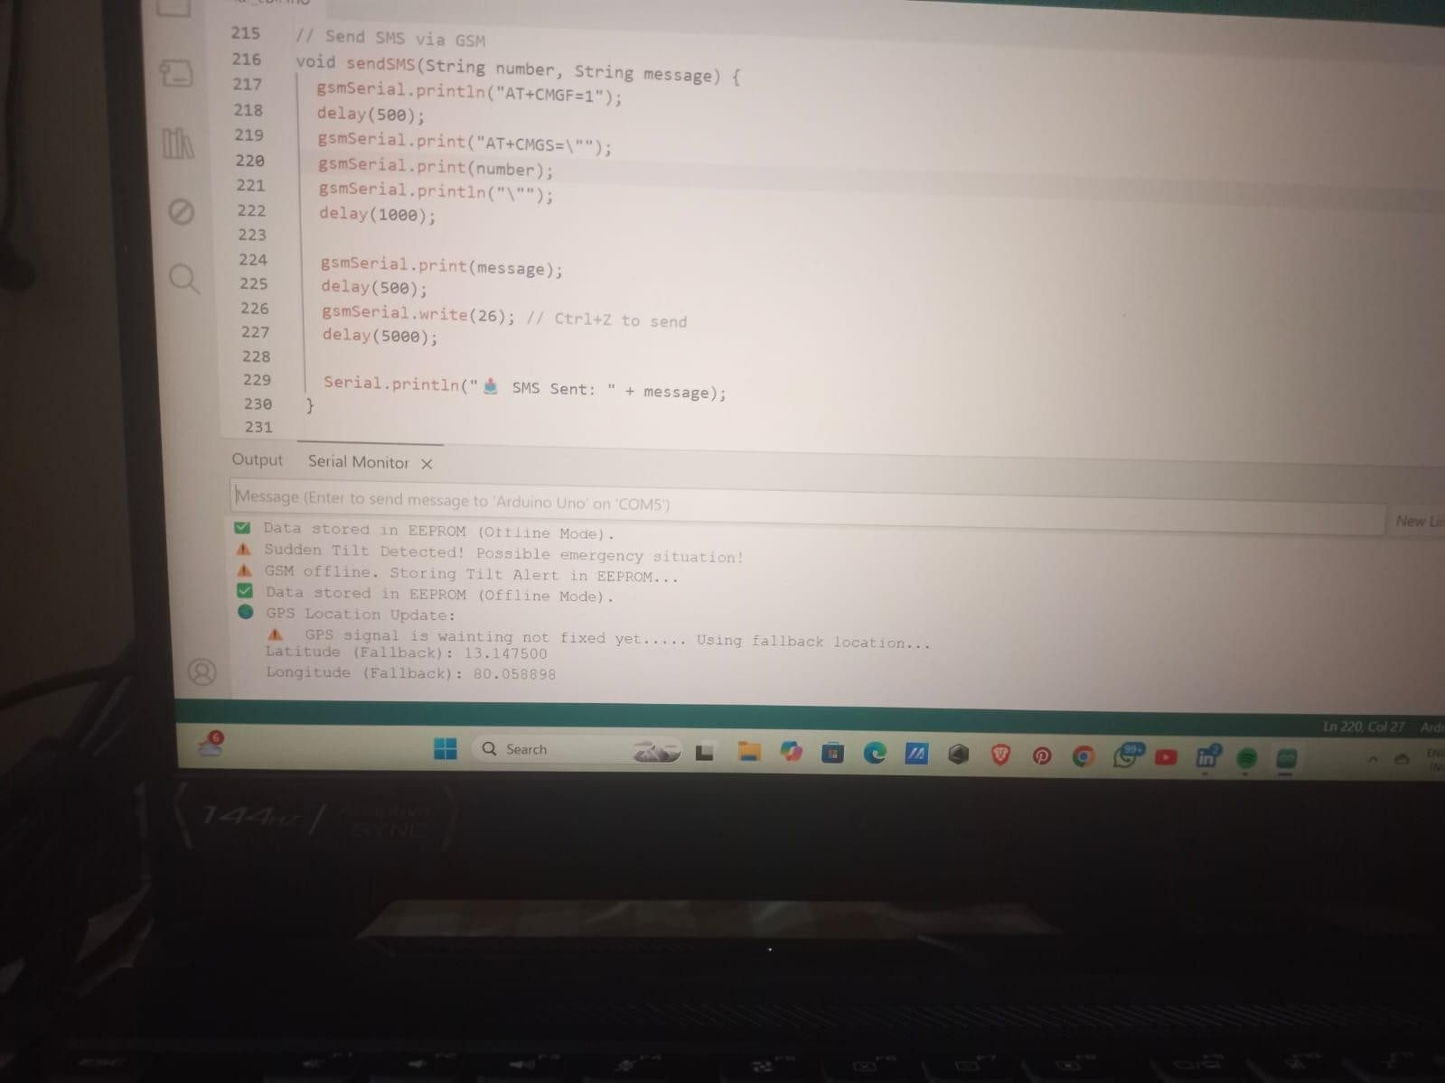

Fig.10.2.3 Detection of tilt.

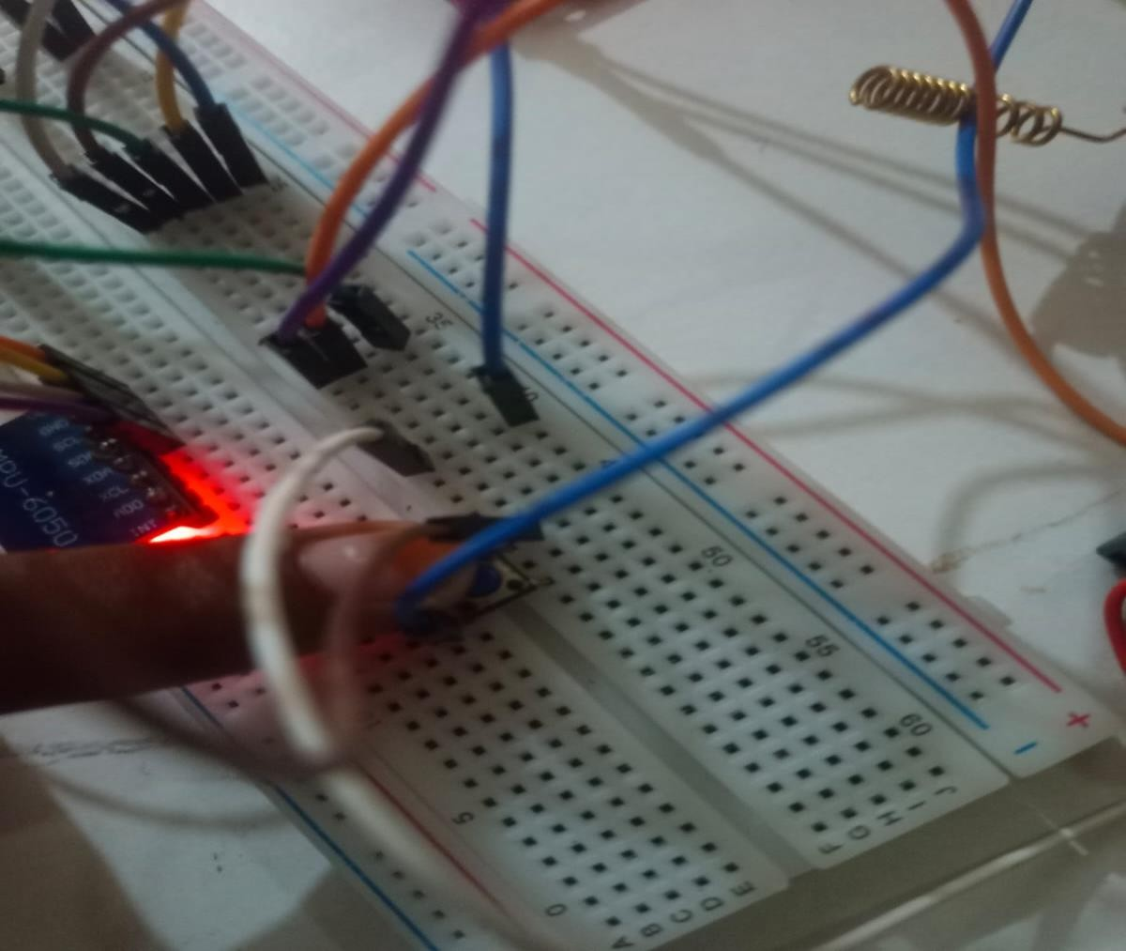

Fig.10.2.4 SOS Button got pressed

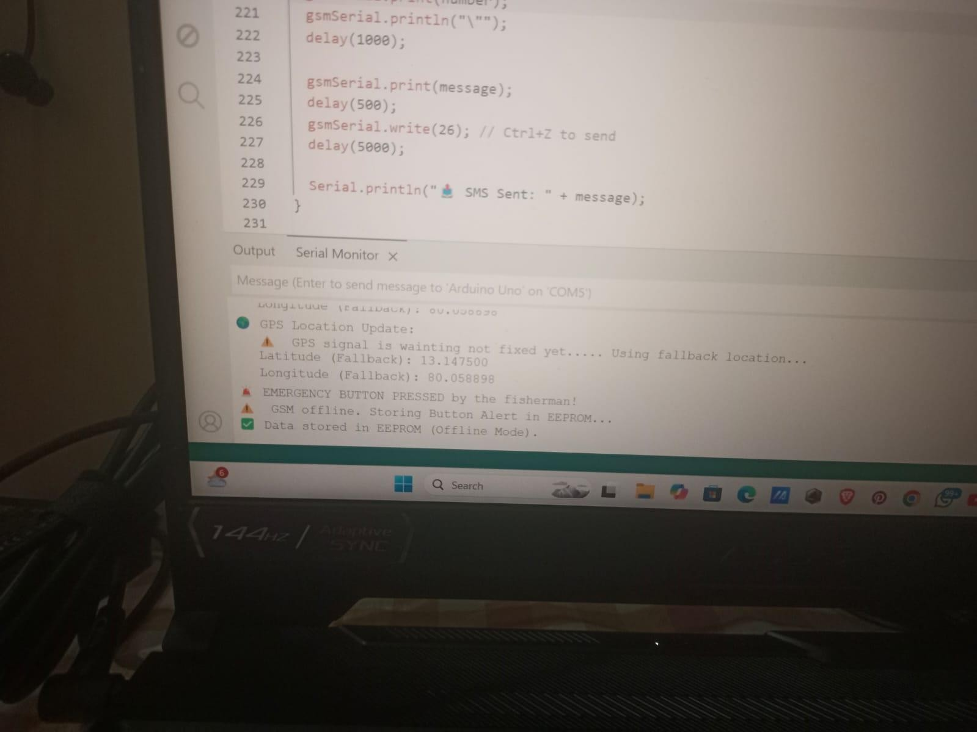

Fig.10.2.5 GPS location Updation

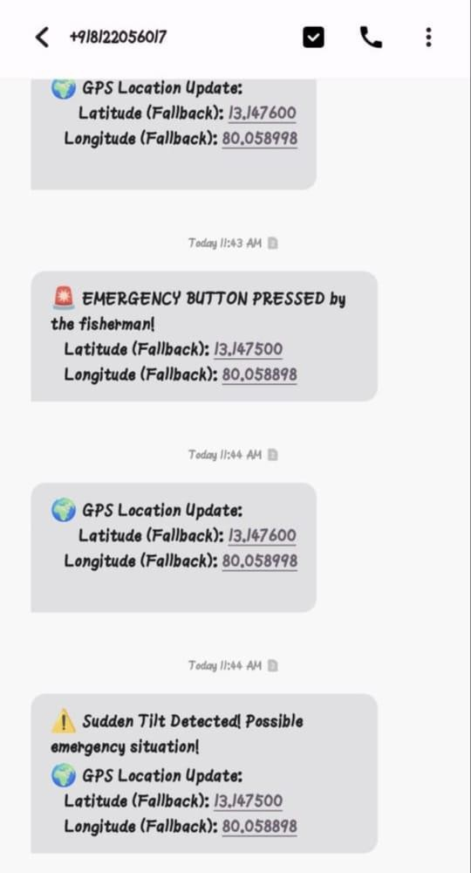
Fig.10.2.6 Alert message send to the rescue team and family member

REFERENCES

- J. Han, “Enhanced Target Ship Tracking with Geometric Parameter Estimation for Unmanned Surface Vehicles,” IEEE Access, vol. 9, pp. 44644–44656, Mar. 2021.
- H. Lu, H. Li, L. Chen, and Y. Cheng, “A Ship Detection and Tracking Algorithm for an Airborne Passive Interferometric Microwave Sensor,” IEEE J. Sel. Topics Appl. Earth Observ. Remote Sens., vol. 14, pp. 1957–1969, Mar. 2021.
- X. Sun, M. Zhang, and J. Dong, “Deep Framework for Eddy Detection and Tracking from Satellite Sea Surface Height,” IEEE Geosci. Remote Sens. Lett., vol. 18, no. 2, pp. 297–301, Oct. 2020.
- D. Mythily et al., “Border and Weather Alert Security System for Fishermen,” in Proc. IEEE SmartTechCon, May 2020, pp. 764–768.
- R. M. Woo-García and V. Herrera-Nevraumont, “Location Monitoring System for Sailboats by GPS Using GSM/GPRS Technology,” IEEE Lat. Am. Trans., vol. 20, no. 7, pp. 1238–1244, Jul. 2022.
- M.S. Güzel and E. Meral, “A Novel Real-Time Geolocation Tracking Tool,” arXiv, 2018.
- Design and Implementation of a GSM-Based Remote Monitoring System, IEEE Xplore.
- Design of an Emergency Alert System for Maritime Safety Using GSM Technology, IEEE Xplore.
- Efficient Data Logging Techniques for IoT Applications, IEEE Xplore.
- Development of a SIM800L Based Reprogrammable Household Automation System, IJCERT.
- R. Jayanthi and B. R. Sandhya, “IoT Based GSM and GPS Based Fishermen Tracking and Alert System,” International Journal of Creative Research Thoughts (IJCRT), vol. 11, no. 5,
pp. 145–150, May 2023. [Online].
- M. P. Amirtha, “Location Tracker for Fishermen Using GPS,” International Journal of Trend in Research and Development (IJTRD), vol. 9, no. 4, pp. 28–30, Jul. 2022. [Online].
- R. S. Meenakshi and G. Pavithra, “IoT Based Fisherman Tracking and Communication Using Wireless Water Communication,” International Journal of Engineering Research and Technology (IJERT), vol. 11, no. 3, pp. 210–213, Mar. 2023. [Online].

- R. Devi and M. Suba, “SMS and GPS Based Fisherman Tracking System Using IoT,” International Journal for Multidisciplinary Research (IJFMR), vol. 6, no. 2, pp. 55–58, Feb. 2024. [Online].
- S. Gowri and P. Dinesh, “IoT Based Fisherman Border Alert System Using GPS and WSN,” International Research Journal of Engineering and Technology (IRJET), vol. 6, no. 3,
pp. 1342–1346, Mar. 2019. [Online].
- Cirkit Designer, “Arduino UNO Based GPS and GSM Tracking System with ADXL335 Accelerometer.” [Online].
- Cirkit Designer, “Arduino UNO Based GPS Tracker with SMS Updates.” [Online].
- Mechatrofice, “Send GPS Location Via SMS using GSM and Arduino.” [Online].
- S. Kumar et al., “Internet of Things in Marine Environment Monitoring: A Review,”
Sensors, vol. 19, no. 7, p. 1711, Apr. 2019. [Online].
- R. Gopalan and A. A. Shinde, “IoT Technology with Marine Environment Protection and Monitoring,” in Recent Trends in IoT and Big Data, Springer, 2021, pp. 101–114. [Online].

