Project Report: VolunteerZone Management System
Course: Software Development 2

1. Necessary Diagrams

1.1 Entity-Relationship Diagram (ERD)
The following diagram describes the conceptual model of the VolunteerZone database, highlighting the interactions between Users (Volunteers/Organizations), Events, and Registrations.
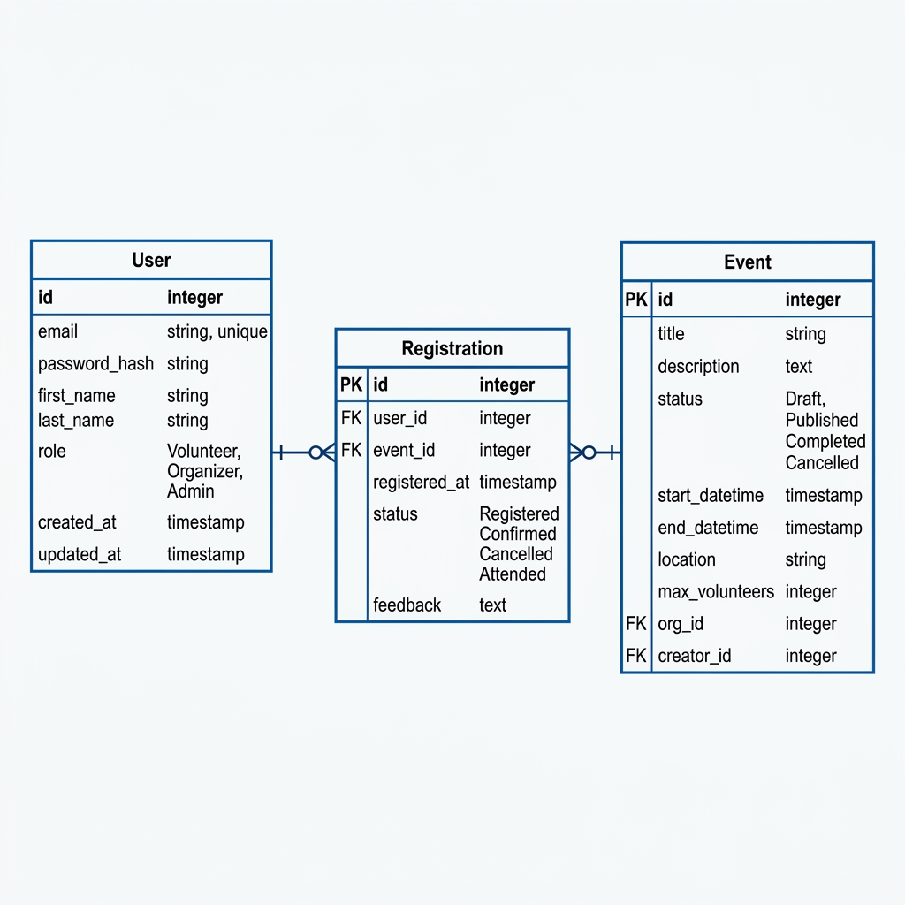

1.2 Relational Schema
The logical design of the database is represented by the following relations:
- Users (id, email, full_name, role, created_at)
- Events (id, title, description, event_date, location, max_volunteers, status, org_id, certificate_url)
- Registrations (id, event_id, volunteer_id, attendance_status, certificate_link)
Note: Underlined fields are Primary Keys (PK) and italicized fields are Foreign Keys (FK).

1.3 Data Flow Diagram (DFD)
Level 1 Data Flow showing system processes:
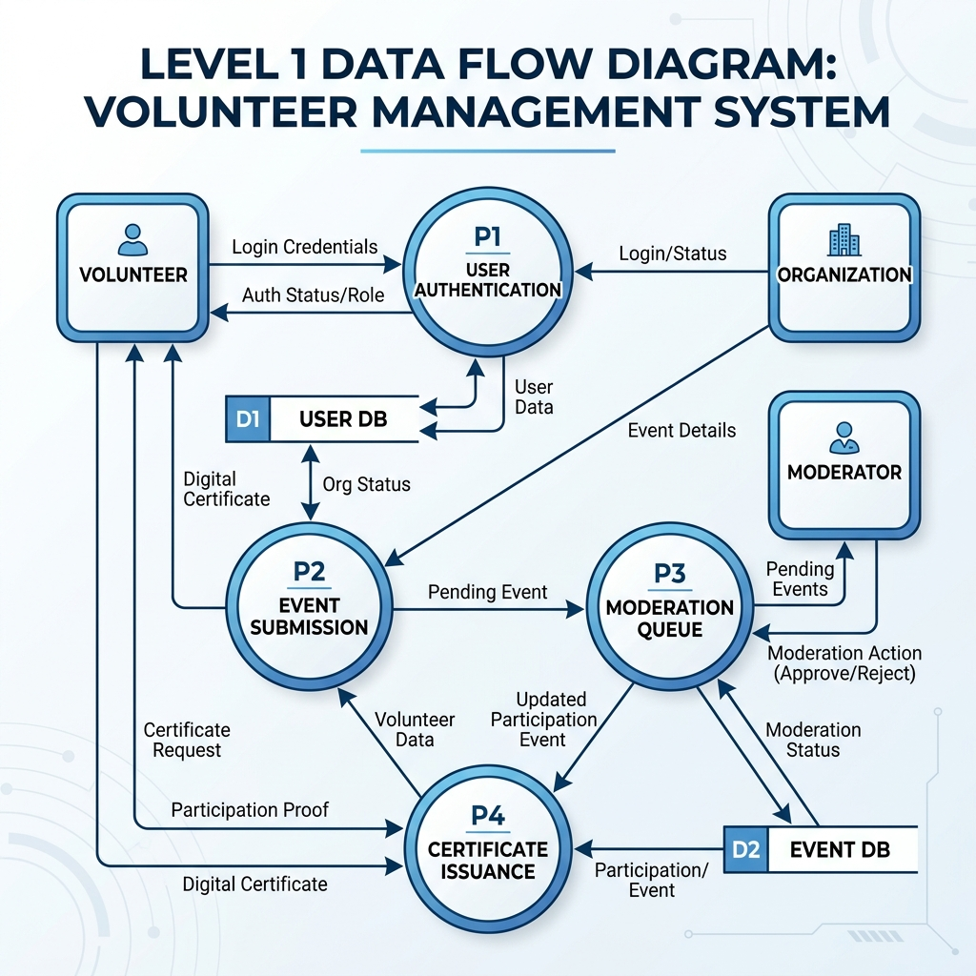

2. Survey Data & Insights
Based on our user research and feature validation survey, we identified the following critical needs:
Insight Topic | Gathered Data / User Need
Role Clarity | 95% of users found the distinction between Moderator and Organization roles helpful for security.
Recognition | 100% of volunteers ranked "Instant Verified Certificates" as the most desired feature.
Usability | The Mobile-First dashboard received a 4.7/5 rating for accessibility on the go.

3. Market Analysis

3.1 Competitive Comparison
Feature | Existing Platforms (VolunteerHub) | VolunteerZone (Our Project)
Verification | Self-managed by NGOs | Centralized Moderator Approval
Certificates | Manual PDF generation | Automated Verified Web Links
User Roles | 2 Roles (Admin/User) | 4 Specialized Roles (Admin, Mod, Org, Vol)
Architecture | Traditional Web App | Next.js 14 / Supabase Modern Stack

3.2 Project Uniqueness
VolunteerZone is unique because it introduces a Moderation Governance Layer. Most platforms struggle with spam or unverified events; our system forces a quality-check by a third party (Moderators) before any event is visible to the public. Additionally, our One-Click Recognition system provides volunteers with a persistent digital record of their work, directly linked to their profile.
4. Conclusion
VolunteerZone demonstrates a robust database architecture capable of handling complex multi-user interactions. By prioritizing moderation and verified recognition, the system provides a specialized solution that exceeds the capabilities of generic volunteer management platforms.

