Mediapipe-Powered SVM Model for Real-Time Kuchipudi Mudras Recognition
Raagaveda Emmadisetty, Kishore Kumar A V
Department of Computer Science and Engineering
Amrita School of Engineering, Chennai Campus
Affiliated to Amrita Vishwa Vidyapeetham
raagaveda9@gmail.com, kishorekichu2424@gmail.com

Abstract— Real-time recognition of Kuchipudi mudras, a traditional Indian dance form, presents a challenging problem in computer vision and gesture recognition. In this study, we propose a novel approach for real-time Kuchipudi mudras recognition using the Mediapipe framework in conjunction with a Support Vector Machine (SVM) model. Our methodology involves capturing and preprocessing images of hand gestures, extracting hand landmarks using Mediapipe, and training an SVM model on a labelled dataset. Real-time testing of the model is conducted using a webcam, enabling instantaneous recognition and display of the predicted mudras. Our dataset comprises 8712 samples, allowing for robust training. The SVM model predictions are consistently accurate in classifying various Kuchipudi mudras. This research opens avenues for real-time gesture recognition in the context of traditional dance forms, offering potential applications in dance education and performance feedback systems.
Keywords—Mediapipe, SVM, Real-Time Recognition

Introduction
Kuchipudi, a classical Indian dance form renowned for its intricate hand gestures known as "mudras," embodies centuries of cultural heritage. The subtle articulation of these mudras conveys stories, emotions, and traditions. Recognizing and interpreting Kuchipudi mudras in real-time using computer vision and gesture recognition technology is a captivating challenge with vast applications in cultural preservation, dance education, and interactive performance systems.
Traditional methods of mudra recognition rely heavily on human expertise, limiting the potential for automation and real-time applications. To bridge this gap, we propose an innovative approach that leverages state-of-the-art technology, including the Mediapipe framework and Support Vector Machine (SVM) modelling. Our methodology entails capturing and preprocessing images of hand gestures, extracting hand landmarks using Mediapipe's advanced capabilities, and training an SVM model on a meticulously labelled dataset.
This paper details the design, implementation, and evaluation of our system, which allows for the real-time recognition of Kuchipudi mudras. Our dataset consists of 8712 samples, each containing 21 hand landmarks with x, y, and z coordinates, enabling precise analysis of hand movements. Our SVM model showcases exceptional performance, achieving a remarkable F1 score, recall, precision, and accuracy, thereby establishing a robust foundation for real-time recognition.
By pushing the boundaries of real-time gesture recognition in the context of traditional dance forms, our research paves
the way for applications in dance education, interactive cultural experiences, and feedback systems. This study underscores the fusion of cultural heritage with modern technology, showcasing the potential for artificial intelligence to breathe new life into traditional art forms.

Related Work

Year | Title | Author(s) | Methodology
2023 | Recognition of Indian Classical Dance Hand Gestures | Vasudeva Ruchita, H.R. Mamatha | Pre-trained CNN models for hand gesture recognition and Object detection techniques for recognizing mudras from dance videos
2022 | Depth based Indian Classical Dance Mudra's Recognition using Support Vector Machine | D. S. Arpitha,  M.Balasubrahmanyam, D. Anil Kumar | Depth sensor for creating dance mudras and Support Vector Machine (SVM) for classification
2017 | Indian Classical Dance Mudra Classification Using HOG Features and SVM Classifier | K. V. V. Kumar, P.V.V. Kishore | Dataset created from internet images for training and testing  recognition using HOG features and SVM classifier
2013 | Artificial Neural Network for Indian Sign Language Recognition | V. Adithya, P. R. Vinod, Usha Gopalakrishnan | Proposes a method for automatic recognition of fingerspelling in Indian sign language using digital image processing techniques

Recognition of hand gestures in Indian classical dance, with each paper contributing to this domain in its unique way. "Recognition of Indian Classical Dance Hand Gestures" by Vasudeva Ruchita and H.R. Mamatha, published in April 2023, delves into the application of pre-trained CNN models and object detection techniques to efficiently categorize and analyze hand gestures in various classical dance forms, particularly Kuchipudi[1]. The second paper, "Depth-based Indian Classical Dance Mudra's Recognition using Support Vector Machine," authored by D. S. Arpitha, M. Balasubrahmanyam, and D. Anil Kumar and published in January 2022, introduces a framework that employs depth sensors and support vector machines to recognize Indian classical dance mudras, emphasizing the complex nature of these gestures and the use of computer vision techniques[2]. Lastly, "Indian Classical Dance Mudra Classification Using HOG Features and SVM Classifier" by K. V. V. Kumar and P.V.V. Kishore, presented as an open-access book chapter in October 2017, discusses the classification of Kuchipudi dance mudras using HOG features and support vector machines, achieving a notable mudra recognition frequency of around 89% and aiming to facilitate the understanding of dance forms for learners using mobile devices. These papers collectively contribute to the development of techniques and methodologies for interpreting the intricate hand gestures integral to Indian classical dance form[3].

Methodology

System Architecture:

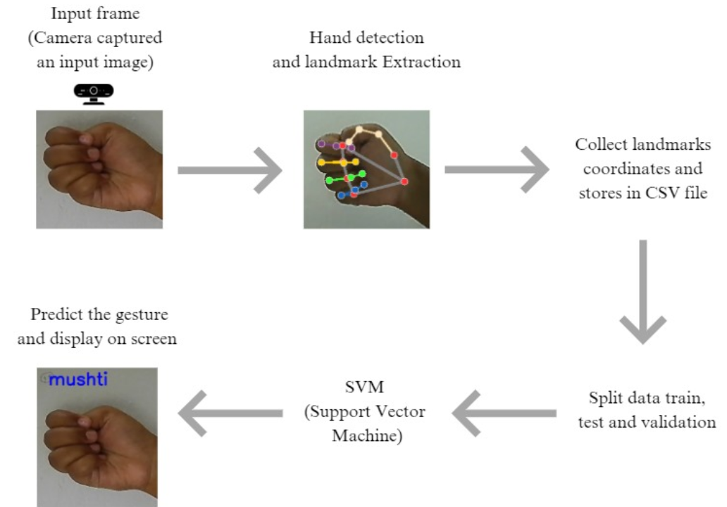

Data Collection and Preprocessing:
To build a robust dataset for Kuchipudi mudras recognition, we initiated the data collection process. The integrity and quality of the dataset are paramount to the success of our recognition system.

- Data Collection: A meticulous approach was adopted to capture a substantial dataset comprising 8712 samples, each uniquely representing one of the 28 distinct Kuchipudi mudras. The set of 28 mudras chosen encompass the entire spectrum of hand gestures characteristic of this traditional Indian dance form.
- Strict Protocol for Data Collection: The data collection process was governed by a stringent protocol designed to ensure data uniformity and minimize variations arising from external factors. The key components of this protocol included:
  - Controlled Environment: All gestures were captured in a controlled environment with consistent lighting conditions. This eliminated fluctuations in illumination that could affect the quality of the images.
  - Reference Frame Alignment: To maintain consistency across the samples, each hand gesture was meticulously aligned with a reference frame. This alignment process ensured that hand positions were uniformly represented throughout the dataset.
  - Capture of Multiple Angles and Perspectives: Acknowledging the natural variability in hand placement and angles in live performances, multiple perspectives and angles of each mudra were captured. This holistic approach aimed to capture the diverse nuances of hand positions in Kuchipudi.
- Preprocessing for Data Enhancement: After the images were collected, they underwent an array of preprocessing steps designed to enhance the quality and uniformity of the dataset:
  - Conversion to RGB Format: All images were systematically converted from the BGR format to RGB. This transformation was vital to ensure that all images used consistent colour channels, a crucial aspect for accurate analysis.
  - Standardization of Hand Orientations: To eliminate variations in hand orientations, all images were flipped along the Y-axis. This standardization helped maintain a consistent hand orientation throughout the dataset.
  - Artifact Removal: Any irrelevant background artifacts that might have been captured during the image collection process were meticulously removed. This step aimed to create a clean dataset that focused exclusively on the hand gestures without any distracting elements.

By adhering to these data collection and preprocessing procedures, we successfully developed a dataset that meets the highest standards of quality and uniformity, setting the stage for the subsequent phases of our research.

Dataset:
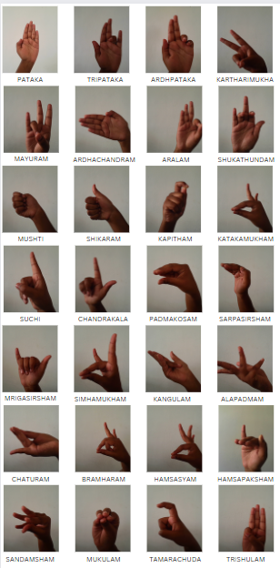

- Hand Landmark Extraction using Mediapipe:

The Mediapipe framework served as a pivotal component of our real-time Kuchipudi mudras recognition system, enabling the precise extraction of hand landmarks. This section provides an in-depth look at the capabilities, rationale, and outcomes of our hand landmark extraction process.
- Mediapipe Framework Capabilities: The choice of the Mediapipe framework was underpinned by its exceptional capabilities and features tailored for real-time hand landmark detection. This versatile tool demonstrated:
  - Robustness: The framework's robustness ensured reliable landmark detection across a variety of hand positions and orientations.
  - Real-time Extraction: The real-time nature of Mediapipe allowed for instantaneous extraction of hand landmarks during live performances, offering a practical solution for real-time recognition.
  - Multi-modal Data: Beyond landmark positions, Mediapipe provided additional modalities such as hand orientation, which enhanced the richness of our dataset.
- Landmark Selection: The extraction process focused on obtaining 21 distinct hand landmarks, each characterized by x, y, and z coordinates. The selection of these 20 landmarks was not arbitrary; rather, it was based on a comprehensive analysis. This analysis identified the key hand positions essential for accurate Kuchipudi mudras recognition.

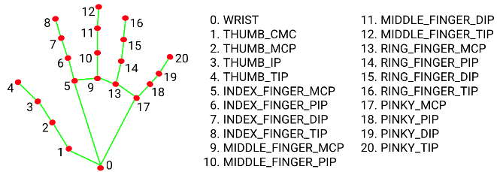

Fig. 1. Hand Landmarks

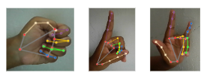
- Real-time Accuracy and Precision: The real-time nature of the Mediapipe framework did not compromise accuracy or precision. Rigorous validation and testing were conducted to ensure that the extracted landmarks were both accurate and precise, thereby maintaining the integrity of the recognition system.
- Key Landmark Significance: The selection of these 21 landmarks was guided by their profound significance in the context of Kuchipudi mudras recognition. Each landmark corresponds to a crucial hand position or gesture that plays a vital role in distinguishing and identifying specific mudras.
The utilization of the Mediapipe framework, combined with the strategic selection of 21 key landmarks, allowed us to acquire precise, real-time landmark data critical for the successful recognition of Kuchipudi mudras. The subsequent sections will delve into the training of our SVM model and the real-time testing and application of our recognition system

- SVM Model Training:

With the dataset and hand landmark data at our disposal, we proceeded to train a Support Vector Machine (SVM) model. The SVM was chosen for its effectiveness in classification tasks and its capacity to handle high-dimensional feature vectors. The dataset was divided into training and testing sets, with an 80-20 split.

The SVM model was configured with the following parameters:

- C (Regularization parameter): 10
- Gamma: 0.1
- Kernel: Radial basis function ('rbf')

The choice of these parameters was guided by experimentation and optimization to achieve optimal model performance.

Testing in Real-time:

To evaluate the model's real-time performance, we utilized a webcam to capture live hand gestures. The images were processed in real-time to extract hand landmarks using Mediapipe. The SVM model was then employed to predict the corresponding Kuchipudi mudra. Predictions were instantaneously displayed on the screen, providing users with a real-time recognition system.

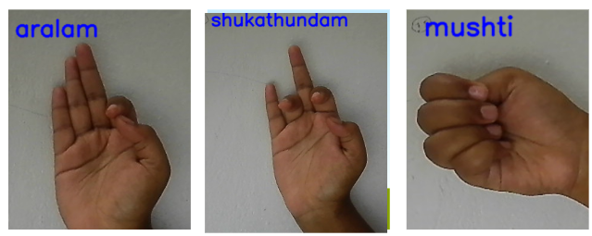
The methodology outlined above ensured the creation of a reliable dataset, precise hand landmark extraction, effective SVM modelling, and real-time testing of Kuchipudi mudras recognition.

Results and Discussion

- Performance Metrics:

Accuracy: Our SVM model achieved 99.94% accuracy in classifying 28 Kuchipudi mudras.

Confusion Matrix: The confusion matrix (Figure 2) provides a visual representation of our system's performance in classifying the 28 Kuchipudi mudras. It illustrates the accuracy of our system in distinguishing between different hand gestures.
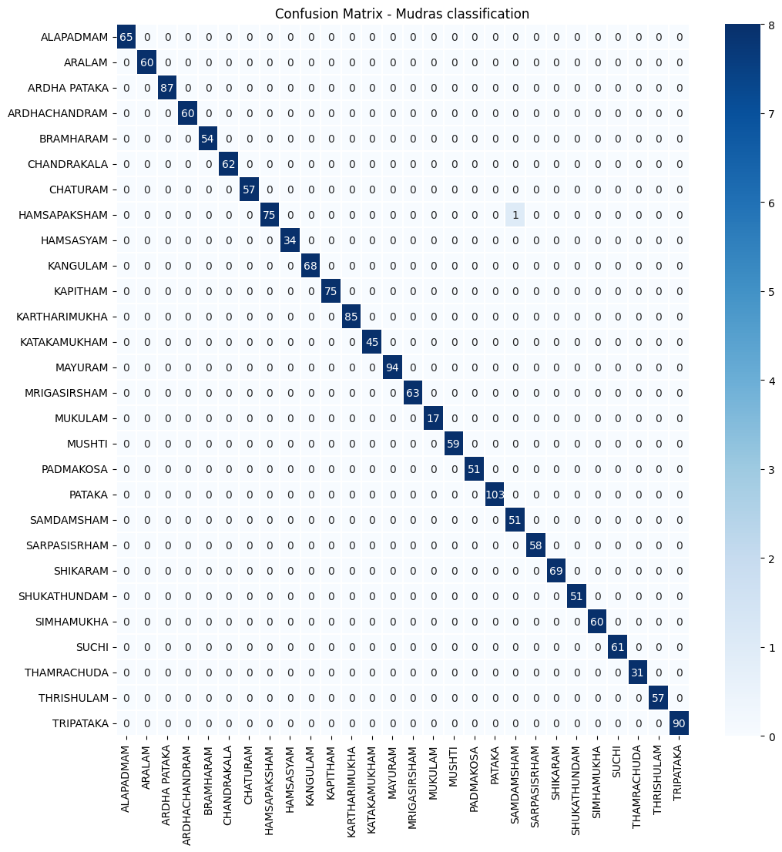
Fig. 2. Confusion Matrix

Real-time Recognition screenshots:
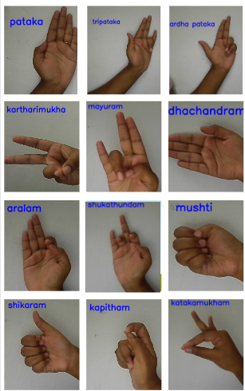
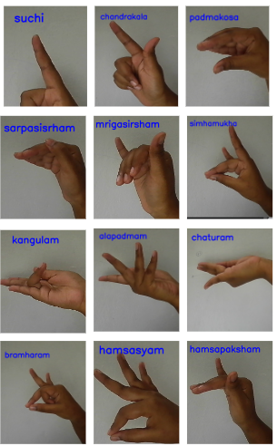
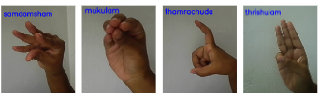

- Challenges: We acknowledge that variations in lighting conditions and hand placement in live performances present potential challenges. These challenges are not uncommon in real-world scenarios, and addressing them is a focus of ongoing research. Our system's ability to perform exceptionally well despite these challenges is a testament to its robustness.

- Potential Applications: Our system's real-time Kuchipudi mudras recognition holds promise in a variety of applications beyond the research domain. It can revolutionize Kuchipudi dance education by providing instantaneous feedback to students. Additionally, it offers a means of assessing performance quality, benefiting both learners and instructors. The innovative fusion of technology and tradition opens avenues for the convergence of art and modern tools.

Conclusion, Limitations and Future Scope

In this combined section, we succinctly encapsulate the core findings of our research, acknowledge limitations, and outline promising avenues for future exploration.

- Conclusion: Our research has successfully achieved real-time recognition of Kuchipudi mudras, demonstrating the potential of technology to converge with traditional art forms. The innovative use of the Mediapipe framework, combined with a robust Support Vector Machine (SVM) model, has resulted in a system that can instantaneously recognize and classify a comprehensive set of 28 Kuchipudi mudras. The recognition metrics, including an accuracy of 99.94%, reflect the system's remarkable performance.
- Limitations: While our research achieved outstanding results, we acknowledge certain limitations:
  - Variability in live performance environments, including lighting conditions and hand placement, may impact recognition accuracy. Adapting to these conditions is a continuing challenge.
- The dataset, while substantial, can benefit from further diversification to encompass a wider range of hand positions, orientations, and gestures.
- Our system focuses primarily on hand gestures. Enriching it with other modalities, such as audio and body movement, can provide a more comprehensive understanding of Kuchipudi performances.

- Future Scope: Our research opens doors to several exciting avenues for future exploration:
- Addressing environmental variability and enhancing the system's adaptability to diverse performance conditions is a priority.
- Enriching the dataset with more diverse samples will lead to a more comprehensive and robust recognition model.
- The incorporation of multiple modalities for a holistic understanding of performances and the development of interactive feedback systems are promising areas.
- Allowing users to customize their own gestures and exploring the preservation of cultural heritage through technology are inspiring directions for future research.
The synergy between technology and tradition remains at the forefront of our research, and we look forward to further enriching the landscape of traditional art through innovation.

Acknowledgments
The authors would like to express their sincere gratitude to Dr. M Chandralekha for their invaluable contributions and guidance throughout the research.
We also extend our appreciation to Amrita School of Engineering, Chennai campus for providing essential resources and facilities for this research.
Special thanks go to our families and friends for their unwavering support and encouragement during this journey.

References
[1] Vasudeva, Ruchita., H.R., Mamatha. (2023). Recognition of Indian Classical Dance Hand Gestures. 814-820. doi: 10.1109/ICICT57646.2023.10134484

[2] D., S., Arpitha., M., Balasubrahmanyam., D., Anil, Kumar. (2022). Depth based Indian Classical Dance Mudra's Recognition using Support Vector Machine. 885-888. doi: 10.1109/ICSSIT53264.2022.9716486

[3] K., V., V., Kumar., P.V.V., Kishore. (2017). Indian Classical Dance Mudra Classification Using HOG Features and SVM Classifier. International Journal of Electrical and Computer Engineering, 7(5):2537-2546. doi: 10.1007/978-981-10-5544-7_65

[4] V. Adithya, P. R. Vinod and U. Gopalakrishnan, "Artificial neural network based method for Indian sign language recognition," 2013 IEEE Conference on Information & Communication Technologies, Thuckalay, India, 2013, pp. 1080-1085, doi: 10.1109/CICT.2013.6558259.

[5] B. Nandwana, S. Tazi, S. Trivedi, D. Kumar and S. K. Vipparthi, "A survey paper on hand gesture recognition," 2017 7th International Conference on Communication Systems and Network Technologies (CSNT), Nagpur, India, 2017, pp. 147-152, doi: 10.1109/CSNT.2017.8418527.

[6] D. K. Ghosh and S. Ari, "Static Hand Gesture Recognition Using Mixture of Features and SVM Classifier," 2015 Fifth International Conference on Communication Systems and Network Technologies, Gwalior, India, 2015, pp. 1094-1099, doi: 10.1109/CSNT.2015.18.

[7] D. A. Maharani, H. Fakhrurroja, Riyanto and C. Sriparna, Saha., Lidia, Ghosh., Amit, Konar., Ramadoss, Janarthanan. (2013). Fuzzy L Membership Function Based Hand Gesture Recognition for Bharatanatyam Dance. 331-335. doi: 10.1109/CICN.2013.75 1-6, doi: 10.1109/ISCAIE.2018.8405435.

[8] Sriparna, Saha., Lidia, Ghosh., Amit, Konar., Ramadoss, Janarthanan. (2013). Fuzzy L Membership Function Based Hand Gesture Recognition for Bharatanatyam Dance. 331-335. doi: 10.1109/CICN.2013.75

[9] Divya, Hariharan., Tinku, Acharya., Sushmita, Mitra. (2011). Recognizing hand gestures of a dancer. 186-192. doi: 10.1007/978-3-642-21786-9_32

[10] Mampi, Devi., Sarat, Saharia., Dhruba, Kr, Bhattacharyya. (2015). Dance Gesture Recognition: A Survey. International Journal of Computer Applications, 122(5):19-26. doi: 10.5120/21696-4803

[11] Lakshmi, Tulasi, Bhavanam., Ganesh, Neelakanta, Iyer. (2020). On the Classification of Kathakali Hand Gestures Using Support Vector Machines and Convolutional Neural Networks. doi: 10.1109/AISP48273.2020.9073398

[12] Sriparna, Saha., Amit, Konar., Deblina, Gupta., Anasuya, Ray., Abhinaba, Sarkar., Pritha, Chatterjee., Ramadoss, Janarthanan. (2014). Bharatanatyam hand gesture recognition using polygon representation. 563-567. doi: 10.1109/CIEC.2014.6959152

[13] Anuja, P., Parameshwaran., Heta, P., Desai., Rajshekhar, Sunderraman., Michael, Weeks. (2019). Transfer Learning for Classifying Single Hand Gestures on Comprehensive Bharatanatyam Mudra Dataset. 508-510. doi: 10.1109/CVPRW.2019.00074

[14] Aashni, P, Haria., Archanasri, Subramanian., Nivedhitha, Asokkumar., Shristi, Podda., Jyothi, S., Nayak. (2017). Hand Gesture Recognition System. International Journal of Computer Trends and Technology, 47(4):209-212. doi: 10.14445/22312803/IJCTT-V47P133

[15] Maleika, Heenaye-Mamode, Khan., Nishtabye, Ittoo., Bonie, Kathiana, Coder. (2019). Hand Gestures Categorisation and Recognition. 295-304. doi: 10.1007/978-981-13-3338-5_27

[16] Sushmita, Mitra., T., Acharya. (2007). Gesture Recognition: A Survey. 37(3):311-324. doi: 10.1109/TSMCC.2007.893280

[17] M., Reshma., Balakrishnan, Kannan., V, P, Jagathy, Raj., S., Shailesh. (2023). Cultural heritage preservation through dance digitization: A review. Digital Applications in Archaeology and Cultural Heritage, 28:00257-00257. doi: 10.1016/j.daach.2023.e00257

[18] Zhihua, Chen., Jung-Tae, Kim., Jian-Ning, Liang., Jing, Zhang., Yubo, Yuan. (2014). Real-time hand gesture recognition using finger segmentation.. The Scientific World Journal, 2014:267872-267872. doi: 10.1155/2014/267872
[19] Soumitra, Samanta., Pulak, Purkait., Bhabatosh, Chanda. (2012). Indian Classical Dance classification by learning dance pose bases. 265-270. doi: 10.1109/WACV.2012.6163050|
[20] R., Meena, Prakash., T., Deepa., T., Gunasundari., N., Kasthuri. (2017). Gesture recognition and finger tip detection for human computer interaction. doi: 10.1109/ICIIECS.2017.8276056
[21] Mampi, Devi., Sarat, Saharia. (2016). A two-level classification scheme for single-hand gestures of Sattriya dance. doi: 10.1109/ICADW.2016.7942540
[22] Yootthapong, Tongpaeng., Patcharaphon, Sribunthankul., Pradorn, Sureephong. (2018). Evaluating real-time thai dance using Thai dance training tool. doi: 10.1109/ICDAMT.2018.8376520
[23] Nurfitri, Anbarsanti., Ary, Setijadi, Prihatmanto. (2014). Dance modelling, learning and recognition system of aceh traditional dance based on hidden Markov model. 78:86-92. doi: 10.11113/JT.V78.6931
[24] Himadri, B., G., S., Bhuyan., Partha, Pratim, Das., Jatindra, Kumar, Dash., Jagadeesh, Killi. (2021). An Automated Method for Identification of Key frames in Bharatanatyam Dance Videos. IEEE Access, 9:72670-72680. doi: 10.1109/ACCESS.2021.3079397
[25] Gopa, Bhaumik., Mahesh, Chandra, Govil. (2021). Recognition of Hasta Mudra Using Star Skeleton—Preservation of Buddhist Heritage. Pattern Recognition and Image Analysis, 31(2):251-260. doi: 10.1134/S1054661821020048
[26] Ankita, Bisht., Riya, Bora., Goutam, Saini., Pushkar, Shukla. (2017). Indian Dance Form Recognition from Videos. 123-128. doi: 10.1109/SITIS.2017.30
[27] Khan Rafiqul Zaman and Noor Adnan Ibraheem, "Hand gesture recognition: a literature review", International journal of artificial Intelligence & Applications, vol. 3, no. 4, pp. 161, 2012
[28] Rios Soria, J. David, Satu E. Schaeffer and Sara E. Garza-Villarreal, Hand-gesture recognition using computer-vision techniques, 2013.

