NASA Lithium-Ion Battery Ageing
Capacity Prediction — Model Report

A Regression Study using Linear Regression, Random Forest & LSTM

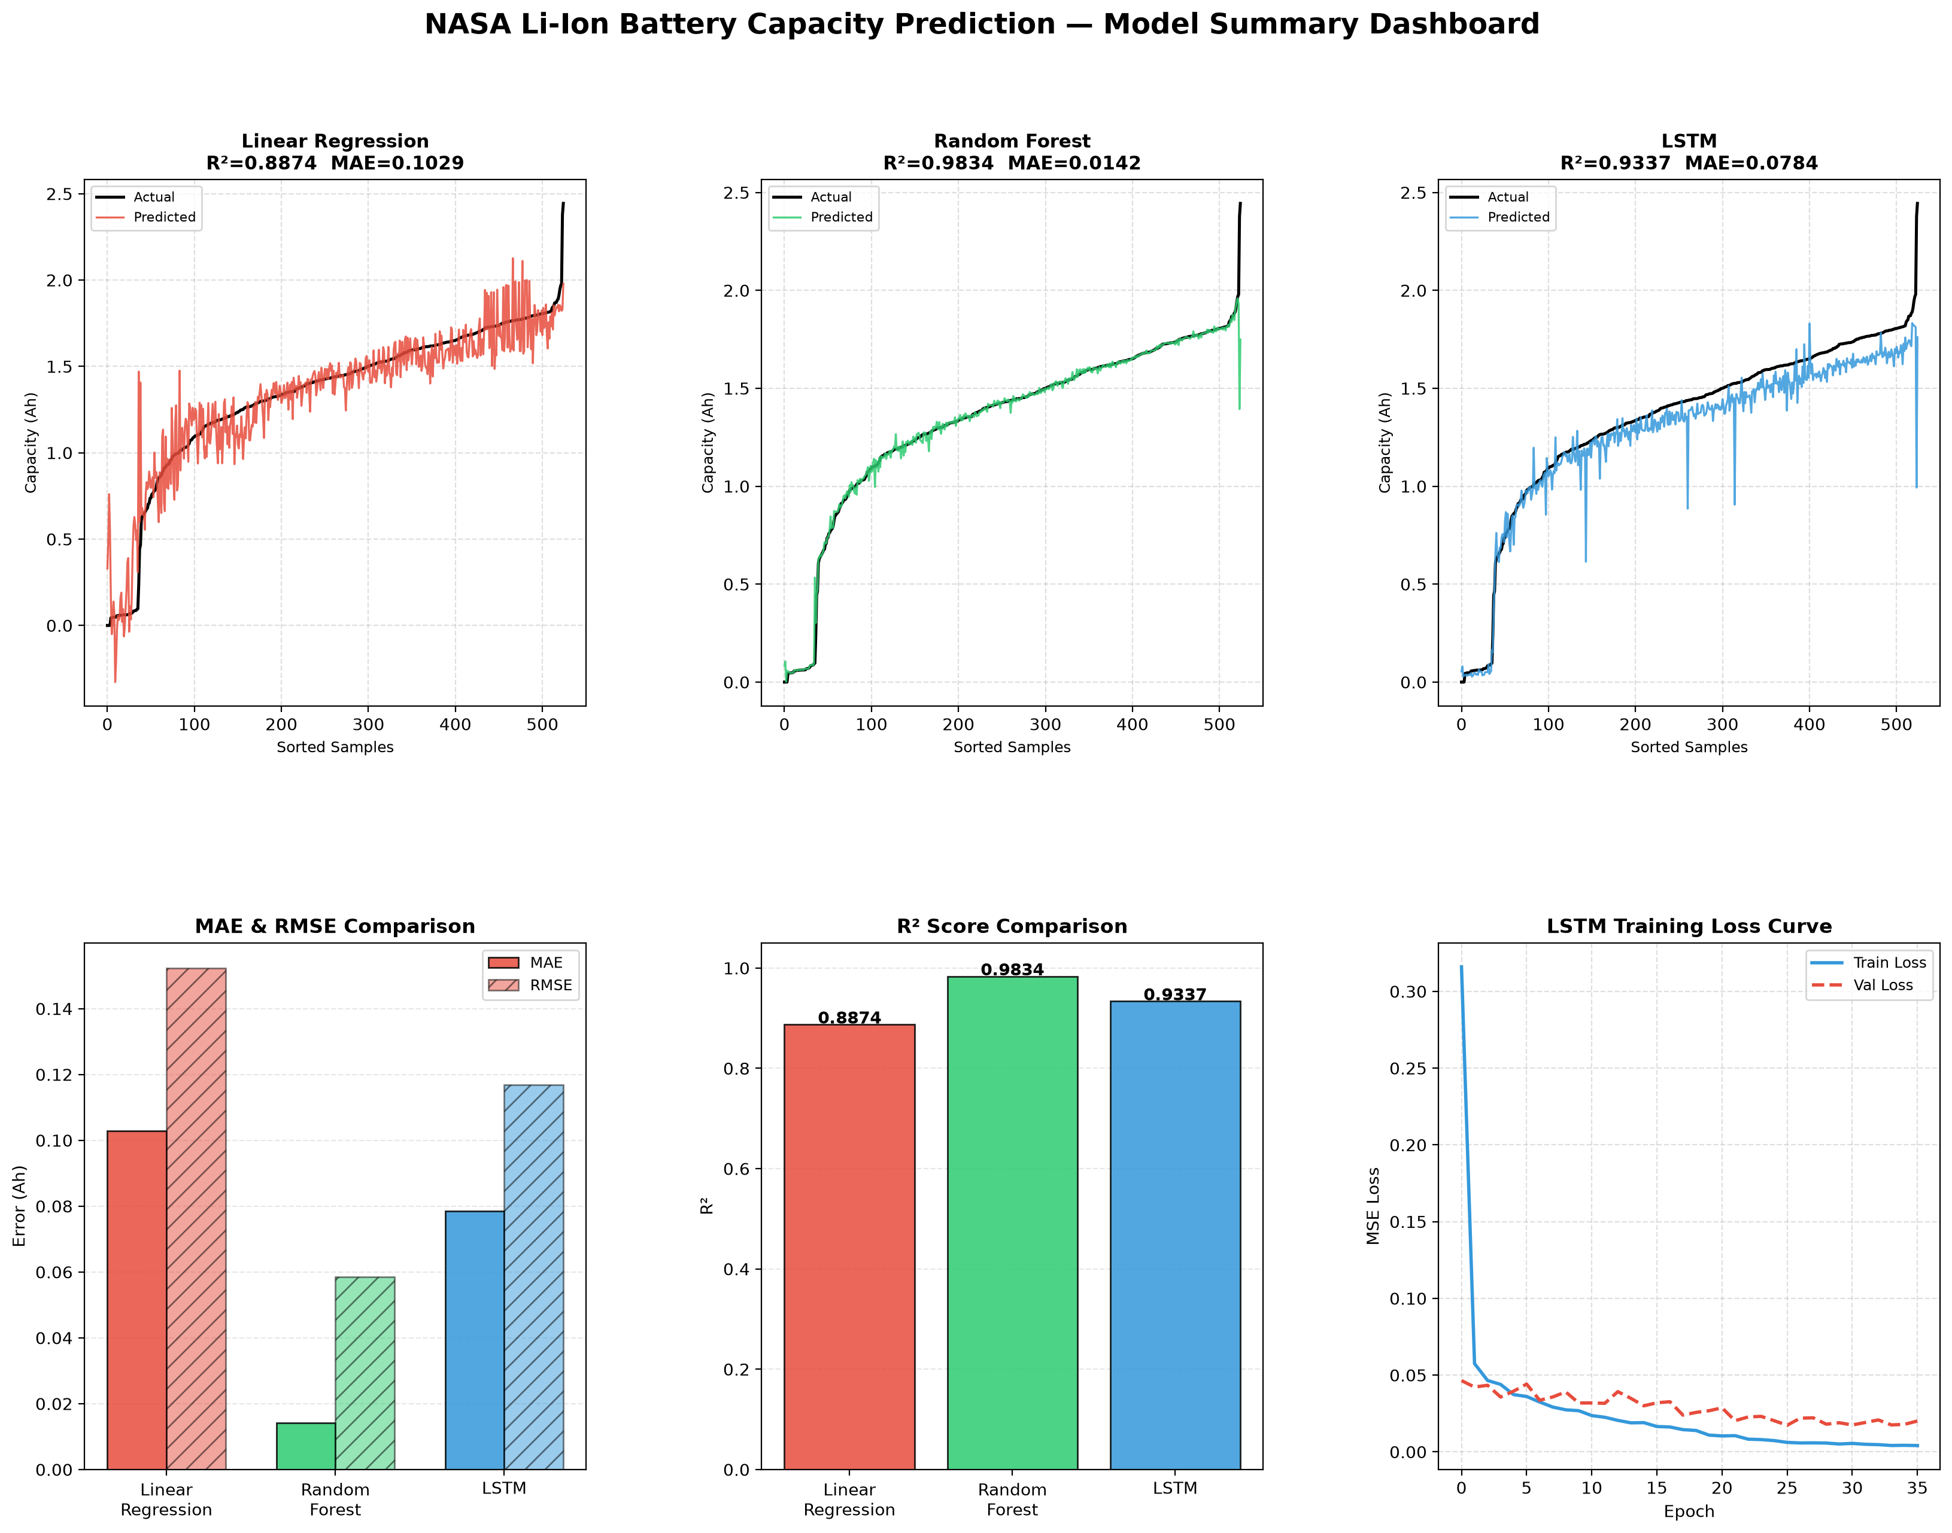
Fig. Grand Summary Dashboard — All Models

Raaghav Agarwal · NASA Battery Aging Dataset

1. Linear Regression
Baseline Model — Phase 5

What is Linear Regression?
- Models capacity as a linear combination of 17 engineered features
- Simple, interpretable, and computationally inexpensive
- Serves as a robust baseline for comparison with more complex models

Training Setup
Parameter | Value
Features | 17 engineered cycle statistics
Train / Test | 80% / 20%
Scaling | StandardScaler (zero mean, unit variance)
Library | scikit-learn LinearRegression

Results
Metric | Value
MAE | 0.1029 Ah
RMSE | 0.1523 Ah
R² | 0.8874

Key Observations
- Achieves R² ≈ 0.89 — a solid baseline but underfits non-linear degradation patterns
- Residuals show mild heteroscedasticity — prediction errors grow at lower capacities
- Outlier filtering of Re and Rct impedance sensors was critical for numerical stability

Plots
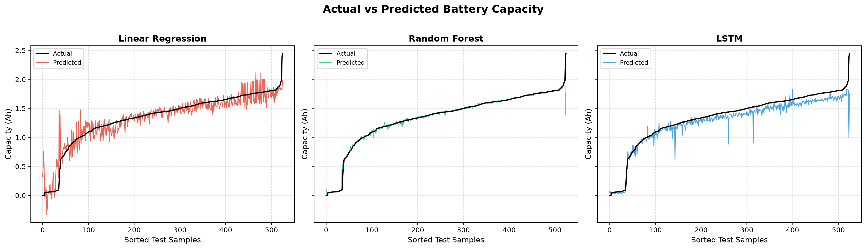
Fig 1. Actual vs Predicted Capacity — Linear Regression (left panel)

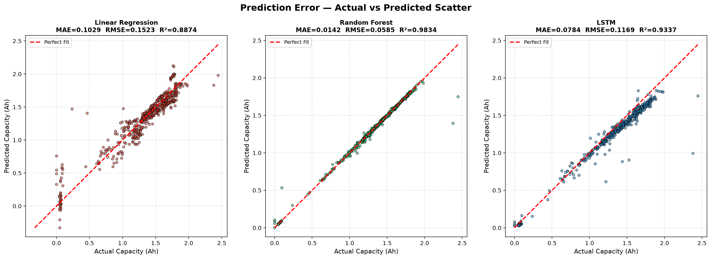
Fig 2. Prediction Error Scatter — Linear Regression (left panel)

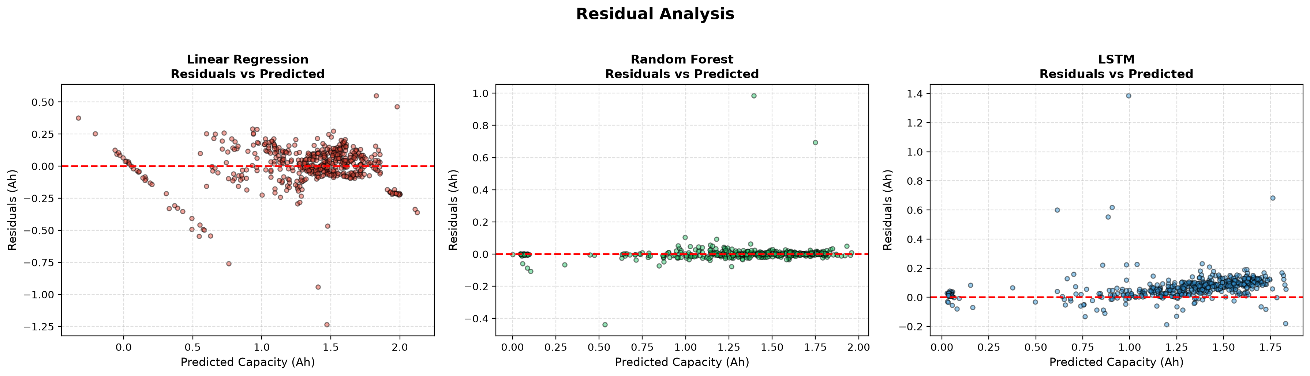
Fig 3. Residual Analysis — Linear Regression (left panel)

2. Random Forest
Ensemble Tree Model — Phase 6 🏆 Best Performer

What is Random Forest?
- Ensemble of 100 decision trees trained on random subsets of data and features
- Captures non-linear relationships and feature interactions automatically
- Robust to overfitting via bagging (Bootstrap Aggregation)

Training Setup
Parameter | Value
Features | 17 engineered cycle statistics (flat, non-sequential)
Train / Test | 80% / 20%
Estimators | 100 trees
Max Features | sqrt(n_features)
Library | scikit-learn RandomForestRegressor

Results
Metric | Value
MAE | 0.0142 Ah ✅ Best
RMSE | 0.0585 Ah ✅ Best
R² | 0.9834 ✅ Best

Key Observations
- Best performing model with R² of 0.983 — captures the degradation curve with high precision
- Predictions tightly cluster around the perfect-fit diagonal line
- Top predictive features: Cycle_Number, Discharge_Duration, Voltage_Mean
- Recommended model for production deployment

Plots

Fig 1. Actual vs Predicted Capacity — Random Forest (middle panel)


Fig 2. Prediction Error Scatter — Random Forest (middle panel)

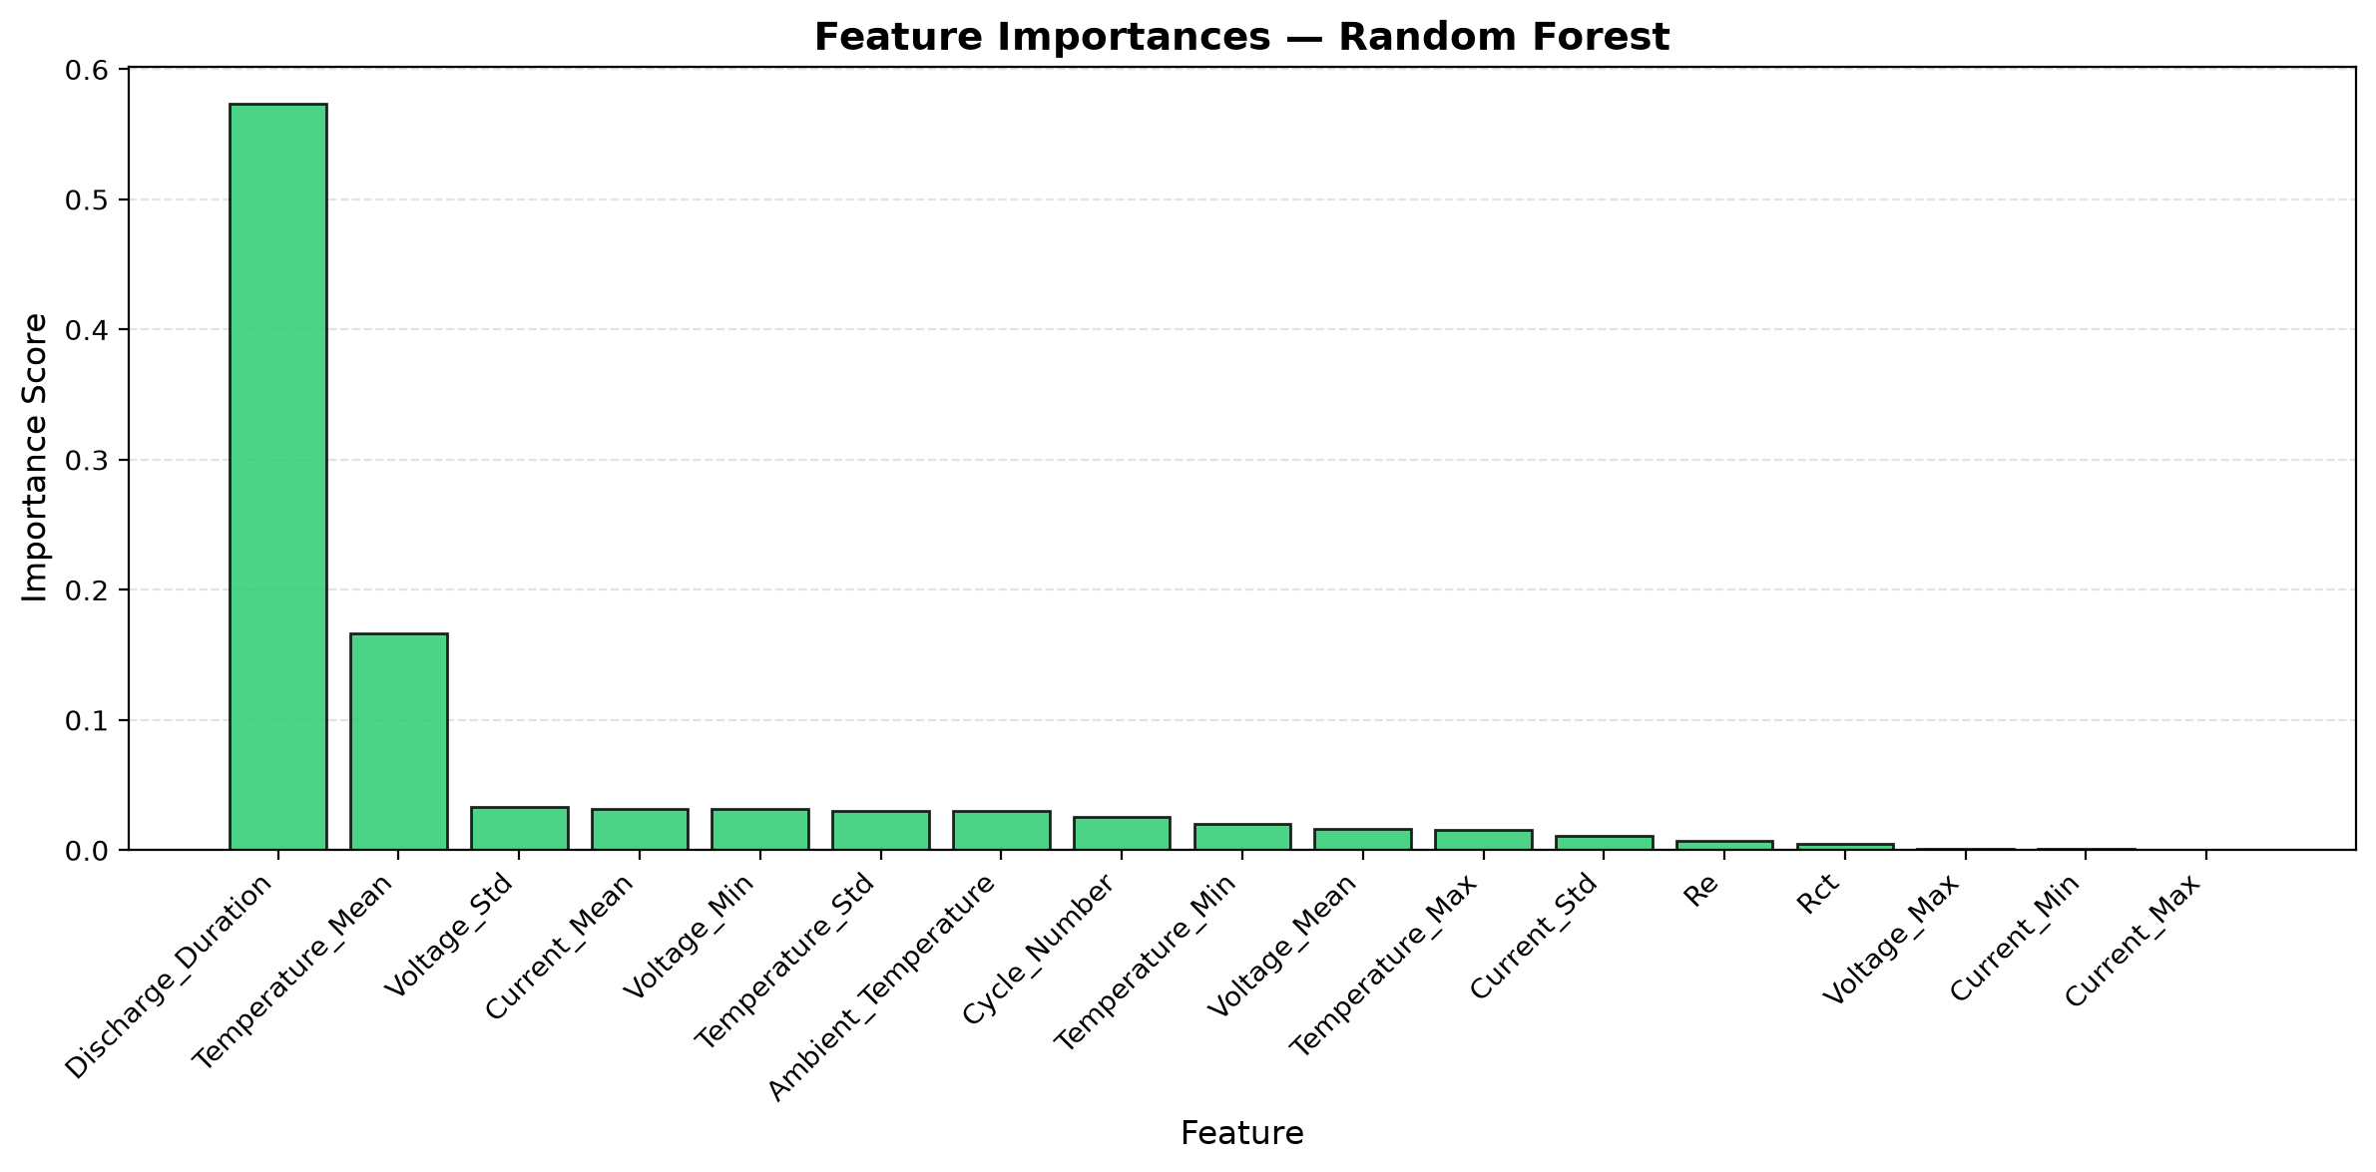
Fig 6. Feature Importances — Random Forest

3. LSTM Neural Network
Deep Learning Sequential Model — Phase 7

What is LSTM?
- Long Short-Term Memory — a type of Recurrent Neural Network (RNN)
- Designed to model temporal sequences — captures how capacity degrades over cycles
- Uses a sliding window of 5 past cycles to predict the current cycle's capacity

Network Architecture
Layer | Configuration
Input | Shape: (5 cycles × 17 features)
LSTM Layer 1 | 64 units, return_sequences=True
Dropout 1 | Rate = 0.2
LSTM Layer 2 | 32 units, return_sequences=False
Dropout 2 | Rate = 0.2
Dense (hidden) | 16 units, ReLU activation
Dense (output) | 1 unit (Capacity)
Optimizer | Adam
Loss | Mean Squared Error (MSE)
Early Stopping | Patience = 10 epochs

Training Setup
Parameter | Value
Sequence length | 5 cycles (sliding window)
Batch size | 16
Max epochs | 60
Validation split | 15% of training data
Library | TensorFlow / Keras

Results
Metric | Value
MAE | 0.0784 Ah
RMSE | 0.1169 Ah
R² | 0.9337

Key Observations
- Explicitly models temporal degradation trajectory — understands trends across cycles
- Loss curve shows stable convergence; early stopping prevents overfitting
- Best suited for multi-step ahead forecasting tasks
- Slightly lower R² than Random Forest due to smaller effective training set after windowing

Plots

Fig 1. Actual vs Predicted Capacity — LSTM (right panel)


Fig 2. Prediction Error Scatter — LSTM (right panel)

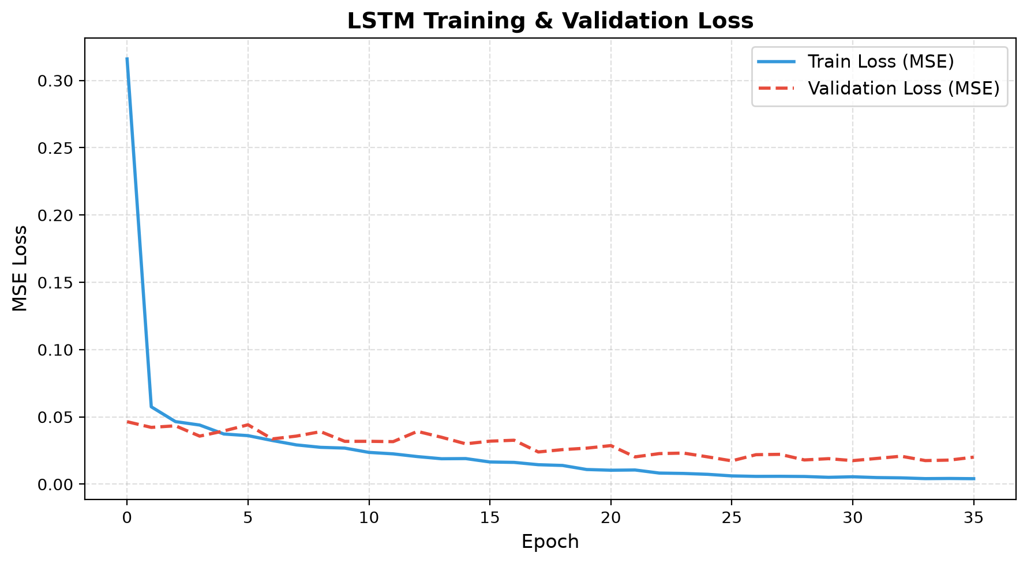
Fig 5. LSTM Training & Validation Loss Curve

4. Model Comparison & Conclusion
Linear Regression vs Random Forest vs LSTM

Performance Summary
Model | MAE ↓ | RMSE ↓ | R² ↑ | Rank
Linear Regression | 0.1029 | 0.1523 | 0.8874 | 🥉 3rd
LSTM | 0.0784 | 0.1169 | 0.9337 | 🥈 2nd
Random Forest | 0.0142 | 0.0585 | 0.9834 | 🥇 Best

Model Characteristics
Aspect | Linear Regression | Random Forest | LSTM
Captures non-linearity | No | Yes | Yes
Uses temporal sequences | No | No | Yes
Interpretable | Yes | Partial | No
Training speed | Very fast | Moderate | Slow
Best use case | Baseline | Production | Forecasting

Key Takeaways
- Random Forest is the recommended model — highest R² (0.983), lowest MAE (0.014 Ah)
- Linear Regression provides an interpretable baseline with R² = 0.887
- LSTM captures temporal degradation patterns — best suited for multi-step forecasting
- Outlier filtering of impedance sensors (Re, Rct) was critical for stable Linear Regression training
- Cycle_Number and Discharge_Duration are the most predictive features of capacity fade

Comparison Plots
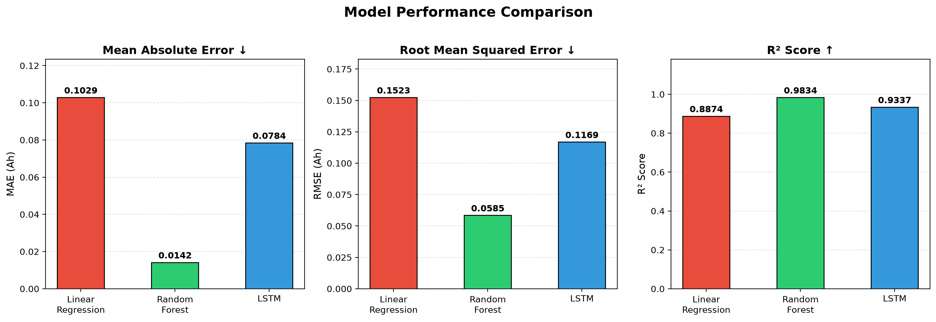
Fig 4. MAE, RMSE and R² Comparison Across All Models


Fig 3. Residual Analysis — All Three Models


Fig 7. Grand Summary Dashboard — All Models

