

File Format Compatibility for the   
2007 Microsoft® Office System

November 2006

Table of Contents

Cover is for   
position only

Executive overview 1

Copyright 1

The Ecma Office Open XML Formats 1

[Spotlight on the new Excel Binary Format: XLSB 1](http://my/personal/grayk/FF/Shared%20Documents/Approved,%20current%20content/IT%20Pro%20Content/RTM%20Open%20XML%20Format%20Compatibility%20Overview.docx)

Adding new file formats to the 2007 Office system 2

The importance of the 2007 Office system formats 3

Redefining compatibility with 2007 Microsoft Office system file formats 4

Enabling compatibility for Office XP and 2003 4

Enabling compatibility for Office 2000 5

What to Expect When No Compatibility Pack or Office update is Installed 5

Office XP and Office 2003 experience when no updates or Compatibility Pack is installed 5

Scenario: PowerPoint 2003 attempts to edit a .PPTX file 6

Office 2000 Experience when no Compatibility Pack is installed 7

Scenario: Converting documents in Windows Explorer using the Compatibility Pack 7

Behavior chart describing expected behavior when opening 2007 file formats 9

Feature Compatibility Between versions of Word, Excel and PowerPoint 10

Compatibility Mode 10

Word, Excel, and PowerPoint Compatibility 11

Excel 11

PowerPoint 11

Word 12

Triggering Compatibility Mode 12

Compatibility Checker 13

Feature Refresh 13

Conclusion 16

For more information 17

# Executive overview

The new Open XML Formats are designed to improve interoperability of Office documents with other programs and systems. Open XML Formats are designed to enable the information in billions of Office documents today to be converted to open file formats. The Open XML Formats will be the default file formats for Word, Excel and PowerPoint 2007.

Open XML Formats are designed to be compatible with earlier releases of Microsoft Office and to be integrated easily with other applications and systems. In order to ensure the Open XML Formats become an important part of all Office users’ environments, Microsoft has made extensive efforts to enable compatibility for current Office users to ensure they can exchange documents that are created using the Open XML Formats.

This document is intended for audiences who seek to understand the specific compatibility aspects of Word, Excel and PowerPoint 2000, XP, 2003 and 2007. This document will explain how compatibility is enabled, what Office applications and versions are impacted by file format compatibility, and what features within the document formats are impacted by compatibility.

Readers of this white paper will gain an understanding of how compatibility is enabled, what applications and operating systems are supported, and how Office users will experience compatibility.

## 

### Copyright

This is a preliminary document and may be changed substantially at a later date.

The information contained in this document represents the current view of Microsoft Corporation on the issues discussed as of the date of publication. Because Microsoft must respond to changing market conditions, it should not be interpreted to be a commitment on the part of Microsoft, and Microsoft cannot guarantee the accuracy of any information presented after the date of publication.

This White Paper is for informational purposes only. MICROSOFT MAKES NO WARRANTIES, EXPRESS, IMPLIED OR STATUTORY, AS TO THE INFORMATION IN THIS DOCUMENT.

Complying with all applicable copyright laws is the responsibility of the user. Without limiting the rights under copyright, no part of this document may be reproduced, stored in or introduced into a retrieval system, or transmitted in any form or by any means (electronic, mechanical, photocopying, recording, or otherwise), or for any purpose, without the express written permission of Microsoft Corporation.

Microsoft may have patents, patent applications, trademarks, copyrights, or other intellectual property rights covering subject matter in this document. Except as expressly provided in any written license agreement from Microsoft, the furnishing of this document does not give you any license to these patents, trademarks, copyrights, or other intellectual property.

Unless otherwise noted, the example companies, organizations, products, domain names, e-mail addresses, logos, people, places and events depicted herein are fictitious, and no association with any real company, organization, product, domain name, email address, logo, person, place or event is intended or should be inferred.

© 2006 Microsoft Corporation. All rights reserved.

Microsoft, Office, Office 2000, Office XP, Office 2003, Excel, PowerPoint, Word, Windows, Windows 2000, Windows XP, Windows Server are either registered trademarks or trademarks of Microsoft Corporation in the United States and/or other countries.

The names of actual companies and products mentioned herein may be the trademarks of their respective owners.

# The Ecma Office Open XML Formats

Ecma Office Open XML Formats are open, standardized file formats designed to provide interoperability, transparency and compatibility for the billions of Microsoft Office documents that already exist, and those that will be created in the future. Taking advantage of an open license, an extensible format, and compatibility with the most widely used software, with Open XML Formats you can build sustainable, integrated solutions today. Interoperability, accessibility, robustness and transparency are core to the design of the 2007 Office system file formats.

Beyond just a simple transition to XML-based file formats, the these Formats promote interoperability with custom XML data sources, recover successfully from corruptions, support machine-readable environments, but perhaps most importantly, provide users with the performance characteristics they expect in comparison to past binary formats.

In addition, through using ZIP packaging technology, the 2007 Office system file formats offer a substantial reduction in file sizes, between 50-75% smaller for Word and Excel, and 25% smaller in the case of the image-intensive PowerPoint file format. The size reduction alone offers immediate and tangible benefit to any organization seeking to improve efficiency.

The new Open XML formats are offered under an open, royalty-free license from Microsoft, and have been submitted as the basis of an ECMA standard. The open file format licensing ensures that any technology provider can incorporate the Open XML formats into their technologies without consideration to Microsoft.

## Spotlight on the new Excel Binary Format: XLSB

Many organizations have stated a clear preference for open, XML-based file formats for the future. Some users, however, continue to choose binary file formats. Microsoft Office offers a broad choice in file formats, to enable people to choose the formats that are best suited for their needs.

Excel 2007 introduces new XML based file formats to enable interoperability with external systems and information sources. However, many Excel workbooks are complex, with many charts, pivots and other information. When a workbook becomes very large it‘s file performance can slow down due to the large amount of cycles needed to parse all the XML text information.

If organizations find a particular file is getting slow to load (because it has many large cells or pivot tables) they may prefer to use the new XLSB format for that file.  While most people will not need to use the new XLSB format, because the overwhelming majority of Excel workbooks will load in under a couple of seconds regardless of format.

# Adding new file formats to the 2007 Office system

Microsoft introduced full XML-based document format options with Office 2003, which began a new level of interest from hundreds of thousands of developers in XML document solutions. The 2007 release of the Microsoft® Office system will introduce the new Open XML Formats as the default to encourage routine interoperability of Office documents with other programs and systems. The Ecma Office Open XML Formats are designed to enable the information in billions of Office documents today to be converted to XML formats.

In addition to the new Ecma Office Open XML Formats, Microsoft is introducing other new file formats for Word, Excel and PowerPoint 2007. These include macro-enabled versions of the Open XML Formats, as well as new template formats, a new binary file format for Excel specifically optimized for complex workbooks, and more. Beyond the Ecma Office Open XML Formats, these new formats for the 2007 Office system are designed to provide the choice necessary to enable optimal use of Microsoft Office applications, and optimal interoperability of Office programs with other applications and systems. The table below lists the new file formats supported with Word, Excel and PowerPoint 2007.

|  |  |  |  |
| --- | --- | --- | --- |
| **Word 2007 Supported File Formats** | | |  |
| .docx | Word Document (.docx) | New | Compatible with 2000, XP, 2003 |
| .docm | Word Macro-enabled Document (.docm) | New | Compatible with 2000, XP, 2003 |
| .dotx | Word Template (.dotx) | New |  |
| .dotm | Word Macro-enabled Document Template (.dotm) | New |  |
| **Excel 2007 Supported File Formats** | | |  |
| .xlsx | Excel Workbook (.xlsx) | New | Compatible with 2000, XP, 2003 |
| .xlsm | Excel Macro-enabled Workbook (.xlsm) | New | Compatible with 2000, XP, 2003 |
| .xltx | Excel Template (.xltx) | New | Compatible with 2000, XP, 2003 |
| .xltm | Excel Macro-enabled Workbook Template (.xltm) | New | Compatible with 2000, XP, 2003 |
| .xlsb | Excel Binary Workbook (.xlsb) | New | Compatible with 2000, XP, 2003 |
| .xlam | Excel Add-in (.xlam) | New | Compatible with 2000, XP, 2003 |
| **PowerPoint 2007 Supported File Formats** | | |  |
| .pptx | PowerPoint Presentation (.pptx) | New | Compatible with 2000, XP, 2003 |
| .pptm | PowerPoint Macro-enabled Presentation (.pptm) | New | Compatible with 2000, XP, 2003 |
| .ppsx | PowerPoint Slide Show (.ppsx) | New | Compatible with 2000, XP, 2003 |
| .ppsm | PowerPoint Macro-enabled Slide Show (.ppsx) | New | Compatible with 2000, XP, 2003 |
| .potx | PowerPoint Template (.potx) | New | Compatible with 2000, XP, 2003 |
| .potm | PowerPoint Macro-enabled Presentation Template (.potm) | New | Compatible with 2000, XP, 2003 |
| .ppam | PowerPoint Add-in (.ppam) | New |  |

Table 1: New File Formats of the 2007 Microsoft Office system. Red Text indicates the default file format for the 2007 versions

# The importance of the 2007 Office system formats

Changing file formats for Microsoft Office applications is an important change that impacts many people. When considering the impact of the 2007 Office system formats, understanding the benefits establishes clear value for change; and motivates people to migrate to a better environment. In short, the 2007 Office system formats represent the future of file format technology; open, transparent file formats that are more compact, more stable, facilitating true interoperability with existing systems, improving security, and most importantly, **maintaining compatibility with your existing documents.**

* The Open XML Formats offer substantially reduced file sizes for users of Word and Excel
* The Open XML Formats support improved recovery of documents that have become damaged because of the modular, XML-based architecture
* Open XML Formats are optimized for performance, to ensure that the transition to open document formats doesn’t slow down your users
* Open XML Formats are designed to support accessible software, to enable advanced support from screen readers
* Open XML Formats represent all of the features currently supported by Microsoft programs to help ensure a complete and full-fidelity conversion, and to help ensure compatibility across existing programs
* People can open and edit Microsoft Office Word, Microsoft Office Excel, and Microsoft Office PowerPoint files with any XML processing program, without having to "Save As" XML or use Microsoft Office programs
* For macro-enabled documents, new, special-purpose formats have been introduced. Because the macro-enabled document formats have new extensions, IT organizations can detect potentially unsafe files by the file format extensions, rather than having to scan the document contents.
* The Open XML formats include support for integrating your own XML information using a custom XML data store. With this capability, documents are a critical front end to everyday business process improvement.

# Redefining compatibility with 2007 Microsoft Office system file formats

A change to the default file formats of Word, Excel and PowerPoint is significant because billions of documents are potentially affected, as well as hundreds of millions of Office users. Ensuring a smooth transition to new file formats is critical to ensure the benefits are realized with minimal user impact.

Unlike other applications that require users to “just use the old format,” Office users must have a solution for file format compatibility that accounts for their existing documents and applications; without a way to provide an error-free conversion to a new file format, users are left to wonder what’s missing or lost.

The 2007 Office system formats can be edited by Microsoft Office 2003, XP, and 2000 through the addition of compatibility tools. The 2007 Microsoft Office system introduces an innovative and unique way of managing file format evolution and compatibility by controlling what features and content can be used in documents.

Because of these important innovations, users no longer will be required to share documents across versions by using the “old” file formats; instead, they will have the choice of using either the “old” file formats (.doc, .xls, and .ppt) or the “new” file formats (.docx, .xlsx, .pptx, etc.) when exchanging files between Office versions. To enable this flexibility, Microsoft will provide support for Office 2003, XP and 2000 to open, edit and save the “new” file formats of Office 2007.

# Enabling compatibility for Office XP and 2003

Microsoft will make compatibility much easier by adding support for the 2007 Office system formats inside of Word, Excel and PowerPoint XP and 2003. Users of Office XP and Office 2003 will open, edit and save documents using the new file formats just as they would open, edit, and save documents using the current file formats. In other words, the new, supported file extensions are added to the File Open, Save and Save As dialog boxes of Word, Excel and PowerPoint XP and 2003, and can even be set as the default file format for these applications. Enabling compatibility is a 2-step process:

1. **Keep your installations of Office current with security fixes** and updates from <http://www.microsoft.com/office>. Included in the current updates for the Office system is an update to enable Office XP and 2003 to recognize the new file formats of the 2007 Office system. You may already have this installed if you’re keeping Office up to date.
2. **Install the Compatibility Pack for the 2007 Office system file formats.** This is a free download for anyone using at least Windows 2000 SP4. When installed on a system running Office XP or 2003, the Compatibility Pack will enable you to open, edit and save documents directly from Word, Excel, and PowerPoint using the new file formats; if you choose, you can even enable these formats as the new default for your applications. The Compatibility Pack can be downloaded from the following location: <http://www.microsoft.com/downloads/details.aspx?FamilyId=941B3470-3AE9-4AEE-8F43-C6BB74CD1466>

# Enabling compatibility for Office 2000

Users of Excel and PowerPoint 2000 can also work with the 2007 Office system formats. Using the Compatibility Pack, you can convert between 2007 Office system formats and binary file formats from within Windows explorer. This ensures that when you receive a document stored in the new format, you can manually convert it to a supported binary format, and convert the format back to the 2007 Office system formats when completed. For users of Word 2000, installing the Compatibility Pack will enable the opening, editing and saving of the 2007 Office system formats from within Word natively. Enabling compatibility for Office 2000 is a 1-step process:

1. **Install the Compatibility Pack for the 2007 Office system file formats.** This is a free download for anyone using at least Windows 2000 SP4. The Compatibility Pack can be downloaded from the following location: <http://www.microsoft.com/downloads/details.aspx?FamilyId=941B3470-3AE9-4AEE-8F43-C6BB74CD1466>

## Behavior chart describing expected behavior when opening 2007 file formats

The table below explains the expected behavior when a user attempts to open or save a 2007 Office system format from their version of Microsoft Office.

|  |  |  |  |
| --- | --- | --- | --- |
| What happens when… | Excel 2000 and PowerPoint 2000 | Word 2000, Office XP & Office 2003 | The 2007 Office system |
| I open a 2007 Office system format? | * After installing the Compatibility Pack, you can right click on the document to convert to a supported format for editing * Double-clicking the file opens the document | * After updating Office and installing the Compatibility Pack, you can open, edit and save the 2007 Office system format natively within the application. | * The file can be opened and edited with no additional configuration |
| I want to save a file using the 2007 Office system formats? | * After installing the Compatibility Pack, you can save a file to Windows, and then convert the file to the 2007 Office system formats by right-clicking on the document and choosing Save As. | * After installing the Office updates and Compatibility Pack, the file can be saved using the 2007 Office system formats directly from these applications. | * The file can be saved with no additional configuration |

*\*Note, the current binary document formats are fully supported across Office 2000, XP, 2003 and 2007.*

# What to Expect When No Compatibility Pack or Office update is Installed

The new file formats of the 2007 Office system will be unrecognized by users of earlier releases of Office until compatibility is enabled by installing either the Compatibility Pack or required Office Updates.

## Office XP and Office 2003 experience when no updates or Compatibility Pack is installed

If neither the Office Update or Compatibility Pack are installed, when users of Office XP or 2003 attempt to open an 2007 Microsoft Office system file, they will be notified that the file cannot be opened, and they will be presented with the standard Microsoft Windows interface for handling unknown file types. By selecting the “Use a Web service to find the appropriate program” option, users will be directed to a download site, [http://www.microsoft.com/downloads/details.aspx?FamilyId=941B3470-3AE9-4AEE-8F43-C6BB74CD1466](http://www.microsoft.com/downloads/details.aspx?FamilyId=CFBB047A-9B48-4AE9-AF23-77BF5A18A10A), that enables them to update Office with all of the latest service packs and updates, and to install the Compatibility Pack. Installing the Updates and the Compatibility Pack (in this order), will enable users to open, edit and save the new file formats inside of the applications, just as they open, edit, and save 97-2003 formats.

## Office XP and Office 2003 experience when only updates are installed

If the installation of Office XP and 2003 are current with security fixes and updates, when you try to open a file saved in one of the supported new formats, Word, Excel or PowerPoint XP and 2003 will guide you to the download page for the Compatibility Pack.

### Scenario: PowerPoint 2003 attempts to edit a .PPTX file

Jane uses Office 2003 for her daily work. Jane keeps her Office installation current with security fixes and updates. She knows that important security fixes are offered from Office Online, so she visits frequently to check for updates.

One of Jane’s partners has sent a presentation for review, but they sent it using the .PPTX format. How can Jane get to a point where she can edit the file?

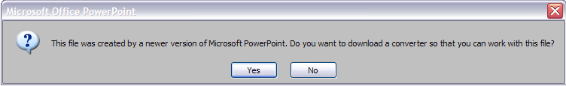Because Jane is current on her Office installation, she received the required Office update already. When she double-clicks the file to open it, PowerPoint 2003 provides her with the following information:

**Figure :** A dialog box in PowerPoint 2003 can help users find the converters to open .PPTX and other supported file types

By selecting “Yes”, Jane is directed to a web page where she can download and install the Compatibility Pack. The Beta version of the web site is shown in the screen capture. The download page for the Compatibility Pack offers simple instructions and a download button. After the installation has completed, the PPTX file can now be opened within PowerPoint 2003. The content created by PowerPoint 2007 features that cannot be edited by PowerPoint 2003 is represented as an image, but can be “refreshed” when returned to PowerPoint 2007 in some cases. Feature refresh is discussed at length in the next section, “Feature Compatibility Between Versions of Office.”

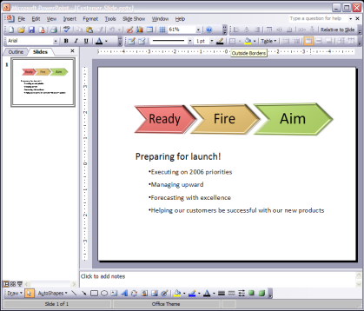

**Figure** : After installing the Compatibility Pack, the .PPTX file can be edited by PowerPoint 2003

## Office 2000 Experience when no Compatibility Pack is installed

If neither the Compatibility Pack is not installed, when users of Office 2000 attempts to open an 2007 Microsoft Office system file, they will be notified that the file cannot be opened, and they will be presented with the standard Microsoft Windows interface for handling unknown file types. By selecting the “Use a Web service to find the appropriate program” option, users will be directed to the Compatibility Pack download page , [http://www.microsoft.com/downloads/details.aspx?FamilyId=941B3470-3AE9-4AEE-8F43-C6BB74CD1466](http://www.microsoft.com/downloads/details.aspx?FamilyId=CFBB047A-9B48-4AE9-AF23-77BF5A18A10A), that enables them to install the Compatibility Pack. Installing the Compatibility Pack will enable Word 2000 users to open, edit and save the new file formats inside of the applications, just as they open, edit, and save 97-2003 formats. Excel and PowerPoint users can right-click on documents from Windows Explorer to convert between binary and the 2007 Office system formats.

### Scenario: Converting documents in Windows Explorer using the Compatibility Pack

John is using Office 2000 to edit documents. After receiving a file with a .docx extension, John tries to open the file for editing in Word. After double-clicking on the file icon, John is directed to use a Web service to identify how the files should be opened, and following this link he is directed to Microsoft.com, [http://www.microsoft.com/downloads/details.aspx?FamilyId=941B3470-3AE9-4AEE-8F43-C6BB74CD1466](http://www.microsoft.com/downloads/details.aspx?FamilyId=CFBB047A-9B48-4AE9-AF23-77BF5A18A10A), to download the Compatibility Pack.

After installing the Compatibility Pack, John can open, edit, and save files saved in the document formats new to Word 2007 just like he would .doc files.

When he has finished editing, John can then save the file and then save it as one of the new formats from the Windows shell (see figures below).

The following series of graphics illustrates how users of Word, Excel, and PowerPoint 2000 can convert documents.

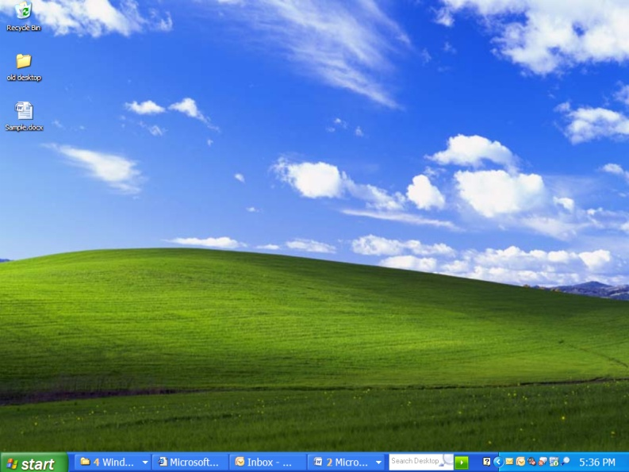

Figure 3: After installing the compatiblity pack, John's system is aware of the new file format extension.

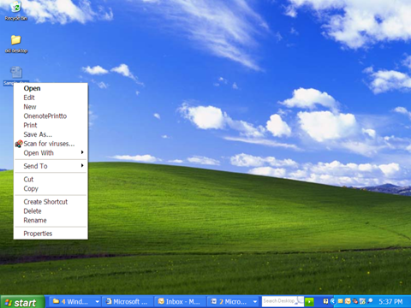

Figure 4: By right-clicking on the file, John can use the "Save As" feature to convert between binary and the 2007 Office system formats.

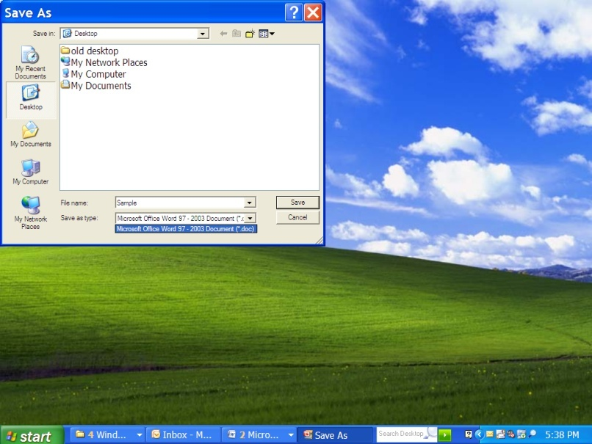

Figure 5: Saving a new version of the file will not overwrite the original document John received.

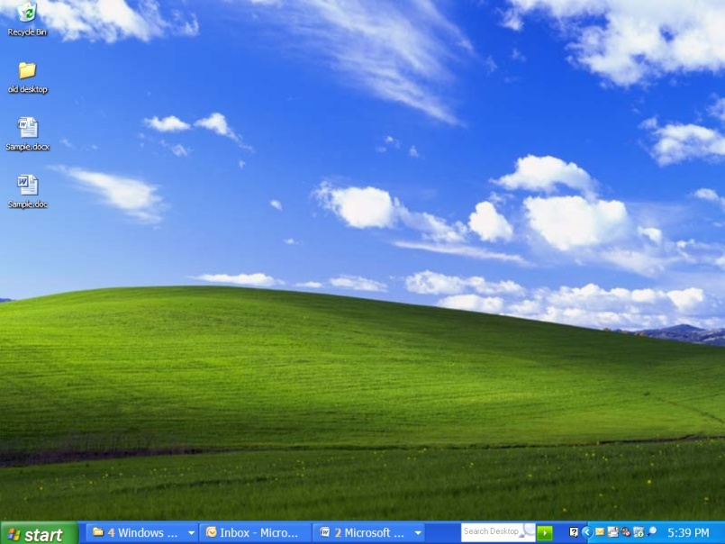

Figure 6: After selecting the save option, John has a new version of the file compatible with his 2007 application.

# Feature Compatibility Between versions of Word, Excel and PowerPoint

Once the compatibility environment has been established by installing the Compatibility Pack and Office update, users can exchange the 2007 Office system formats with others. Whether the current binary file formats are used, or the new 2007 Office system file formats are used, people can edit the documents they receive to review, read or otherwise interact with.

For users of the 2007 Office system, however, compatibility with prior releases raises an important question: “If I am using all the great new features of the 2007 Office system, like SmartArt™ Diagrams or the Equation Builder in Word, what happens when users of earlier versions of Office try to edit the file?” This is an important question. Because earlier releases of Office do not support many of the new features of the 2007 Office system, users need a way to ensure this type of content will can be exchanged without incident.

Beyond the extensive effort made to enable both non-Microsoft products and earlier Office versions to open the new 2007 Office system formats, Microsoft has undertaken substantial work in ensuring the new features that are used when authoring documents don’t cause problems when documents are exchanged. Beyond the file itself, Microsoft takes the extra step of ensuring the *content* moves across versions as well.

Microsoft has introduced a new “Compatibility Mode” to enforce compatibility of 2007 Office applications with prior relapses. A new Compatibility Checker is introduced to alert users when content will not operate correctly in prior releases. Feature refresh will allow some types of 2007-only content to remain editable even after the formats are downgraded, and then upgraded back to 2007 full functionality.

## Compatibility Mode

To help offset some of the feature compatibility issues, Microsoft will introduce new technologies and features: A new **Compatibility Mode** has been added to Word, Excel and PowerPoint 2007. Its purpose is ensure that content not supported by prior releases can actually be converted or downgraded to be usable in a form that the earlier product understands. In Word, for example, this means that when users click “Insert SmartArt™”, they will see the diagramming engine from Office 2003. This ensures the diagram they add to their files can be fully edited by the Word 2003 user. When not in compatibility mode, Word 2007 users get the new SmartArt™ Diagram tools for creating diagrams and limited objects are upgraded again, or ‘renewed’.

**Figure :** Enhanced ScreenTips provide users with information about how the features of 2007 programs are affected by Compatibility Mode

Compatibility Mode in 2007 Microsoft Office system helps users collaborate with prior releases of Word, Excel, and PowerPoint. When 2007 Microsoft Office system users are working with Office 97–2003 file formats such as .doc, .xls, and .ppt, the files will work in 2007 Microsoft Office system Compatibility Mode. Using Compatibility Mode in 2007 Microsoft Office system ensures that Word, Excel, and PowerPoint 2007 will be able to open and save Office 97–2003 file formats without converting them to 2007 Microsoft Office system files.

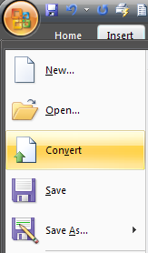In Compatibility Mode, some features of 2007 Microsoft Office system are limited in order to be consistent with the features of the prior Office releases. Compatibility Mode is document-specific, and it is automatically enabled when Office 97–2003 file formats are edited in 2007 Microsoft Office system applications. Compatibility Mode is not required for prior Office releases, as their features are fully supported within Office 2007.

Across the three applications – Word, Excel, and PowerPoint – users will see visual cues to alert them that they are in Compatibility Mode for a particular file – for example, “Compatibility Mode” will be added to the application’s title bar. Enhanced ScreenTips are provided to give additional detail for specific features that are enabled in Compatibility Mode.

Users also are provided with the means to convert the document from Compatibility Mode to full functionality. By selecting “Convert” from the Office Start Button, users can convert the document to full functionality mode in 2007, and begin to add content using the new features of 2007. The appendix at the end of this paper details which features in the 2007 versions of Word, Excel and PowerPoint are only available in full functionality mode.

**Figure :** Users can enable full 2007 functionality using the "Convert" command.

## Word, Excel, and PowerPoint Compatibility

Word, Excel and PowerPoint utilize Compatibility Mode to control exchange of content between each application. This ensures the maximum quality for sharing content between various versions of the applications. The following sections explain the purpose of Compatibility Mode for each application, and which criteria are important for defining how exchanges take place.

### Excel

Compatibility Mode is designed to prevent new features in Excel 2007 from being saved to a file destined for use with a prior version. For example, all releases of Excel prior to Excel 2007 can support a maximum of 65,536 rows in a worksheet. Excel 2007 removes this limitation. If an Excel 2007 user creates a worksheet with 100,000 rows of data, prior releases of Excel must truncate rows beyond 65,536 when opening the file. To minimize disruption to users who are collaborating between releases of Excel, these new features in Excel 2007 are limited while Excel 2007 is running in Compatibility Mode. In this case, while working in compatibility mode, users cannot add more than 65,536 rows to an Excel workbook.

### PowerPoint

The primary goal of downgrading features via Compatibility Mode in PowerPoint is to disable functionality that cannot be rendered with an adequate level of visual fidelity – and, in some cases, editability – in prior releases of the application. This is important because content that looks different across versions can adversely affect the message of the presentation.

PowerPoint 2007 can create and edit the various types of content created by prior versions, but can also add many new effects and attributes to this content which are not supported in prior releases. For example, text effects can be added in PowerPoint to provide shadows, reflections, bevel or other types of effects. Because prior versions of PowerPoint cannot render this content, PowerPoint must represent these effects using images in prior releases.

Any image representations of content created by PowerPoint 2007 in earlier edits is also renewed, and is now editable again using PowerPoint 2007. When the presentation is saved back to Compatibility Mode, shapes, diagrams, and graphics are represented as images.

### Word

One of the most critical aspects of Word document exchange is visual fidelity. Ensuring documents look the same across many versions of Word is critical. To minimize the risk of layout differences, when exchanging documents between various versions, Word strictly enforces Compatibility Mode, in order to ensure fidelity between releases. When files are opened in compatibility mode, no automatic conversion of any content takes place. Some new Word 2007 features are throttled to prevent the addition of content that is not compatible.

While working in Word 2007, if a user attempts to paste content that is not supported by earlier versions (for example, an 2007 Microsoft Office system chart, diagram, equation, or citation), Word will immediately “downgrade” the content into compatibility with the Office 97–2003 file formats.

Using the Office 97-2003 file formats for Word also enables some features to be renewed when converted back to full functionality mode in Word 2007.

### Triggering Compatibility Mode

Compatibility Mode is enabled in the following situations:

|  |  |  |  |
| --- | --- | --- | --- |
| 2007 Microsoft Office system Action | Excel 2007 | PowerPoint 2007 | Word 2007 |
| Open a file saved using Office 97–2003 formats | ✓ | ✓ | ✓ |
| Convert an 2007 Microsoft Office system file format to an Office 97–2003 format using “Save As” | ✓ | ✓ | ✓ |
| Set the application default to save using the Office 97–2003 file formats | ✓ | ✓ | ✓ |
| Create a new document based on a .dot (Office 97–2003) template |  |  | ✓ |

Table 4: Actions in the 2007 Office system that trigger compatibility mode

## Compatibility Checker

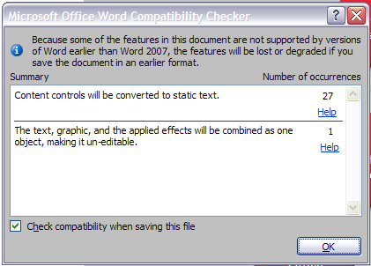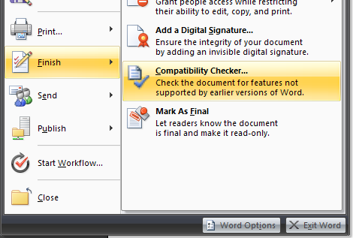A **Compatibility Checker** has been added to Word Excel and PowerPoint 2007 to detect any features that cannot be consumed by earlier versions of the respective products. This helps when users are saving a document they know they wish to exchange with many Office versions. As in the previous example, Excel 2007 enables users to store 1,000,000 rows in any worksheet, which goes far beyond the 65,536 limit of Excel 2003. When users have 800,000 rows in an Excel 2007 Workbook, and they try to save using the .XLS format, the Compatibility Checker will prompt them with a warning that data will be lost. This helps ensure people don’t make unnecessary sacrifices when sending files and ensures they don’t get unexpected results.

The Compatibility Checker displays a list of any content in the document that may not appear the same or be fully editable when the current new file format (for example, .pptx) is saved to an Office 97–2003 format (in this case, .ppt). The Compatibility Checker is launched either when a user downgrades a file by saving one of the new file formats to an Office 97–2003 file format, or when the user clicks **Compatibility Checker** on the **Office Button Finish** menu.

**Figure :** The Compatibility Checker is used to detect content in documents, presentations and spreadsheets that is not compatibility with earlier versions.

## Feature Refresh

Perhaps the most advanced of the additions is the new **“refresh”** technology offered in the 2007 versions of the applications. When a 2007 user adds content to a document that is not compatible with a prior release, it is important that the earlier versions can render that content correctly, even if it cannot be edited.

When a user adds content in 2007 that is not compatible with a prior release, it is represented as an uneditable image in earlier versions. But when the 2007 Office user begins to edit the content again, it is represented again as an editable graphic! Because much of the information about the content is retained within the file, content can be renewed after it is brought back into the 2007 versions of the programs. It is important to note that not all content can be renewed, and some content is lost when downgrading to compatibility mode or to a prior release. For Word 2007, refresh is only supported using the binary file formats. The appendix has additional detail on which features are affected by compatibility mode, and which can be renewed.

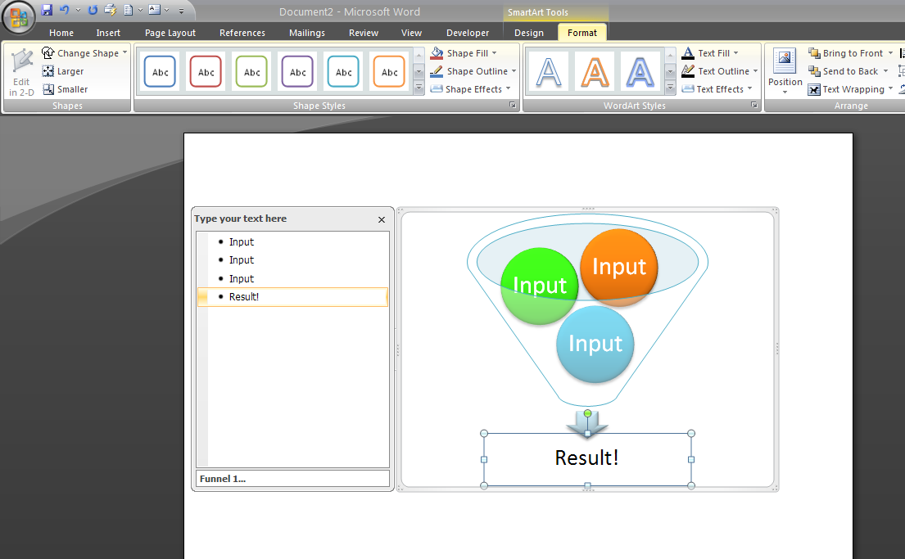

**Figure** 11: SmartArt™ Diagrams are editable within Word 2007, but cannot be edited within earlier versions. When saving the document the .doc file format, the SmartArt™ Diagram is shown as an image.

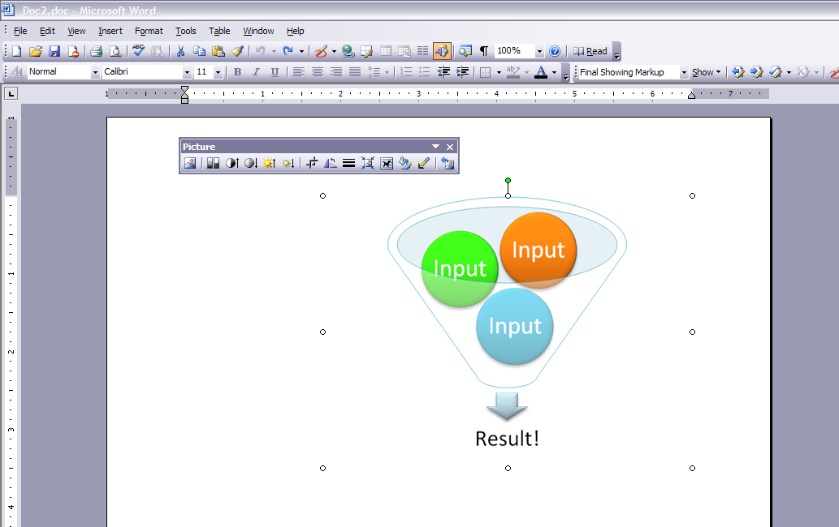

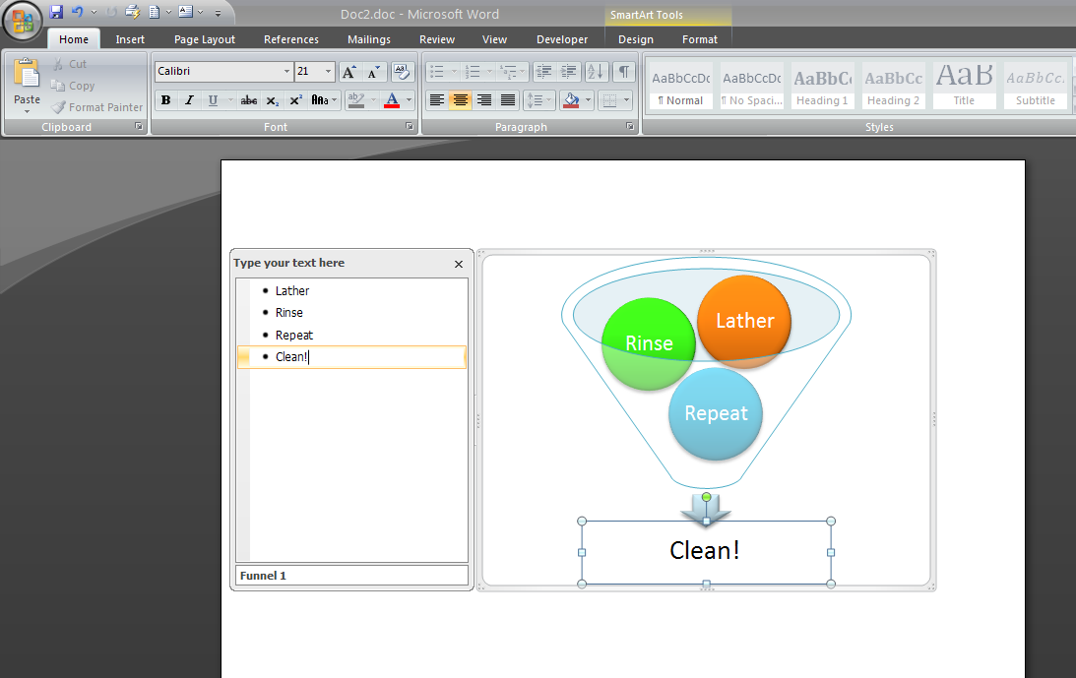**Figure** 12**:** Using Word 2003, the same SmartArt™ Diagram is represented as an image. If the Word 2007 user converts the document to compatibility mode using the .doc format, the diagram can be edited again, after returning to Word 2007.

## 

**Figure** : After returning to Word 2007, the SmartArt™ Diagram can be edited again

# Conclusion

The 2007 Office system formats are an important step toward the future of file format technology. Enabling interoperability, improved robustness, security and transparency help organizations succeed with “smarter documents.” To ensure the new file formats of the 2007 Office system don’t break the software you already use, the 2007 Office system formats are designed to move you to the new work style without breaking compatibility with your existing documents and programs.

Microsoft has made important and unprecedented strides to enable compatibility for the billions of documents that utilize the Microsoft Office file formats. By enabling compatibility across multiple versions of Office, while introducing new benefits from the advanced Open XML Formats technology, Office users will be able to exchange files now, and long into the future. By maintaining compatibility for the current file formats, and enabling backward compatibility for documents that use the new file formats, Microsoft has taken important steps to ensure that the choice of file formats does not become a barrier to users of the Microsoft Office system.

Organizations can immediately recognize the benefits of smaller file sizes, better data recovery, and integration with external sources of information, but not at the expense of compatibility with their co-workers, customers and partners.

## For more information

For the latest announcements leading up to the release of the 2007 Microsoft Office system, including feature comparisons, developer tools, and deployment resources, visit Office online at <http://www.microsoft.com/office>

Brian Jones, a Program Manager and 6-year veteran of the Microsoft Office team, maintains a blog on the Microsoft Developer Network (MSDN) devoted to the XML file formats in Office. <http://blogs.msdn.com/brian_jones/default.aspx>

For developers seeking information on incorporating the Open XML formats into their solutions, a new, free community has been created to share information about the development of the Open XML Formats.

<http://www.openxmldeveloper.org>

This document is developed prior to the product’s release to manufacturing, and as such, we cannot guarantee that all details included herein will be exactly as what is found in the shipping product. The information contained in this document represents the current view of Microsoft Corporation on the issues discussed as of the date of publication. Because Microsoft must respond to changing market conditions, it should not be interpreted to be a commitment on the part of Microsoft, and Microsoft cannot guarantee the accuracy of any information presented after the date of publication. The information represents the product at the time this document was printed and should be used for planning purposes only. Information is subject to change at any time without prior notice.

This document is for informational purposes only. MICROSOFT MAKES NO WARRANTIES, EXPRESS OR IMPLIED, IN THIS DOCUMENT.

© 2006 Microsoft Corporation. All rights reserved.

Microsoft, Excel, InfoPath, the Office logo, Outlook, SharePoint, Visual Studio, Windows, and Windows Server are either registered trademarks or trademarks of Microsoft Corporation in the United States and/or other countries. All other trademarks are property of their respective owners.