RAAGUL PRASANTH

COMPUTER SCIENCE STUDENT

# CONTACT

**Phone:**

+91 9597421511

**Email Address:**

[raagulprasanth430@gmail.com](mailto:raagulprasanth430@gmail.com)

**Address:**

2/1512 3rd cross street valluvar nagar burma colony karaikudi 630002

# SOFT SKILLS

Teamwork

Time Management Leadership

Effective Communication Critical Thinking

# TECH SKILLS

**PROFILE**

I am a dedicated, organized and methodical individual. I have good interpersonal skills, am an excellent team worker and am keen and very willing to learn and develop new skills. I am reliable and dependable and often seek new responsibilities within a wide range of employment areas.

|  |  |
| --- | --- |
| **EDUCATION** |  |
| **10th** | 2022 |
| The Leaders Academy |  |
| **12th**  The Leaders Academy | 2024 |
| **B.tech(Computer Science)** | 2024-2028 |
| **Karunya Institute of Technology** |  |
| **ACHIEVEMENTS** |  |
| Performed seemingly well in my 10th board | exams and had |

scored 76%. In12th board exams had scored 73%

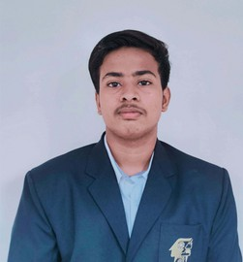

Python (Intermediate) C(Intermediate)

# LANGUAGES

English (Fluent) Tamil (Fluent)