

PRODUCT PROFILE

Name: No. 5 Eau de Parfum

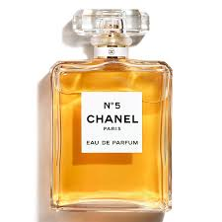
Brand: Chanel
price: $174.00
Gender: Women
Rating: 4.8/5
Description:The essence of femininity. A powdery floral bouquet.
Ingredients:
• Aldehydes

• Jasmine

• May Rose

