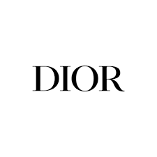

PRODUCT PROFILE

Name: J'adore

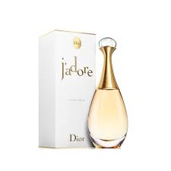
Brand: Dior
price: $160.00
Gender: Women
Rating: 4.8/5
Description:A grand feminine floral with a balanced bouquet.
Ingredients:
• Ylang-ylang

• Damascus Rose

• Jasmine

