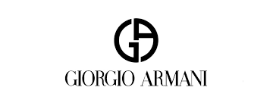

PRODUCT PROFILE

Name: Acqua di Gio

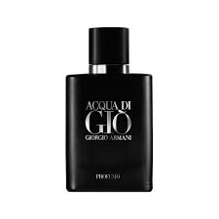
Brand: Giorgio Armani
price: $115.00
Gender: Men
Rating: 4.7/5
Description:Inspired by the sea, air, and sun.
Ingredients:
• Marine Notes

• Bergamot

• Persimmon

