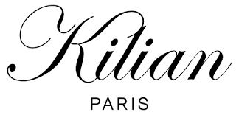

PRODUCT PROFILE

Name: Angels' Share

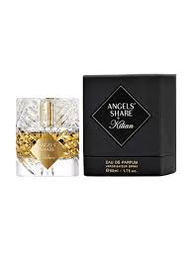
Brand: Kilian Paris
price: $255.00
Gender: Unisex
Rating: 4.9/5
Description:A cocktail of boozy cognac and sweet cinnamon.
Ingredients:
• Cognac

• Cinnamon

• Oak

• Praline

