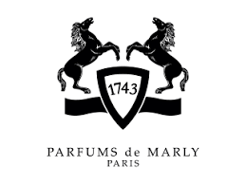

PRODUCT PROFILE

Name: Delina

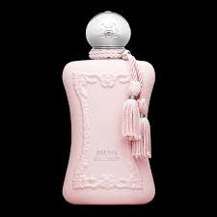
Brand: Parfums de Marly
price: $375.00
Gender: Women
Rating: 4.9/5
Description:A modern, nuanced floral bouquet.
Ingredients:
• Turkish Rose

• Lychee

• Rhubarb

