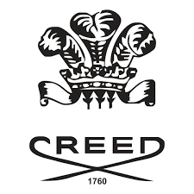

PRODUCT PROFILE

Name: Aventus

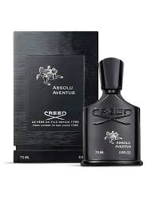
Brand: Creed
price: $495.00
Gender: Men
Rating: 4.7/5
Description:Audacious, contemporary, and confident.
Ingredients:
• Pineapple

• Birch

• Oakmoss

• Patchouli

