

PRODUCT PROFILE

Name: Lost Cherry

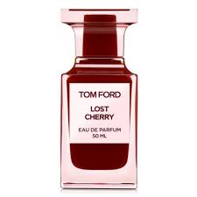
Brand: Tom Ford
price: $395.00
Gender: Unisex
Rating: 4.5/5
Description:A full-bodied journey into the once-forbidden fruit.
Ingredients:
• Black Cherry

• Bitter Almond

• Tonka Bean

