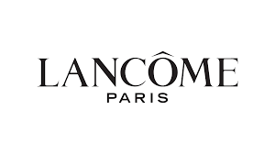

PRODUCT PROFILE

Name: La Vie Est Belle

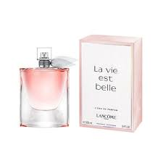
Brand: Lancôme
price: $150.00
Gender: Women
Rating: 4.7/5
Description:The fragrance of joy and happiness.
Ingredients:
• Iris

• Patchouli

• Spun Sugar

