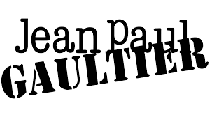

PRODUCT PROFILE

Name: Le Male Elixir

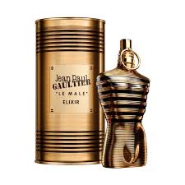
Brand: Jean Paul Gaultier
price: $145.00
Gender: Men
Rating: 4.9/5
Description:A burning intensity of wood and spices.
Ingredients:
• Lavender

• Tonka Bean

• Benzoin

• Honey

