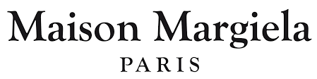

PRODUCT PROFILE

Name: Jazz Club

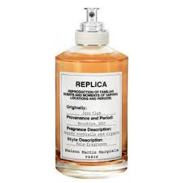
Brand: Maison Margiela
price: $165.00
Gender: Unisex
Rating: 4.7/5
Description:Memory of cocktails and cigars in a Brooklyn club.
Ingredients:
• Rum

• Tobacco

• Pink Pepper

• Vanilla

