

PRODUCT PROFILE

Name: Goddess

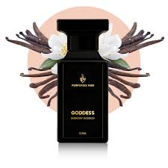
Brand: Burberry
price: $168.00
Gender: Women
Rating: 4.7/5
Description:A unique aromatic gourmand featuring three vanillas.
Ingredients:
• Vanilla Infusion

• Vanilla Caviar

• Lavender

