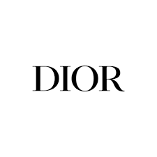

PRODUCT PROFILE

Name: Sauvage

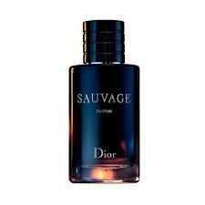
Brand: Dior
price: $145.00
Gender: Men
Rating: 4.8/5
Description:A radically fresh composition inspired by wide-open spaces.
Ingredients:
• Bergamot

• Ambroxan

• Sichuan Pepper

