

PRODUCT PROFILE

Name: Oud Wood

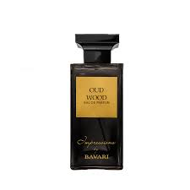
Brand: Tom Ford
price: $310.00
Gender: Men
Rating: 4.8/5
Description:Pioneering composition of exotic woods and spices.
Ingredients:
• Oud

• Sandalwood

• Cardamom

