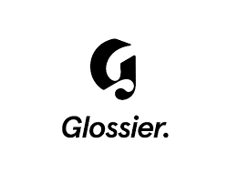

PRODUCT PROFILE

Name: You

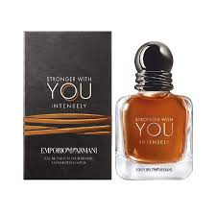
Brand: Glossier
price: $78.00
Gender: Unisex
Rating: 4.4/5
Description:Personalized scent that smells different on everyone.
Ingredients:
• Pink Pepper

• Iris

• Ambrox

