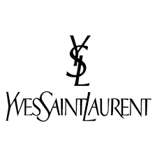

PRODUCT PROFILE

Name: Libre

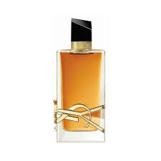
Brand: Yves Saint Laurent
price: $155.00
Gender: Women
Rating: 4.7/5
Description:The scent of freedom for a modern woman.
Ingredients:
• Lavender

• Orange Blossom

• Musk

