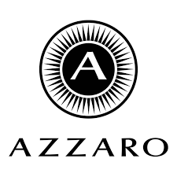

PRODUCT PROFILE

Name: The Most Wanted

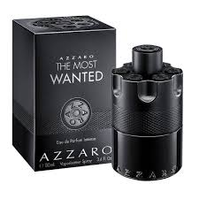
Brand: Azzaro
price: $115.00
Gender: Men
Rating: 4.8/5
Description:A magnetic and sophisticated woody-spicy scent.
Ingredients:
• Cardamom

• Toffee

• Amberwood

