

PRODUCT PROFILE

Name: Wood Sage Sea Salt

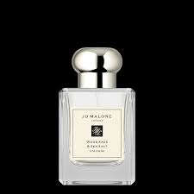
Brand: Jo Malone
price: $165.00
Gender: Unisex
Rating: 4.5/5
Description:Windswept walks along the English coast.
Ingredients:
• Sea Salt

• Sage

• Ambrette Seed

