

PRODUCT PROFILE

Name: Born in Roma

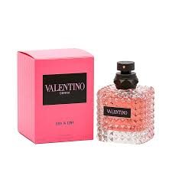
Brand: Valentino
price: $156.00
Gender: Women
Rating: 4.8/5
Description:A couture floriental celebrating your roots.
Ingredients:
• Jasmine Sambac

• Vanilla Bourbon

• Blackcurrant

