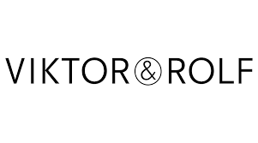

PRODUCT PROFILE

Name: Spicebomb Extreme

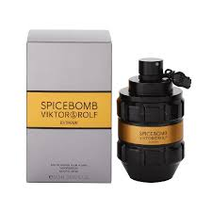
Brand: Viktor
price: $150.00
Gender: Men
Rating: 4.9/5
Description:A massive spicy amber explosion.
Ingredients:
• Black Pepper

• Tobacco

• Vanilla

• Cumin

