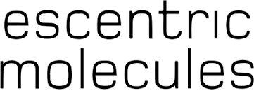

PRODUCT PROFILE

Name: Molecule 01

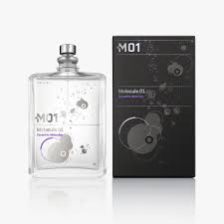
Brand: Escentric Molecules
price: $150.00
Gender: Unisex
Rating: 4.6/5
Description:A minimalist aroma that works with your pheromones.
Ingredients:
• Iso E Super

