

PRODUCT PROFILE

Name: Coco Mademoiselle

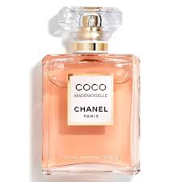
Brand: Chanel
price: $174.00
Gender: Women
Rating: 4.9/5
Description:The essence of a bold, free woman.
Ingredients:
• Orange

• Patchouli

• Turkish Rose

